Title Page

Title: Renal dysfunction in stroke patients: a hospital based cohort study and systematic review.

Cover Title: Renal dysfunction after stroke
Authors:
Correspondence: Anne Rowat, Lecturer, School of Nursing, Midwifery and Social Care, Edinburgh Napier University, SNMSC, Sighthill Campus, Edinburgh, EH11 4BN, Scotland. email: a.rowat@napier.ac.uk; telephone: 01314555670; Fax: 01314555631.

Catriona Graham, MSc, Senior Statistician, University of Edinburgh, Western General Hospital, Edinburgh.

Martin Dennis, MD, Professor of Stroke Medicine, University of Edinburgh, Western General Hospital, Edinburgh.

Word Count:
Abstract=240; Full manuscript (including abstract, main text, references and tables) =3940; References=45; Tables=2; Figures=4

Key Words: Acute Stroke; Complications; Estimated Glomerular Filtration Rate; Renal Function
Abstract
Background and purpose: Renal dysfunction (i.e. a reduced estimated glomerular filtration rate, eGFR) is commonly found in hospitalised stroke patients but its associations with patients’ characteristics and outcome require further investigation.
Methods: We linked clinical data from stroke patients enrolled between 2005 and 2008 into two prospective hospital registers with routine laboratory eGFR data. The eGFR was calculated using the Modification of Diet in Renal Disease (MDRD) method and renal dysfunction was defined as <60 ml/Min/1.73 m². In addition we systematically reviewed studies investigating the association between eGFR and outcome after stroke.
Results: Of 2520 patients who had an eGFR measured on admission hospital, 805 (32%) had renal dysfunction. On multivariate analysis, renal dysfunction was significantly less likely in those with a predicted good outcome (OR 0.27, 95% CI 0.21, 0.36) based on the well validated Six Simple Variable (SSV) model. After adjustment for other predictive factors, stroke patients with renal dysfunction were more likely to die in hospital compared with those without (OR 1.59, 95% CI 1.26, 2.00). Of the 31 studies involving 41896 participants included in the systematic review, 18 studies found that low eGFR was an independent predictor of death and 6 reported a significant association with death and disability.
Conclusion: Our findings suggest that renal dysfunction on admission is common and associated with poor outcomes over the first year. Further work is required to establish to what extent these associations are causal and whether treating impaired renal function improves outcomes.
Introduction
Renal dysfunction, defined as a low estimated Glomerular Filtration Rate (eGFR) (<60ml/min/1.73m²), is independently associated with the risk of first-ever stroke in the general population (1). Clinical guidelines therefore recommend screening patients at risk of cardiovascular disease for renal dysfunction with eGFR (2). There are also concerns that renal dysfunction in the acute phase of stroke is associated with: increased bleeding risk after an ischaemic stroke (IS) (3), reduced efficacy of thrombolysis (4), adverse effects of contrast agents used for multimodel tomography (CT) imaging (5), the high frequency of dehydration (6), and the safety of renally excreted medications, including the new anticoagulants (7).

We aimed to investigate what clinical factors on admission are associated with renal dysfunction and estimate the strength of any independent association between low eGFR rates and outcome by adjusting for other prognostic variables including the extensively validated six simple variable (SSV) model in a large in-hospital stroke population (8). We also reviewed available studies to determine whether eGFR on admission was associated with outcomes after stroke.
Methods
Cohort Study
Patients
We included all consecutive stroke admissions prospectively registered in the Scottish Stroke Care Audit (SSCA) from two teaching hospitals within 14 days of stroke onset between 1st of January 2005 and 30th of December 2008 (9). We included patients with first ever recorded IS and intracerebral haemorrhage (ICH) stroke, but excluded those with subarachnoid haemorrhage using brain imaging. We also excluded patients who had a stroke while in-hospital or who had transient ischaemic attack (TIA, symptoms <24 hours duration). The SSCA did not record if patients had chronic renal dysfunction prior to admission, therefore these patients are included in the analyses. To adjust for stroke severity we used the SSV model (age, living alone, independence in activities of daily living before the stroke, the verbal component of the Glasgow Coma Scale, arm power, and the ability to walk) to predict outcomes after stroke (8).

Ethics
Full ethical approval was not required as it aimed to inform local practice, involved linking routinely available datasets and did not involve any patient identifiable data. The study was approved by the Caldicott Guardian.

Measurements and outcomes
Estimated GFR was calculated using the MDRD equation with the formula for Isotope Dilution Mass Spectrometry (IDMS) = 175 x [serum creatinine, SCr]^{-1.154} x [age]^{-0.203} x 0.742 (if female) (2). However, between 2005-2007 the SCr was not standardised to IDMS, so a factor of 186 (rather than 175) was used when using non-IDMS spectrometry (10). Ethnicity was not included in the equation as almost all the population admitted to the hospitals during this period were white. As recommended by the National Kidney Foundation our laboratory reported normal renal function over 60 as >60 due to the tendency for MDRD equation to underestimate normal function (2). Renal dysfunction was therefore defined as <60ml/min/1.73 m² (2). We further categorised renal dysfunction into moderate (eGFR = 30-59 ml/min/1.73 m²) and severe (<30 ml/min/1.73 m²).

Analyses
Univariate associations between renal dysfunction, the SSV model and other available clinical factors were investigated with Chi-square tests. Logistic regression models were used to identify independent associations between the significant explanatory factors in the univariate analysis and renal dysfunction and then to determine the association with renal dysfunction and patient outcomes at hospital discharge. Data analyses were performed using IBM SPSS statistics for windows, Version 20.0, 2011 (Armonk, NY: IBM Corp) and SAS Institute Inc, SAS® 9.2 Enhanced Logging Facilities, Cary, NC: SAS Institute Inc., 2008.

Systematic review
The initial search strategy included key stroke subject terms used by the Cochrane Stroke Group (11). We also included: renal function, renal dysfunction, estimated glomerular filtration rate, prognosis, death, mortality, morbidity, case fatality, disability, dependence and independence. The MEDLINE, CINAHL and AMED databases using EBSCO host were searched, restricted to adult, human and English language studies from earliest date to October 2013. Only studies that met the following criteria were included: results reported for acute stroke (IS and/or ICH); eGFR measured on hospital admission; and outcome measures of death and/or disability. All potentially relevant articles were read in full and reference lists were scrutinised to identify further studies. Abstracts, conference proceedings and letters were excluded because of lack of reporting detail. A data extraction form was developed to collect data on the study design, stroke pathology, methods, maximum follow-up, effect measures and outcomes. Odds ratios (OR) were extracted from logistic regression models or calculated from 2 x 2 tables. Studies reporting hazard ratios from survival analyses were also included.
Results
A total of 2591 patients were identified in our local cohorts. We excluded 71 (2.7%) patients in whom eGFR could not be calculated. Of the 2520 remaining patients, 805 (32%) had renal dysfunction.

Univariate comparisons of clinical characteristics
Table 1 shows stroke patients with renal dysfunction were significantly more likely to be: older; female; prescribed antihypertensive medication, angiotensin converting enzyme (ACE) inhibitors or diuretics; dependent in activities of daily living prior to the stroke; living alone; and unable to talk, not orientated or unable to walk after the stroke (p<0.05). Neither stroke pathology or clinical classification differed significantly between those with and without renal dysfunction.

Factors associated with renal dysfunction on admission
Significant factors (p<0.05) in the univariate analysis as well as stroke pathology, which was approaching statistical significance, were included in logistic regression model. After removing sequentially those variables that failed to reach statistical significance, a final model showed that renal dysfunction on admission was significantly less likely in men, in patients with intracerebral haemorrhage, and in those with a predicted good outcome, but more likely in those prescribed diuretics (p≤0.001) (table 2).

Outcomes at discharge
Discharge destination was known for 2481 patients (n=39 missing). Stroke patients with moderate (185/690, 27%) and severe (25/102, 25%) renal dysfunction were significantly more likely to die in hospital compared with those without (255/1689, 15%) (Chi-square=52.04, df=4, P<0.0001). After adjustment for other predictive variables, eGFR <60 ml/min/1.73 m² was found to be an independent predicator of death in-hospital (OR 1.59, 95% CI 1.26, 2.00). Further analyses of the subcategories of renal dysfunction confirmed that moderate renal dysfunction (eGFR <60 , ≥30 ml/min/1.73 m²) was independently associated with death in hospital (OR 1.67, 95% CI 1.31, 2.13), but severe renal dysfunction (eGFR <30 ml/min/1.73 m²) was not (OR 1.30, 95% CI 0.78, 2.18).

Systematic review
The initial search identified 1,293 non-duplicate articles of which 31 studies met the inclusion criteria (Figure 1). There were a total of 41896 participants: 13241 had an IS; 6707 had an IS and were thrombolysed; 3135 an ICH, 90 a TIA, and for 18723 the pathology was not specified (12-42). Thirteen studies were performed in Europe (13,16,18,20,26-29,33,35,37,39,40), 10 in Asia (14,17,19,21,22,25,30,32,38,41), 6 in USA (12,15, 31,34,36,42), and 2 in Brasil (23,24). Twenty-two studies measured the frequency of eGFR<60mL/min/1.73m², but studies used different formulae to calculate eGFR including: Modification of Diet in Renal Disease (MDRD) (12-17,19-22,25-26,28,30-37,39-42); Crockcault-Croft (23,29,38); Chronic Kidney Disease Epidemiology Collaboration (CKD-EPI) (18,24,27,41); and Mayo Clinical Quadratic Equation (MCQE) (42). Only one study reported using different formulae depending on whether or not creatinine was measured by IDMS methods (35). Among 12 studies that reported combined outcomes of death and disability, 6 reported a significant association with low eGFR (Figure 2) (15,18,19,28,32,41). Of 13 studies that reported death after stroke, 8 (including the present study) reported that low eGFR was an independent predictor of mortality (in-hospital -1 year), after adjusting for confounding factors such as age, gender and stroke severity (17,18,25, 32,38,41,42) (Figure 3). A further 14 studies applied survival analysis: 2 found that low eGFR was a predictor of early (in-hospital-30-days) mortality (13,20); and in 9 found it was a predictor of late (1-10 years) mortality (24,26,29-31,33,35,39,40) (Figure 4). One study also reported that a high eGFR (>120) was associated with increase risk of death in younger stroke patients (35). Thirteen studies used different eGFR cut-offs or definitions of renal dysfunction making it difficult to compare and/or combine effect measures (20,22,23,25,27-30,36,37,39,41,42).

Discussion
This study found that a third of stroke patients had a low eGFR (≤60mL/min/1.73 m²) on the day of admission, which is similar to other studies that used the MDRD equation to estimate GFR (13,22,31,32,37,39,40,42). However, the systematic reviewed found that the prevalence of renal dysfunction in patients with acute stroke varies between 5% to 61% in different populations, depending on the definitions of renal dysfunction used and methods used to calculate eGFR (table 4) (12-42). We found that low eGFR remained significantly more common in female stroke patients, which may be as a result of differences in the effects of sex hormones on renal physiology as well as responses to ischaemia and reperfusion (43). Patients prescribed diuretics were also more likely to have renal dysfunction and poorer outcomes. However, it remains controversial whether diuretics worsen renal function, perhaps as a result neurohumoral mechanisms, but this requires further investigation in larger prospective studies (44).

This is the first study to use the externally validated SSV model to adjust for prognostic factors (8). Our results support the results of 4 studies included in our systematic review, confirming that low eGFR was an independent predictor of death in-hospital (17,20,25,38). The review also highlights that low eGFR is an independent predictor of poor long-term survival (24,26,29-31,33,35,39,40,41). However, 12 studies found no significant association between low eGFR and death (12,16,19,21,23,27,36,37,42) and/or combined outcomes of death and disability (12,14,22,34,37,42). The statistical heterogeneity across studies is probably as a result of the differences in study methodology. However, our findings and the majority of studies in the review do provide further support to the importance of measuring eGFR on admission to hospital to potentially reduce deleterious effects of renal dysfunction after stroke.

A major limitation of this study is that renal function was estimated, although direct measurement is expensive and not used in everyday clinical practice. Our laboratory used the MDRD to calculate eGFR, which has mainly been validated in patients with impaired renal function. However, there is growing support that future studies use the CKD-EPI to calculate eGFR, which may be more accurate in older patients with chronic disease such as stroke (45). Second, eGFR was categorised, rather than used as a continuous measure, and was measured on admission, whereas it would be ideal to verify renal function on several measurements. Third, we did not record previous renal dysfunction or other indicators of renal function, such as proteinuria and microalbuminuria, which others have suggested may more accurately predict stroke outcomes than eGFR (34). The retrospective nature of the analysis, means that we could not study unmeasured confounding such as risk factors, other medications, clinical indices and co-morbidities that might be associated with renal dysfunction. We did try and avoid possible selection bias by retrieving data for all patients in our database during the study period. Fourth, we determined outcomes at hospital discharge, rather than at a fixed time after stroke admission or onset so that our results may be confounded by length of hospital stay. Lastly, meta-analysis would not have been appropriate due to significant methodological heterogeneity across the observational studies included in the systematic review.

Conclusions
The results of this study supports the growing body of evidence that renal dysfunction is common in stroke patients on admission to hospital and is a strong independent predictor of poor outcome at hospital discharge. Larger prospective studies are warranted to determine if this association is causal and whether treatment aimed at improving eGFR might improve stroke outcomes.
References
- Lee M, Saver JL, Chang KH, Liao HW, Chang SC, Ovbiagele B. Low glomerular filtration rate and risk of stroke: meta-analysis. BMJ. 2010 341: c4249.
- Brosius FC 3rd, Hostetter TH, Kelepouris E, et al. Detection of chronic Kidney disease in patients with or increased risk of cardiovascular disease: a science advisory from the American Heart Association kidney and cardiovascular disease council; the councils on high blood pressure research, cardiovascular disease in the young, and epidemiology and prevention; and the quality of care and outcomes research Interdisciplinary working group: developed in collaboration with the National Kidney Foundation. Circulation. 2006; 114:1083-1087.
- Lee GJ, Lee KB, Jang IM, et al. Low Glomerular Filtration rate increase hemorrhagic transformation in acute ischaemic stroke. Cerebrovasc Dis. 2013; 35:53-59.
- Power A, Epstein D, Cohen D, et al. Renal impairment reduces efficacy of thrombolytic therapy in acute ischemic stroke. Cerebrovasc Dis 2013; 35:45-52.
- Lima FO, Lev MH, Levy RA, et al. Functional contrast-enhanced CT for evaluation of acute ischemic stroke does not increase the risk of contrast-induced nephropathy. Am J Neuroradiol. 2010; 31:817-21.
- Rowat A, Graham C, Dennis M. Dehydration in hospital-admitted stroke patients: detection, frequency and association. Stroke. 2012; 43:857-859.
- Lobo BL. Use of newer anticoagulants in patients with chronic kidney disease. Am J Health Syst Pharm. 2007; 64:2017-2026.
- Ayis SA, Coker B, Rudd AG, Dennis MS, Wolfe C. Predicting independent survival after stroke: a European study for the development and validation of standardised stroke scales and prediction models of outcome. J Neurol Neurosurg Psychiatry. 2013; 84: 288-296.
- Dennis MS. Developing a National System to Monitor the Quality of Hospital-based Stroke Services. The Scottish Stroke Care Audit website. http://www.strokeaudit.scot.nhs.uk/Downloads/files/Final_Proof_140207.pdf. Accessed April 10, 2013.
- Levey AS, Bosch JP, Lewis JB, et al for the Modification of Diet in renal Disease Study Group. A more accurate method to estimate glomerular filtration rate from serum creatinine: A new predication equation. Annals of Internal Medicine. 1999; 330:877-884.
- The Editorial Team. The Cochrane Stroke Group. In: The Cochrane Library, Issue 4, 2013. Chichester: Wiley. http://onlinelibrary.wiley.com/o/cochrane/clabout/articles/STROKE/frame.html. Accessed May 20, 2013.
- Agrawal V, Rai B, Fellows J, McCullough. In-hospital outcomes with thrombolytic therapy with acute ischaemic stroke. Nephrol Dial Transplant 2010, 25:1150-1157.
- Brozosko S, Szkolka T, Mysliwiec M. Kidney disease is a negative predicator of 30 day survival after acute stroke. Nephron Clin Practice. 2009; 112:c79-85.
- Chao TH, Lin TC, Shieh Y, et al. Intracerebral hemorrhage after thrombolytic therapy in acute ischemic stroke patients with renal dysfunction. Eur Neurol. 2013; 70:316-321.
- Cutting S, Castro C, Lee VH, Prabhakaran S. Impaired renal function is not associated with increased volume of intracerebral haemorrhage. J Stroke and Cerebrovasc Dis. 2014, 23(1):86-90.
- Del Fabbro P, Luthi JC, Carrera E, Michel P, Burnier M, Burnand B. Anemia and chronic kidney disease are potential risk factors for mortality in stroke patients: a historic cohort study. BMC Nephrol. 2010;11:27.
- Fu X, Wong KS, Wei JW, et al. Factors associated with severity on admission and in-hospital mortality after primary intracerebral haemorrhage in China. Int J Stroke. 2013; 8:73-79.
- Gensicke H, Zinkstok SM, Roos YB, et al. IV thrombolysis and renal function. Neurology. 2013; 81:1-9.
- Hao Z, Wu B, Lin Sen, et al. Association between renal function and clinical outcome in patients with acute stroke. Euro Neurol. 2010; 63:237-242.
- Hojs-Faban T, Hojs R, Tetickovic E, Pecovnik-Balon B. Ischaemic stroke-impact of renal dysfunction on in-hospital mortality. Eur J Neurol. 2007; 14:1351-1356.
- Kudo K, Konta T, Degawa N, et al. Relationship between kidney damage and stroke types in Japanese patients. Clin Exp Nephrol. 2012; 16:564-569.
- Kumai Y, Kamouchi M, Hata J, et al. Proteinuria and clinical outcomes after ischaemic stroke. Neurology. 2012; 78:1909-1915.
- Lima HN, Cabral NL, Gonclaves AR, Hauser A, Pecoits-Filho R. Association between albuminuria, glomerular filtration rate and mortality or recurrence in stroke patients. Nephron Clin Pract 2011; 117:c246-252.
- Lima HN, Cabral NL, Franklin J, Moro CHC, Pecoits-Filho R, Gonclaves AR. Age dependent impact of estimated glomerular filtration rate on long-term survival after ischaemic stroke. Nephrology 2012; 17:725-732.
- Liu D, Ding H, Liu S, Shen J. Estimated glomerular filtration rate in 567 patients with acute stroke. Scand J Urol Nephrology. 2012;46:142-147.
- Losito A, Pittavini L, Ferri C, De Angelis L. Reduced kidney function and outcome in acute ischaemic stroke: relationship to arterial hypertension and diabetes. Nephrol Dial Transplant. 2012, 25:1154-1158.
- Luneburg N, von Holten RA, Topper RF, Schwedhelm E, Maas R, Boger RH. Symmetric dimethlargine is a marker of detrimental outcome in the acute phase after ischemic stroke: role of renal function. Clin Sci. 2012; 122: 105-111.
- Lyrer PA, Fluri F, Gisler D, Papa S, Hatz F, Engelter ST. Renal function and outcome among stroke patients treated with IC thrombolysis. Neurology. 2008; 71:1548-1550.
- MacWalter RS, Wong SYS, Wong, KYK, et al. Does renal dysfunction predict mortality after acute stroke?: A 7 year follow-up study. Stroke. 2002, 33:1630-1635.
- Molshatzki N, Orion D, Tsabari R, et al. Chronic kidney disease in patients with acute intracerebral hemorrhage: association with large hematoma volume and poor outcome. Cerebrovasc Dis. 2011;31:271-277
- Mostofsky E, Wellenius GA, Noheria A, et al. Renal function predicts survival in patients with acute ischemic stroke. Cerebrovasc Dis. 2009, 28:88-94.
- Naganuma M, Koga M, Shiokawa Y, et al. Reduce estimated glomerular filtration rate is associated with stroke outcome after intravenous rt-PA: the stroke acute management with urgent risk factor assessment and improvement (SAMURAI) rt-PA registry. Cerebrovasc Dis. 2011; 31:123-129.
- Oksala NK, Salonen T, Strandberg T, et al. Cerebral small vessel disease and kidney function predict long term survival in patients with acute stroke. Stroke. 2010; 41:1914-1920
- Ovbiagele B, Sanossian N, Liebeskind DS, et al. Indices of kidney dysfunction and discharge outcomes in hospitalised stroke patients without known renal disease. Cerebrovasc Dis. 2009; 28:582-588
- Putaala J, Haapaniemi E, Gordin D, et al. Factors associated with impaired kidney function and its impact on long-term outcome in young ischemic stroke. Stroke. 2011; 42: 2459-2464.
- Rhoney DH, Parker D, Millis SR, Whittaker P. Kidney dysfunction at the time of intracerebral hemorrhage is associated with increased in-hospital mortality: a retrospective observational cohort study. Neurol Research. 2012; 34(5): 518-521.
- Sobolwski P, Kozer G, Michalak, S, Szczuchniak W, Sledzinska-Dzwigal M, Nyka WM: Intravenous rt-PA in patients with ischaemic stroke and renal dysfunction. Clin Neurol Neurosurg 2013; 115(9):1770-1779.
- Sweileh WM. Predicators of in-hospital mortality after acute stroke: impact of renal dysfunction. Int J Clin Pharmacol Ther. 2008; 46:637-43.
- Tsagalis G, Akrivos T, Alevizaki M, et al. Renal dysfunction in acute stroke: an independent predicator of long-term all combined vascular events and overall mortality. Nephrol Dial Transplant. 2009; 24:194-200.
- Tsagalis G, Neratzoula B, Spengos K, et al. Long-term prognosis of combined chronic heart failure and chronic renal dysfunction after acute stroke. Eur J Heart Failure. 2010; 12:849-854.
- Wang X, Luo Y, Wang Y, et al. Comparison of associations of outcome after stroke with estimated GFR using Chinese modifications of the MDRD study and CKD-EPI creatinine equations: results from the China National Stroke Registry. Am J Kidney Dis. 2013 [Epub ahead of print available from: http://www.ajkd.org/inpress]
- Yahlom G, Schwartz R, Schwammenthal Y, et al. Chronic kidney disease and clinical outcome in patients with acute stroke. Stroke. 2009; 40:1296-1303.
- Nitsch D, Grams, M,Sang Y, Black C, et al for the Chronic Kidney Disease Prognosis Consortium Associations of estimated glomerular filtration rate and albuminuria with mortality and renal failure by sex: a meta-analysis. BMJ. 2013: 346:f324.
- Schetz M. Should we use diuretics in acute renal failure. Best Pract Res Clin Anaesthesiol. 2004; 18:75-85.
- Matsushita K, Mahmoodi BK, Woodward M, et al. Comparison of risk predication CKD-EPI equation and the MDRD study equation for estimating glomerular filtration rate. J Am Med Assoc. 2012; 307:1941-51.
Table 1: Univariate comparisons of clinical characteristics by eGFR
Characteristic | eGFR (mL/min/1.73 m²) |  | P value
Characteristic | ≥60  (n=1715) | <60  (n=805) | P value
Age (years) | 75 (64, 82) | 80 (76, 87) | <0.001
Men (n)  Length of stay in acute and/or rehabilitation hospital (days) | 861 (50%)  14 (4,52) | 301 (37%)  21 (7, 56) | <0.001  <0.001
Stroke pathology and subtype  Ischaemic stroke  Haemorrhagic stroke  Uncertain  Total Anterior Circulation Stroke | 1416 (83%)  214 (12%)  85 (5%)  256 (15%) | 684 (85%)  76 (9%)  43 (5%)  136 (17%) | 0.074*  0.204
Medications  Anti-hypertensives  ACE inhibitors  Diuretics | 226 (13%)  155 (9%)  182 (11%) | 138 (17%)  101 (13%)  144 (18%) | 0.008  0.007  <0.001
Predictors of outcome†  Independent  Lives alone  Able to talk  Oriented  Able to lift both arms  Able to walk | 1396 (81%)  660 (38%)  1359 (79%)  1041 (61%)  1134 (66%)  599 (35%) | 551 (68%)  344 (43%)  596 (74%)  394 (49%)  505 (63%)  200 (25%) | <0.001  0.042  0.003  <0.001  0.096  <0.001
Outcomes at discharge (missing=39)  Discharged home  Institutional care  Dead | 1192 (71%)  242 (14%)  255 (15%) | 457 (58%)  125 (16%)  210 (27%) | <0.001*
Data are median (IQR) or number (%). *Chi-square (df = 2). Non-parametric Mann-Whitney tests were used to compare the differences between medians and Chi-square tests for nominal data. ACE, angiotensin converting enzyme. TACS, total anterior circulation stroke. †Factors included in the SSV model to predict probability of stroke severity (8).
Table 2: Multiple logistic regression analysis showing associations between renal dysfunction and clinical factors on admission.
Variable | Renal dysfunction  OR (95% CI) p value
Sex (male v female)  Stroke pathology (ICH v IS)  Prescribed diuretics  Prescribed anti-hypertensive medications  Prescribed ACE inhibitors  Predicted probability of being alive and independent in daily activities at 6 months (SSV model) | 0.68 (0.57, 0.81) <0.001  0.62 (0.47, 0.83) <0.001  1.88 (1.47, 2.40) <0.001  1.13 (0.86, 1.47) 0.383  1.17 (0.85, 1.59) 0.340  0.27 (0.21, 0.36) <0.001
All factors are expressed as binary variables. CI, confidence intervals. OR, odds ratio. ICH, intracerebral haemorrhage. IS, Ischaemic Stroke; ACE, angiotensin converting enzyme. SSV, six simple variable.

Figure 1: Flow of information of the systematic review

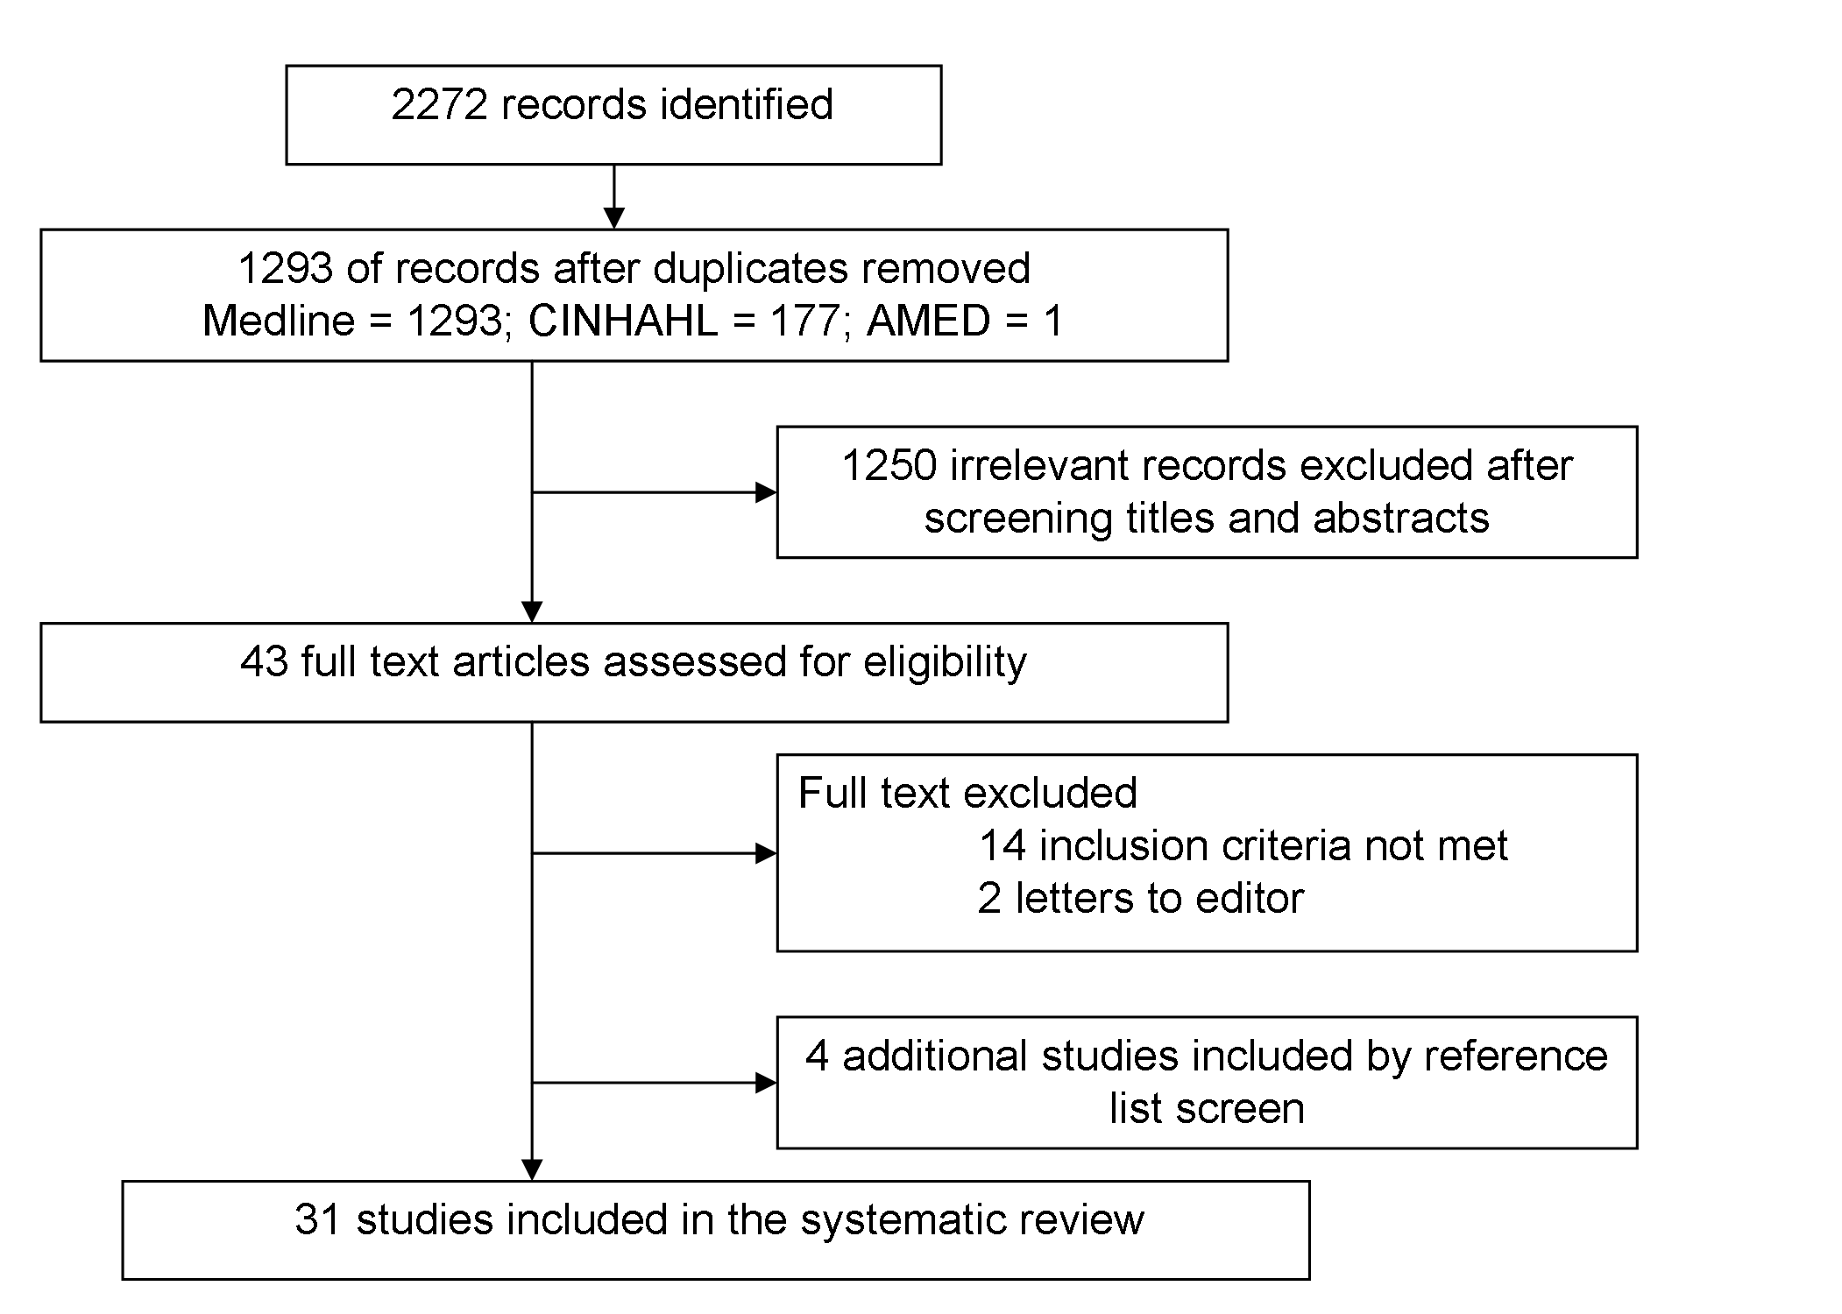

Figure 2: Forest plot of OR (95% confidence intervals) of the effect of eGFR on combined outcomes of death and/or disability at the end of follow-up.

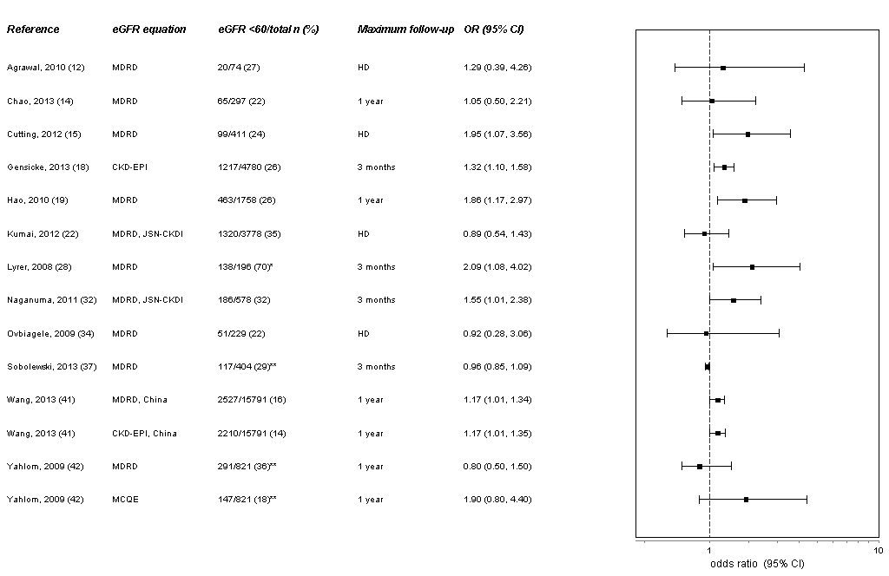
Figure 3: Forest plot of OR (95% confidence intervals) of the effect of eGFR on death at the end of follow-up.

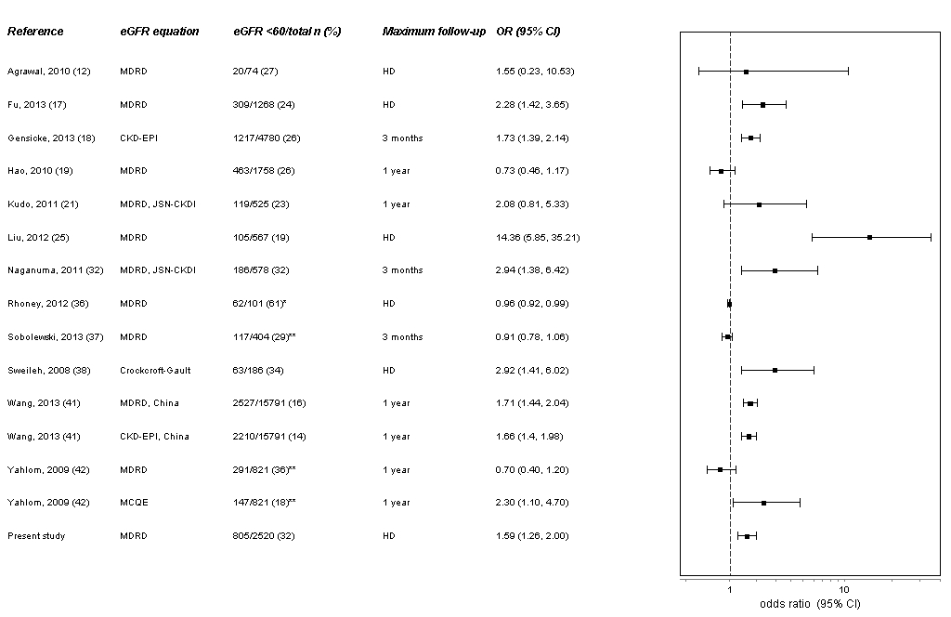
Figure 4: Forest plot of HR (95% confidence intervals) of the effect of eGFR on survival at the end of follow-up.

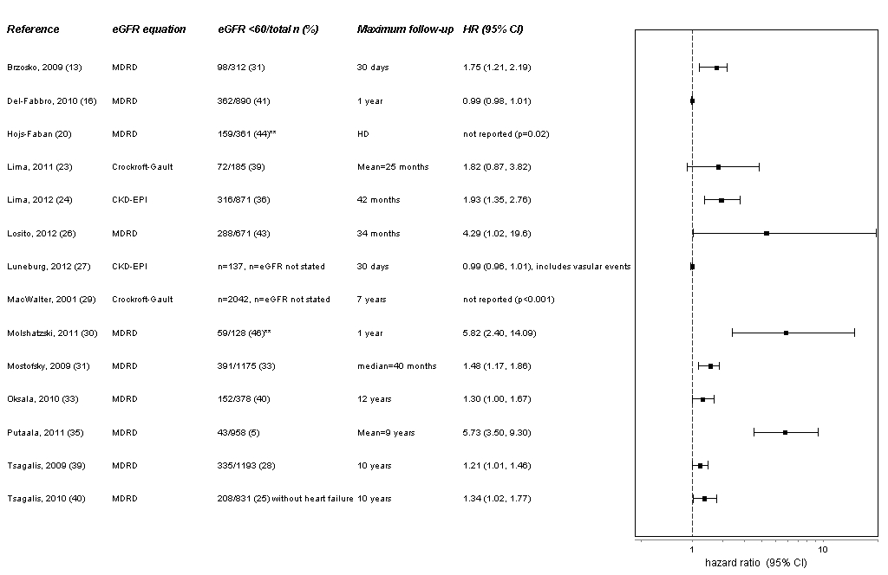
Forest Plot Figures (2, 3, 4) Legend:
Other definitions of eGFR: *<90*; **≤60 Abbreviations: IS, Ischaemic Stroke; ICH, Intra-Cerebral Haemorrhage; MDRD, Modification of Diet in Renal Disease; JSN CKDI, Japanese Society of Nephrology-Chronic Kidney Disease Initiatives; CKD-EPI, Chronic Kidney Disease Epidemiology Collaboration; MCQE, Mayo Clinical Quadratic Equation; HD, Hospital Discharge; CI, Confidence Interval; OR, Odds Ratio; HR, Hazards Ratio.

