Comparison of Heart Rate Responses between Coronary Heart Disease and Age Matched Normal Subjects in Water and Land Based Exercise: A Pilot Study.

Authors
Scott M Graham MSc, School of Applied Sciences, Edinburgh Napier University, Edinburgh, Scotland.

Marianne F Baird PhD, School of Applied Sciences, Edinburgh Napier University, Edinburgh, Scotland.

Chris Connaboy PhD, Warrior Human Performance Research Center, University of Pittsburgh, Pittsburgh, USA.

Morag Thow, PhD, Division of Physiotherapy, Glasgow Caledonian University, Glasgow, Scotland.

Article category
Research report

Corresponding Author
Dr Marianne Baird. PhD.
School of Applied Sciences
Edinburgh Napier University
Sighthill Campus
9 Sighthill Court
Edinburgh
EH11 4BN
E-mail m.baird@napier.ac.uk

Disclosure
The authors have no financial support or conflict of interests to disclose.

Comparison of Heart Rate Responses between Coronary Heart Disease and Age Matched Normal Subjects in Water and Land Based Exercise: A Pilot Study.

Abstract
Background and purpose
Exercise therapy is an integral component of Cardiac Rehabilitation (CR). Currently, land based exercise classes are prescribed in Phase IV CR. However, with its unique properties, water based exercise potentially offers an alternative, or additional mode of exercise, which could be utilised by rehabilitating individuals. The purpose of this pilot study was to measure and compare the heart rate (HR) response, and perception of exercise intensity, between similar land and water based classes.
Methods
Participants in land based Phase IV CR classes (n = 7, aged 68 ± 7 yr), and similar aged-matched participants partaking in water based exercise (n =7, aged 64 ± 6 yr) completed 1 hr exercise sessions on four consecutive weeks. HR, beats per minute (bpm) was measured continuously during each session and rating of perceived exertion (RPE) [Borg scale 6 – 20] was recorded at regular intervals.
Results
A main effect for HR was found (P < 0.05). During the four weeks, average HR in water was 9% higher than on land (Water 85 ± 1 bpm vs Land 78 ± 5 bpm). Similar exercises elicited significantly higher HR’s in water than on land (warm up 6%, shuttle run 9%, hamstring curls 17% and cool down was 8% higher in water compared to land). (P < 0.05). RPE was more accurately perceived in water, and generally, RPE was lower in water.
Discussion and conclusion
The results of this study indicate that water based exercise allows individuals to maintain exercise work load at higher levels than similar exercise on land while perceiving variations in exercise intensity.

Introduction

Cardiac Rehabilitation (CR) is a multifactor, secondary prevention intervention.¹ The aim of CR is to support and restore psychological, physical and social functioning of the individual to an optimal level.^{2,3,4,1} In Phase IV CR the objective is to establish lifelong changes in lifestyle ensuring the best prognosis for individuals who have suffered a cardiac event.^{2,5}
Regular appropriate exercise is regarded as a safe and effective intervention³ which improves health outcomes, and can reduce mortality rates.⁶ Physiological adaptations allow individuals to exercise at a greater intensity, with a lower HR than previously; this results in an augmented work capacity, lessening cardiac work load.² Furthermore, there is evidence that exercise improves endothelial function and the bio-availability of nitrogen; this suggests the regression and/or reduction in progress of atherosclerosis is possible.^{7,8}
Adherence to long term physical activity in CR individuals continues to be a challenge;^{9,10} A number of suggestions to address this problem include the need for innovative strategies and novel models of delivery in CR.¹⁰ Presently in the UK, Phase IV CR classes are primarily conducted on land. However, a choice of exercise mediums such as water based exercise may have similar exercise potential as land based and enhance psychological well-being.¹¹ Water based exercise is more prevalent in other countries, for example in France, 27% of CR centres have a swimming pool.¹² With its unique properties of buoyancy and resistance, water based exercise potentially offers an alternative, or additional, mode of exercise which could be utilised by rehabilitating individuals and may improve adherence in the UK.
Water based exercise can provide healthy individuals, and those with physical limitations such as orthopaedic or neurological condition, with an alternative medium to achieve optimal exercise intensities.¹³ Exercise which may not be physically possible, or too stressful when executed on land, may be performed safely and more comfortably in water¹⁴, thereby increasing exercise potential for those who may have physical or physiological limitations.¹⁵ Musculoskeletal problems are experienced by a high proportion of people participating in CR programmes and have recently been identified as a constraint to exercise participation in CR.⁹ Mandic, Body, Barclay et al.⁹ recommend CR schemes should design protocols which manage and minimise musculoskeletal pain during exercise. As the buoyancy properties of water minimize the stress of weight bearing and reduce joint discomfort this may encourage adherence. Meredith-Jones, Water, Legge et al. ¹⁶ provide a comprehensive review of the potential physiological benefits of aquatic exercise.
There is however, a dearth of research relating to the efficacy of water-based exercise in CR. One of the few studies to evaluate water based CR¹⁷ compared the effects of exercise performed on land with water based exercise in male patients with coronary artery disease (CAD) throughout a four-month period (n = 32; randomly assigned to a control, water or land group). It was concluded that similar benefits of exercise: reduced myocardial oxygen demands, increased muscular strength, and improved body composition and lipid profile. These benefits occurred irrespective of whether exercise was performed in water or land. This study highlighted that aquatic exercise was well tolerated, and elicited favourable improvements in the health status of individuals with CAD. Further work¹² provided additional evidence that water-based exercise is a safe and effective training modality for males with CAD. At the conclusion of a 3-week exercise intervention (5 sessions per week), left ventricular end diastolic function was significantly improved, and diastolic arterial pressure was lowered (P < 0.05), in n = 24 males with CAD (normal left ventricular function). Participants were randomly allocated to either land based, or combined land and water-based endurance and callisthenic exercise. Additionally, maximal aerobic capacity, and aerobic peak power improved significantly in both exercise mediums.
Exercise in water can induce feelings of well-being in some individuals; the mechanisms for this are not fully understood, however, may be linked to increased blood shunting to central circulation¹⁸. Buoyancy in water may help reduce weight stress on joints¹⁹, which could contribute to feelings of well-being in individuals with co-morbidities such as arthritis and obesity. This may allow individuals to exercise at a greater intensity compared to exercise on land.
Nevertheless, a feeling of well-being in the water does not guarantee that increased heamodynamic responses are not placing unacceptable stress on the myocardium.¹⁸ Hydrostatic pressure reduces vascular capacitance, and capacity, increasing the translocation of peripheral blood volume into the abdomen and thoracic cavity, which can lead to an augmented pre-load.^{20,21,22} However, when submersion is to the iliac crest, the effect is minimal.¹⁸ Nevertheless, with immersion, the energy cost of respiration rises, and cardiac output is increased by 10-15% at hip depth.²³ Therefore, it is important to ascertain if rehabilitating individuals participating in aquatic exercise can accurately perceive exercise intensity.. The purpose of this pilot study was to measure and compare HR response, and the perception of exercise intensity, between similar land and water based classes; additionally, to determine if aquatic exercise has potential as a suitable exercise intervention in Phase IV CR.
Methods
Subjects were recruited from local land based Phase IV CR classes and water based from general practitioner (GP) referral classes, in local authority leisure centres in Renfrewshire, Scotland, UK. Ethical approval was sought and granted from the host University’s ethical group. Inclusion criteria was males and females, aged between 40-75 yr, regular participation in identified exercise class, (at least one session per week in land or water). Exclusion criteria; participants new to groups and/or unfamiliar with exercise modality or any adverse health conditions which would severely limit exercise participation.
Forty one volunteers initially completed consent forms and health questionnaires. Participants were advised on the correct procedure for using the HR monitor and familiarised with Borg’s Rating of Perceived Exertion (RPE) scale.²⁴ Each participant was given a copy of the scale, and a written description of its application. Three volunteers were excluded due to unsuitable age, one for medical reasons, and eight for technical failure of heart rate monitors during sessions. Sixteen were excluded during the trial as they failed to complete four consecutive exercise sessions.
Fourteen participants completed the study and were included in the final analysis. Land based (n =7, [n = 2 female, n = 5 male] aged 68 ± 7 yr) and water based (n =7, [n 2 female, n = 5 male] aged 64 ± 6 yr). N = 4 participants included in water and n = 4 in the land group reported taking beta blocker medication, no other medications reported were likely to affect HR response to exercise.
Study Design
Subjects participated in their regular exercise class and were instructed to exercise as normal; exercise sessions were conducted by qualified instructors. Land and water classes were not replicated in a standardised manner, however, followed a similar format; exercise intensity was not standardised in this study as the purpose was to gather information regarding HR and RPE rates during typically available classes. All exercises were performed in an upright position; duration was 50-60 min and consisted of a 10 min aerobic group warm up, followed by circuit based aerobic and light resistance exercise, and concluded by a 10 min aerobic cool down for 10 min on land and 15-20 min in water. Air temperature was ~ 20º C on land, and ~ 30º C in water with air temperature maintained ~1º C higher.
HR was measured continuously throughout each session (Suunto Peripheral Observation Device, USA). Borg’s RPE scale (6-20 scale)²⁴ was used to measure perceived exercise intensity. Participants responded verbally at regular intervals (~ 5 min into warm up, ~ 2 min during the main component and ~ 5 min during the cool down). One familiarisation session was performed prior to commencement of the study. Data for each participant, and individual exercises were recorded during one class (land or water), per week, for four consecutive weeks.

Statistical Analysis
Comparisons were made for HR and RPE within groups, across land and water groups, and for individual exercises. Data analysis was conducted using repeated measures and independent t-tests, significance was set at P < 0.05 . The strength of linear association was measured using Pearson’s correlation coefficients.
Results
Results were based on the 14 subjects (land: n =7 & water; n = 7) who completed four consecutive exercise sessions with all data recorded.
Water versus Land
Average HR was significantly higher in water compared to land based exercise (t, 3 = 3.517, P < 0.05) (water: 85 ± 1 bpm vs land: 78 ± 5 bpm). Average RPE was not significantly different between land and water (P > 0.05). There was a very strong association (r = 1.0) between HR and RPE in water throughout the four weeks: In land, a moderate negative relationship was found between HR and RPE (r = -0.42).
Similar exercises which elicited significantly higher (P < 0.05) HR’s in water compared to land were: warm up (6% greater in water), shuttle run (9% greater in water), hamstring curls (17% greater in water) and cool down (8% greater in water).
Discussion
The purpose of this pilot study was to compare HR and RPE response to land based exercise in Phase IV CR with a similar matched population exercising in water. The main findings were, that HR was significantly higher (P < 0.05) in water than land (9% higher in water) (Figure1). On average, RPE was more accurately perceived in water (Figure 2) than land (Figure 3). Finally, RPE was not significantly different in water compared to land (Figure 4). However, as HR was higher in water than in land, this suggests the perception of intensity was lower. These findings may be due to several factors:
Water resistance creates turbulence and viscosity friction, creating a greater resistance than air²⁵, therefore, the increased energy requirement for movement in water may have increased HR (factors which may affect the haemodynamic response of HR in aquatic exercise are illustrated in Figure 5). Additionally, water resistance offers an exercise medium which may allow higher levels of exercise intensity than similar exercise on land.²⁶ As physical movement below water level is slower than through air, and buoyancy reduces stressful impact, there may be a reduced risk of musculoskeletal discomfort, and/or injury, compared to exercise on land, whilst maintaining, or even increasing, energy expenditure. The results of this study would suggest that aquatic exercise effectively augmented work rate in a population similar to that of those participating in Phase IV CR.
In this study RPE was more accurately perceived in aquatic exercise than on land (r = 1.0), indicating that the current Borg RPE scale can be used to measure variations in perception of exercise intensity in water. There was a moderately strong negative relationship between RPE and HR (r = -.42). This negative relationship was influenced in week two when HR was higher than in week one, however, RPE was lower than in week one. In weeks three and four the relationship between HR and RPE was closer. It is not known why this discrepancy occurred in week two. Possible explanations include: daily variations in RPE, differences in instructor interaction with participants or previous experience with using RPE scales.
RPE has previously been reported as being higher in water (P < 0.01)²⁷, the same (P > 0.05)^{28,15}, or lower, for a given HR (swimming)²⁹ than on land. Equivocal findings may be influenced by extrinsic influences such as exercise intensity, mode of exercise, and environmental conditions.²⁹ Although not significantly different, there was a trend in the present study, for RPE to be lower in water compared to land. A reduction in joint discomfort and weight support of buoyancy may diminish fatigue sensations, subsequently reducing RPE²⁶, therefore, a scale specific to water based-exercise may be required to ensure exercise intensity and the level of cardiac strain is safe and appropriate.²⁹ The findings of this study support the hypothesis of Thow²⁹, as, although HR was higher in water, RPE was not greater.
Limitations
This was a convenience sample and is not representative of the entire CR population, additionally, there were differences in participant attributes in each locality. However, the purpose of this pilot study was to gather primary data which would inform future study design. Direct comparisons between the water and land groups in this work cannot be made; due to the difference in environment, non-standardisation of exercise intensity and individual variations in groups, nevertheless, there were close similarities in participants’ ages, physical activity and health status, class structure, exercise types and intensity. There was a large drop-out from the original sample number in this study. Whilst this is similar to adherence rates in CR programmes ⁹, it should be taken into consideration when interpreting the findings in this work.
There are few studies documenting the effects of aquatic exercise in Phase IV CR. Difficulties lie in standardising intensity for similar exercise in water and land exercise. There is also much scope for variation in study design concerning the type of exercise, disease status of individuals, gender and socioeconomic status. Nevertheless, future clinical trials, rigorously standardising intensity between exercises in water and land, are crucial to explore the potential benefits and problems which may be associated,
Conclusion
This pilot study demonstrates aquatic exercise can elicit a higher HR response than comparable land based exercise in individuals with CHD and similar matched populations, with a strong correlation between RPE and HR in water. Therefore, water-based exercise may be a suitable exercise intervention in Phase IV CR, increasing choice, and improving physiological and psychological health status. The validity of RPE in aquatic exercise for Phase IV CR requires additional investigation, as variation in exercise type and intensity, with RPE accuracy, may exist. The present work proposes further research is warranted into the suitability of aquatic-exercise as a choice in Phase IV CR.
Acknowledgments
The authors would like to thank the volunteers and instructors at Erskine Community Sports Centre and the Lagoon Leisure Centre Paisley for their participation and assistance in this study.
References
1. Stoira E, Capoferri M, Molteni A, Bachmann M, Moccetti T. Effects of the implementation of a multidisciplinary cardiac rehabilitation programme in clinical practice. Cardiovasc Med. 2010; 13(5):162-166.
2. Bethell H, Dalal H, Lewin R. Cardiac rehabilitation: worth it? Heart Online First. 2008; 6(2).
3. Casillas JM, Gremeaux V, Damask S, Perennou. Exercise training for patients with cardiovascular disease. Annales de Réadaption et de Médecine Physique. 2007; 50(6): 403-418.
4. Jowett NI, Thompson DR. Comprehensive Coronary Care. 3rd ed. London: Elsevier Limited; 2004.
5. Cano-de-la Cuerda R, Alguacil Diego IM, Alonso Martin JJ, Sanchez AM, Miangolarra Page JK. Cardiac rehabilitation programs and health related quality of life. State of the art. Revista Espanola de Cardiologia, 2015; 65(1): 72-79.
6. Thompson PD. Exercise prescription and proscription for patients with coronary artery disease. Circulation. 2005; 112(15): 2354-2363.
7. Mourot L, Teffaha D, Bouhadi M, Regnard J. Training-induced increase in nitric oxide metabolites in chronic heart failure and coronary artery disease: an extra benefit of water-based exercise? Eur J Cardiovasc Prev Rehabil. 2009; 16(2): 215-221.
8. Roberts C T, Barnard RJ. Effects of exercise and diet on chronic disease. J Appl Physiol. 2005; 98(1): 3-30.
9. Mandic S, Body D, Barclay L, Walker R, Nye ER, Grace SL. Community-based cardiac rehabilitation maintenance. Heart, Lung & Circ. 2015; 24(7): 710-718.
10. Sandesara PB, Lambert CT, Gordon NF, Fletcher GF, Franklin BA, Wenger NK. Cardiac rehabilitation and risk reduction: time to ‘rebrand and reinvigorate’. J Am Coll Cardiol. 2015; 65(4): 389- 395.
11. Parfitt G, Gledhill C. The effect of choice of exercise mode on psychological responses. Psychol Sport Exerc. 2004; 5(2): 111-117.
12. Teffaha D, Mourot l, Vernochet P, Ounissi F, Regnard J, Monpere C. Relevance of water gymnastics in rehabilitation programs in patients with chronic heart failure or coronary artery disease with normal left ventricular function. J Card Fail. 2011; 17(8): 676-683.
13. Noh DK, Lim JY, Shin HI, Nam-Jong P The effect of aquatic therapy on postural balance and muscle strength in stroke survivors – a randomized controlled pilot trial. Clin Rehabil. 2008; 22(10-11): 966-976.
14. Getz M, Hutzler Y,Vermeer A. Effects of aquatic interventions in children with neuromotor impairments: a systematic review of the literature. Clin Rehabil. 2006; 20(11): 927-936.
15. Takeshima N, Rogers ME, Watanabe E, Brechue WF, Okada A, Yamada T. Water-based exercise improves health- related aspects of fitness in older women. Med Sci Sports Exerc. 2002; 34 (3): 544-551.
16. Meredith-Jones, K, Waters D, Legge, M, Jones L. Upright water-based exercise to improve cardiovascular and metabolic health: a qualitative review. Compl Ther Med. 2011; 19 (2): 93-103.
17. Volaklis KA, Spassis AT, Tokmakidis SP. Land versus water exercise in patients with coronary artery disease: effects on body composition, blood lipids, and physical fitness. Am Heart J. 2007; 154(3): 560.e1-6
18. Meyer K, Leblanc M-C. Aquatic therapies in patients with compromised left ventricular function and heart failure. Clin Invest Med. 2008; 31(2): 90-97
19. Chu KS. Rhodes EC. Physiological and Cardiovascular Changes Associated with Deep Water Running in the Young. Possible Implications for the Elderly. Sports Med. 2008; 31(1): 33-46.
20. Arborelius M Jr, Ballidin UI, Lilja B, Lundgren CE. Hemodynamic changes in man during immersion with head above water. Aerosp Med. 1971; 43(6); 592-598.
21. Cider A, Sunnerhagen KS, Schaufelberger M, Andersson B. Cardiorespiratory effects of warm water immersion in elderly patients with chronic heart failure. Clin Physiol Funct Imaging. 2005; 25(6); 313-317.
22. Park KS, Choi JK, Park YS. Cardiovascular regulation during water immersion. Applied Human Science: J Physiol Anthropol. 1999; 18(6): 233- 241.
23. Reilly T, Dowzer CN, Cable NT. The physiology of deep-water running. J Sports Sci. 2003; 21(12): 959-972.
24. Borg GA. Psychophysical bases of perceived exertion. Med Sci Sports Exerc. 1982; 14(5): 377-381.
25. Johnson BL, Stromme SB, Adamczyk JW, Tennoe KO. Comparison of oxygen uptake and heart rate during exercises on land and in water. Phys Ther. 1977; 57 (3): 273-278.
26. Wilcock IM, Cronin JB, Hing WA. Physiological response to water immersion. A method for sport recovery? Sports Med. 2006; 36(9): 747-765.
27. Barbosa TM, Garrido MF, Bragada J. Physiological adaptations to head-out aquatic exercises with different levels of body immersion. J Strength Cond Res. 2007; 21(4): 1255-1259.
28. Heithold K, Glass S. Variations in Heart Rate and Perception of Effort During Land and Water Aerobics in Older Women. JEP online.2002; 5(4): 22-28
29. Thow M. ed. Exercise leadership in cardiac rehabilitation. Chichester. Whurr Publishers Limited; 2006.
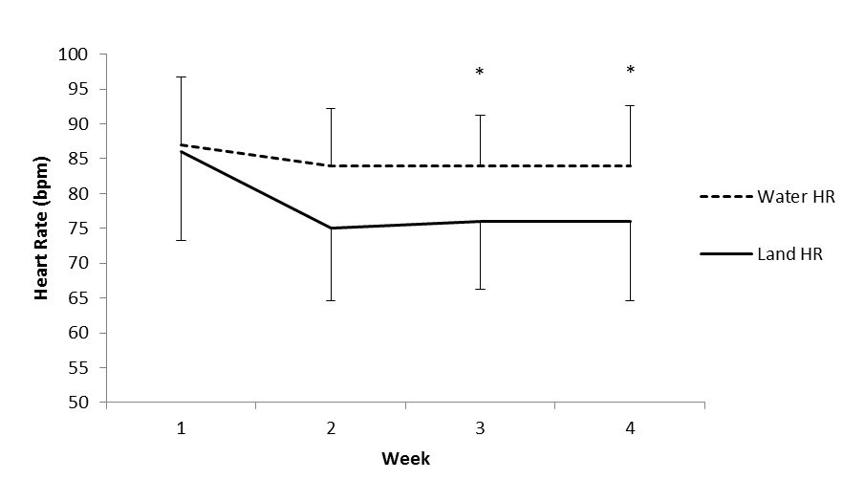
*
Figure 1. Average heart rates in Cardiac Rehabilitation Phase IV land based, and GP exercise referral aquatic exercise classes. * denotes a significant difference between land and water each week (P < 0.05, n = 7 land, n = 7 water).

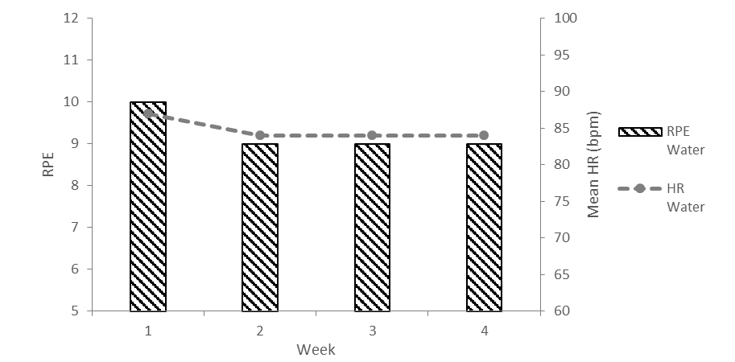
Figure 2. Relationship between heart rate (HR) and rating of perceived intensity (RPE) in GP exercise referral water based exercise classes.

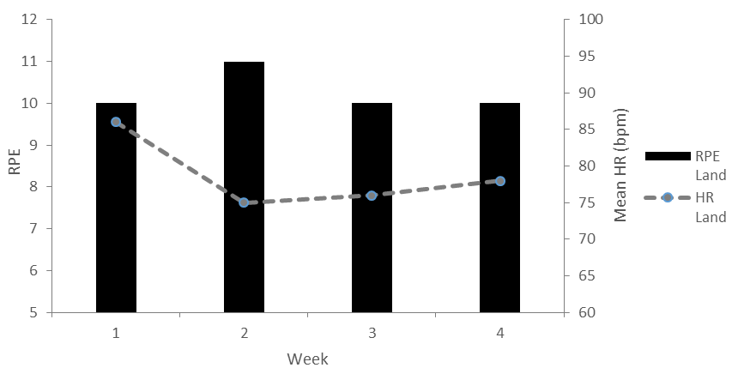
Figure 3. Relationship between heart rate (HR) and rating of perceived intensity (RPE) in Cardiac Rehabilitation Phase IV land based exercise classes.

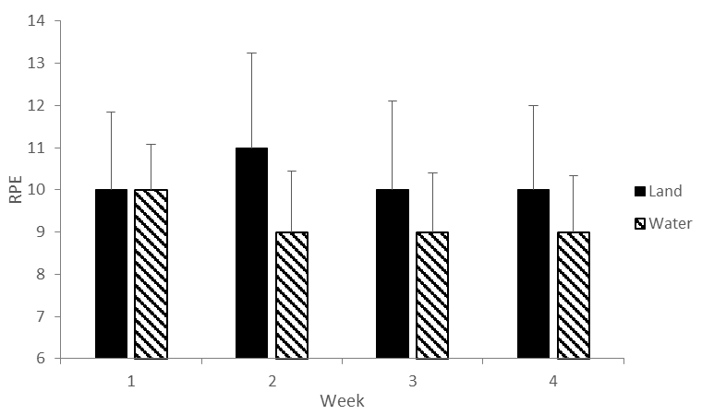
Figure 4. Average rating of perceived exertion (RPE) score in Cardiac Rehabilitation Phase IV land based, and GP exercise referral water based exercise classes. (P > 0.05, n = 7 land, n = 7 water).

Figure 5. Factors affecting the hemodynamic response to aquatic exercise.

