What helps or hinders treatment decision making capacity in psychosis? A systematic review and meta-analysis.

Running head: Treatment decisional capacity in psychosis

Amanda Larkin^{1*}
Paul Hutton²

¹Psychosis Research Unit
Greater Manchester Mental Health NHS Foundation Trust
Rico House
Prestwich
M25 3BL

²School of Health and Social Care
Edinburgh Napier University
Edinburgh
EH11 4BN

*Corresponding author: Amanda Larkin, amanda.larkin@nhs.net

Abstract

Background: The evidence on factors that may influence treatment decisional capacity (‘capacity) in psychosis has yet to be comprehensively synthesised, which limits the development of effective strategies to improve or support it.

Aims: To determine the direction, magnitude and reliability of the relationship between capacity in psychosis and a range of clinical, demographic and treatment related factors, thus providing a thorough synthesis of current knowledge.

Method: We did a systematic review, meta-analytical and narrative synthesis of factors that help or hinder treatment decision-making capacity in psychosis (PROSPERO registration CRD42015025568), assessing the direction, magnitude, significance and reliability of reported associations.

Results: We identified 23 relevant studies (N=1823). Psychotic symptoms had small, moderate and strong associations with appreciation, understanding, and reasoning, respectively. Both verbal cognitive functioning and duration of education had small to moderate correlations with understanding and reasoning. Better capacity was also associated with better insight, better metacognitive ability, higher anxiety and lower perceived coercion. No linear relationship with depression was observed. Interventions linked to improved capacity over time were inpatient care (including antipsychotic treatment), information-simplification, shared decision-making and metacognitive training.

Conclusion: This synthesis of over 25 years of research provides a comprehensive assessment of factors that may help or hinder treatment decision-making capacity in psychosis. Although much is known about the role of symptoms and other clinical variables, effective and acceptable psychological interventions to support capacity in this group are lacking.

Introduction

Decisional capacity is a term that has its origins in legislation, but has considerable implications for clinical practice. Definitions vary but research in this area has centred on a model published by Paul Appelbaum and Thomas Grisso in 1995, who conceptualised capacity in terms of four abilities; ability to communicate a choice, ability to understand relevant information, ability to appreciate relevant information and ability to manipulate information rationally (1).

In healthcare, treatment decision-making capacity (hereafter referred to as ‘capacity’) is closely related to agency, autonomy and the exercise of self-governance, concepts that are fundamental to human dignity and rights (2). For example Article 12 of the United Nations Convention on the Rights of Persons with Disabilities recognises the right to be recognised as a person before the law, and the subsequent right to have one’s decisions legally recognised. Autonomy and empowerment are thought to be essential components of patient-defined recovery from psychosis (3, 4) and mental health legislation frequently requires clinicians to empower patients to make decisions and to make an assumption of capacity until proven otherwise [e.g., The Adults with Incapacity (Scotland) Act (2000) (5) and the Mental Capacity Act (MCA) 2005]. However, there is also a concern that if patients who lack capacity to make specific decisions are allowed to make these decisions, then these may not reflect their true wishes, with the consequence being a poor outcome and inadequate protection of the patient (6). Capacity has understandably been called the “gatekeeper for autonomy”(7).

Lepping, Stanley, & Turner (2015) found that the average percentage of patients with impaired capacity on psychiatric wards is 45% (8). Despite the frequency with which psychiatrists are asked to make such judgements, almost 50% of them view the evidence base in this area as weak (9). Nonetheless, the field of decision-making capacity research has grown in recent years. This has been spurred on by changes in legislation, but also by a change in the culture in which healthcare decisions are made. Users of mental health services are showing a greater desire to be included in decisions about their treatment (10), and there has been an increasing emphasis on ensuring that not only are patients giving their informed consent to treatment, but also that they are actively involved in the decision making process (11). The most common model for such involvement is called ‘shared decision-making’, but there is evidence that people with psychosis do not typically experience this (12). Since impaired capacity is a major barrier to psychiatrists implementing shared decision-making with people with psychosis (13) improving our understanding of factors that cause or maintain this impairment may help to help to change this. Moreover, British Medical Association (2015) guidance on assessing and managing capacity advises that it is the duty of the assessing clinician to enhance capacity where it is possible to do so (14). In the context of psychiatric and mental health conditions, this is often achieved through treatment of the condition itself; however there has been little research on the effectiveness of current treatments for enhancing decision making capacity. Although some studies have examined whether specific psychological and educational interventions can enhance capacity (15, 16) the overall evidence is surprisingly limited.

Previous reviews have examined the prevalence of incapacity in psychiatric patients (17), the reliability and validity of measurement tools (18, 19), the degree of impairment in decisional capacity in schizophrenia (20), the role of poor insight (21) and the role of specific neuropsychological deficits (22). Although one older review examined the correlates of capacity in psychiatric populations generally (17) no reviews have yet looked at the factors associated with capacity in psychosis specifically. Identifying these factors may help us develop a clinically useful theoretical model, which in turn will aid the development of effective interventions to support capacity. Thus, the primary objective of this systematic review is to identify which clinical, demographic and treatment-related variables are associated with treatment decision-making capacity in psychosis and, where a sufficient number of comparable studies exist, use meta-analysis to produce pooled estimates of the magnitude and reliability of any relationship.

Method

Protocol registration
To minimise the risk of selective reporting bias and maximise transparency, a protocol for the systematic review was registered in advance with the PROSPERO International Prospective Register of Systematic Reviews (registration number: CRD42015025568) (23). The protocol was updated to include a quantitative synthesis of effect sizes using meta-analytic procedures where three or more studies provided usable data, and incorporation of GRADE to assess outcome quality (24).

Inclusion and exclusion criteria
Studies were included if they were published in English before October 2015, included a reliable and valid assessment of capacity with adults diagnosed with a non-affective psychotic disorder and provided data on the association between capacity and at least one other clinical or demographic variable. Assessment of capacity was accepted as valid if participants had been asked to make a real or hypothetical decision about a health care or treatment decision, and if a valid and reliable tool was used to measure at least one of the accepted domains of decisional capacity: ability to communicate a choice, ability to understand relevant information, ability to appreciate relevant information and ability to manipulate information rationally (1). Studies reporting usable cross-sectional or longitudinal data were eligible for inclusion, regardless of overall study design or purpose. Studies were excluded where the proportion of participants with non-affective psychosis was less than 50%. Since we were specifically investigating correlates of treatment decision-making capacity, and because capacity is a decision-specific concept, we excluded studies where only capacity to consent to participate in research or legal proceedings was examined.

Search strategy
A search using the terms (Schizo* OR Psychosis) AND (Capacity OR Decision making OR Consent) AND (Treatment OR Health care) was conducted in the databases Embase, Embase Classic, Medline, and PsycInfo from 1947 to October 2015. One researcher (AL) conducted the search (with support and training from a qualified librarian), and another (PH) provided supervision and consultation. Previous reviews and included studies were hand searched for additional studies, and authors were contacted for any further unpublished studies.

Study selection
The titles and abstracts of studies identified by the search were screened to eliminate obviously ineligible studies (e.g. studies of unrelated conditions, or other reviews). The full-text reports for any remaining studies were then examined to determine eligibility against the inclusion and exclusion criteria.

Study quality assessment
In line with previous systematic reviews (25, 26) the assessment of observational study quality was conducted using an adapted version of the Agency for Healthcare Research and Quality assessment tool (AHRQ) (27). The adequacy of the methods used to select the cohort, the sample size, the methods used to assess outcomes, the degree of missing data, and the appropriateness of the analytic methods used were all assessed as “yes”,”no”, “partial” or ‘can’t tell’ (see supplement). Randomised controlled trials were assessed using the well-established Cochrane Risk of Bias tool (28) which assesses risk of selection, performance, detection, attrition and reporting biases. An adapted version of GRADE (Grades of Recommendation, Assessment, Development, and Evaluation) (24) was used to assess the quality of the effect size estimates, whether derived from single studies or groups of studies. Specific criteria for assessing outcome quality within the GRADE approach are outlined in the supplement.

Analysis
Meta-analysis was conducted when at least three studies reported usable data on the relationship between a particular variable and treatment decision-making capacity. These were conducted using MetaXL software (29). Correlations were transformed into Fisher’s Z, and a random effects model using the DerSimonian and Laird method was used to compute an overall effect size, together with 95% confidence intervals (30). This approach allows for true heterogeneity in effect size magnitude (due to differences in measurement, sample, etc.) to be distinguished from sampling error (31). Fisher’s Z estimates were then back-transformed to Pearson’s r to allow interpretation according to Cohen’s (1988) conventions (0.1 = small; 0.3 = moderate; 0.5 = large) (32).

Results

Study selection
The process of study selection is represented in the PRISMA diagram below (Figure 1). Of the 2,057 papers initially identified, 1,994 were excluded after inspection of title or abstract. Full-text publications were sought for the remaining 63 papers. Of these, 40 were excluded; 21 did not include a measure of capacity or did not examine or report correlates, 12 were case descriptions, editorials or reviews, 4 examined a different population and 2 examined research decision making capacity. A full list of excluded studies with reason for exclusion is provided in the supplementary file.

A total of 23 studies were included for review, and are summarised in Table 1. These provided data on the relationship between capacity and symptoms (k=12), insight (k=4), affect (k=3), cognitive performance (k=6), executive functioning, (k=2), duration of illness (k=2), education (k=5), metacognition (k=1) and various interventions (k=10).

Quality assessment
AHRQ ratings of observational and uncontrolled intervention studies are provided in Table 2 and 3 respectively, and Table 4 provides Cochrane Risk of Bias ratings for randomised controlled trials. Overall GRADE ratings for each outcome are presented in the right hand column of Tables 5-7.

The studies generally performed well on the AHRQ and Cochrane Risk of Bias assessment. Methods used to assess key outcomes were generally reliable and valid, and cohorts were as a rule well-described and characterised, and most of the studies selected their participants in a relatively unbiased way, although convenience samples were widely used. The evidence was weakened by a general failure to provide prespecified power calculations. Although only a minority of studies (k=5) had masked raters assess the relevant outcomes, we made a post hoc decision to exclude this from the quality assessment. Intervention studies often did not include a follow up assessment. Funnel plots did not detect evidence of publication bias for the majority of the outcomes, however there were generally too few studies to properly assess this (33).

Outcomes from meta-analysis

Psychotic symptoms (Figure 2)
Pooled data from 9 studies (N=610) suggested there was a moderate to large negative association between total psychotic symptom severity, as assessed by total Brief Psychiatric Rating Scale (BPRS) or Positive and Negative Syndrome Scale (PANSS) scores, and the capacity of participants to understand information relevant to treatment decisions (r=-0.45, 95% CI -0.55, -0.34; I² 60%; moderate quality evidence). All studies reported a negative correlation between symptom severity and understanding, although one (34) reported a considerably smaller effect size. Removing this led to a slightly larger correlation and lower heterogeneity (r=-0.49, 95% CI -0.39, -0.56; I² 46%). Data from 6 studies (N=453) suggested there was a small correlation between overall symptoms and the ability of participants to appreciate information relevant to a treatment decision (r=-0.23, 95% CI -0.14, - 0.32; I² 0%; moderate quality evidence).

According to data from 7 studies (N=528) there was a moderate correlation between total symptoms and the ability of participants to reason in relation to treatment decision-making (r=-0.31, 95% CI -0.48,- 0.12; I² 80%), however the quality of the evidence was judged to be low because of risk of bias and high heterogeneity. This high heterogeneity appeared to be attributable to the very large correlation reported by a study of forensic inpatients (35). Removing this study removed the heterogeneity and also lowered the effect size (r=-0.24, 95% CI -0.33, -0.14; I² 0%).

Depression (Figure 3)
There was no evidence that depression was associated with the ability of participants to understand information about their treatment (k=3, N=146, r=-0.04, 95% CI -0.20, 0.13, I² 0%; moderate quality evidence).

Cognitive and intellectual performance (Figure 4)
Moderate to large associations were observed between verbal cognitive functioning (asssesed using subtests from the Wechsler Adult Intelligence Scale) and the ability of participants to understand information relating to treatment decision-making (k=4, N=203, r=0.42, 95% CI 0.20, 0.60; I² 60%; low quality evidence), and use reasoning (k=3, N=177, r=0.39, 95% CI 0.26, 0.51; I² 0%; low quality evidence).

Years of education (Figure 5)
Moderate quality evidence suggested a large association between years spent in education and the ability of participants to understand information relating to treatment decisions (k=3, N=201, r=0.46, 95% CI 0.36, 0.56; I² 0%). The association between years of education and participants’ reasoning ability was small to moderate in magnitude (k=3, N=201, r=0.26, 95% CI 0.12, 0.38; I² 0%; moderate quality evidence).

Outcomes from individual studies

A full description of the results of individual studies is provided in the supplement; a briefer synopsis is provided here.

Executive functioning
One small study (36) reported non-significant moderate correlations between domains of CAPACITY and aspects of executive functioning, whereas another reported large reductions in CAPACITY in those with poor executive functioning (37).

Insight
Five studies (38) (39) (40) (41) (42) assessed the relationship between capacity and different aspects of insight, and generally found large reductions in capacity in those with poor insight. One of these studies (42) used the Beck Cognitive Insight Scale, and found much smaller and generally non-significant associations between capacity and self-certainty and self-reflectiveness, with the exception of reasoning and appreciation, which both had moderate positive correlations with self-reflectiveness (r = 0.43, 95% CI 0.20, 0.62; reasoning, r = 0.33, 95% 0.08, 0.54; appreciation). Overall we judged the evidence on insight to be of moderate quality, and consistent with the view that insight is associated with improved capacity, in particular reasoning ability.

Duration of illness
Two studies provided low quality data on the relationship between duration of illness and capacity (42, 43). One did not find a relationship (42) whereas the other (43) reported a small yet significant relationship with understanding (r = -0.24, 95% CI -0.02, -0.44).

Metacognitive ability
One very small study (36) found metacognitive ability was significantly associated with the understanding domain of capacity (r = 0.60, 95% CI 0.23, 0.82).

Perceived coercion
Moderate quality evidence from one study (38) suggested that participants without capacity reported higher levels of perceived coercion (Mann-Whitney U = 422.5, p < 0.001).

Anxiety
Moderate quality evidence from two studies suggests state and trait anxiety may be positively associated with aspects of capacity – i.e., greater anxiety was linked to greater treatment decisional capacity (39, 42).

Interventions

Of the 10 intervention studies we identified, 5 assessed the effect of altering the presentation of information on capacity, 2 examined the effect of usual treatment, 2 examined the effect of shared decision making, and 1 study examined the effect of metacognitive training (MCT), which is a form of psychological intervention designed to improve a person’s awareness of cognitive biases and thinking styles that may be involved in psychotic symptoms (44).

Altering presentation of material
Repetition of information, and discussion of presented information with others, were associated with significant large increases in capacity in two studies (d = 1.83, 95% CI 0.48, 3.18) (45); (χ2 = 12.05, p = 0.002) (46)), whereas a non-significant, small improvement was reported by a third (d = 0.27, 95% CI -0.51, 1.06) (47). However, Kennedy et al (2009) found that providing extra information to participants in a forensic setting was associated with a significant fall in capacity (d = 0.75, 95% CI 0.30, 1.20), with a statistically significant proportion of the sample becoming incapable of making a treatment choice following the presentation of extra information (48). Wong et al (2000) successively simplified the presentation of information and found that as the task was simplified, capacity improved significantly (Cochran’s Q = 14.4, df = 3, p < 0.01) (49). Overall, the risk of bias across these studies suggested the evidence was of low quality.

Usual treatment, including antipsychotic medication
Owen et al (2011) found that 37% of patients regained capacity following a month of treatment in hospital (50). Dornan et al. (2015) found that patients receiving treatment as usual, which included 25 hours per week of individual programmed activities, as well as treatment with antipsychotic medications, improved on all domains of capacity (d = 0.62, 95% CI 0.15, 1.09, understanding; d = 0.39, 95% CI-0.07, 0.85, appreciation; d = 0.63, 95% CI 0.16, 1.09, reasoning) (51). These authors also found that patients treated with clozapine had significantly larger improvements in appreciation than patients treated with other antipsychotics (d = 2.10, 95% CI 1.15, 3.05, appreciation), and smaller non-significant improvements were also observed for understanding (d = 0.75, 95% CI -0.09, 1.59) and reasoning (d = 0.71, 95% CI -0.13, 1.55). Overall, the evidence for the effect of usual treatment, including antipsychotic medication, was judged to be moderate in quality, with the risk of bias across the studies being mitigated by the large observed effects.

Shared decision making
Two trials examined the effect of a shared decision making (SDM) intervention on capacity. However, these studies found conflicting results, meaning the overall estimate was low in quality. Elbogen et al (2007) found a significant effect of SDM on reasoning (F(1,355) = 4.30, p <0.05), but not appreciation or understanding (41), whereas Hamann et al (2011) found a non-significant small negative effect on capacity (d = -0.34, 95% CI -0.85, 0.16) (52).

Metacognitive training
In a small uncontrolled study, Naughton et al (2012) found that patients who received group metacognitive training had significantly improved understanding (d = 1.44, 95% CI 0.42, 2.45) and reasoning ability (d = 1.21, 95% CI 0.22, 2.20), but there was no evidence of improvement in appreciation (d = 0.19, 95% CI -0.72, 1.10) (16).

Discussion

Our primary objective was to identify which clinical, demographic and intervention-related variables are associated with treatment decision-making capacity (capacity) in psychosis, and assess the direction, magnitude and reliability of any relationships. We will now consider the theoretical and clinical implications of our findings.

Theoretical and clinical implications

Taken together, our findings suggest that individuals with psychosis are at high risk of being judged to lack capacity if they have spent less time in education, if they disagree with their clinician that they are ill and if they present with severe psychotic symptoms and poor verbal cognitive functioning. Conversely, a person with psychosis is more likely to be judged to retain the capacity to make their own decisions if they are relatively well-educated, if they demonstrate a reflective ‘metacognitive’ awareness of their difficulties, and if they experience less severe psychotic symptoms or cognitive impairments. Although there is preliminary evidence that heightened anxiety may also be associated with a reduced risk of incapacity in psychosis, depression does not at present seem to be an important factor.

Overall, our review has shown there is promising evidence that treatment decision-making capacity may be responsive to intervention. On the other hand, it has been at least 25 years since the first study of capacity in psychosis, and we still lack robust evidence from randomised controlled trials to know how to support it. Indeed, the absence of high quality evidence on interventions to improve capacity precludes recommendation of one particular approach. However we believe basic standards in ethical and clinical practice dictate that clinicians should endeavour to take a collaborative approach when seeking to support or restore the capacity of their patients, that they should take all reasonable steps to seek their patients’ assent for any capacity-supporting interventions they attempt, that any decisions are informed by a thorough assessment and understanding of the specific predisposing and maintaining factors involved in maintaining that person’s impaired capacity, and that they use the least invasive (and safest) capacity-supporting interventions available to them. It is likely that interventions meeting this latter criterion will include collaborative decision-making and simplification and repetition of decision-relevant information, as well as more complex psychological interventions such as metacognitive training (MCT), cognitive remediation (CRT) and cognitive behavioural therapy (CBT). The latter are relatively ‘tried and tested’ psychological treatments for psychosis, and we know they have beneficial effects on some of the correlates of impaired capacity we have identified – namely symptoms (53, 54), metacognition (54-56) and cognition (57). Nonetheless, the current absence of direct evidence means that clinicians cannot assume such approaches are effective for supporting capacity, or that they are free of adverse effects (48). For example, it is entirely plausible that improvements in capacity could be accompanied by increased emotional distress (39, 42), perhaps because of increased insight, self-stigma or hopelessness (58, 59). This uncertainty therefore underlines the importance of clinicians carefully evaluating the success, safety and acceptability of their capacity-supporting interventions.

Study Limitations

Some may object to capacity being treated as a continuous variable in the meta-analyses, noting that in legal and clinical practice binary decisions must be made. However continuous and categorical approaches to classification in psychiatric research and practice are not necessarily mutually exclusive. At this early stage in our understanding of capacity in psychosis, we believe both approaches can and should be used. Relying only on comparisons between those who have and do not have capacity is problematic for a number of reasons. For example, dichotomising continuous variables is associated with a significant loss of statistical power, equivalent to discarding one third of the data (Altman & Royston, 2006). Dichotomising also masks the fact that a person who has borderline impaired capacity may differ much more from someone with very impaired capacity than they do someone with borderline intact capacity. Thus, analysing capacity only as a binary construct may lead to incorrect conclusions about the underlying factors which help or hinder capacity.

We originally decided that studies that did not use assessors masked to clinical status when assessing capacity were lower in quality than those that did. However we acknowledge this approach does not recognise that real-life judgements of impaired capacity often require clinicians to first decide that a mental disorder is present, and that capacity assessment often involves assessing a person’s views on their diagnosis, something which is clearly incompatible with assessor masking. Of course the fact that assessors need to know diagnosis to perform a thorough capacity assessment does not negate the possibility that such assessments are subject to bias. Without some degree of masking, there remains a significant risk that an assessor’s beliefs about particular diagnoses may influence the way in which they appraise the values and beliefs of the people they are assessing.

The concept of capacity was developed partly in response to widespread recognition that status-based tests of competence lack validity. However there is a concern that capacity has become a simple proxy for insight for many clinicians (65) thus allowing status-based tests of competence to continue to exert undue influence, albeit in a less obvious way (66). If decisional capacity is to be accepted as a valid proxy for patient autonomy, however, then it must take seriously those definitions of recovery and self-governance advocated by patients, as well as the existence of competing explanatory frameworks (67). Given that recovery of the ability to self-govern in relation to psychiatric treatment is without doubt an outcome of great importance to many service users with psychosis, further research and analysis in this area is required.

The correlational nature of much of the data in this meta-analysis limits a definitive assessment of causality. Experimental studies conducted within a causal-interventionist framework (68) are now required to develop and test a theoretical model of capacity in psychosis. It is also important to consider there is wealth of research on cognitive and neuropsychological factors involved in less emotionally salient or ‘real-life’ decision-making – for example, as measured by the Iowa Gambling Task. The development of a comprehensive theory of capacity in psychosis will require integration and synthesis of this literature, but this was outwith the scope of the current review.

Conclusion

Although some researchers have started to adapt and apply more sophisticated non-pharmacological therapeutic approaches to impaired capacity (16) we still lack a good model to inform treatment development. Future research might usefully examine the role of reasoning biases (69, 70), attitudes and beliefs (71), emotions such as fear or anxiety (72) and values (73). The findings of such studies could have important implications for current concepts of decisional capacity in psychosis, and how these interact with the underlying models held by those carrying out capacity assessments – be they primarily social (74), psychological (69, 75) or biological (76).

Acknowledgement

We would like to thank all those authors who provided additional information about their studies. We would also like to thank anonymous reviewers for their high quality reviews and helpful comments and suggestions.

Declaration of interest

There was no funding for this work. The authors report no financial conflicts of interests. PH is a member of the National Institute for Health and Care Excellence Committee which is developing new guidance on supporting decision-making and mental capacity (Decision-Making and Mental Capacity; GID-NG10009).

References

1. Appelbaum PS, Grisso T. The MacArthur Treatment Competence Study. I: Mental illness and competence to consent to treatment. Law Hum Behav. 1995;19(2):105-26.
2. Owen GS, Freyenhagen F, Richardson G, Hotopf M. Mental capacity and decisional autonomy: An interdisciplinary challenge. Inquiry. 2009;51(1):79-107.
3. Pitt L, Kilbride M, Nothard S, Welford M, Morrison A. Researching recovery from psychosis: a user-led project. Psychiatric Bulletin. 2007;31:55-60.
4. Law H, Morrison AP. Recovery in psychosis: a Delphi study with experts by experience. Schizophr Bull. 2014;40(6):1347-55.
5. Adults with Incapacity (Scotland) Act 2000, (2000).
6. Lepping P, Raveesh BN. Overvaluing autonomous decision-making. Br J Psychiatry. 2014;204(1):1-2.
7. Donnelly MMA. Healthcare decision-making and the law : autonomy, capacity and the limits of liberalism. Cambridge: Cambridge University Press; 2010.
8. Lepping P, Stanly T, Turner J. Systematic review on the prevalence of lack of capacity in medical and psychiatric settings. Clin Med (Lond). 2015;15(4):337-43.
9. Seyfried L, Ryan KA, Kim SY. Assessment of decision-making capacity: views and experiences of consultation psychiatrists. Psychosomatics. 2013;54(2):115-23.
10. Hamann J, Cohen R, Leucht S, Busch R, Kissling W. Do patients with schizophrenia wish to be involved in decisions about their medical treatment? Am J Psychiatry. 2005;162(12):2382-4.
11. National Collaborating Centre for Mental Health. Psychosis and Schizophrenia in Adults: The NICE Guideline on Treatment and Management (Updated Edition) (Clinical Guideline CG178): National Institute for Health and Care Excellence; 2014.
12. Royal College of Psychiatrists. Report of the second round of the National Audit of Schizophrenia (NAS) 2014. London: Healthcare Quality Improvement Partnership; 2014.
13. Hamann J, Mendel R, Cohen R, Heres S, Ziegler M, Bühner M, et al. Psychiatrists' use of shared decision making in the treatment of schizophrenia: patient characteristics and decision topics. Psychiatr Serv. 2009;60(8):1107-12.
14. British Medical Association, The Law Society. Assessment of Mental Capacity: A Practical Guide for Doctors and Lawyers, 4th Edition.2015.
15. Carpenter WT, Gold JM, Lahti AC, Queern CA, Conley RR, Bartko JJ, et al. Decisional capacity for informed consent in schizophrenia research. Arch Gen Psychiatry. 2000;57(6):533-8.
16. Naughton M, Nulty A, Abidin Z, Davoren M, O'Dwyer S, Kennedy HG. Effects of group metacognitive training (MCT) on mental capacity and functioning in patients with psychosis in a secure forensic psychiatric hospital: a prospective-cohort waiting list controlled study. BMC Res Notes. 2012;5:302.
17. Okai D, Owen G, McGuire H, Singh S, Churchill R, Hotopf M. Mental capacity in psychiatric patients: Systematic review. Br J Psychiatry. 2007;191:291-7.
18. Dunn LB. Capacity to consent to research in schizophrenia: the expanding evidence base. Behav Sci Law. 2006;24(4):431-45.
19. Sturman ED. The capacity to consent to treatment and research: a review of standardized assessment tools. Clin Psychol Rev. 2005;25(7):954-74.
20. Jeste DV, Depp CA, Palmer BW. Magnitude of impairment in decisional capacity in people with schizophrenia compared to normal subjects: an overview. Schizophr Bull. 2006;32(1):121-8.
21. Ruissen AM, Widdershoven GA, Meynen G, Abma TA, van Balkom AJ. A systematic review of the literature about competence and poor insight. Acta Psychiatr Scand. 2012;125(2):103-13.
22. Palmer BW, Savla GN. The association of specific neuropsychological deficits with capacity to consent to research or treatment. J Int Neuropsychol Soc. 2007;13(6):1047-59.
23. Treatment decision making capacity in psychosis: what are the risk factors and correlates? CRD42015025568 [Internet]. PROSPERO International prospective register of systematic reviews. 2015. Available from: http://www.crd.york.ac.uk/PROSPERO/display_record.asp?ID=CRD42015025568.
24. Guyatt GH, Oxman AD, Vist GE, Kunz R, Falck-Ytter Y, Alonso-Coello P, et al. GRADE: an emerging consensus on rating quality of evidence and strength of recommendations. BMJ. 2008;336(7650):924-6.
25. Taylor PJ, Hutton P, Wood L. Are people at risk of psychosis also at risk of suicide and self-harm? A systematic review and meta-analysis. Psychol Med. 2015;45(5):911-26.
26. Dudley R, Taylor P, Wickham S, Hutton P. Psychosis, Delusions and the "Jumping to Conclusions" Reasoning Bias: A Systematic Review and Meta-analysis. Schizophr Bull. 2016;42(3):652-65.
27. Williams JW, Plassman BL, Burke J, Holsinger T, Benjamin S. Preventing alzheimer’s disease and cognitive decline. Evidence report/technology assessment No. 193. (Prepared by the duke evidence-based practice center under contract No. HHSA 290-2007-10066-I). Rockville, MD.: Agency for Healthcare Research and Quality; 2010.
28. Higgins JP, Altman DG, Gøtzsche PC, Jüni P, Moher D, Oxman AD, et al. The Cochrane Collaboration's tool for assessing risk of bias in randomised trials. BMJ. 2011;343:d5928.
29. Epigear. MetaXL. Epigear2012.
30. DerSimonian R, Laird N. Meta-analysis in clinical trials. Controlled Clinical Trials. 1986;7:177-88.
31. Borenstein M. Introduction to meta-analysis. Oxford: Wiley; 2009.
32. Cohen J. Statistical power analysis for the behavioral sciences. 2nd ed. ed. Hillsdale, N.J.: L. Erlbaum Associates; 1988.
33. Ioannidis JP, Trikalinos TA. The appropriateness of asymmetry tests for publication bias in meta-analyses: a large survey. CMAJ. 2007;176(8):1091-6.
34. Grisso T, Appelbaum PS, Hill-Fotouhi C. The MacCAT-T: a clinical tool to assess patients' capacities to make treatment decisions. Psychiatr Serv. 1997;48(11):1415-9.
35. Rutledge E, Kennedy M, O'Neill H, Kennedy HG. Functional mental capacity is not independent of the severity of psychosis. Int J Law Psychiatry. 2008;31(1):9-18.
36. Koren D, Poyurovsky M, Seidman LJ, Goldsmith M, Wenger S, Klein EM. The neuropsychological basis of competence to consent in first-episode schizophrenia: a pilot metacognitive study. Biol Psychiatry. 2005;57(6):609-16.
37. Mandarelli G, Parmigiani G, Tarsitani L, Frati P, Biondi M, Ferracuti S. The relationship between executive functions and capacity to consent to treatment in acute psychiatric hospitalization. J Empir Res Hum Res Ethics. 2012;7(5):63-70.
38. Cairns R, Maddock C, Buchanan A, David AS, Hayward P, Richardson G, et al. Reliability of mental capacity assessments in psychiatric in-patients. Br J Psychiatry. 2005;187:372-8.
39. Capdevielle D, Raffard S, Bayard S, Garcia F, Baciu O, Bouzigues I, et al. Competence to consent and insight in schizophrenia: is there an association? A pilot study. Schizophr Res. 2009;108(1-3):272-9.
40. Owen GS, David AS, Richardson G, Szmukler G, Hayward P, Hotopf M. Mental capacity, diagnosis and insight in psychiatric in-patients: a cross-sectional study. Psychol Med. 2009;39(8):1389-98.
41. Elbogen EB, Swanson JW, Appelbaum PS, Swartz MS, Ferron J, Van Dorn RA, et al. Competence to complete psychiatric advance directives: effects of facilitated decision making. Law Hum Behav. 2007;31(3):275-89.
42. Raffard S, Fond G, Brittner M, Bortolon C, Macgregor A, Boulenger JP, et al. Cognitive insight as an indicator of competence to consent to treatment in schizophrenia. Schizophr Res. 2013;144(1-3):118-21.
43. Wong JG, Cheung EP, Chen EY. Decision-making capacity of inpatients with schizophrenia in Hong Kong. J Nerv Ment Dis. 2005;193(5):316-22.
44. Moritz S, Woodward TS, Balzan R. Is metacognitive training for psychosis effective? Expert Rev Neurother. 2016;16(2):105-7.
45. Munetz MR, Roth LH. Informing patients about tardive dyskinesia. Arch Gen Psychiatry. 1985;42(9):866-71.
46. Palmer BW, Nayak GV, Dunn LB, Appelbaum PS, Jeste DV. Treatment-related decision-making capacity in middle-aged and older patients with psychosis: a preliminary study using the MacCAT-T and HCAT. Am J Geriatr Psychiatry. 2002;10(2):207-11.
47. Kleinman I, Schachter D, Jeffries J, Goldhamer P. Informed consent and tardive dyskinesia. Long-term follow-up. J Nerv Ment Dis. 1996;184(9):517-22.
48. Kennedy M, Dornan J, Rutledge E, O'Neill H, Kennedy HG. Extra information about treatment is too much for the patient with psychosis. Int J Law Psychiatry. 2009;32(6):369-76.
49. Wong JG, Clare CH, Holland AJ, Watson PC, Gunn M. The capacity of people with a 'mental disability' to make a health care decision. Psychol Med. 2000;30(2):295-306.
50. Owen GS, Ster IC, David AS, Szmukler G, Hayward P, Richardson G, et al. Regaining mental capacity for treatment decisions following psychiatric admission: a clinico-ethical study. Psychol Med. 2011;41(1):119-28.
51. Dornan J, Kennedy M, Garland J, Rutledge E, Kennedy HG. Functional mental capacity, treatment as usual and time: magnitude of change in secure hospital patients with major mental illness. BMC Res Notes. 2015;8:566.
52. Hamann J, Mendel R, Meier A, Asani F, Pausch E, Leucht S, et al. "How to speak to your psychiatrist": shared decision-making training for inpatients with schizophrenia. Psychiatr Serv. 2011;62(10):1218-21.
53. Turner DT, van der Gaag M, Karyotaki E, Cuijpers P. Psychological interventions for psychosis: a meta-analysis of comparative outcome studies. Am J Psychiatry. 2014;171(5):523-38.
54. Eichner C, Berna F. Acceptance and Efficacy of Metacognitive Training (MCT) on Positive Symptoms and Delusions in Patients With Schizophrenia: A Meta-analysis Taking Into Account Important Moderators. Schizophr Bull. 2016.
55. Cella M, Preti A, Edwards C, Dow T, Wykes T. Cognitive remediation for negative symptoms of schizophrenia: A network meta-analysis. Clin Psychol Rev. 2016;52:43-51.
56. Cella M, Reeder C, Wykes T. Lessons learnt? The importance of metacognition and its implications for Cognitive Remediation in schizophrenia. Front Psychol. 2015;6:1259.
57. Wykes T, Huddy V, Cellard C, McGurk SR, Czobor P. A meta-analysis of cognitive remediation for schizophrenia: methodology and effect sizes. Am J Psychiatry. 2011;168(5):472-85.
58. Belvederi Murri M, Respino M, Innamorati M, Cervetti A, Calcagno P, Pompili M, et al. Is good insight associated with depression among patients with schizophrenia? Systematic review and meta-analysis. Schizophr Res. 2015;162(1-3):234-47.
59. Belvederi Murri M, Amore M, Calcagno P, Respino M, Marozzi V, Masotti M, et al. The "Insight Paradox" in Schizophrenia: Magnitude, Moderators and Mediators of the Association Between Insight and Depression. Schizophr Bull. 2016.
60. Leucht S, Arbter D, Engel RR, Kissling W, Davis JM. How effective are second-generation antipsychotic drugs? A meta-analysis of placebo-controlled trials. Mol Psychiatry. 2009;14(4):429-47.
61. Faber G, Smid HG, Van Gool AR, Wiersma D, Van Den Bosch RJ. The effects of guided discontinuation of antipsychotics on neurocognition in first onset psychosis. Eur Psychiatry. 2012;27(4):275-80.
62. Takeuchi H, Suzuki T, Remington G, Bies RR, Abe T, Graff-Guerrero A, et al. Effects of risperidone and olanzapine dose reduction on cognitive function in stable patients with schizophrenia: an open-label, randomized, controlled, pilot study. Schizophr Bull. 2013;39(5):993-8.
63. Husa AP, Moilanen J, Murray GK, Marttila R, Haapea M, Rannikko I, et al. Lifetime antipsychotic medication and cognitive performance in schizophrenia at age 43 years in a general population birth cohort. Psychiatry Res. 2017;247:130-8.
64. Knowles EE, David AS, Reichenberg A. Processing speed deficits in schizophrenia: reexamining the evidence. Am J Psychiatry. 2010;167(7):828-35.
65. Shek E, Lyons D, Taylor M. Understanding ‘significant impaired decision-making ability’ with regard to treatment for mental disorder: an empirical analysis. The Psychiatrist. 2010;34:239-42.
66. Allen. Is Capacity "In Sight"? Journal of Mental Health Law. 2009:165-70.
67. Division of Clinical Psychology. Understanding Psychosis and Schizophrenia: Why people sometimes hear voices, believe things that others
find strange, or appear out of touch with reality… and what can help. Leicester: The British Psychological Society; 2014.
68. Kendler KS, Campbell J. Interventionist causal models in psychiatry: repositioning the mind-body problem. Psychol Med. 2009;39(6):881-7.
69. Garety PA, Kuipers E, Fowler D, Freeman D, Bebbington PE. A Cognitive Model of the Positive Symptoms of Psychosis. Psychological Medicine. 2001;31:189-95.
70. Kahneman D. A perspective on judgment and choice: mapping bounded rationality. Am Psychol. 2003;58(9):697-720.
71. Armitage CJ, Conner M. Efficacy of the Theory of Planned Behaviour: a meta-analytic review. Br J Soc Psychol. 2001;40(Pt 4):471-99.
72. Hartley CA, Phelps EA. Anxiety and decision-making. Biol Psychiatry. 2012;72(2):113-8.
73. Mukherjee D, Kable JW. Value-based decision-making in mental illness: A meta-analysis. Clinical Psychological Science. 2014.
74. Selten JP, van der Ven E, Rutten BP, Cantor-Graae E. The social defeat hypothesis of schizophrenia: an update. Schizophr Bull. 2013;39(6):1180-6.
75. Morrison AP. The interpretation of intrusions in psychosis: An integrative cognitive approach to hallucinations and delusions. Behavioural and Cognitive Psychotherapy. 2001;29(3):257-76.
76. Howes OD, Murray RM. Schizophrenia: an integrated sociodevelopmental-cognitive model. Lancet. 2014;383(9929):1677-87.

Figure 1. PRISMA flow chart of study selection
Records identified through other sources
Hand search: 30
Author contact: 16

Records identified through database search: 2011
Included studies: 23
Studies excluded based on full text review: 40

No usable measure of capacity or did not examine correlates: 21

Sample <50% psychosis or schizophrenia: 4

Research capacity only: 2

Case study, Editorial or Review: 12

No usable data: 1

Full text articles assessed for eligibility: 63
Excluded according to title or abstract: 1994
Records screened by reviewer: 2057

Table 1. Characteristics of included studies
 |  |  |  |  |  | Baseline demographics
Study (First author, year) | Total N | % with psychosis | Country | Measure of capacity | Variables measured (name of measure) | Age, mean (SD or range) | Proportion female (%) | Treatment setting
Cairns 2005 | 112 | 55 | England | MacCAT-T | Psychotic symptoms (BPRS)  Insight (SAI-E)  Cognition (MMSE)  Coercion (BPCS) | 37.2 (11.8) | 37 | Inpatient
Capdevielle 2009 | 60 | 100 | France | MacCAT-T | Psychotic symptoms (PANSS)  Insight (SUMD)  Depression (BDI-2)  Anxiety (STAI) | 36.3 (10.9) | 28 | Outpatient
Di 2013 | 192 | 100 | China | SSICA | Psychotic symptoms (BPRS)  Years of education | 30.3 (15.2) | 19 | Inpatient
Dornan 2015 | 37 | 89 | Ireland | MacCAT-T | Psychotic symptoms (PANSS)  Functioning (GAF) | 32.3 (19.8–56.4) | 8 | Inpatient (forensic)
Elbogen 2007 | 469 | 59 | USA | DCAT-PAD | Psychotic symptoms (BPRS)  Functioning (GAF)  Insight (ITAQ)  Cognition (AMNART; WAIS-III; COWAT; HVLT) | 42 (10.7) | 60 | Outpatient
Grisso 1991 | 26 | 100 | USA | MUD | Psychotic symptoms (BPRS)  Depression (BDI)  Cognition (WAIS-R) | 36.8 (NS) | 31 | Inpatient
Grisso 1995 | 75 | 100 | USA | UTD, POD, TRAT | Psychotic symptoms (BPRS)  Depression (BDI)  Cognition (WAIS-R) | 35.4 (7.4) | 48 | Inpatient
Grisso 1997 | 40 | 100 | USA | MacCAT-T | Psychotic symptoms (BPRS) | 39 (NS) | 20 | Inpatient
Hamann 2011 | 61 | 100 | Germany | Clinical | Controlled trial; no correlational data reported | 40.7 (11.7) | 62 | Inpatient
Howe 2005 | 110 | 81 | Australia | MacCAT-T | Psychotic symptoms (PANSS) | 37.2 (12.3) | 51 | Inpatient
Kennedy 2009 | 88 | 74 | Ireland | MaCAT-T | Uncontrolled trial; no other correlational data reported | NS | 9 | Inpatient (forensic)
Koren 2005 | 21 | 100 | Israel | MacCAT-T | Metacognition (WCST)  Cognition (WAIS-R) | 23.9 (4.5) | 38 | Inpatient
Kleinman 1996 | 26 | 100 | Canada | Knowledge of medication | Controlled trial; no correlational data reported | NS | NS | Inpatient
Mandarelli 2012 | 45 | 56 | France | MacCAT-T | Psychotic symptoms (BPRS)  Cognition (WCST)  Cognition (MMSE) | 41 (13.1) | 55 | Inpatient
Munetz 1985 | 25 | 88 | USA | Questionnaire | Uncontrolled trial; no other correlational data reported | 48.6 (NS) | 66 | NS
Naughton 2012 | 19 | 95 | Ireland | MacCAT-T | Uncontrolled trial; no other correlational data reported | 36.7 (10.6) | 100 | Inpatient (forensic)
Owen 2008 | 40 | 100 | England | MacCAT-T | Psychotic symptoms (BPRS)  Cognition (WAIS-R)  Insight (SAI-E) | NS | NS | Inpatient
Palmer 2002 | 16 | 94 | USA | MacCAT-T; HCAT | Psychotic symptoms (PANSS, BPRS)  Cognition (DRS) | 54.6 (7.2) | 44 | Outpatient
Raffard 2013 | 60 | 100 | France | MacCAT-T | Psychotic symptoms (PANSS)  Insight (BCIS)  Depression (BDI-2)  Anxiety (STAI) | 36.8 (11.1) | 32 | Outpatient
Rutledge 2008 | 102 | 88 | Ireland | MacCAT-T | Psychotic symptoms (PANSS)  Functioning (GAF) | 38.1 (16.2) | 9 | Inpatient (forensic)
Schachter 1994 | 59 | 100 | Canada | Questionnaire | Psychotic symptoms (BPRS) | 37 (NS) | 17 | Outpatient
Wong 2000 | 19 | 100 | England | Interview | Psychotic symptoms (BPRS) | 40.1 (10.6) | 24 | Outpatient
Wong 2005 | 81 | 100 | Hong Kong | MacCAT-T | Psychotic symptoms (PANSS)  Depression (MADRS)  Insight (DAI)  Cognition (WAIS-R-HK; WCST; WMS; MCT) | 36.9 (10.4) | 46 | Inpatient
Notes: MacCAT-T, MacArthur Competence Assessment Tool-Treatment; SSICA, Semi-structured Inventory for Competence Assessment; DCAT-PAD, Decisional Competence Assessment Tool for Psychiatric Advance Directives; BPRS, Brief Psychiatric Rating Scale; PANSS, Positive And Negative Syndrome Scale; SAI-E, Expanded Schedule for the Assessment of Insight; MMSE, Mini Mental State Examination; BPCS, Brief Perceived Coercion Scale; SUMD, Scale to Assess Unawareness of Mental Disoder; BDI-2, Beck Depression Inventory – 2nd Edition; STAI, Spielberger State Trait Anxiety Inventory; GAF, Global Assessment of Functioning Scale; ITAQ, Insight and Treatment Attitudes Questionnaire; AMNART, American National Reading Test; WAIS-III, Wechsler Adult Intelligence Scale – Third Edition; COWAT, Controlled Oral Word Association Test; HVLT, Hopkins Verbal Learning Test; MUD, Measuring Understanding of Disclosure; BDI, Beck Depression Inventory; WAIS-R, Wechsler Adult Intelligence Scale-Revised; UTD, Understanding Treatment Disclosure; POD, Perceptions of Disorder; TRAT, Thinking Rationally about Treatment; WCST, Wisconsin Card Sorting Test; HCAT, Hopkins Competency Assessment Test; DRS, Mattis Dementia Rating Scale; BCIS, Beck Cognitive Insight Scale; MADRS, Montgomery and Asberg Depression Rating Scale; DAI, Drug Attitude Inventory; WAIS-R-HK, Wechsler Adult Intelligence Scale – Revised – Hong Kong; WCST, Wisconsin Card Sorting Task; WMS, Wechsler Memory Scale; MCT, Monotone Counting Test.
Table 2. Assessment of quality of cross-sectional observational studies
Study ref | Unbiased selection of cohort? | Selection minimises baseline differences in prognostic factors?¹ | Sample size calculation? | Adequate description of the cohort? | Validated method for assessing capacity? | Validated methods for ascertaining correlates? | Outcome assessments blind to clinical status? | Analysis controls for confounding? | Analytic methods appropriate?
Cairns et al. (2005) | Yes | Yes | No | Yes | Yes | Yes | Can’t tell | No | Yes
Capdevielle 2009 | Yes | Yes | Partial | Yes | Yes | Yes | Yes | No | Yes
Di 2013 | Yes | Yes | No | Yes | Yes | Yes | No | No | Yes
Grisso 1991 | No | No | No | Yes | Yes | Yes | Can’t tell | No | Yes
Grisso 1995 | No | Yes | Partial | Yes | Yes | Yes | No | No | Yes
Grisso 1997 | Yes | Yes | No | Yes | Yes | Yes | No | No | Yes
Howe 2005 | No | Yes | No | Yes | Yes | Yes | Yes | No | Yes
Koren 2005 | Yes | Yes | No | Yes | Yes | Partial | Yes | No | Yes
Mandarelli 2012 | Yes | Yes | No | Yes | Yes | Yes | Yes | No | Yes
Owen 2009 | Yes | Yes | Partial | Yes | Yes | Yes | No | Yes | Yes
Raffard 2013 | Yes | Yes | No | Yes | Yes | Yes | Partial | Yes | Yes
Rutledge 2008 | No | No | Partial | Yes | Yes | Yes | No | No | Yes
Schachter 1994 | No | Yes | No | Yes | No | Yes | Yes | Yes | Yes
Wong 2005 | No | Yes | No | Yes | No | Yes | No | No | Yes

Table 3. Assessment of quality of non-randomised or uncontrolled intervention studies.
Study ref | Unbiased selection of cohort? | Selection minimises baseline differences in prognostic factors?¹ | Sample size calculation? | Adequate description of the cohort? | Adherence to intervention? | Valid measure of capacity? | Blind outcome assessment? | Adequate follow-up period? | Missing data at follow-up? | Analysis controls for confounding? | Analytic methods appropriate?
Dornan 2015 | No | No | No | Yes | Partial | Yes | Partial | Can’t tell | Yes | No | Yes
Kennedy 2009 | No | No | No | Yes | Yes | Yes | No | Yes | Yes | No | Yes
Kleinman 1996 | Yes | Yes | No | Yes | Yes | No | No | No | Yes | No | Yes
Munetz 1985 | Yes | Yes | No | Yes | Yes | No | No | Yes | Yes | Yes | Yes
Naughton 2012 | No | No | No | Yes | Yes | Yes | No | No | Yes | Yes | Yes
Owen 2011 | Yes | Yes | No | Yes | N/A | Yes | No | Yes | Yes | No | Yes
Palmer 2002 | No | No | No | Yes | Yes | Yes | Partial | Yes | No | No | Yes
Wong 2000 | No | No | No | Yes | Yes | Yes | Can’t tell | Yes | Yes | No | Yes

Table 4. Risk of bias assessment for randomised controlled trials
Study ref | Sequence generation | Allocation concealment | Blinding | Attrition | Selective reporting | Other
Elbogen 2007 | Yes | Yes | Unclear | No | No | Yes
Hamann 2011 | Yes | Yes | No | Yes | No | Yes

Table 5. Summary of meta-analytical estimates
Outcome and number of studies | Included studies (first author, year) | N | Pooled Fisher’s Z (95% CI)  Pooled r (95% CI) | Heterogeneity I² for Z | Quality (GRADE)
Relationship between total symptom severity and understanding (9 studies) | Capdevielle 2009  Grisso 1991  Grisso 1995  Grisso 1997  Howe 2005  Raffard 2013  Rutledge 2008  Schachter 1994  Wong 2005 | 610 | Z= -0.49 (-0.62, -0.35)  r = -0.45 (-0.55, -0.33) | 60% | Moderate (-1 for risk of bias)
Relationship between total symptom severity and appreciation (6 studies) | Capdevielle 2009  Grisso 1997  Howe 2005  Raffard 2013  Rutledge 2008  Wong 2005 | 453 | Z = -0.24 (-0.33, -0.14)  r = -0.23 (-0.14, - 0.32) | 0% | Moderate (-1 for risk of bias)
Relationship between total symptom severity and reasoning (7 studies) | Capdevielle 2009  Grisso 1995  Grisso 1997  Howe 2005  Raffard 2013  Rutledge 2008  Wong 2005 | 528 | Z = -0.32 (-0.52, - 0.12)  r = -0.31 (-0.48, - 0.12) | 80% | Low (-1 risk of bias, -1 inconsistency)
Relationship between depression and understanding (3 studies) | Capdevielle 2009  Grisso 1991  Raffard 2013 | 146 | Z = -0.04 (-0.21, 0.13)  r = -0.04 (-0.20, 0.13) | 0% | Moderate (-1 for imprecision)
Relationship between verbal IQ and understanding (4 studies) | Grisso 1991  Grisso 1995  Koren 2005  Wong 2005 | 203 | Z = 0.45 (0.20, 0.69)  r = 0.42 (0.20, 0.60) | 60% | Low (-1 risk of bias, -1 imprecision)
Relationship between verbal IQ and reasoning (3 studies) | Grisso 1995  Koren 2005  Wong 2005 | 177 | Z = 0.42 (0.27, 0.57)  r = 0.39 (0.26, 0.51) | 0% | Low (-1 risk of bias, -1 imprecision)
Relationship between years of education and understanding (3 studies) | Capdevielle 2009  Raffard 2013  Wong 2005 | 201 | Z = 0.49 (0.35, 0.63)  r = 0.46 (0.34, 0.56) | 0% | Moderate (-1 imprecision)
Relationship between years of education and reasoning (3 studies) | Capdevielle 2009  Raffard 2013  Wong 2005 | 201 | Z = 0.26 (0.12, 0.40)  r = 0.26 (0.12, 0.38) | 0% | Moderate (-1 imprecision)

Table 6. Summary of individual observational study findings
Correlate (number of studies) | Studies included | N | Outcome measures used | Key findings | Quality (GRADE)
Executive functioning  (2 studies) | Koren 2005  Mandarelli 2012 | 66 | Wisconsin Card Sorting Test (WCST) | Some evidence of large correlations in one study, but no clear evidence in other. | Very low (-1 risk of bias, -1 inconsistency, -1 imprecision)
Insight  (5 studies) | Cairns et al. (2005)  Capdevielle 2009  Owen 2009  Raffard 2013  Elbogen 2007 | 813 | Scale to Assess Unawareness of Mental Disorder (SUMD)  Expanded Schedule for the Assessment of Insight (SAI-E)  Beck Cognitive Insight Scale (BCIS)  Insight and Treatment Attitudes Questionnaire (ITAQ) | Insight strongly and significantly associated with capacity, and reasoning in particular | Moderate (-1 risk of bias, -1 indirectness, +1 large effects)
Duration of illness  (2 studies) | Raffard 2013  Wong 2005 | 141 | Years since diagnosis | Some evidence of small correlation in one study, but no clear evidence in other. | Low (-1 risk of bias, -1 imprecision)
Metacognitive ability (1 study) | Koren 2005 | 21 | Participant ratings of confidence in the correctness of the sort (0-100) | Metacognitive ability found to be associated with capacity | Moderate (-2 imprecision, +1 large effect)
Perceived coercion | Cairns (2005) | 112 | Brief Perceived Coercion Scale (BPCS) | Participants judged to have impaired capacity were more likely to report high perceived coercion | Moderate (-1 imprecision)
Anxiety | Capdevielle et al. (2009)  Raffard et al. (2013) | 120 | Spielberger State- Trait Anxiety Inventory (STAI Trait and STAI State) | Both state and trait anxiety had a small to medium positive correlations with appreciation and reasoning, but not understanding or communicating. | Moderate (-1 imprecision)

Table 7. Summary of individual interventional study findings (non-randomised controlled trials)
Interventions | Studies included | N | Outcome measure used | Key findings | Quality (GRADE)
Altering presentation of material  (5 studies) | Kennedy 2009  Kleinman 1996  Munetz 1984  Palmer 2002  Wong 2000 | 176 | Change in capacity scores | Altering presentation of material associated with improved capacity | Low (-2 risk of bias)
Treatment as usual (antipsychotic medication)  (2 studies) | Dornan 2015  Owen 2011 | 237 | Change in capacity scores | Treatment as usual (including antipsychotics) associated with improved capacity | Moderate (-2 risk of bias, +1 large effect)
Shared decision making (SDM)  (2 studies) | Elbogen 2007  Hamann 2011 | 442 | Change in capacity scores | SDM caused improved capacity in one trial, but not another | Low (-1 risk of bias, -1 inconsistency)
Metacognitive training  (1 study) | Naughton 2012 | 19 | Change in capacity scores | MCT associated with improved capacity scores | Low (-1 risk of bias, -2 imprecision, +1 large effects)

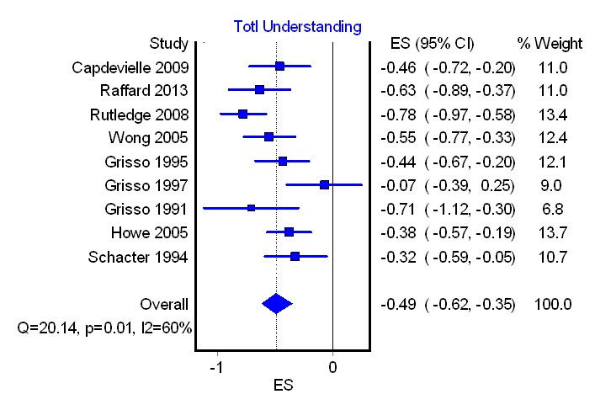
Figure 2a. Total symptoms and understanding

Figure 2b. Total symptoms and appreciaton
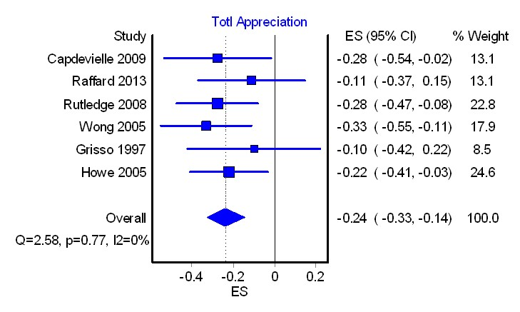

Figure 2c. Total symptoms and reasoning
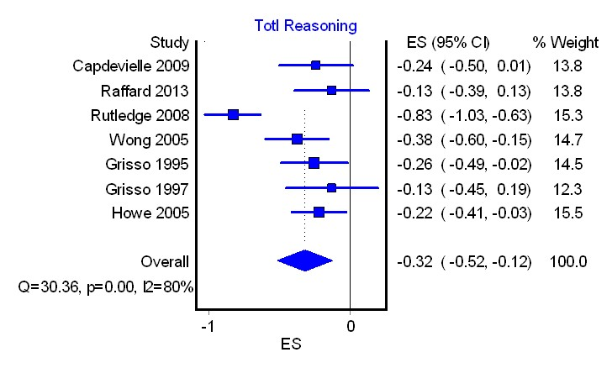

Figure 3. Depression and understanding
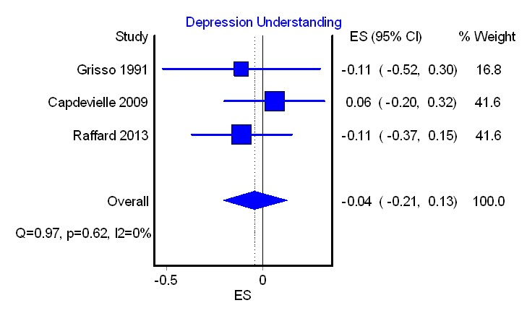

Figure 4a. Verbal IQ and understanding

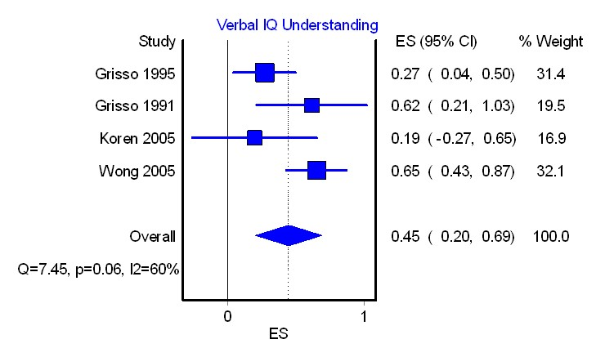
Figure 4b. Verbal IQ and reasoning.
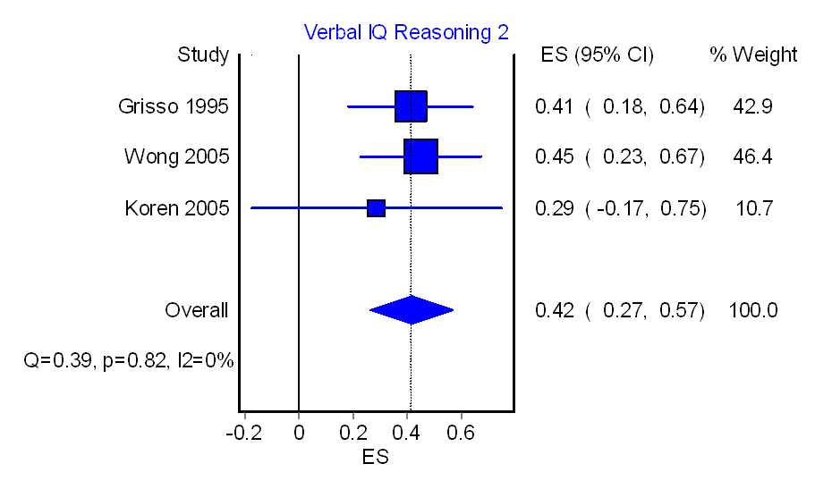

Figure 5a. Years of education and understanding
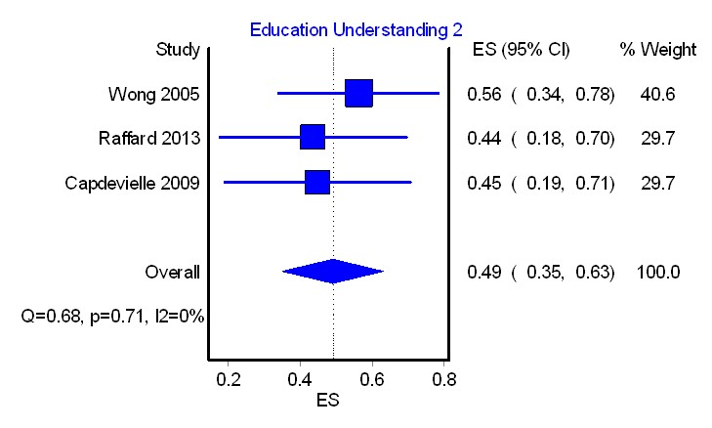

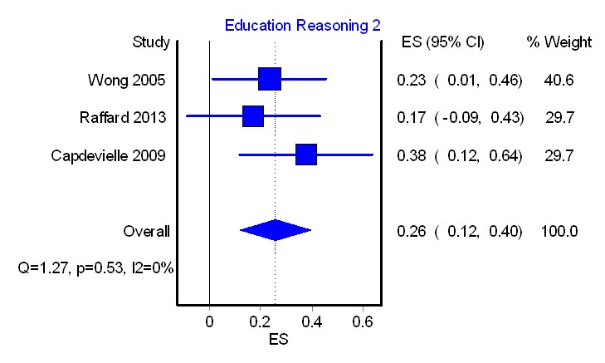
Figure 5b. Years of education and reasoning

Agency in this context refers to the capacity of a person, or ‘agent’, to take intentional action. An influential conceptualisation of agency is provided by Harry Frankfurt in Frankfurt, H. G. (1988). The importance of what we care about: philosopical essays. Cambridge: Cambridge University Press.
‘Metacognition’ refers to the implicit and explicit awareness, knowledge, beliefs and understanding we have about our cognitive systems and processes.

