MEASURING PEDESTRIAN TRAJECTORIES with Low Cost infrared Detectors: Preliminary Results
Editors: Galea ER
Book title: Pedestrian and Evacuation Dynamics
Publisher: CMS Press
Year of publication: 2003 Pagination: 101-110 ISBN: 1-904521-08-8

Armitage, A., Binnie, T. D., Kerridge, J., & Lei, L.
School of Computing, Napier University
10 Colinton Road, Edinburgh, EH10 5DT

Corresponding author: a.armitage@napier.ac.uk

ABSTRACT
The accurate measurement of Pedestrian trajectories has been difficult to achieve in environments other than carefully controlled laboratories. Traditional techniques include direct observation, and analysis of recorded video footage. The Transport Research Institute at Napier University has been using recorded video footage to analyse pedestrian movements for some time. Recently we have started using infrared detectors to record trajectories. Although infrared imaging systems are normally very expensive, a recent commercial product has provided the possibility of low-cost imaging, albeit at low resolutions. The detectors are normally used to count people moving across a line, but we have been extracting extra data from the detectors in order to extract complete trajectories. Our preliminary studies show that the detectors are very efficient at gathering large amounts of trajectory data. We have also started to look at using multiple detectors to cover larger areas. Preliminary results are encouraging, but there are some problems with matching targets as they move between the fields of view of adjacent detectors.

INTRODUCTION
The Transport Research Institute at Napier University has been developing a microscopic, agent-based model of pedestrian flow. This has been used to simulate the effects of, for instance, changes in the environment on pedestrian movements. In order to inform the development of this model, video footage of pedestrian activity has been used. The footage is digitised and calibrated according to real-world measurements of the filming area. The technique uses commercially available image-analysis software to partially automate the digitisation of pedestrian positions on a frame-by-frame basis. This provides very accurate data under well-controlled conditions (specific instances can be selected for analysis). The process is somewhat time-consuming.

An alternative approach we are investigating is the use of commercial infrared detectors that have been specifically produced for people counting applications. The commercial detectors, as provided, are designed for counting people as they move across a line. We have been using the detectors to extract more information, so that we can record trajectories. This provides information that is slightly less accurate than the video footage, but which is considerably easier to obtain in large quantities.

DETECTOR TECHNOLOGY
Several models of people counter are made by Irisys. Details are given on the company web site, but the main differences are in the housing; two models are available depending on whether they are to be used indoors or outdoors. The technical details of the sensors have been described elsewhere .

The Irisys detector is primarily designed for counting people moving back and forth across a line. In this mode a single detector can be used for instance to count movements along a corridor or through a doorway. Multiple detectors can be aligned to create a larger counting line. In this mode, detectors have been used successfully to count pedestrian movements in and out of supermarkets, in station concourses, and over the Millennium footbridge in London during trials after the bridge was modified.

We would like to be able to extract more information from the detectors, in particular to record pedestrian trajectories. In normal counting mode, the detectors can be used stand-alone, with total people counts being read out periodically, or counted by the number of relay closures produced. In trajectory mode, the counter is connected to a computer that gathers extra data.

The detector uses a 16 x 16 array of pyroelectric ceramic detectors to measure changes in temperature. Normal infrared imaging systems measure absolute temperature, which adds complexity to a pyroelectric detector. These detectors therefore rely on the pedestrian being at a different temperature from the background. This has the disadvantage that a few pedestrians are difficult to discriminate because their temperature is close to ambient (ideally a difference of at least 2 degrees Celsius is required). However, it does have the advantage that the background disappears from the image, leaving pedestrians as clear targets (figure 1)
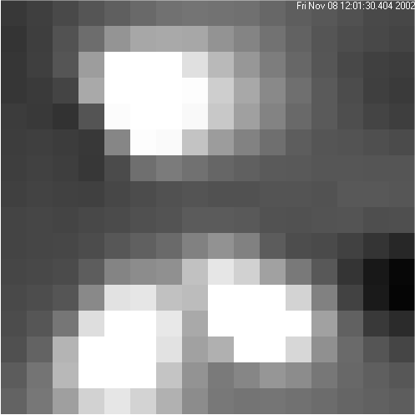

Figure 1: An image of a typical scene containing three pedestrians.

The normal mode of using the detector is to mount it at a height of three metres or so above the region of interest. At this height, the detector covers a ground area three metres by three metres. The detector has a processor on-board that does some pre-processing. Likely targets have an ellipse fitted to them, and the centroid of the ellipse is then calculated and sent down a serial link to a data-gathering computer. The X and Y positions are recorded approximately three times per second. These values are presented as a floating point number in the range 0 – 16 for each axis. Each unit, being the width of a pixel, corresponds to just under 20 centimetres on the ground. However, as the centroid effectively averages data from a number of pixels, the position is actually recorded with sub-pixel accuracy. Figure 2 shows a recording of several hundred pedestrians moving along a corridor. The data was recorded over a particularly busy ten minute spell.

There are several limitations in the detectors we have been using so far. The frame rate is approximately three frames per second. For many pedestrians, this corresponds to one reading every half-metre or so. Ideally, we would like a finer resolution for some applications. However, a more serious limitation is caused by the difficulty the on-board processor has in acquiring targets at the edge of an image. This can be seen in figure 2, where a number of spurious artefacts appear, as if pedestrians had suddenly changed course at the edge of the field of view. Many of these can be eliminated using the status information provided by the detector system. However, this means that some readings at the edges of fields are dropped.
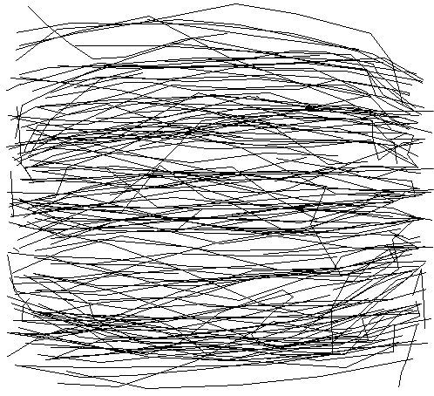

Figure 2: recording of pedestrian trajectories. Movements along a three-metre stretch of corridor are shown.

MATCHING ACROSS DETECTORS
The three metre square field of view of the Irisys detector is not sufficient for many applications. Ideally, we would like to be able to use multiple detectors to cover larger areas. In the simple counting-across-a-line application, this has already been done with great success. However, matching target information moving in arbitrary directions across the fields of view of multiple detectors is considerably more complicated. In principle, as a target leaves the field of view of one detector, it can be ‘handed over’ to the appropriate adjacent detector. In practice this is not always easy, especially in crowded scenes where many people may be in a field of view at any given time. If the fields of view overlap considerably, then a single target will appear in multiple fields of view at the same time. This would allow unambiguous identification of the target. However, overlapping fields of view reduces the coverage of the detectors. Also, we would like a system that didn’t rely on precision alignment of adjacent detectors. We have therefore been working towards a system that tolerates small amounts of overlap or gap between adjacent detectors.

In practice, this has meant we have not always been able to accurately match a pedestrian leaving one field of view with a pedestrian arriving in the field of view of another detector. The problem can be seen in figure three, which has been selected to show a mixture of normal tracks, and tracks that start quite far in from the edge.

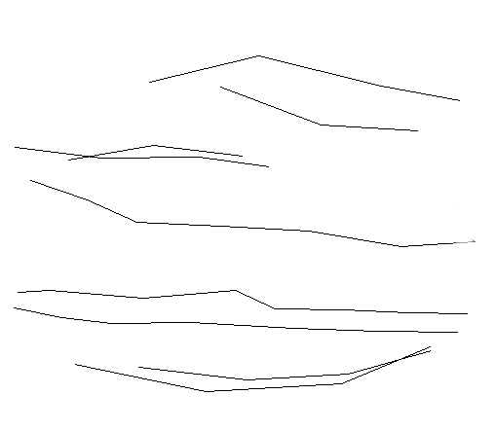

Figure 3: This illustrates the difficulties caused by some trajectories not being picked up until the target is well into the field of view.
Although figure three contains a large proportion of tracks with a poorly defined start or end, this is not representative (the figure contains tracks mostly from pedestrians who happen to have a temperature near ambient). Normally, the majority of tracks are clean and can be followed up the edge of the field.

MATCHING ACROSS MULTIPLE DETECTORS
The area covered by a detector depends n the height that it is mounted at. For the on-board processor to accurately identify candidate targets, the height should be in the range 2.5 to 3.5 metres. This gives a coverage per detector of about 2.5 to 3.5 metres square on the ground. It would be very useful to extend this by being able to track candidates as they move from the field of view of one detector to another. The first difficulty with this is that the low-resolution image does not give enough information to be able to recognise individuals. Figure 1 shows a typical scene: pedestrians are little more than blobs. Tracking between detectors has to be based on some sort of prediction of when and where the person will enter the field of view of the next detector. Currently, this is done with a fairly simple algorithm that looks for a person entering a boundary region within a well-defined time gap. This is illustrated in figure 4, where a target leaves the left hand detector at time t. The minimum requirement is that a target will match if it appears in the right hand detector within a band of width dx, at a time that is close to the time t, and with a similar y value. We don’t enforce the rule that the target should appear in the second field of view after it leaves the first, as the fields might overlap, meaning that the target could appear in the second before it leaves the first.

dx
y
t

Figure 4: A target leaving the left detector’s field of view is expected to appear in the right detector’s field of view. A band of width dx is searched, and the y position would be expected to match approximately.

RESULTS
Measurements with a single detector give reliable results for the majority of pedestrians moving through the detector’s field of view. The trajectories can be plotted across the three metre square area with a resolution of the order of 20 centimetres. As an example of the sort of data that can be gathered, figure 5 shows a corridor where an obstruction has been placed in the middle of the right hand side of the field of view. The flow of pedestrians round the obstacle can be clearly visualised. Note also the presence of a ‘loitering’ pedestrian in the top left hand corner of the image. Approximately 85 pedestrians have crossed the field of view, and been recorded, in 10 minutes.
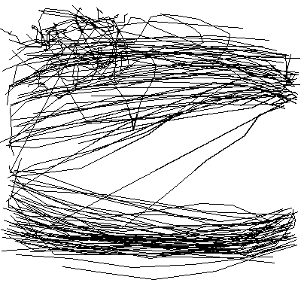

obstruction

Figure 5: Pedestrian flow round an obstruction

There are a number of limitations to the system, of which the main one comes from the slow frame rate giving three measurements per second. Also, some pedestrians are not accurately tracked because they are too close to the ambient temperature. However, this applies to a very small minority (typically of the order of 5%). Occasionally, readings near the edge of the frame are inaccurate, as the processor has trouble identifying a target that is only partially in the field of view.

Despite these limitations, the detectors are a quick way of gathering data. Some post-processing of recordings is needed, but the data files are much smaller than would be recorded from a typical video recording system. Because the resolution and frame rates are low, the detectors produce data at a rate of approximately 1 Mbyte every 10 minutes. This includes the full images as well as the target information. Once the target information is extracted, and the images are discarded, the data is reduced by a factor of 10 or more.

Figures 2 and 3 illustrate the fact that the quality of position information at the edges of the Detector’s field of view is poorer, with some targets being lost, or incorrectly measured. This has meant that, in our preliminary experiments, we are not matching as many targets across a boundary as we would have hoped. Currently, only about 60% of targets can be correctly matched. Initially, we are only interested in the entry and exit points of the pedestrian in the combined field of view. When we do get a match, the data we get is in the following form:

 | CAMERA | ID | TIME (h:m:s.ms) | X | Y
Entry | 0 | 2 | 11:59:07.623 | 0.72 | 8.77
Exit | 1 | 2 | 11:59:11.904 | 14.52 | 7.05
Table 1: Entry and exit points for a target that has crossed two detectors

This is interpreted as follows: Just before noon, at 11:59:07.6, a person entered the left hand side of camera 0. This was at a position of x=0.7, y=8.8, i.e. about half way up the left hand side of the detector’s field of view (see figure 6). The detector gave the person an id of 2. They then moved across the fields of the two detectors and exited from the right hand side of camera 1 at 11:59:11.9. The last recorded position at this time was x=14.5, y=7.1, i.e. about half way up the right hand side of the right-hand detector.

Entry
0.7, 8.8
Exit
14.5, 7.1
x
y
0,0
16,16

Camera 0 Camera 1

Figure 6: Entry and exit points for a target moving across the fields of view of two detectors.
Each detector returns the current position of the target in its own frame of reference. In order to correlate these, the displacement of one filed of view with respect to the other needs to be known. Our current aim is to be able to cover a stretch of pavement in the Edinburgh area with a sequence of four detectors. The location has been chosen because it is an area of interest to Edinburgh Council as part of an urban regeneration study. Four detectors would allow us to monitor the entrances of several shops, and a busy bus stop. However, the current difficulties with matching targets between detectors means that this is not possible at present. Over the next few months, we hope to be able to improve the matching by using improved algorithms.

CONCLUSION
The use of the Irisys infrared people counters has been extended to tracking of complete pedestrian trajectories. This gives an efficient method of measuring trajectories with an accuracy of about 20 centimetres over distance of the order of 2.5 to 3.5 metres. The method is non-invasive, and can be used indoors or outdoors, requiring only a point to mount the detectors at a height of 2.5 to 3.5 metres above the ground or floor. Limitations with the detector (particularly edge effects) have led to difficulties in matching the trajectories across multiple fields of view. It is hoped that these problems can be resolved in the near future.

ACKNOWLEDGEMENTS
Funding for this project under the LINK Future Integrated Transport Project: FIT002 is gratefully acknowledged.

REFERENCES

Kukla, R. & Kerridge, J., “PEDFLOW: Development of an Autonomous Agent Model of Pedestrian Flow”, 80th Annual Meeting TRB, Washington, DC, USA, 07/01/2001-11/01/2001, 2001,
Kukla, R. & Kerridge, J., “Laying the foundations: the use of video footage to explore pedestrian dynamics in PEDFLOW”, Pedestrian Evacuation and Dynamics, 2001 Duisburg, Germany, 2001,
www.irisys.co.uk
Hollock, S,. Galloway, J. L., “ Smart Sensors Using Array Based Infrared Detectors”, Sensors and their applications XI/ISMCR 2001 - Institute of Physics, City University London, September 2001
Mansi, M. V., Porter, S. G. Galloway, J. L. &. Sumpter N., “Very low cost infrared array based detection and imaging systems” (SPIE) Aerosense 2001, Orlando, Florida USA, 17-19 April 2001

