Table and Figure Legends
Table 1 Sample characteristics in the healthy control group (n=11960) and breast cancer group (n=295)
 |  | No cancer control group |  |  | Breast cancer group
 |  | % | (95%CI) |  | % | (95%CI)
Characteristic variables
Mean age |  | 49.30 | (48.99-49.61) |  | 66.44 | (65.19-67.70)
Years since diagnosis
 | 1 to 4 years ago | - |  |  | 31.53 | (26.22-36.83)
 | 5 to 10 years ago | - |  |  | 31.53 | (26.22-36.83)
 | >10 years ago | - |  |  | 36.95 | (31.44-42.46)
Survey year
 | 2008 | 22.24 | (21.50-22.99) |  | 15.59 | (11.45-19.73)
 | 2009 | 25.83 | (25.04-26.61) |  | 24.41 | (19.51-29.31)
 | 2010 | 25.65 | (24.87-26.43) |  | 28.14 | (23.00-33.27)
 | 2011 | 26.28 | (25.49-27.07) |  | 31.86 | (26.55-37.18)
Socio-economic status
 | Managerial and professional | 31.48 | (30.63-32.32) |  | 28.13 | (22.93-33.32)
 | Intermediate | 24.01 | (23.23-24.79) |  | 22.92 | (18.06-27.77)
 | Routine and manual | 44.51 | (43.61-45.42) |  | 48.96 | (43.18-54.73)
Education
 | No formal | 21.19 | (20.45-21.92) |  | 37.97 | (32.43-43.50)
 | High school/certificate/diploma | 51.60 | (50.70-52.49) |  | 42.03 | (36.40-47.67)
 | University/above | 27.22 | (26.42-28.01) |  | 20.00 | (15.44-24.56)
Marital status
 | Partnered | 63.09 | (62.22-63.95) |  | 59.32 | (53.72-64.93)
 | Not partnered | 36.91 | (36.05-37.78) |  | 40.68 | (35.07-46.28)
Body mass index
 | Underweight/normal | 29.94 | (29.12-30.76) |  | 23.05 | (18.24-27.86)
 | Overweight | 28.81 | (28.00-29.62) |  | 33.90 | (28.50-39.30)
 | Obese | 26.05 | (25.26-26.83) |  | 28.14 | (23.00-33.27)
Smoking status
 | Current smoker | 23.80 | (23.03-24.56) |  | 18.31 | (13.89-22.72)
 | Ex-smoker | 27.86 | (27.06-28.66) |  | 37.29 | (31.77-42.81)
 | Non-smoker | 48.34 | (47.45-49.24) |  | 44.41 | (38.74-50.08)
Alcohol consumption
 | Drinker | 77.81 | (77.06-78.55) |  | 67.80 | (62.46-73.13)
 | Non-drinker | 22.19 | (21.45-22.94) |  | 32.20 | (26.87-37.54)
Explanatory variables
Optimism (mean) |  | 3.27 | (3.25-3.28) |  | 3.19 | (3.08-3.30)
Poor general health (mean) |  | 1.97 | (1.95-1.99) |  | 2.51 | (2.39-2.62)
Outcome variable
Psychologically distressed |  | 16.94 | (16.27-17.61) |  | 16.61 | (12.36-20.86)

Table 2 Logistic regression results presenting the odds ratios of psychological distress
 |  | No cancer control group |  |  | Breast cancer group
 |  | OR | (95%CI) |  | OR | (95%CI)
Model 1: Unadjusted
 | Optimism | 0.57 | (0.54-0.60) |  | 0.64 | (0.47-0.88)
Model 2: Adjusted for general health
 | Optimism | 0.50 | (0.44-0.57) |  | 1.15 | (0.32-4.11)
 | Poor general health | 1.47 | (1.25-1.72) |  | 4.98 | (1.32-18.75)
Model 3: Adjusted for all control variables
 | Optimism | 0.47 | (0.41-0.54) |  | 1.09 | (0.29-4.11)
 | Poor general health | 1.53 | (1.30-1.81) |  | 5.10 | (1.28-20.35)
Variables included in model 3 were optimism, poor general health, age, year since breast cancer diagnosis (in the breast cancer group), survey year, socio-economic status, education, marital status, body mass index, smoking status, and alcohol consumption; not psychologically distressed was referent outcome category

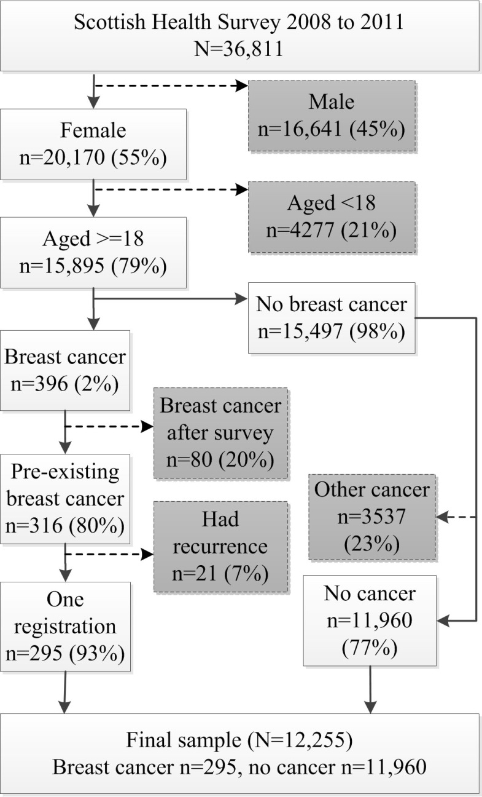
Figure 1. Flowchart of participant inclusion

