Figure 1: Research topics over the years
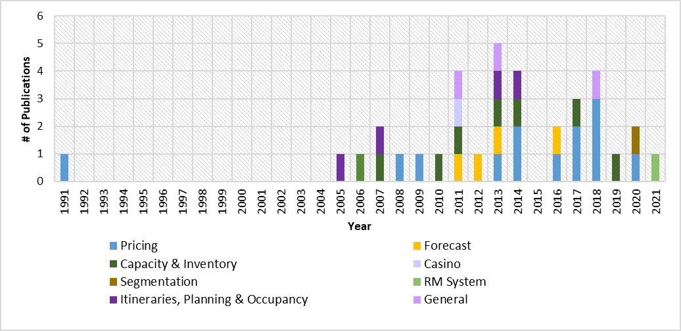

Figure 2: Cruise revenue functions and timeline
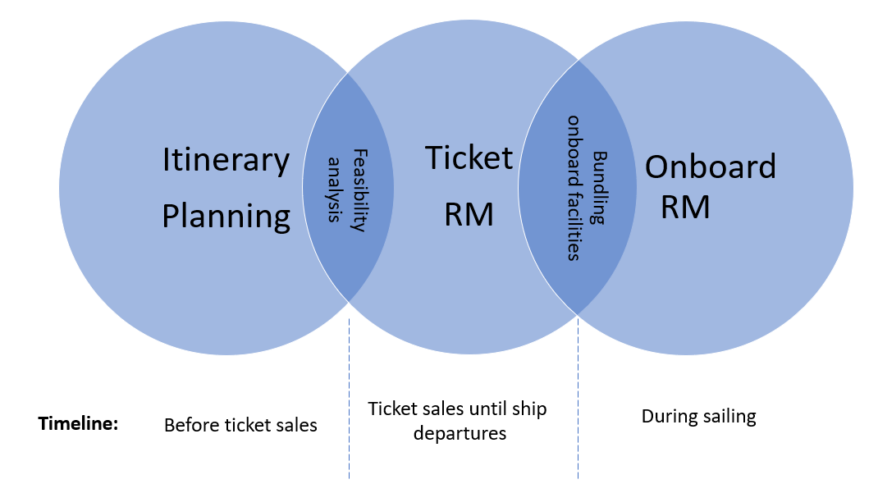

Figure 3: Cruise ticket and onboard RM cycles
(a): Ticket (b): Onboard
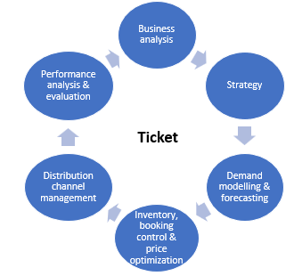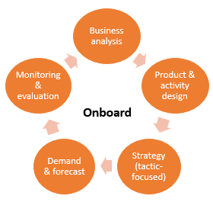

Figure 4: A holistic view of existing cruise RM cycle framework
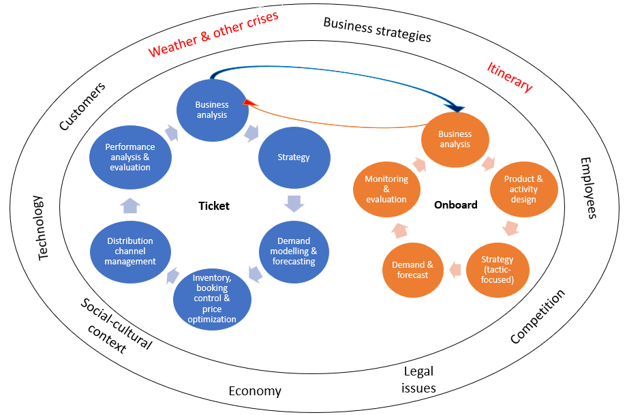

Figure 5: Integrated cruise RM framework
