Article

Environmental impacts of upgrading gas to electric heating and cooling, considering decarbonisation of the electricity grid

Ina Eileen Peukes 1,*, Francesco Pomponi 2 and Bernardino D'Amico2

|  |
| --- |
| **Citation:** Lastname, F.; Lastname, F.; Lastname, F. Title. *Sustainability* **2022**, *14*, x. https://doi.org/10.3390/xxxxx  Academic Editor: Firstname Lastname  Received: date  Accepted: date  Published: date  **Publisher’s Note:** MDPI stays neutral with regard to jurisdictional claims in published maps and institutional affiliations.    **Copyright:** © 2022 by the authors. Submitted for possible open access publication under the terms and conditions of the Creative Commons Attribution (CC BY) license (https://creativecommons.org/licenses/by/4.0/). |

1 Affiliation 2, 1; ina.peukes@gmail.com

2 Affiliation 2; F.Pomponi@napier.ac.uk

**\*** Correspondence: ina.peukes@gmail.com

**Abstract:** Heating and/or cooling account for around 20 % to 50 % of the total energy use of residential buildings in Australia. Hence, more efficient heating and cooling appliances can lower the environmental impact of residential buildings. This research aims to determine the environmental impacts of upgrading 59 gas heaters to electric reverse cycle air conditioners through a life cycle assessment (LCA), using the *ecoinvent 3.7 cut-off database*. It further assesses if the gas savings from the upgrade will outweigh the embodied impacts and the increased electricity usage. As the decarbonisation of the electricity grid plays an important role on the impacts and potential offsets of the upgrade it has also been taken into consideration.

The results show that operational energy savings offsets the following impact categories: climate change, fossil and nuclear energy use, mineral resources use, photochemical oxidant formation, ozone layer depletion, ionizing radiation and land transformation (biodiversity). However, freshwater and terrestrial acidification, marine eutrophication, particulate matter formation, land occupation (biodiversity) and water scarcity can only be offset with the decarbonisation of the electricity grid. Nonetheless, human toxicity, freshwater ecotoxicity and eutrophication cannot be offset even with a complete decarbonisation of the electricity grid, as the impacts from the production stage are too high.

**Keywords:** Gas heating; Reverse cycle air conditioning; Life cycle Assessment; Embodied energy; Operational energy; Electricity grid decarbonisation, Environmental impact assessment

1. Introduction

The impacts of climate change are omnipresent and buildings account for 32 % of global energy consumption and 19 % of energy related carbon dioxide equivalent (CO2 eq.) emissions [1]. Therefore, reducing the energy related CO2 emissions of buildings can significantly reduce overall CO2 emissions. Globally, the energy used for heating and cooling of buildings can vary between 18 % and 73 % [3]. In Australia, depending on the climate zone, heating and/or cooling accounts for 20 % to 50 % of the total energy use of residential buildings [2,4]. Consequently, a reduction of the energy used by heating and cooling appliances can contribute to the overall reduction of CO2 emissions of residential buildings but also to the reduction of further environmental impacts. Though, the question arises if it is reasonable to upgrade a heating system to a heating and cooling system before the end of its lifetime. It is often not clear if the operational energy savings will offset the embodied energy of the upgrade. A life cycle assessment (LCA) is a suitable instrument to consider the environmental impacts of the upgrade and makes the environmental impacts of the embodied and operational energy comparable.

1. Previous Work

From 1990 to 2016 the energy use of air conditioners has more than tripled [5,6]. By 2016 more than 135 million units were sold annually [5] and it is expected that around two-thirds of all households around the world will have air conditioning by 2050 [6]. This growth demonstrates the increased demand for cooling in buildings. Zhang et al. [7] showed that with the increase of residential air conditioners the CO2 eq. emissions in Shenzhen, China, increased by 2.9 million tonnes (Mt) CO2 eq. from 2005 to 2017, with a predicted increase to 10 Mt CO2 eq. by 2030. Gheewela et al. [8] ascertain that individual split air conditioners emit 40 % more CO2 emissions than central air conditioning systems. Zhang et al. [7] implies that emissions from residential air conditioners can be reduced if the refrigerant R22 is replaced with R410A. In 2021, Beshr et al. [9] further assessed the impact on CO2 emissions of refrigerants and showed that shifting from R410A to low global warming potential (GWP) refrigerants, N-40 and L-41a, lowered the total CO2 emissions of residential air conditioners by 30 %Click or tap here to enter text.. Further to that, Yanjie et al. [10] determined that BAT-R32 was the refrigerant with the most significant greenhouse gas (GHG) emission reduction pathway [10]. Almutairi et al. [11] assessed the environmental impacts of an air conditioner based on an LCA and demonstrated that most impacts occur in the use phase while transportation has a minor impact, which has been further confirmed by Lui et al. [12], and it was further assumed that metals are 100 % recyclable whereby non-metals are only 50 % recyclable at the the End-of-Life (EoL) [11]. Karkour et al. [13] investigated the environmental impacts of residential air conditioners in Indonesia and also noted that the use stage has the highest impacts on GWP, while copper and nickel have the largest impacts on resource consumption. Moreover, the importance of the impacts on air pollution was highlighted as well as the energy mix of the country, which plays a crucial role on the environmental impacts of the residential air conditioner [13]. Shah et al. [14] and Li [15] also highlighted the impacts of the electricity mix on the air conditioner while considering the different electricity mixes within the American states [14,15].

Nonetheless, the use phase of most studies was not based on primary data, thus variation due to behaviour is not included in the research. Other studies which distinguish the share and type of material for the heating appliance could not be found. There is clearly a lack of research in this field and more detailed research, coming predominantly from primary data, is needed. It is also important to consider what happens when switching from gas heating to electric heating and cooling while at the same time decarbonising the electricity grid. These issues are what this research aims to investigate and assess.

This research paper therefore aims to close the gap of LCAs of air conditioning upgrades. It further assesses an upgrade of a heating only unit to a heating and cooling appliance which most likely will occur in an existing residential building. Furthermore, the decarbonisation of the electricity grid and its impacts on a sole heating to heating and cooling upgrade are assessed.

1. Research Aim and Goal

Firstly, this research paper aims to determine whether a gas to electric heating and cooling upgrade is environmentally beneficial. Hence, the upgrade of 59 gas heaters to reverse cycle air conditioners were assessed via an LCA. Secondly, this research aims to determine if a gas heating to electric heating and cooling upgrade is worthwhile when considering the decarbonisation of the electricity grid.

The goal is to help decision makers choose between the most environmentally friendly heating and cooling options and to take future grid developments into consideration. Furthermore, the research aims to answer the following questions:

* Can the embodied energy of the old gas heater and new reverse cycle air conditioner be offset by the operational energy savings?
* To what extent does the decarbonisation of the electricity grid impact the environmental footprint of the reverse cycle air conditioner upgrade?

1. Methods

A sample size of 59 gas heater to 6-star reverse cycle air conditioner upgrades was assessed. An LCA approach was considered to be the most suitable as the embodied and operational energy of the old and new appliance could be aggregated and compared in detail. SimaPro [16] was used to assess the life cycle of the upgrades via the *ecoinvent 3.7.1 cut-off database* [17]. The IMPACT World+ Midpoint V1.00 impact assessment method [18] was chosen, which is an update to the IMPACT 2002+, LUCAS, and EDIP methods. The following impact categories have been assessed: climate change (short and long term) [20,21], fossil and nuclear energy use, mineral resources use [22], photochemical oxidant formation, ozone layer depletion [23], human toxicity (cancer and non-cancer) [24,25], particulate matter formation [26,27], ionizing radiation, land transformation (biodiversity) and land occupation (biodiversity) [28,29], terrestrial acidification [30], water scarcity [31], freshwater ecotoxicity, acidification and eutrophication [32,33] as well as marine eutrophication. All data on the operational energy use one year prior and after the upgrade, the weight and the environmental impacts of each upgrade are publicly available [34]. The methods, system boundaries, goal and scope have been extensively described by Peukes et al. [35]. This research paper uses the same approach for data collection and quality therefore, predominantly the differences will be highlighted in this research paper.

* 1. Life Cycle Inventory

The life cycle inventory (LCI) of the old gas heater and the new reverse cycle air conditioner, as well as the energy savings from the upgrade are shown in Figure 1. Country specific data was predominantly used where possible. Where not possible, rest-of-the-world (ROW) countries or geographical location global (GLO) data of the *ecoinvent 3.7.1 cut-off database* were used.

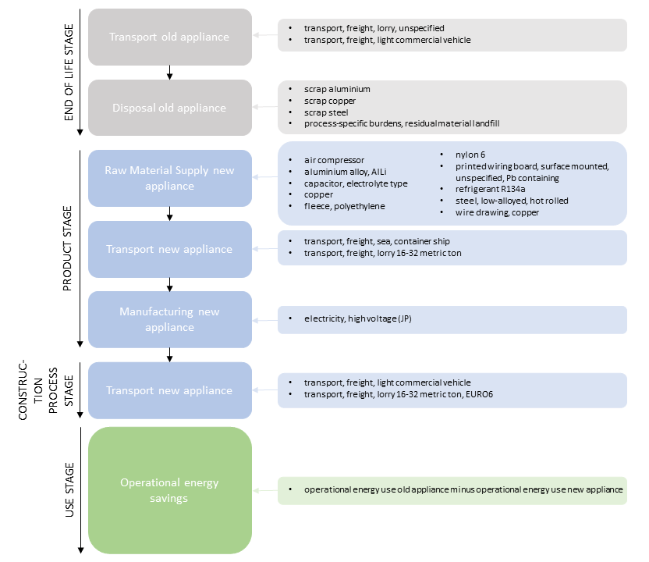

**Figure 1:** Life cycle inventory of the old gas heater and new reverse cycle air conditioner

* 1. End-of-Life Stage

The installation company travels on average 53.61 km from the installation company to the customer within the Australian Capital Territory (ACT) [35]. After the removal of the old appliance and the installation of the new appliance it is assumed that the same distance is driven to reach the recycling facility. The transportation from the recycling facility in Canberra to the recycling facility in Sydney (which further processes the appliance) is assumed to be 290 km by truck [35].

As previously shown, there has been limited research on gas heating, which is why an old gas heater was deconstructed (as seen in Figure 2) and assessed on its weight as well as the type and quantity of material. Internal copper gas pipes in the building were excluded, as the length might vary by house type. The deconstructed gas heater was then used as a reference for the 59 upgrades.

All types of material have been determined and existing components in the *ecoinvent 3.7.1 cut-off database* have not been further deconstructed. The type of plastic could not be determined but it was assumed that it is heat resistant and therefore PA 6 plastic of the *ecoinvent 3.7.1 cut-off database* was chosen [35]. Copper has been listed as a raw material in the *ecoinvent 3.7.1 cut-off database*, nonetheless, the values are based on an older version. A cast Aluminium–lithium alloys (AlLi) and low-alloy was chosen from the database for aluminium and steel respectively, due to the increased strength, hardness and resistance. The exact weight of the components and material can be seen in Table 1. The reference gas heater weighs 58.97 kg and 67.61 % of the system is made of steel.

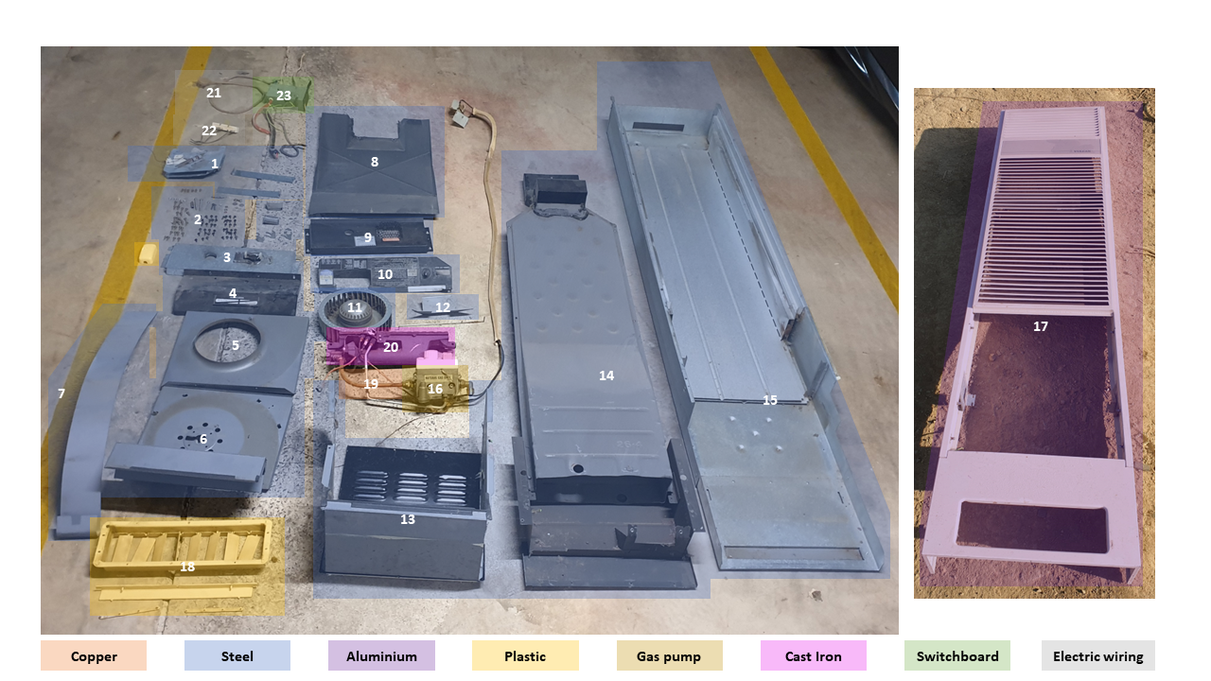

**Figure 2:** Material composition of deconstructed gas heater

**Table 1:** Material weight of gas heater

|  |  |  |  |
| --- | --- | --- | --- |
| **Material** | **No** | **Grams** | **Percentage** |
| **Steel** | 1 | 620 | **1.05 %** |
| 2 | 130 | **0.22 %** |
| 3 | 400 | **0.68 %** |
| 4 | 370 | **0.63 %** |
| 5 | 670 | **1.14 %** |
| 6 | 1,450 | **2.46 %** |
| 7 | 340 | **0.58 %** |
| 8 | 1,140 | **1.93 %** |
| 9 | 230 | **0.39 %** |
| 10 | 210 | **0.36 %** |
| 11 | 1,840 | **3.12 %** |
| 12 | 90 | **0.15 %** |
| 13 | 2,980 | **5.05 %** |
| 14 | 9,100 | **15.43 %** |
| 15 | 18,900 | **32.05 %** |
| 16 | 1,400 | **2.37 %** |
| **Aluminium** | 17 | 15,000 | **25.44 %** |
| **Plastic** | 18 | 270 | **0.46 %** |
| **Copper** | 19 | 200 | **0.34 %** |
| **Cast Iron** | 20 | 2,940 | **4.99 %** |
| **Electric wiring** | 21 | 120 | **0.20 %** |
| 22 | 130 | **0.22 %** |
| **Switchboard** | 23 | 440 | **0.75 %** |
| **Total** |  | **58,97** | **100 %** |

As mentioned above, the deconstructed gas heater was used as a reference. The brand and model of some gas heaters was provided and their weight could be assessed based on the installation manual. Nonetheless, most of the replaced gas heaters were so old, that there were no installation manuals available with which the weight could have been determined. Therefore, similar types of heaters have been assessed on their weights and most heaters ranged from 29 kg to 39 kg. Therefore, depending on the type of heater, an estimated weight was assigned.

Afterwards, the share of materials was multiplied with the weight of each old gas heater. While the metals will be recycled; the rest would be going to landfill, as advised by the recycling facility. The output streams of the old gas heater were fed into *SimaPro*.

* 1. Manufacturing Stage

A reverse cycle air conditioner can be a standalone unit or a multi-split unit. In this case a gas heater has been replaced with a standalone reverse cycle air conditioner. Almutairi et al. [11] provided details on the construction material constituents of an air conditioner unit. The split of materials could not be verified by further research. Furthermore, the gas heater was upgraded with a reverse cycle air conditioner, therefore it can be assumed that the material share of an air conditioner would differ to that of a reverse cycle air conditioner. Hence, a reverse cycle air conditioner was deconstructed (as seen in Figure 3) and assessed on its weight as well as the type and quantity of material. The same assumptions for the rubber and insulation were made as in Peukes et al. [35]. The reverse cycle air conditioner was then used as reference for the 59 upgrades. A detailed view of the share of materials can be seen in Table 2. The total system weighs 34.20 kg and 27.47 % of the system is made of steel, while 19.67 % is made of plastic and 18.50 %.

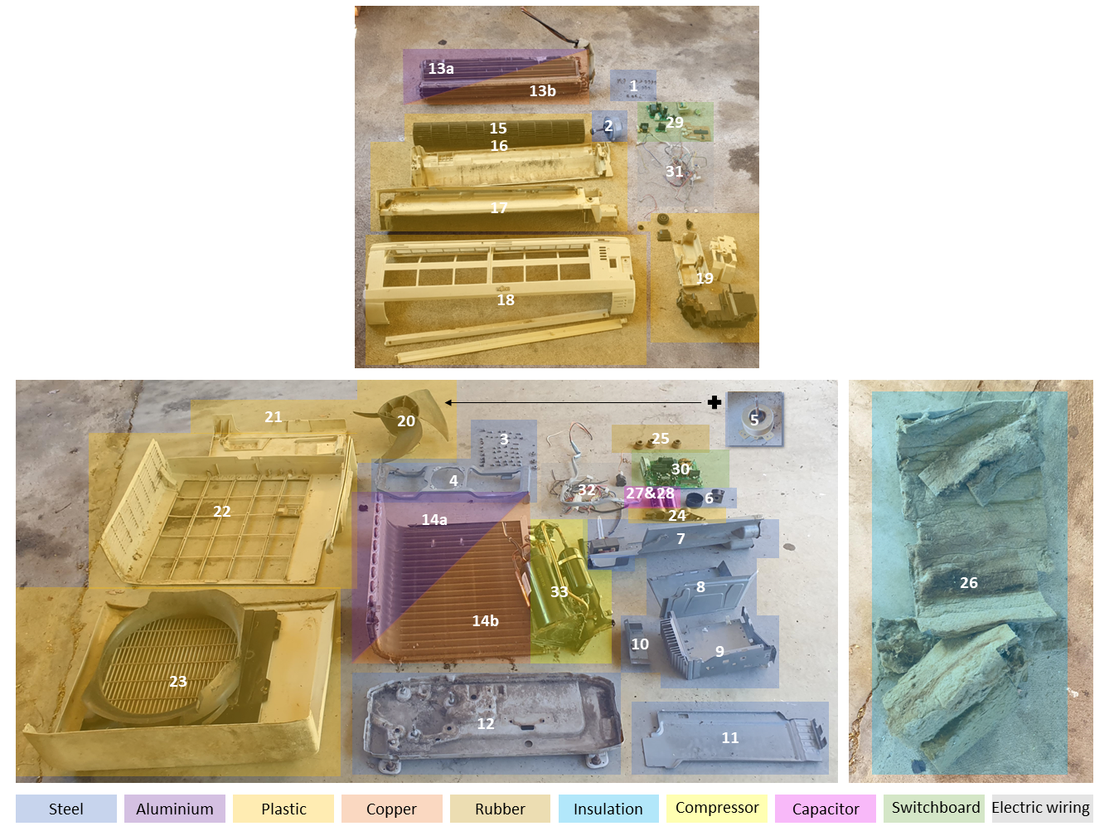

**Figure 3:** Material composition of reverse cycle air conditioner

**Table 2:** Material weight of reverse cycle air conditioner

|  |  |  |  |
| --- | --- | --- | --- |
| **Material** | **No** | **Grams** | **Percentage** |
| **Steel** | 1 | 60 | **0.18 %** |
| 2 | 1,800 | **5.25 %** |
| 3 | 160 | **0.47 %** |
| 4 | 560 | **1.63 %** |
| 5 | 1,620 | **4.73 %** |
| 6 | 70 | **0.20 %** |
| 7 | 1,590 | **4.64 %** |
| 8 | 420 | **1.23 %** |
| 9 | 780 | **2.28 %** |
| 10 | 110 | **0.32 %** |
| 11 | 510 | **1.49 %** |
| 12 | 1,730 | **5.05 %** |
| **Aluminium** | 13a | 525 | **1.53 %** |
| 14a | 1,588 | **4.63 %** |
| **Copper** | 13b | 1,575 | **4.60 %** |
| 14b | 4,763 | **13.90 %** |
| **Plastic** | 15 | 540 | **1.58 %** |
| 16 | 450 | **1.31 %** |
| 17 | 1,160 | **3.39 %** |
| 18 | 730 | **2.13 %** |
| 19 | 410 | **1.20 %** |
| 20 | 410 | **1.20 %** |
| 21 | 240 | **0.70 %** |
| 22 | 940 | **2.74 %** |
| 23 | 1,820 | **5.31 %** |
| 24 | 40 | **0.12 %** |
| **Rubber** | 25 | <5 | **0.00 %** |
| **Insulation** | 26 | 920 | **2.69 %** |
| **Capacitor** | 27 | 220 | **0.64 %** |
| 28 | 180 | **0.53 %** |
| **Switchboard** | 29 | 570 | **1.66 %** |
| 30 | 640 | **1.87 %** |
| **Electric  wiring** | 31 | 160 | **0.47 %** |
| 32 | 270 | **0.79 %** |
| **Compressor** | 33 | 6,700 | **19.56 %** |
| **Total** |  | **34,260** | **100 %** |

As the deconstructed reverse cycle air conditioner and all 59 reverse cycle air conditioner upgrades are made in Japan, it has been assumed that the raw materials would come from South-East Asia. A lot of mining in South-East Asia is inland and has a distance to the coastal line of approximately 500 km. It is assumed that the raw materials would be transported 500 km by truck in South-East Asia before being shipped to Japan. The transportation journey by ship from continental Asia to Japan is estimated to be 2,250 km. Furthermore, it is believed that the raw materials are then transported a further 8,750 km by ship to Australia. The contractor advised that the appliances are then delivered from Sydney harbour to the manufacturer by truck within a distance of 50 km.

The manufacturing process takes place in Japan. Therefore, the electricity production mix for Japan of the *ecoinvent 3.7.1 cut-off database* was used. It was assumed 20 MJ/kg of energy was needed for the production of the appliances [36].

* 1. Construction Stage

It was assumed that only minimal equipment was used for the deconstruction of the old gas heater and the construction of the new reverse cycle air conditioner. Hence, it has not been considered. For the transportation, detailed information was provided by the contractor. It was known that the supplier’s depot is based in Sydney. Therefore, the appliance is transported 285 km from the supplier side to the installation company and stored before it is transported to the recipient by van. As mentioned in Section 4.2 the distance driven by van was calculated based on a dataset of 132 energy efficiency upgrades. The van drives an average distance of 53.65 km [35].

* 1. Use Stage

As per the previous research, only the operational energy one year prior and after the energy efficiency upgrade was considered. This decreases the likelihood of any further upgrades which could have been done during this timeframe. All details on the assumptions can be found in Peukes et al. [35]. The change in energy use prior and after has been multiplied by the lifetime of the new appliance. The lifetime of the reverse cycle air conditioner is around 20 years [37]. Due to the relatively large sample size of 59 energy efficiency upgrades, outliers resulting from unconventional household energy usage can be eliminated from the research.

To assess the environmental impact categories (listed at the start of Section 4) for the use phase, the energy savings were fed into *SimaPro*. The “Heat, central or small-scale, natural gas” with the unit process “{ROW} market for heat, central or small-scale, natural gas” for gas and the “Electricity, low voltage” with the unit process “{AU}| market for | Cut-off, U” for electricity, of the *ecoinvent 3.7.1 cut-off database* were used.

* 1. Decarbonisation of the Electricity Grid

The Australian electricity grid relies heavily on coal, followed by gas. Renewables accounted for 23 % of Australian electricity generation in 2019-2020 [38]. There is no exact data on the energy mix of the ACT, as their energy mix is reported under the New South Wales (NSW) energy generation, where 19 % of their electricity generation was from renewable energy. The ACT reported that its electricity related emissions were zero in 2020-21 due to its renewable electricity supply [39]. Emissions were offset due to offsite renewable generation and retiring Large Generation Certificates [39]. The operational energy increase or decrease in virtue of the energy efficiency upgrade was modelled with the *ecoinvent 3.7.1 cut-off database* (as described in Section 4.5).

To assess the 100 % renewable electricity grid of the ACT and the decarbonisation of the energy grid, the following scenarios were calculated in *Excel* for the gas heating to reverse cycle air conditioning upgrades:

* an energy mix based on the *ecoinvent 3.7.1 cut-off database*
* a multi-scenario approach, considering the decarbonisation of the Australian electricity grid from 10 % to 90 %
* an electricity mix which is assumed to be 100 % renewable and therefore it is assumed that the electricity grid is 100 % decarbonised during the entire use phase.

1. Results
   1. Assessed Impact Categories

The assessment of 59 gas heating to reverse cycle air conditioning upgrades showed that only 3 households of 59 were unable to reduce their operational energy consumption. All other properties reported an increased electricity usage but a decreased gas usage. The decreased gas usage was able to offset the increased electricity usage and overall energy savings were generated. The environmental impact via the IMPACT World+ Midpoint V1.00 impact assessment method was implemented for all 18 impact categories. To ensure the comparability of all impact categories, the values have been normalised. Figure 4 gives an overview of all cumulative impacts across all 59 upgrades. It can be seen that climate change (short and long term), fossil and nuclear energy use, mineral resources use, photochemical oxidant formation, ozone layer depletion, ionizing radiation and land transformation (biodiversity) can be predominately offset by the gas savings even though the electricity usage increased after the upgrade.

For mineral resources use, ozone layer depletion and ionizing radiation; the product stage has the highest impact followed by increased electricity. Nonetheless, the impacts can also be offset by the gas savings.

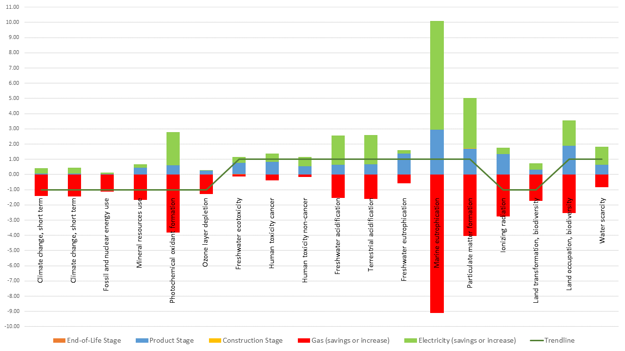

**Figure 4:** Normalisedenvironmental impacts - IMPACT 2002+ Midpoint

However, freshwater and terrestrial acidification, marine eutrophication, particulate matter formation, land occupation (biodiversity) and water scarcity, cannot be offset by the gas savings when no decarbonisation is considered.

As seen in Table 3, the freshwater ecotoxicity impacts are highest in the product stage due to the significant impact of the printed wiring board (Pb containing) production, followed by the copper and air compressor production; the printed wiring board (Pb containing) has the highest impact with 64 %. The product stage also contributes the most to the freshwater eutrophication impacts and cannot be offset by the gas savings. The printed wiring board (Pb containing) contributes 91 % of these product stages emissions. The human toxicity (non cancer) impacts are the highest in the product stage due to the significant impact of the steel and the printed wiring board (Pb containing). The steel has the highest impact with 35 % and the printed wiring board (Pb containing contributes 24 % of these product stages emissions.

For human toxicity (cancer) the impacts of the increased electricity usage are the highest, but the gas savings are not high enough to offset the impacts of the EoL, product and construction stage.

For all impact categories the EoL stage has the least impact. The high content of metals and its reusability contributed to the low impact. The construction stage has also a minor impact. This is due to the minor impact of the transportation, to and from the construction site and to the recycling facility.

**Table 3:** Environmental impacts - IMPACT 2002+ Midpoint

|  |  |  |  |  |  |
| --- | --- | --- | --- | --- | --- |
|  | End- of-life stage | Product stage | Construction stage | Gas (savings or increase) | Electricity (savings or increase) |
| Climate change, short term [kg CO2 eq.] | 290.09 | 89,825.94 | 565.74 | -2,548,727.19 | 650,728.18 |
| Climate change, long term [kg CO2 eq.] | 284.18 | 84,240.74 | 554.86 | -2,340,881.48 | 641,091.04 |
| Fossil and nuclear energy use [MJ deprived] | 4,700 | 1,178,216 | 8,785 | -32,259,827 | 2,387,688 |
| Mineral resources use [kg deprived] | 4.72 | 2,042.76 | 8.36 | -7,686.85 | 1,047.87 |
| Photochemical oxidant formation [kg NMVOC eq.] | 1.63 | 392.97 | 2.75 | -2,489.61 | 1,437.40 |
| Ozone layer depletion  [kg CFC-11 eq.] | 0.0001 | 0.0787 | 0.0001 | -0.3991 | 0.0094 |
| Freshwater ecotoxicity [CTUe] | 1,270,352,112 | 21,613,375,187 | 6,331,307 | -4,048,880,195 | 10,913,113,791 |
| Human toxicity cancer [CTUh] | 0.00005 | 0.13697 | 0.00008 | -0.06364 | 0.09057 |
| Human toxicity non-cancer [CTUh] | 0.00004 | 0.13697 | 0.00005 | -0.04049 | 0.16035 |
| Freshwater acidification [kg SO2 eq.] | 0.000003 | 0.001974 | 0.000004 | -0.004736 | 0.005818 |
| Terrestrial acidification [kg SO2 eq.] | 0.002 | 1.599 | 0.004 | -3.874 | 4.702 |
| Freshwater eutrophication [kg PO4 eq.] | 0.01 | 4.08 | 0.02 | -1.77 | 0.63 |
| Marine eutrophication [kg N eq.] | 0.03 | 11.75 | 0.05 | -36.35 | 28.52 |
| Particulate matter formation [kg PM 2.5 eq.] | 0.16 | 62.86 | 0.27 | -148.69 | 122.33 |
| Ionizing radiation [Bq C-14 eq. ] | 2,297 | 819,809 | 4,270 | -1,672,176 | 237,660 |
| Land transformation, biodiversity [m2yr arable] | 0.10 | 24.71 | 0.14 | -136.69 | 32.54 |
| Land occupation, biodiversity [m2yr arable] | 10.55 | 2,783.04 | 15.05 | -3,760.32 | 2,431.32 |
| Water scarcity [m3 world eq.] | 23.85 | 24,614.89 | 37.93 | -31,868.84 | 46,022.93 |

* 1. Decarbonisation

While the Australian electricity grid relies heavily on coal and gas, it can be expected that the share of renewable electricity is going to grow. Therefore, the decarbonisation of the electricity grid has been taken into consideration and Figure 5 shows that this has an impact on the environmental impact of the upgrades.

The decarbonisation of the electricity grid enables the offset of the following impact categories:

* freshwater acidification: when the electricity grid is decarbonised   
  by around 53 %;
* terrestrial acidification: when the electricity grid is decarbonised   
  by around 52 %;
* marine eutrophication: when the electricity grid is decarbonised   
  by around 14 %;
* particulate matter formation: when the electricity grid is decarbonised   
  by around 30 %;
* land occupation, biodiversity: when the electricity grid is decarbonised   
  by around 61 %; and
* water scarcity: when the electricity grid is decarbonised   
  by around 84 %.

Nonetheless, human toxicity (cancer and non-cancer), freshwater ecotoxicity and freshwater eutrophication cannot be offset even with 100 % decarbonisation of the electricity grid, as seen in Table 4. This is due to the impacts of the product stage as described in Section 5.1. In total, in 14 of the 18 impact categories, the environmental performance can be improved when decarbonising the electricity grid. For the energy efficiency upgrades in the ACT, which has achieved net zero emissions, the energy efficiency upgrade is therefore beneficial as the overall environmental impact improves.

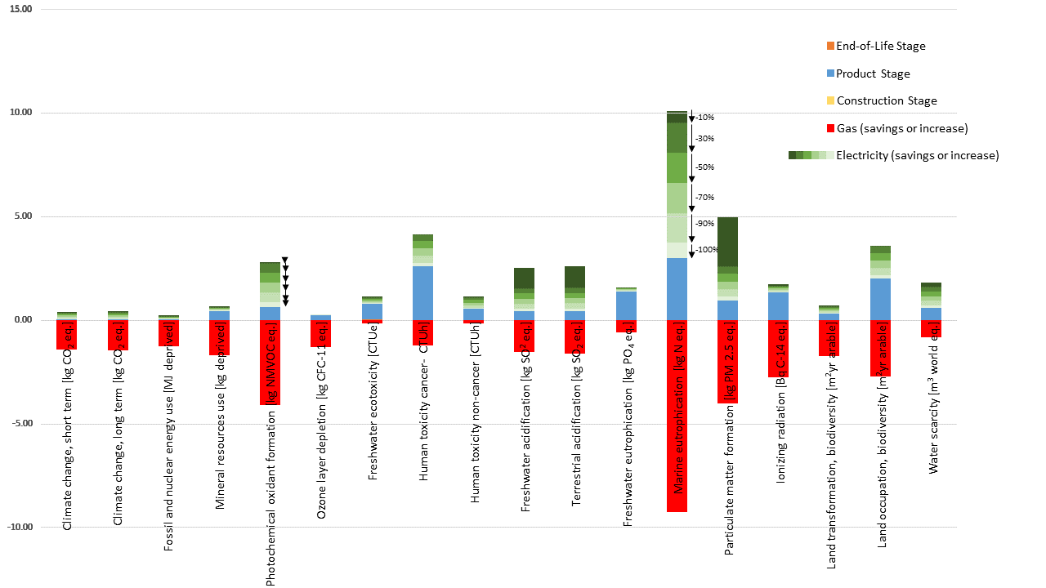

**Figure 5:** Normalised environmental impacts (IMPACT 2002+ Midpoint) taking into consideration the decarbonisation of the electricity grid

**Table 4:** Environmental impacts with decarbonisation of the electricity grid (operational energy savings/increase)

|  |  |  |  |  |  |  |  |
| --- | --- | --- | --- | --- | --- | --- | --- |
|  | **Electricity (savings or increase) – *ecoinvent 3.7.1 cut-off* {AU}** | **Electricity (savings or increase) - decarbonised by 10 %** | **Electricity (savings or increase) - decarbonised by 30 %** | **Electricity (savings or increase) - decarbonised by 50 %** | **Electricity (savings or increase) - decarbonised by 70 %** | **Electricity (savings or increase) - decarbonised by 90 %** | **Electricity (savings or increase) - decarbonised by 100 %** |
| **Climate change, short term** | 650,728 | 585,655 | 455,510 | 325,364 | 195,218 | 65,073 | 0 |
| **Climate change, long term** | 641,091 | 576,982 | 448,764 | 320,546 | 192,327 | 64,109 | 0 |
| **Fossil and nuclear energy use** | 7,288,984 | 6,560,085 | 5,102,288 | 3,644,492 | 2,186,695 | 728,898 | 0 |
| **Mineral resources use** | 1,047.87 | 943.08 | 733.51 | 523.93 | 314.36 | 104.79 | 0 |
| **Photochemical oxidant formation** | 1,437.40 | 1,293.66 | 1,006.18 | 718.70 | 431.22 | 143.74 | 0 |
| **Ozone layer depletion** | 0.01 | 0.01 | 0.01 | 0.00 | 0.00 | 0.00 | 0 |
| **Freshwater ecotoxicity** | 10,913,113,791 | 9,821,802,412 | 7,639,179,654 | 5,456,556,896 | 3,273,934,137 | 1,091,311,379 | 0 |
| **Human toxicity cancer** | 0.09 | 0.08 | 0.06 | 0.05 | 0.03 | 0.01 | 0 |
| **Human toxicity non-cancer** | 0.16 | 0.14 | 0.11 | 0.08 | 0.05 | 0.02 | 0 |
| **Freshwater acidification** | 0.01 | 0.01 | 0.00 | 0.00 | 0.00 | 0.00 | 0 |
| **Terrestrial acidification** | 4.70 | 4.23 | 3.29 | 2.35 | 1.41 | 0.47 | 0 |
| **Freshwater eutrophication** | 0.63 | 0.57 | 0.44 | 0.31 | 0.19 | 0.06 | 0 |
| **Marine eutrophication** | 28.52 | 25.67 | 19.96 | 14.26 | 8.56 | 2.85 | 0 |
| **Particulate matter formation** | 122.33 | 110.09 | 85.63 | 61.16 | 36.70 | 12.23 | 0 |
| **Ionizing radiation** | 237,660 | 213,894 | 166,362 | 118,830 | 71,298 | 23,766 | 0 |
| **Land transformation, biodiversity** | 32.54 | 29.29 | 22.78 | 16.27 | 9.76 | 3.25 | 0 |
| **Land occupation, biodiversity** | 2,431.32 | 2,188.19 | 1,701.92 | 1,215.66 | 729.40 | 243.13 | 0 |
| **Water scarcity** | 46,023 | 41,421 | 32,216 | 23,011 | 13,807 | 4,602 | 0 |

* 1. Discussion

The assessment of the embodied and operational energy made it possible to determine whether the environmental impacts of the materials and the embodied energy can be offset by the energy savings of an energy efficient heating and cooling upgrade. While choosing a conservative approach for the materials, the embodied impacts are rather high. Therefore, the environmental impacts could be lower by choosing a non Pb containing wiring board. Furthermore, reducing the impacts of the air compressor production and using less copper could be considered. Alternatives to copper could be steel or aluminium. It also would be recommended to use a CO2 based refrigerant, as the environmental impacts could be lowered.

The environmental assessment highlights the importance of an LCA approach, as it shows which life cycle stages and materials impact our environment the most. Based on that, manufacturers and policy makers can make decisions on which stages to improve and which materials to substitute or reduce. Therefore, it is recommended to always assess the whole life cycle of products to further enhance transparency and making conscious decisions.

Nonetheless, the environmental impacts of the heating and cooling upgrade cannot be offset in all cases. Human toxicity (cancer and non-cancer), freshwater ecotoxicity and freshwater eutrophication cannot be offset even if the electricity usage has zero emissions due to a 100 % renewable electricity grid. On the one hand, one way to avoid these impacts would be to choose alternative retrofits which decrease the load of heating and cooling. This could be done through further insulation with woodwool, hemp or other sustainable materials or the installation of green roofs and vertical gardens. It is questionable though, if even with a decreased heat and cooling load an energy efficiency upgrade will be avoidable. On the other hand, with increasing weather extremes, a heating to heating and cooling upgrade seems unavoidable. Therefore, it is already recommended to consider the most environmentally friendly alternatives. The upgrade to reverse cycle air conditioning is one alternative. Furthermore, it would be interesting to consider air source heat pumps.

Many countries try to be more environmentally friendly which often goes hand in hand with the decarbonisation of the electricity grid, and the latter is important in encouraging the switch from gas to electric heating and cooling. Nonetheless, this research has some limitations like the availability of data for the raw materials in the appliances as well as on the transportation modes. Therefore, assumptions had to be made. It can be assumed that different parts of the reverse air conditioner are also produced at different factories but this could not be included in the research. Also, the research only contains data on the whole energy use of the building, not just for space heating and cooling, thus energy data one year prior and after the energy efficiency upgrade had to be used which potentially weakens the liability of the energy data.

For a better assessment of heating and cooling appliances more data transparency would be helpful. Most manufacturers provide no information about the share of materials used in the appliances and the commonly used databases do not provide all the exact single components. Often different, proxy components have to be chosen. Also, for refrigerants, databases do not include all types of refrigerants, which makes comparisons harder. Consequently, more data transparency and more extensive databases would help the modelling of energy efficiency upgrades for further research.

1. Conclusion

In this paper, 59 gas heating to reverse cycle air conditioner upgrades have been assessed on their environmental impact while also accounting for the decarbonisation of the Australian electricity grid. The end of the life cycle of the old gas heater as well as the production, construction and use stage of the new reverse cycle air conditioner have been assessed. A gas heater and a reverse cycle air conditioner were deconstructed as reference heaters to determine the material composition. The operational energy data relies on primary data over the course of one year prior and after the energy efficiency upgrade. The impacts on climate change (short and long term), fossil and nuclear energy use, mineral resources use, photochemical oxidant formation, ozone layer depletion, ionizing radiation, as well as land transformation (biodiversity) can be offset by the gas savings generated through the upgrade.

The results show that the human toxicity (cancer and non-cancer), freshwater ecotoxicity, acidification and eutrophication, terrestrial acidification, marine eutrophication, particulate matter formation, land occupation (biodiversity) and water scarcity, cannot be offset by the gas savings with the current electricity mix of Australia.

When increasing the share of renewables in the electricity mix of Australia, the following impact categories can be offset: freshwater acidification, terrestrial acidification, marine eutrophication, particulate matter formation, land occupation (biodiversity) and water scarcity. Nonetheless, even with a 100 % renewable electricity grid the impacts of human toxicity (cancer and non-cancer), freshwater ecotoxicity and freshwater eutrophication of the energy efficiency upgrade cannot be offset. This is due to the high impacts during the product stage. The printed wiring board (Pb containing) impacts freshwater ecotoxicity (64 %) and eutrophication (91 %) as well as land occupation, biodiversity (48 %), the most. The impact category human toxicity (non-cancer) is impacted the most by steel (35 %). For human toxicity (cancer) the impacts of the increased electricity usage are the highest.

The results clearly illustrate that upgrading from gas to electric heating and cooling has environmental impacts which cannot be offset through the gas savings of the upgrade. Especially water categories, human toxicity, particulate matter formation and land occupation, biodiversity are impacted. Nonetheless, most of the impacts can be offset when decarbonising the electricity grid.

From a government and policy maker point of view there should be a stronger focus on the choice of materials. Also, the use of secondary materials could further decrease the environmental impacts of appliances. With a higher decarbonisation of the electricity grid the impacts of gas to electric heating and cooling upgrades can be further reduced. As there is a high likelihood that households will switch from heating only to heating and cooling systems, it is important to assess common energy efficiency upgrades to help decision makers choose the most environmentally friendly solution on the market.

**Supplementary Materials:** The following supporting information can be downloaded at: https://figshare.com/s/faa566fab8409e408b9c details on Table 1 and 2.

**Author Contributions:** Ina Eileen Peukes: conceptualization, methodology, software, validation, formal analysis, investigation, resources, data curation, writing—original draft preparation, project administration.  
Francesco Pomponi: writing—review and editing, supervision, funding acquisition.  
Bernardino D’Amico: writing—review and editing, supervision.  
All authors have read and agreed to the published version.

**Funding:** This research was funded by EPSRC, Grant. No EP/R01468X/1.

**Informed Consent Statement:** Informed consent was obtained from all subjects involved in the study.

**Data Availability Statement:** The data supporting reported results can be found under https://figshare.com/s/faa566fab8409e408b9c

**Acknowledgments:** We would like to thank Jack Martin Scrap Metals (Canberra, Australia) for providing us with the gas heating and reverse cycle air conditioner system for this study and ActewAGL (Canberra, Australia) for supplying us with the data on energy efficiency heating upgrades and the energy use prior and after heating upgrade. The authors gratefully acknowledge funding from the EPSRC, Grant. No EP/R01468X/1.

**Conflicts of Interest:** The authors declare no conflict of interest.

References

* 1. Lucon, O.; Ürge-Vorsatz, D.; Ahmed, A.Z.; Akbari, H.; Bertoldi, P.; Cabeza, L.F.; Eyre, N.; Gadgil, A.; Harvey, L.D.; Jiang, Y.; et al. *Chapter 9 - Buildings;* Cambridge University Press: Cambridge, United Kingdom and New York, 2014.
  2. Kim, J.T.; Yu, C.W.F. Sustainable development and requirements for energy efficiency in buildings–the Korean perspectives. *Indoor and Built Environment* **2018**, *27*, 734–751.
  3. Diana Ürge-Vorsatz; Luisa F. Cabeza; Susana Serrano; Camila Barreneche; Ksenia Petrichenko. Heating and cooling energy trends and drivers in buildings. *Renewable and Sustainable Energy Reviews* **2015**, *41*, 85–98, doi:10.1016/j.rser.2014.08.039.
  4. Commonwealth of Australia. Heating and cooling | energy.gov.au. Available online: https://www.energy.gov.au/households/heating-and-cooling (accessed on 29 August 2022).
  5. IEA - International Energy Agency. The Future of Cooling **2018**.
  6. International Energy Agency. *The Future of Cooling: Opportunities for energy-efficient air conditioning;* OECD Publishing, 2018, ISBN 9264301992.
  7. Zhang, N.; Wang, H.Y.; Gallagher, J.; Song, Q.B.; Tam, V.W.; Duan, H.B. A dynamic analysis of the global warming potential associated with air conditioning at a city scale: an empirical study in Shenzhen, China. *ENVIRONMENTAL IMPACT ASSESSMENT REVIEW* **2020**, *81*, doi:10.1016/j.eiar.2019.106354.
  8. Gheewala, S.H.; Nielsen, P.H. Central and individual air-conditioning systems — A comparison of environmental impacts and resource consumption in a life cycle perspective. *International Journal of Sustainable Development & World Ecology* **2003**, *10*, 149–155, doi:10.1080/13504500309469793.
  9. Beshr, M.; Aute, V.; Abdelaziz, O.; Fricke, B.; Radermacher, R. Potential emission savings from refrigeration and air conditioning systems by using low GWP refrigerants. *Int J Life Cycle Assess* **2017**, *22*, 675–682, doi:10.1007/s11367-016-1186-6.
  10. Yanjie Li; Victor Nian; Hailong Li; Shengchun Liu; Yabo Wang. A life cycle analysis techno-economic assessment framework for evaluating future technology pathways – The residential air-conditioning example. *APPLIED ENERGY* **2021**, *291*, 116750, doi:10.1016/j.apenergy.2021.116750.
  11. Siyu Liu; Uwe W. Schulz; Majid Haji Sapar; Shunzhi Qian. Evaluation of the environmental performance of the chilled ceiling system using life cycle assessment (LCA): A case study in Singapore. *Building and Environment* **2016**, *102*, 207–216, doi:10.1016/j.buildenv.2016.03.005.
  12. Almutairi, K.; Thoma, G.; Burek, J.; Algarni, S.; Nutter, D. *Life cycle assessment and economic analysis of residential air conditioning in Saudi Arabia*, 2015.
  13. Karkour, S.; Ihara, T.; Kuwayama, T.; Yamaguchi, K.; Itsubo, N. Life Cycle Assessment of Residential Air Conditioners Considering the Benefits of Their Use: A Case Study in Indonesia. *Energies* **2021**, *14*, doi:10.3390/en14020447.
  14. Shah, V.P.; Debella, D.C.; Ries, R.J. Life cycle assessment of residential heating and cooling systems in four regions in the United States. *Energy and Buildings* **2008**, *40*, 503–513, doi:10.1016/j.enbuild.2007.04.004.
  15. Li, G. Investigations of life cycle climate performance and material life cycle assessment of packaged air conditioners for residential application. *Sustainable Energy Technologies and Assessments* **2015**, *11*, 114–125, doi:10.1016/j.seta.2015.07.002.
  16. PRé Sustainability B.V. SimaPro. Available online: https://simapro.com/ (accessed on 1 September 2022).
  17. ecoinvent Association. ecoinvent. Available online: https://ecoinvent.org/ (accessed on 1 September 2022).
  18. IMPACT World+. Available online: https://www.impactworldplus.org/en/methodology.php (accessed on 12 February 2022).
  19. Bulle, C.; Margni, M.; Patouillard, L.; Boulay, A.-M.; Bourgault, G.; Bruille, V. de; Cao, V.; Hauschild, M.; Henderson, A.; Humbert, S.; et al. IMPACT World+: a globally regionalized life cycle impact assessment method. *Int J Life Cycle Assess* **2019**, *24*, 1653–1674, doi:10.1007/s11367-019-01583-0.
  20. Tang, L.; Higa, M.; Tanaka, N.; Itsubo, N. Assessment of global warming impact on biodiversity using the extinction risk index in LCIA: a case study of Japanese plant species. *Int J Life Cycle Assess* **2018**, *23*, 314–323, doi:10.1007/s11367-017-1319-6.
  21. Tang, L.; Ii, R.; Tokimatsu, K.; Itsubo, N. Development of human health damage factors related to CO2 emissions by considering future socioeconomic scenarios. *Int J Life Cycle Assess* **2018**, *23*, 2288–2299, doi:10.1007/s11367-015-0965-9.
  22. Goedkoop, M.; Schryver, A. de. Mineral resource depletion in a life cycle impact assessment method which comprises harmonised category indicators at the midpoint and the endpoint level. *Ruimte en milieu, ministerie van Volkshuisvesting, ruimtelijk ordening en milieubeheer* **2008**.
  23. World Meteorological Organization. Assessment for Decision-Makers: Scientific Assessment of Ozone Depletion: 2014: 88 pp., Global Ozone Research and Monitoring Project **2014**.
  24. Tang, L.; Nagashima, T.; Hasegawa, K.; Ohara, T.; Sudo, K.; Itsubo, N. Development of human health damage factors for tropospheric ozone considering transboundary transport on a global scale. *Int J Life Cycle Assess* **2018**, *23*, 2339–2348, doi:10.1007/s11367-015-1001-9.
  25. Tang, L.; Nagashima, T.; Hasegawa, K.; Ohara, T.; Sudo, K.; Itsubo, N. Development of human health damage factors for PM2.5 based on a global chemical transport model. *Int J Life Cycle Assess* **2018**, *23*, 2300–2310, doi:10.1007/s11367-014-0837-8.
  26. Fantke, P.; Jolliet, O.; Evans, J.S.; Apte, J.S.; Cohen, A.J.; Hänninen, O.O.; Hurley, F.; Jantunen, M.J.; Jerrett, M.; Levy, J.I.; et al. Health effects of fine particulate matter in life cycle impact assessment: findings from the Basel Guidance Workshop. *Int J Life Cycle Assess* **2015**, *20*, 276–288, doi:10.1007/s11367-014-0822-2.
  27. Gronlund, C.J.; Humbert, S.; Shaked, S.; O'Neill, M.S.; Jolliet, O. Characterizing the burden of disease of particulate matter for life cycle impact assessment. *Air Qual. Atmos. Health* **2015**, *8*, 29–46, doi:10.1007/s11869-014-0283-6.
  28. Chaudhary, A.; Verones, F.; Baan, L. de; Hellweg, S. Quantifying Land Use Impacts on Biodiversity: Combining Species-Area Models and Vulnerability Indicators. *ENVIRONMENTAL SCIENCE & TECHNOLOGY* **2015**, *49*, 9987–9995, doi:10.1021/acs.est.5b02507.
  29. 'de Baan, L.; Alkemade, R.; Koellner, T. Land use impacts on biodiversity in LCA: a global approach. *Int J Life Cycle Assess* **2013**, *18*, 1216–1230, doi:10.1007/s11367-012-0412-0.
  30. Roy, P.-O.; Azevedo, L.B.; Margni, M.; van Zelm, R.; Deschênes, L.; Huijbregts, M.A.J. Characterization factors for terrestrial acidification at the global scale: A systematic analysis of spatial variability and uncertainty. *SCIENCE OF THE TOTAL ENVIRONMENT* **2014**, *500*, 270–276.
  31. am Boulay; Bare, J.; Benini, L.; Berger, M.; Lathuilliere, M.; Manzardo, A.; Pfister, S. Consensus-based water scarcity footprint method from WULCA: the AWARE model. *Environ Sci Technol submitted* **2018**, *23*, 368–378.
  32. Motoshita, M.; Ono, Y.; Pfister, S.; Boulay, A.-M.; Berger, M.; Nansai, K.; Tahara, K.; Itsubo, N.; Inaba, A. Consistent characterisation factors at midpoint and endpoint relevant to agricultural water scarcity arising from freshwater consumption. *Int J Life Cycle Assess* **2018**, *23*, 2276–2287, doi:10.1007/s11367-014-0811-5.
  33. Kounina, A.; Margni, M.; Bayart, J.-B.; Boulay, A.-M.; Berger, M.; Bulle, C.; Frischknecht, R.; Koehler, A.; Milà i Canals, L.; Motoshita, M.; et al. Review of methods addressing freshwater use in life cycle inventory and impact assessment. *Int J Life Cycle Assess* **2013**, *18*, 707–721, doi:10.1007/s11367-012-0519-3.
  34. Peukes, I.E.; Francesco, P.; D'Amico, B. LCA_IMPACT 2002+_59 gas heating to reverse cycle air conditioning upgrades. Available online: https://figshare.com/s/faa566fab8409e408b9c (accessed on 1 July 2022).
  35. Peukes, I.E.; Francesco, P.; D'Amico, B. Life cycle assessment of 61 ducted gas heating upgrades in Australia. *International Journal of Building Pathology and Adaptation* **2021**, *ahead-of-print*, doi:10.1108/IJBPA-04-2021-0052.
  36. Boustani, A.; Sahni, S.; Gutowski, T.; Graves, S. Appliance remanufacturing and energy savings. *Management* **2010**.
  37. Australian Taxation Office for the Commonwealth of Australia. Residential rental property items. Available online: https://www.ato.gov.au/Individuals/Tax-return/2020/In-detail/Publications/Rental-properties-2020/?page=12 (accessed on 27 February 2022).
  38. Commonwealth of Australia. Australian non-renewable energy resources. Available online: https://www.aph.gov.au/About_Parliament/Parliamentary_Departments/Parliamentary_Library/pubs/BriefingBook44p/EnergyResources (accessed on 15 June 2022).
  39. Point Advisory. ACT-Greenhouse-Gas-Emissions-Inventory-Report-2020-21 **2021**

References

1. Lucon, O.; Ürge-Vorsatz, D.; Ahmed, A.Z.; Akbari, H.; Bertoldi, P.; Cabeza, L.F.; Eyre, N.; Gadgil, A.; Harvey, L.D.; Jiang, Y.; et al. *Chapter 9 - Buildings;* Cambridge University Press: Cambridge, United Kingdom and New York, 2014.

2. Kim, J.T.; Yu, C.W.F. Sustainable development and requirements for energy efficiency in buildings–the Korean perspectives. *Indoor and Built Environment* **2018**, *27*, 734–751.

3. Diana Ürge-Vorsatz; Luisa F. Cabeza; Susana Serrano; Camila Barreneche; Ksenia Petrichenko. Heating and cooling energy trends and drivers in buildings. *Renewable and Sustainable Energy Reviews* **2015**, *41*, 85–98, doi:10.1016/j.rser.2014.08.039.

4. Commonwealth of Australia. Heating and cooling | energy.gov.au. Available online: https://www.energy.gov.au/households/heating-and-cooling (accessed on 29 August 2022).

5. IEA - International Energy Agency. The Future of Cooling **2018**.

6. International Energy Agency. *The Future of Cooling: Opportunities for energy-efficient air conditioning;* OECD Publishing, 2018, ISBN 9264301992.

7. Zhang, N.; Wang, H.Y.; Gallagher, J.; Song, Q.B.; Tam, V.W.; Duan, H.B. A dynamic analysis of the global warming potential associated with air conditioning at a city scale: an empirical study in Shenzhen, China. *ENVIRONMENTAL IMPACT ASSESSMENT REVIEW* **2020**, *81*, doi:10.1016/j.eiar.2019.106354.

8. Gheewala, S.H.; Nielsen, P.H. Central and individual air-conditioning systems — A comparison of environmental impacts and resource consumption in a life cycle perspective. *International Journal of Sustainable Development & World Ecology* **2003**, *10*, 149–155, doi:10.1080/13504500309469793.

9. Beshr, M.; Aute, V.; Abdelaziz, O.; Fricke, B.; Radermacher, R. Potential emission savings from refrigeration and air conditioning systems by using low GWP refrigerants. *Int J Life Cycle Assess* **2017**, *22*, 675–682, doi:10.1007/s11367-016-1186-6.

10. Yanjie Li; Victor Nian; Hailong Li; Shengchun Liu; Yabo Wang. A life cycle analysis techno-economic assessment framework for evaluating future technology pathways – The residential air-conditioning example. *APPLIED ENERGY* **2021**, *291*, 116750, doi:10.1016/j.apenergy.2021.116750.

11. Almutairi, K.; Thoma, G.; Burek, J.; Algarni, S.; Nutter, D. *Life cycle assessment and economic analysis of residential air conditioning in Saudi Arabia*, 2015.

12. Siyu Liu; Uwe W. Schulz; Majid Haji Sapar; Shunzhi Qian. Evaluation of the environmental performance of the chilled ceiling system using life cycle assessment (LCA): A case study in Singapore. *Building and Environment* **2016**, *102*, 207–216, doi:10.1016/j.buildenv.2016.03.005.

13. Karkour, S.; Ihara, T.; Kuwayama, T.; Yamaguchi, K.; Itsubo, N. Life Cycle Assessment of Residential Air Conditioners Considering the Benefits of Their Use: A Case Study in Indonesia. *Energies* **2021**, *14*, doi:10.3390/en14020447.

14. Shah, V.P.; Debella, D.C.; Ries, R.J. Life cycle assessment of residential heating and cooling systems in four regions in the United States. *Energy and Buildings* **2008**, *40*, 503–513, doi:10.1016/j.enbuild.2007.04.004.

15. Li, G. Investigations of life cycle climate performance and material life cycle assessment of packaged air conditioners for residential application. *Sustainable Energy Technologies and Assessments* **2015**, *11*, 114–125, doi:10.1016/j.seta.2015.07.002.

16. PRé Sustainability B.V. SimaPro. Available online: https://simapro.com/ (accessed on 1 September 2022).

17. ecoinvent Association. ecoinvent. Available online: https://ecoinvent.org/ (accessed on 1 September 2022).

18. IMPACT World+. Available online: https://www.impactworldplus.org/en/methodology.php (accessed on 12 February 2022).

19. Bulle, C.; Margni, M.; Patouillard, L.; Boulay, A.-M.; Bourgault, G.; Bruille, V. de; Cao, V.; Hauschild, M.; Henderson, A.; Humbert, S.; et al. IMPACT World+: a globally regionalized life cycle impact assessment method. *Int J Life Cycle Assess* **2019**, *24*, 1653–1674, doi:10.1007/s11367-019-01583-0.

20. Tang, L.; Higa, M.; Tanaka, N.; Itsubo, N. Assessment of global warming impact on biodiversity using the extinction risk index in LCIA: a case study of Japanese plant species. *Int J Life Cycle Assess* **2018**, *23*, 314–323, doi:10.1007/s11367-017-1319-6.

21. Tang, L.; Ii, R.; Tokimatsu, K.; Itsubo, N. Development of human health damage factors related to CO2 emissions by considering future socioeconomic scenarios. *Int J Life Cycle Assess* **2018**, *23*, 2288–2299, doi:10.1007/s11367-015-0965-9.

22. Goedkoop, M.; Schryver, A. de. Mineral resource depletion in a life cycle impact assessment method which comprises harmonised category indicators at the midpoint and the endpoint level. *Ruimte en milieu, ministerie van Volkshuisvesting, ruimtelijk ordening en milieubeheer* **2008**.

23. World Meteorological Organization. Assessment for Decision-Makers: Scientific Assessment of Ozone Depletion: 2014: 88 pp., Global Ozone Research and Monitoring Project **2014**.

24. Tang, L.; Nagashima, T.; Hasegawa, K.; Ohara, T.; Sudo, K.; Itsubo, N. Development of human health damage factors for tropospheric ozone considering transboundary transport on a global scale. *Int J Life Cycle Assess* **2018**, *23*, 2339–2348, doi:10.1007/s11367-015-1001-9.

25. Tang, L.; Nagashima, T.; Hasegawa, K.; Ohara, T.; Sudo, K.; Itsubo, N. Development of human health damage factors for PM2.5 based on a global chemical transport model. *Int J Life Cycle Assess* **2018**, *23*, 2300–2310, doi:10.1007/s11367-014-0837-8.

26. Fantke, P.; Jolliet, O.; Evans, J.S.; Apte, J.S.; Cohen, A.J.; Hänninen, O.O.; Hurley, F.; Jantunen, M.J.; Jerrett, M.; Levy, J.I.; et al. Health effects of fine particulate matter in life cycle impact assessment: findings from the Basel Guidance Workshop. *Int J Life Cycle Assess* **2015**, *20*, 276–288, doi:10.1007/s11367-014-0822-2.

27. Gronlund, C.J.; Humbert, S.; Shaked, S.; O'Neill, M.S.; Jolliet, O. Characterizing the burden of disease of particulate matter for life cycle impact assessment. *Air Qual. Atmos. Health* **2015**, *8*, 29–46, doi:10.1007/s11869-014-0283-6.

28. Chaudhary, A.; Verones, F.; Baan, L. de; Hellweg, S. Quantifying Land Use Impacts on Biodiversity: Combining Species-Area Models and Vulnerability Indicators. *ENVIRONMENTAL SCIENCE & TECHNOLOGY* **2015**, *49*, 9987–9995, doi:10.1021/acs.est.5b02507.

29. 'de Baan, L.; Alkemade, R.; Koellner, T. Land use impacts on biodiversity in LCA: a global approach. *Int J Life Cycle Assess* **2013**, *18*, 1216–1230, doi:10.1007/s11367-012-0412-0.

30. Roy, P.-O.; Azevedo, L.B.; Margni, M.; van Zelm, R.; Deschênes, L.; Huijbregts, M.A.J. Characterization factors for terrestrial acidification at the global scale: A systematic analysis of spatial variability and uncertainty. *SCIENCE OF THE TOTAL ENVIRONMENT* **2014**, *500*, 270–276.

31. am Boulay; Bare, J.; Benini, L.; Berger, M.; Lathuilliere, M.; Manzardo, A.; Pfister, S. Consensus-based water scarcity footprint method from WULCA: the AWARE model. *Environ Sci Technol submitted* **2018**, *23*, 368–378.

32. Motoshita, M.; Ono, Y.; Pfister, S.; Boulay, A.-M.; Berger, M.; Nansai, K.; Tahara, K.; Itsubo, N.; Inaba, A. Consistent characterisation factors at midpoint and endpoint relevant to agricultural water scarcity arising from freshwater consumption. *Int J Life Cycle Assess* **2018**, *23*, 2276–2287, doi:10.1007/s11367-014-0811-5.

33. Kounina, A.; Margni, M.; Bayart, J.-B.; Boulay, A.-M.; Berger, M.; Bulle, C.; Frischknecht, R.; Koehler, A.; Milà i Canals, L.; Motoshita, M.; et al. Review of methods addressing freshwater use in life cycle inventory and impact assessment. *Int J Life Cycle Assess* **2013**, *18*, 707–721, doi:10.1007/s11367-012-0519-3.

34. Peukes, I.E.; Francesco, P.; D'Amico, B. LCA_IMPACT 2002+_59 gas heating to reverse cycle air conditioning upgrades. Available online: https://figshare.com/s/faa566fab8409e408b9c (accessed on 1 July 2022).

35. Peukes, I.E.; Francesco, P.; D'Amico, B. Life cycle assessment of 61 ducted gas heating upgrades in Australia. *International Journal of Building Pathology and Adaptation* **2021**, *ahead-of-print*, doi:10.1108/IJBPA-04-2021-0052.

36. Boustani, A.; Sahni, S.; Gutowski, T.; Graves, S. Appliance remanufacturing and energy savings. *Management* **2010**.

37. Australian Taxation Office for the Commonwealth of Australia. Residential rental property items. Available online: https://www.ato.gov.au/Individuals/Tax-return/2020/In-detail/Publications/Rental-properties-2020/?page=12 (accessed on 27 February 2022).

38. Commonwealth of Australia. Australian non-renewable energy resources. Available online: https://www.aph.gov.au/About_Parliament/Parliamentary_Departments/Parliamentary_Library/pubs/BriefingBook44p/EnergyResources (accessed on 15 June 2022).

39. Advisory, P. ACT-Greenhouse-Gas-Emissions-Inventory-Report-2020-21 **2021**.