TECHNICAL APPENDIX: TCAT
Interim Report: 1 June 2016

DOCUMENT CONTROL

Document Title:
TECHNICAL APPENDIX: TCAT

Document prepared BY:
Edinburgh Napier University Team

Date originally Submitted: 02 maY 2016

document CONTROL: V2: 01/06/2016

EVALUATION METHODOLOGY
This section describes the overall approach and specific methods used between June 2014 and February 2016 by Edinburgh Napier University. It also sets out the work undertaken to date to support the evaluation work of local projects

Evaluation design and approach
The specific objectives for the national evaluation are to:
- provide regular findings that help us to test whether the programme is helping to achieve better outcomes and experience of after care for people with cancer and better resource utilisation
- draw out lessons learned on what works (and what doesn’t work), for whom, why and in what circumstances – to shape the development of the programme and inform future phases
- work collaboratively with the projects and key partners to share learning, and support key stakeholders to understand what the findings means for them;
- support the self-evaluation of the projects to enable them to provide robust and credible evidence that can be used locally to support future sustainability and also influence post treatment care regionally and nationally
- Where possible and appropriate, support the use of the evaluation outputs and findings to further influence and encourage buy-in for the TCAT programme and its aims from local, regional and national stakeholders

In order to achieve the objectives identified above two theoretical approaches have been used in combination by Edinburgh Napier University Evaluation Team. The evaluation is adopting a Realistic Evaluation framework with an Appreciative Inquiry approach.,
This combination of models of evaluation is particularly necessary as the national evaluation involves numerous multi-component interventions within a complex regional and national programme. The TCAT programme in Scotland is not one model of ‘care after treatment’ set up in different locations, but 25 different interventions/projects that are linked by the programme’s overarching aims.
Overall TCAT can be visualised usefully as a complex intervention that is “built up from a number of components, which may act both independently and interdependently”.

Box 1: Key Components of TCAT Programme
Holistic Assessment
Cancer Care Review
Education
and Support
Events
End of
Treatment
Summary
Risk Stratification
Self
Management
25 projects
in 3 Regions

Patient Experiences

/Outcomes
Integration/
coordination

Aftercare – awareness
&
acceptance
Patient
Voice
Partnership
Attitudes/
Behaviours

After Care –
Skills & knowledge

Realistic evaluation focuses upon identifying and making sense of the context, the mechanisms of action and outcomes of care after treatment. Paying attention to each of these connected concepts enables a depth of understanding of each project.
Appreciative inquiry focuses on identifying what works well and taking time to understand why this is so then adapting practices to capture more moments of success. Working with an appreciative approach in TCAT aims to support practitioners to look at their project through an appreciative lens, what is working and what possibilities exist? The evaluation team have embedded an appreciative approach into fieldwork tools such as interview and group discussion topic lists and online survey questionnaire.
As a key issue for this evaluation is to inform the future development of proven effective interventions and models of care, this approach is designed to consistently ask questions which focus on appreciating achievements and identifying how success can be translated across the TCAT programme. This unique combination allows focus on enhancing the potential for roll out, sustainability and transferability of identified ‘successes’ from multi-component interventions, within a complex national programme of projects.
The dual approach being adopted also aims to counter the challenges of an evaluation which doesn’t have traditionally understood baseline and pre and post intervention measures. There is no traditionally understood baseline for TCAT as it is a diverse and complex programme that emphasises localism. This and other factors (such as the timing of the national team being commissioned and having a supporting role in local evaluation only) has resulted in local approaches to baseline work which cannot be collated meaningfully.

Evaluation methods

Ethical approval was obtained from Edinburgh Napier University internal committee to undertake the evaluation work detailed here. National approval for the collection of NHS generated data was granted in June 2015 by the NHS Scotland Caldicott Guardian Scrutiny Panel.

Ongoing document review
A systematic review of Expression of Interest and Macmillan Partnership Application documents was undertaken. In addition, where available, this process included a review of the minutes of local implementation steering groups, TCAT programme board and cancer network TCAT Implementation Steering Group minutes.

Scoping
Using an analysis framework of the key TCAT programme components, devised by the Edinburgh Napier University Evaluation Team each of the 25 projects was defined and scoped, paying particular attention on the key aims of the programme overall and specifically on elements of the Recovery Package.

Data gathered for National Evaluation
Edinburgh Napier University devised four data sheets to gather data from local TCAT projects. In various combinations, these can be used by all projects, irrespective of setting, for example hospital or community.

These are presented in Appendix One and summarised in the diagram below.
Project Number & Unique Patient ID Number
Patient / service user
Feedback
Core Data
HNA Processes / Actions
Concerns Checklist

Core Data: (Appendix 1.A) is collected for all the patients/clients/users of TCAT services/interventions across the whole programme in Scotland and provides basic demographic information. It includes for example, cancer type, age and living situation.
HNA Processes and Actions: (Appendix 1.B) is a data sheet used to record key aspects of the assessment undertaken, regardless of the HNA tool used, such as profession undertaking the assessment, location, length, referral and signposting activity.
Concerns Checklist: (Appendix 1.C) is a record of the identified concerns and overall concern level/score of individuals within the TCAT programme who locally completed a HNA using the Concerns Checklist tool only.
Patient Feedback: (Appendix 1.D) is gathered directly from patients/service users of participating local projects using the questionnaire devised by Edinburgh Napier University (n=12). In addition a questionnaire for use pre the TCAT intervention to provide baseline data was developed and has to date been used by three projects.
Data is gathered at a local level and transferred to Edinburgh Napier University. The data used at this Interim Stage is shown in the table below. It shows the number of patients/service users engaged in the programme (core data) and the scale of end of treatment assessments carried out (Assessment Process/Actions) between October 2014 and December 2015. Data on the concerns identified using the Concerns Checklist was submitted in relation to 429 individuals over the same time period.

Table 1: Data Used in March 2016 report * - end of treatment assessment only
 | Core Data | Assessment Process / Actions | Concerns
NHS Borders | 61 | 45 | 32
NHS Lothian | 83 | 56 | 56
NHS Lothian (prostate only) | 105 | 0 | 0
NHS Fife (Lung) | 192 | 174 | 0
NHS Fife (Melanoma) | 77 | 77 | 77
NHS Tayside | 107 | 107 | 107
NHS Ayrshire & Arran | 86 | 86 | 86
NHS Forth Valley | 132 | 47 | 47
NHS GGC | 24 | 24 | 24
TOTAL | 867 | 616 | 429

*The NHS Lothian Phase 1 project provided data for the 2 service developments within their project – one of which focussed solely on people with prostate cancer

Focus group discussions
Fourteen focus group discussions have been held with projects at the end of their development stage/early implementation stage. The discussions gathered the views and experiences of local projects in relation to their aims, set up challenges and solutions, the role of TCAT programme structures in their work and their early views on key programme aims such as service integration, attitudes to ‘after care’ for people affected by cancer and the potential for sustainability and /or roll out.

Table 2: Focus Group discussions by Phase
 | Number conducted
Phase 1 | 8
Phase 2 | 6

Within each group discussion the number of participants ranged from 2 to 11. A total of 64 participants took part.
A second focus group discussion will be held with these projects at the end of their projects and to date this has been carried out with the one completed project.

Interviews with core stakeholders
In 2014 in-depth interviews with representatives of the programme’s governance structures (n = 11) were undertaken. During November 2015 these were repeated with nine and two representatives from the North of Scotland were interviewed for the first time. Throughout this report they are referred to as ‘core stakeholders’.

Online survey of wider stakeholders
An online survey of 195 wider TCAT stakeholders was distributed online in November 2015. These wider stakeholders included members of national and regional TCAT structures and those involved in Phase 1 project implementation steering groups. The overall response rate was 55% - relating to 108 people. However a number only answered the first question before exiting the survey and have been removed from the overall analysis. The sample also included Phase 2 projects and they too have been removed from this reporting.
A significant number of wider stakeholders have more than one role – for example representatives from local projects are members of regional steering group in their area. The useable sample for this report is therefore 65 wider stakeholders who have 79 roles in TCAT.
Table 3: % response rate by role in the structure
 | Responses
Roles | % | (n)
Programme Board | 31.8 | 7
Regional TCAT Implementation Group | 43.1 | 19
Phase ONE local Project | 37.9 | 53
 |  | 79

The respondents to this survey are representative of the number of ‘wider stakeholders’ within SCAN, WoSCAN and NOSCAN.

Table 4: Response rate and sample by region
 | Responses
Region of Respondent | % | (n)
West of Scotland (WoSCAN) | 39 | 25
South East Scotland (SCAN) | 44 | 28
North of Scotland (NOSCAN) | 17 | 11
 |  | (n=64)

Analysis
All qualitative data were subjected to thematic analysis. All transcripts were initially listened to and read to check the accuracy of the text. The transcripts were coded using the software, QSR NVIVO and verified independently by members of the team for consistency and interpretation.
All quantitative data was reviewed for accuracy and omissions. The Research Fellow worked with the statistician and local projects to ensure the submission and analysis of only robust data. The data was analysed using Excel and SPSS.

Economic impact work strand
A work plan for this was agreed in February 2016 and will report this year and next on nine selected projects.

APPENDIX ONE: a) Data sheets - Core Data
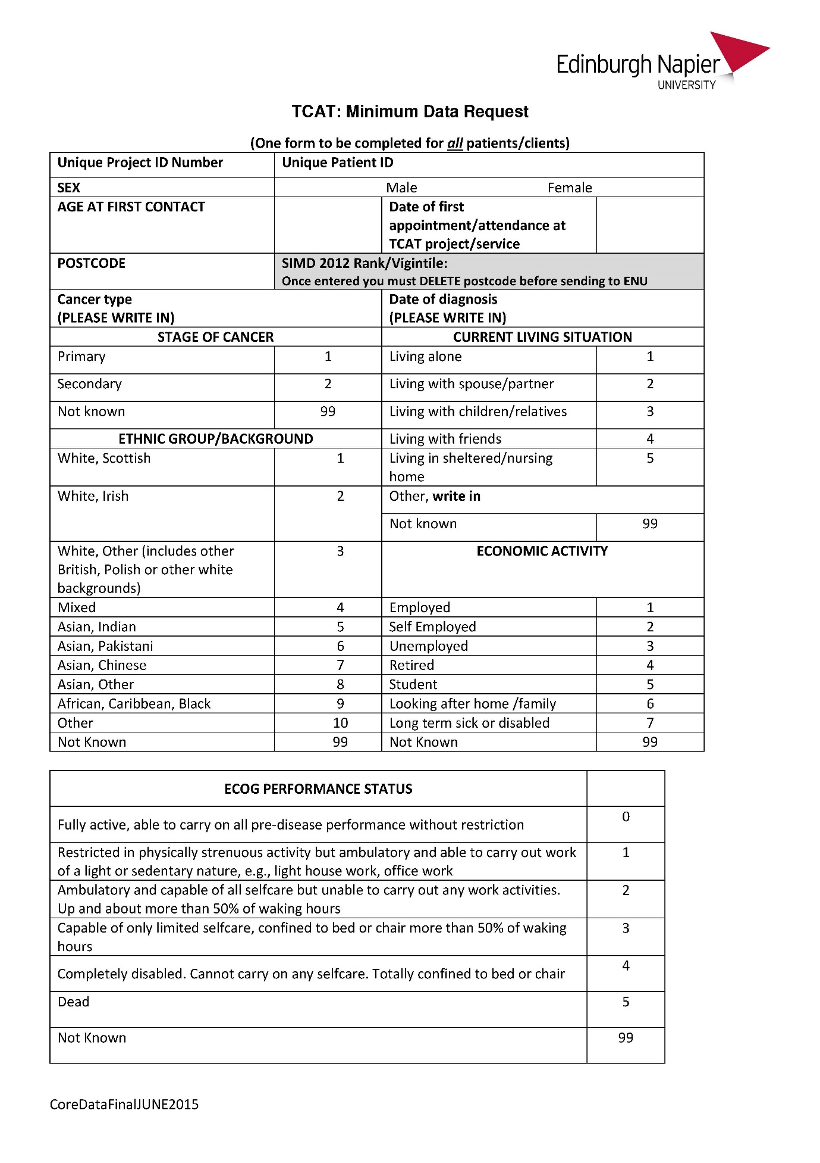
APPENDIX ONE: b) Data sheets - HNA Processes and Actions
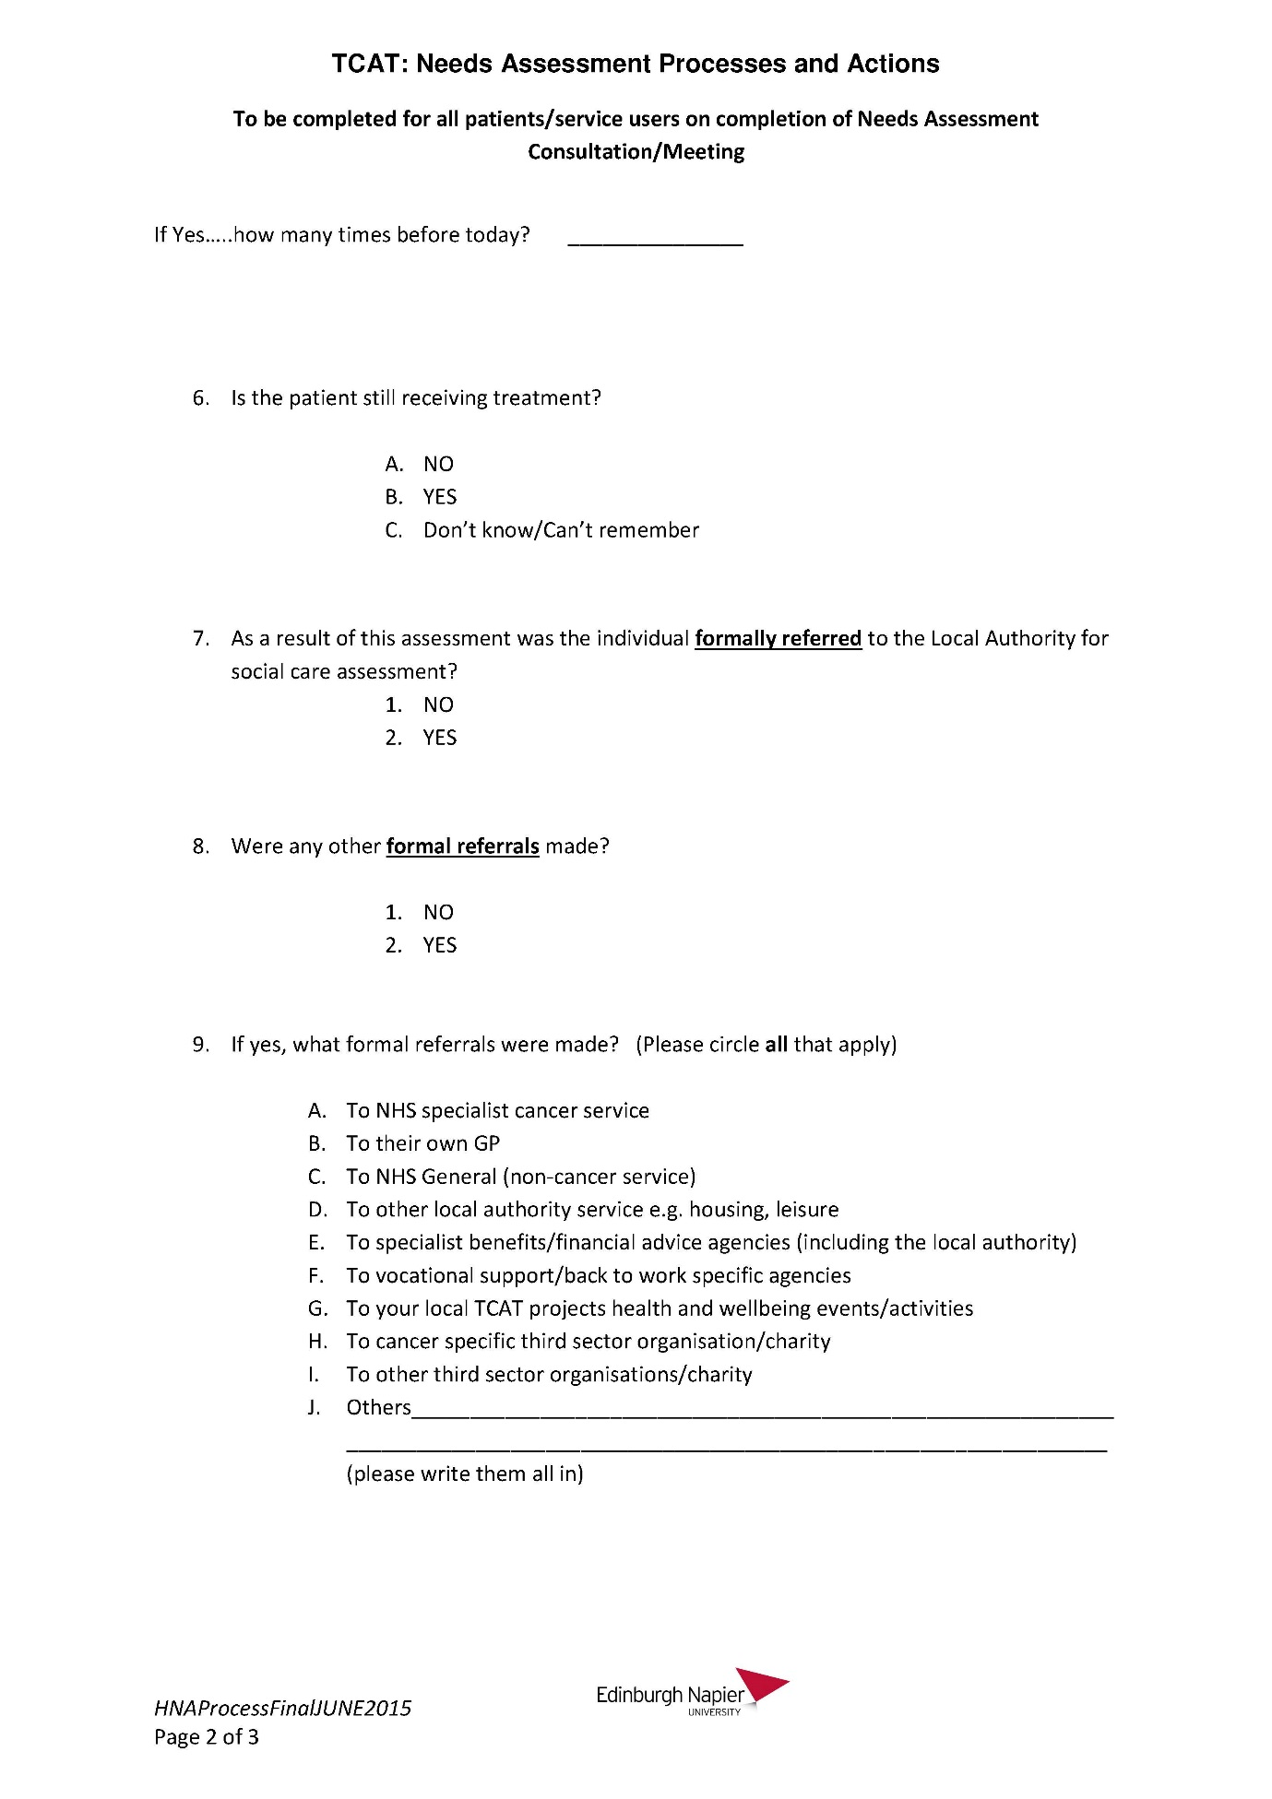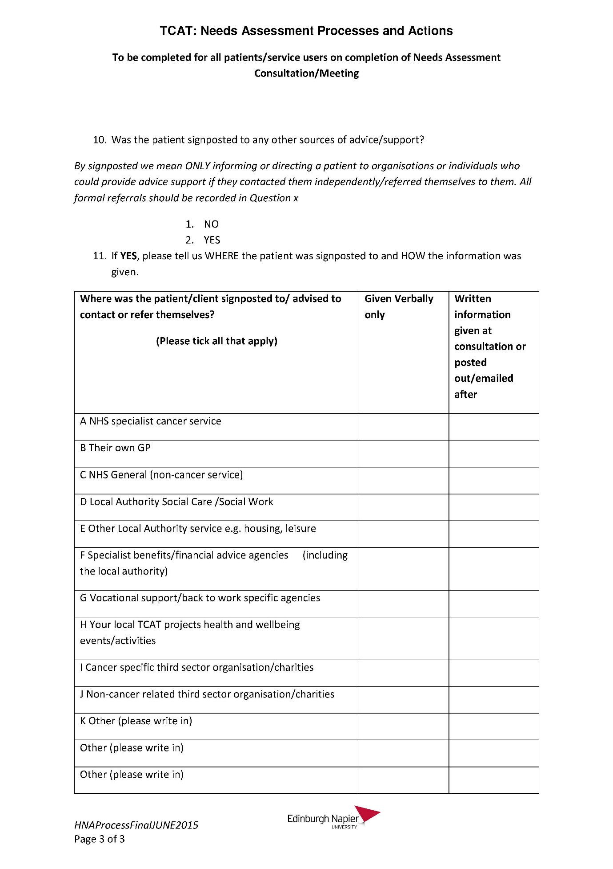
APPENDIX ONE: c) Data sheets - Concerns Checklist
APPENDIX ONE: d) Data sheets - Patient Feedback
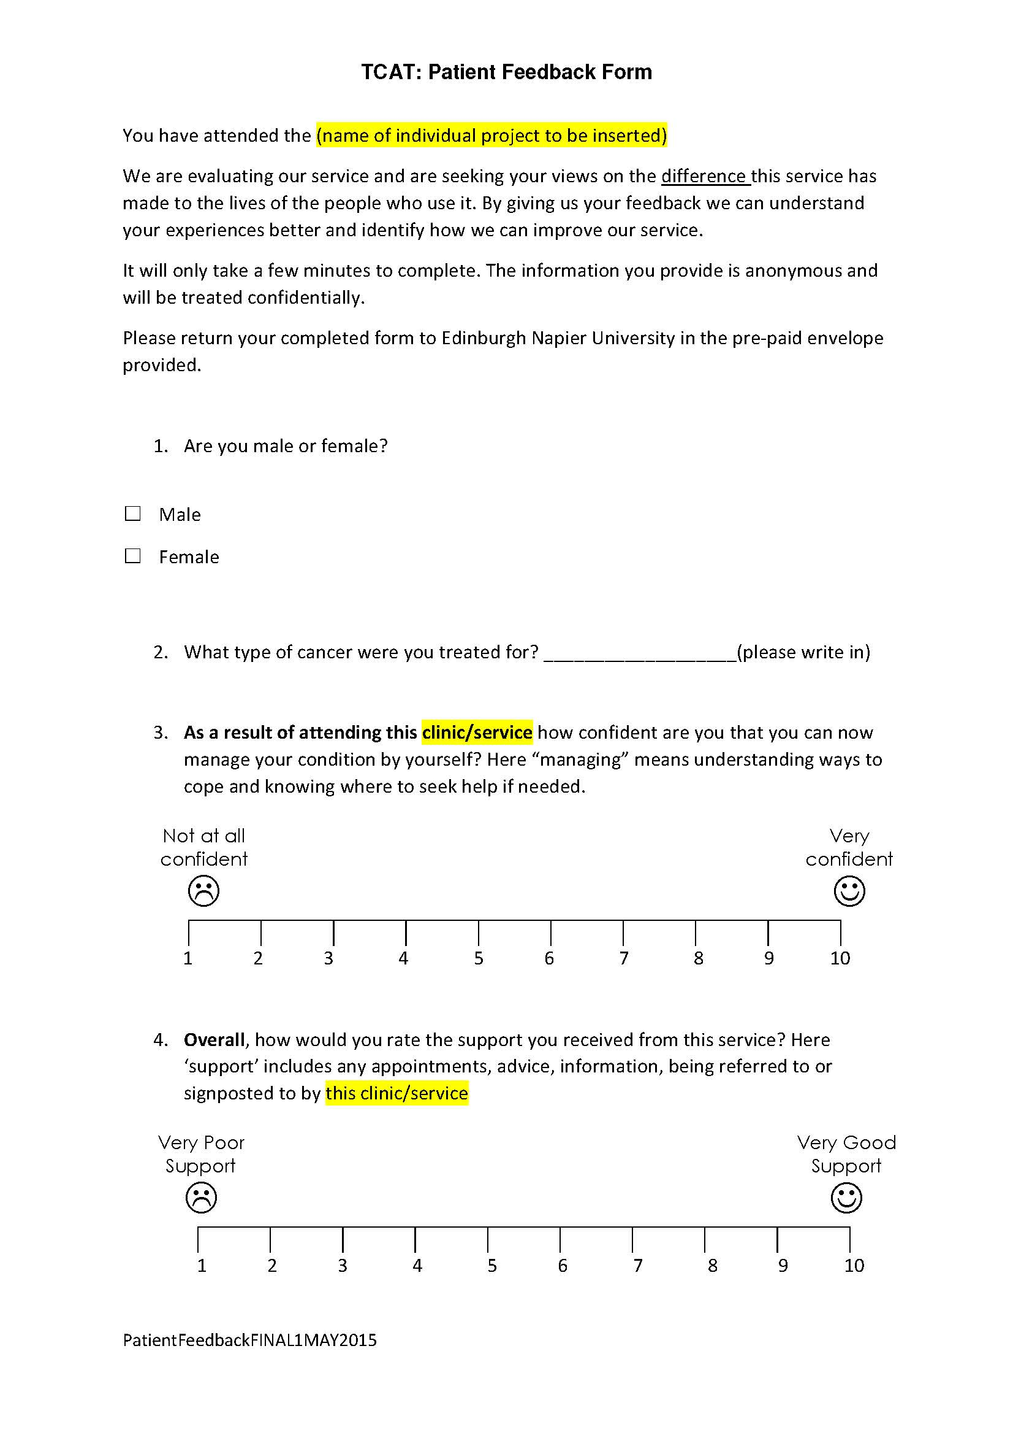
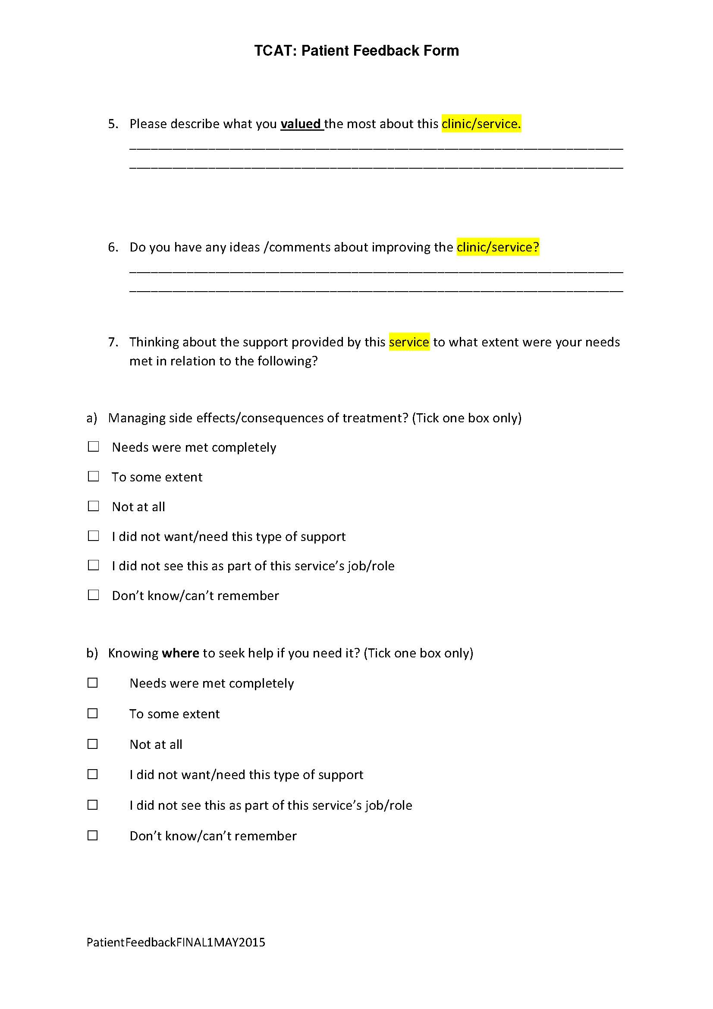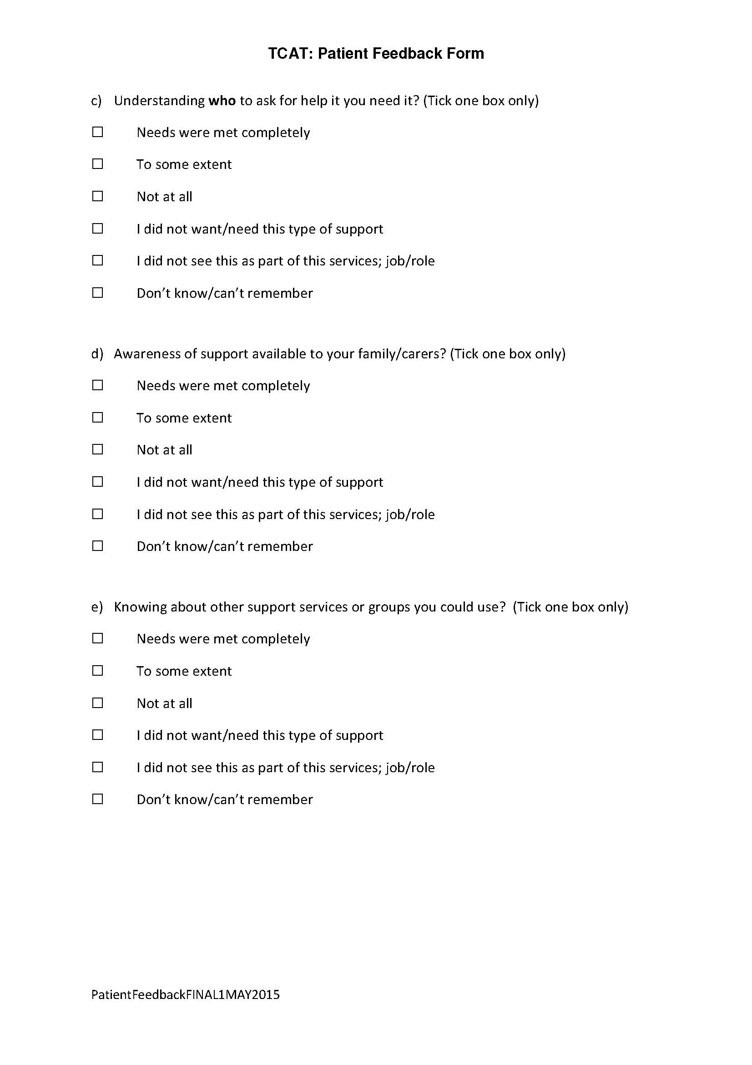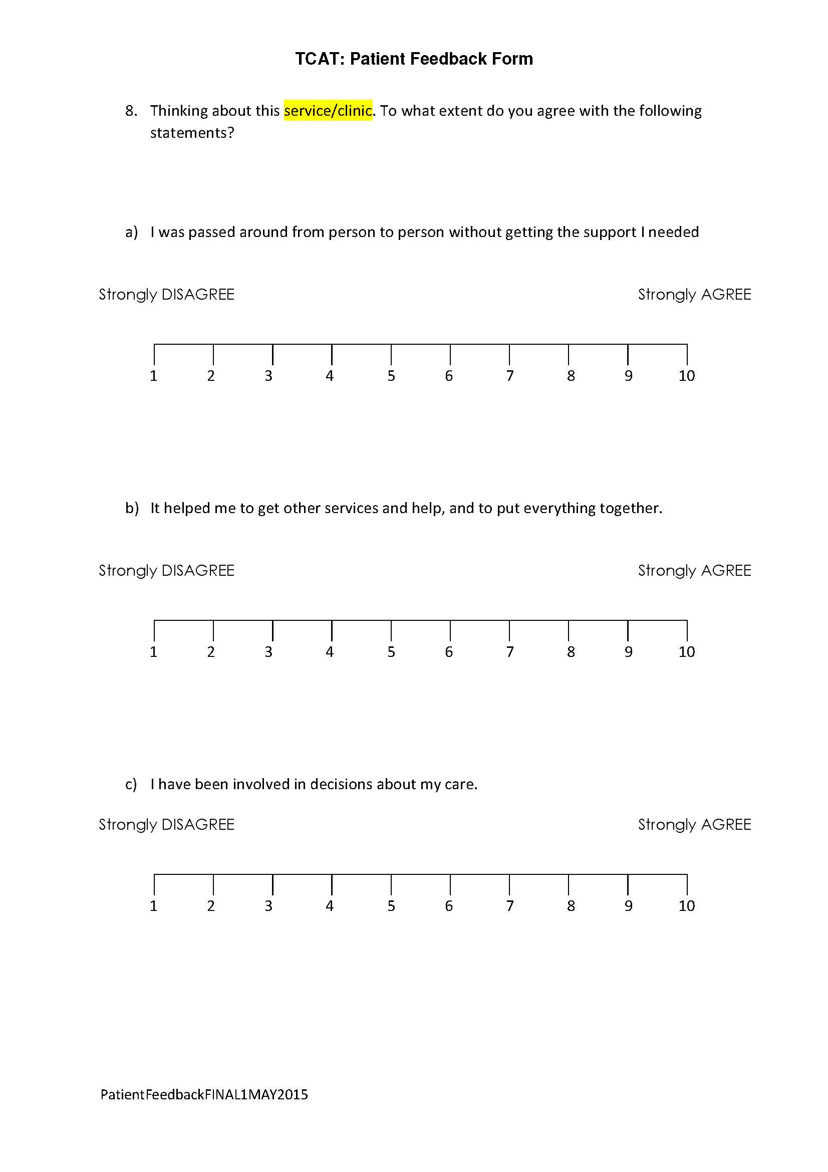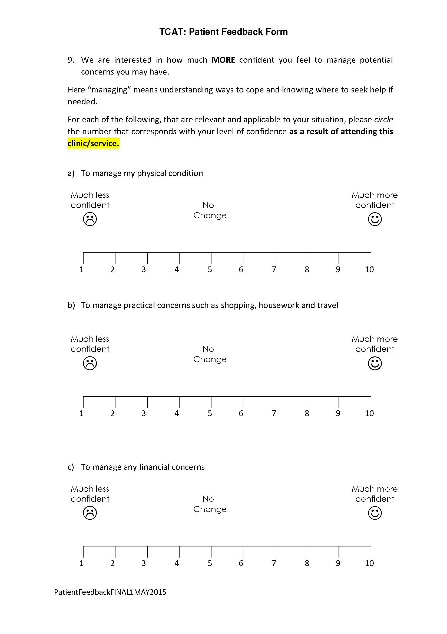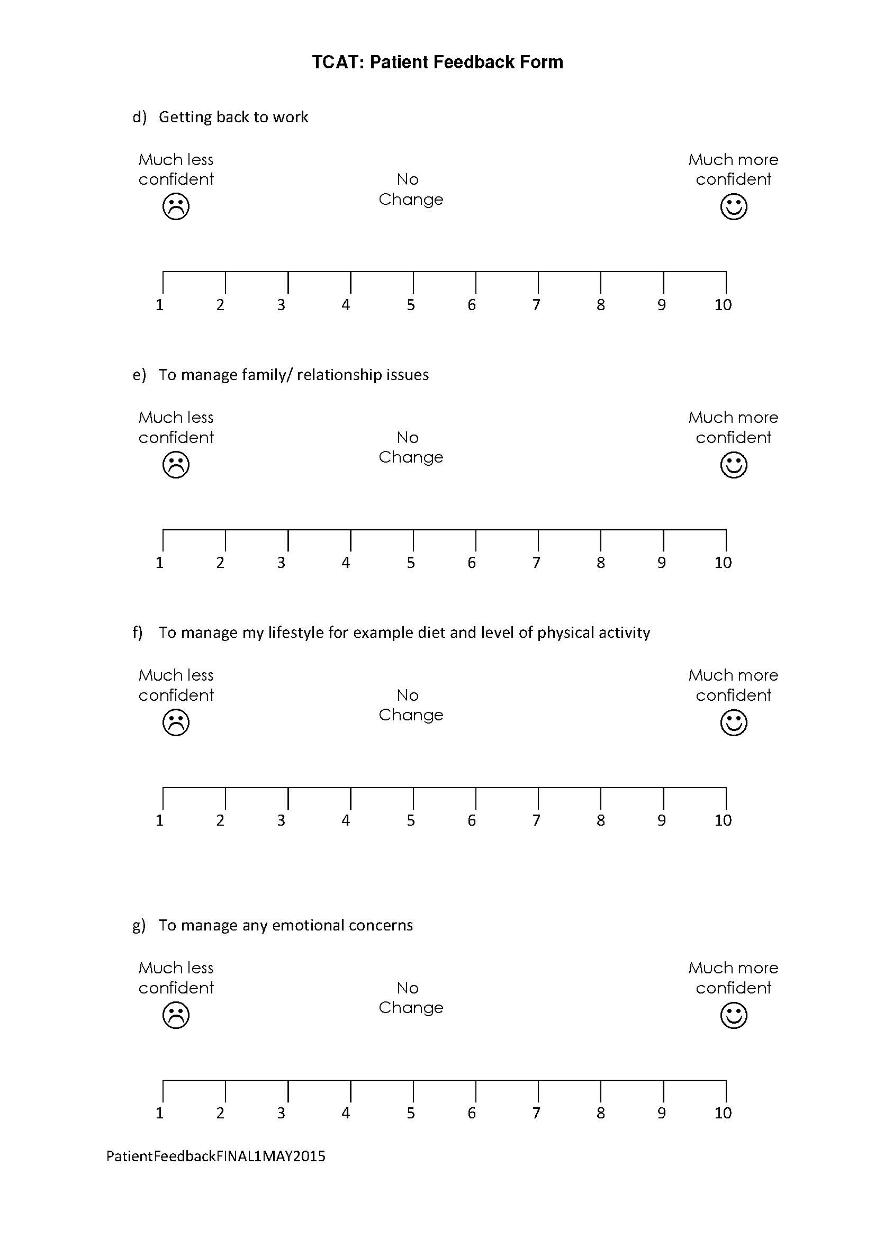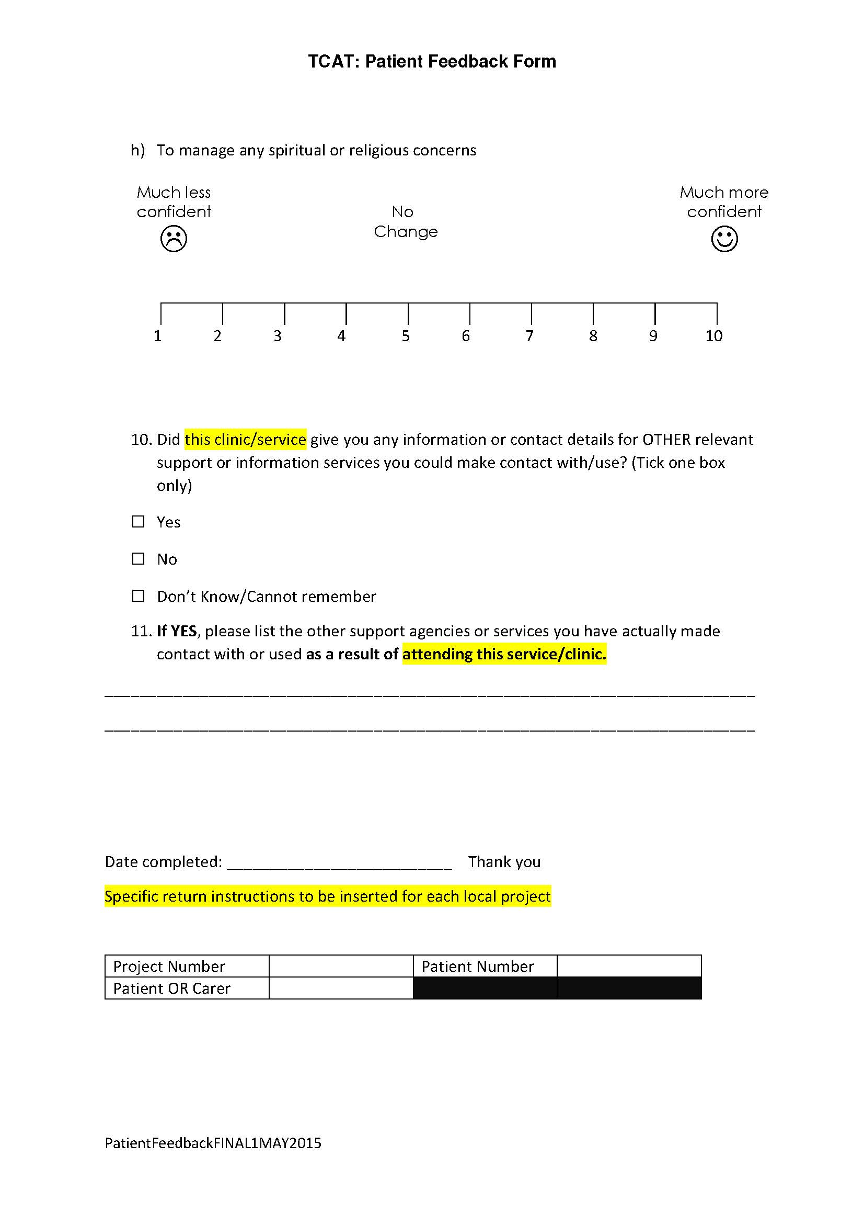

APPENDIX TWO: TCAT Stakeholder Questionnaire

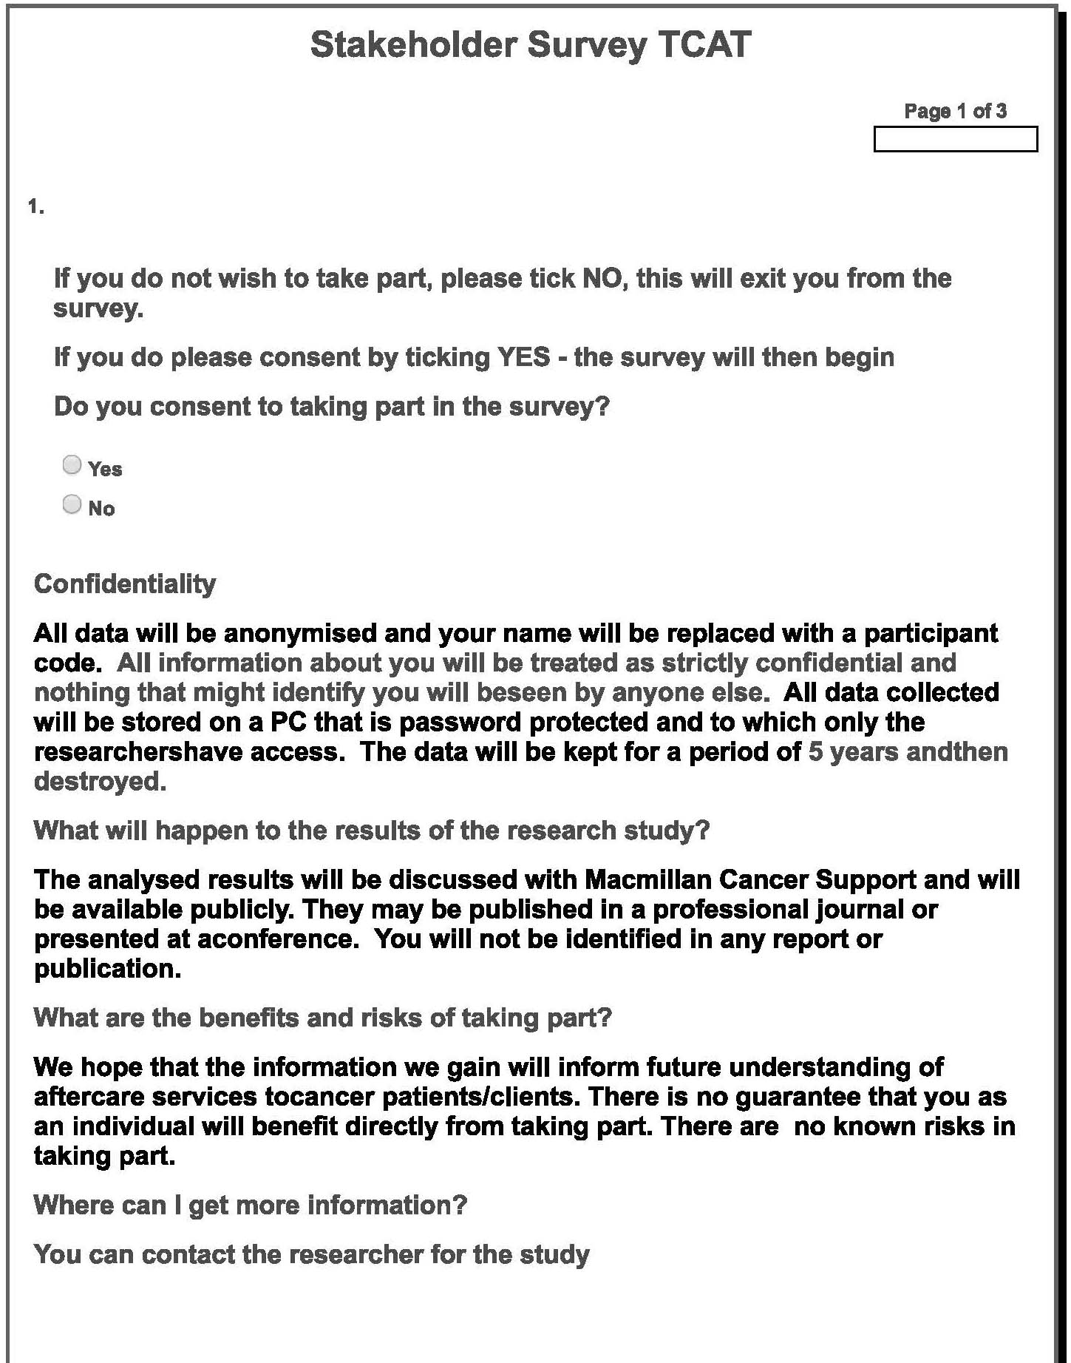
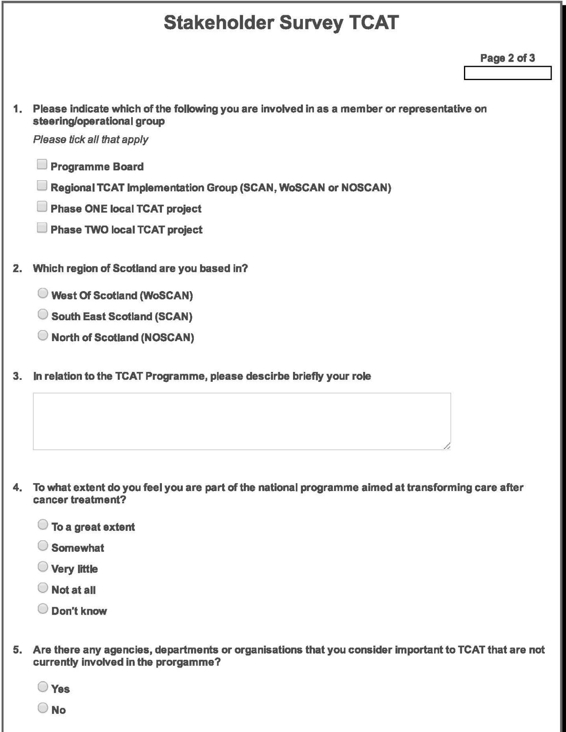
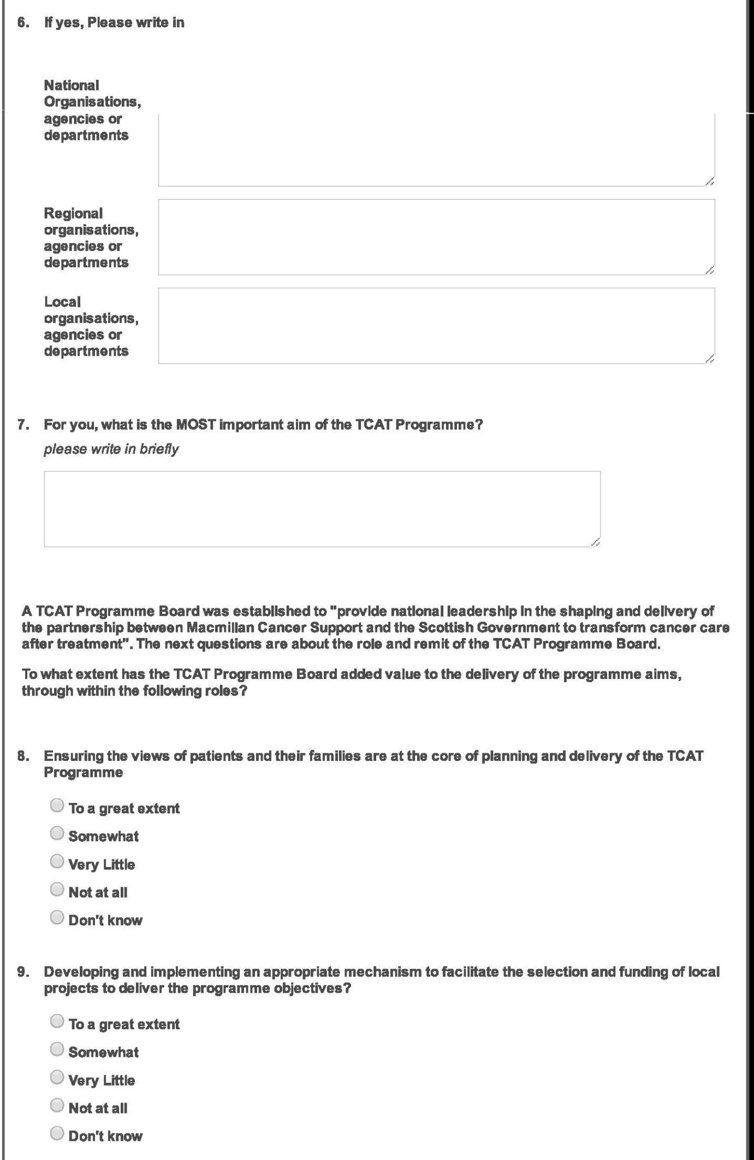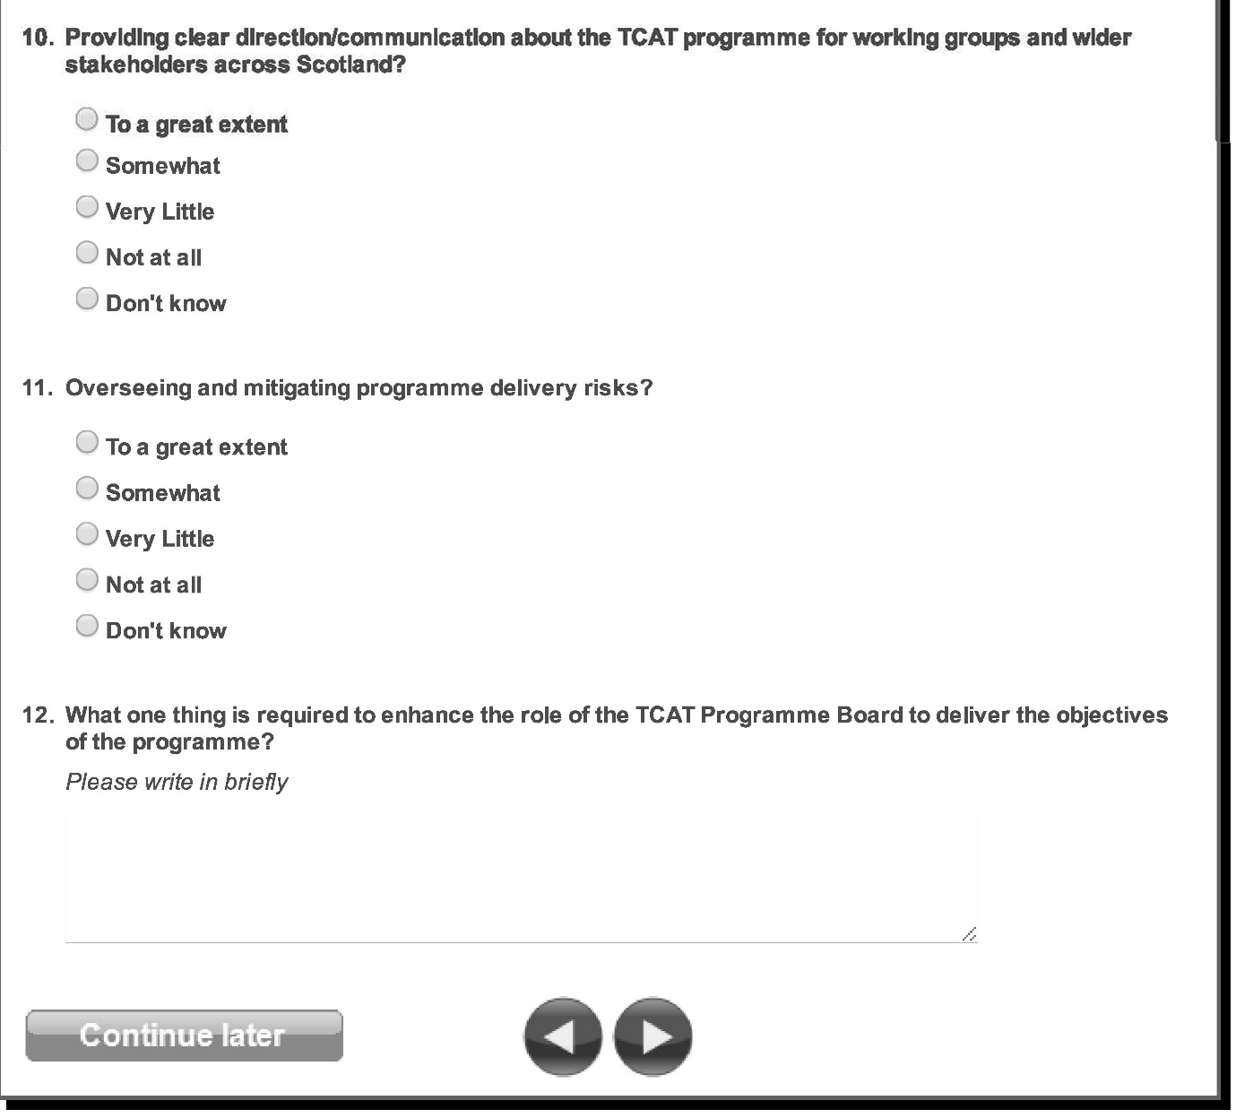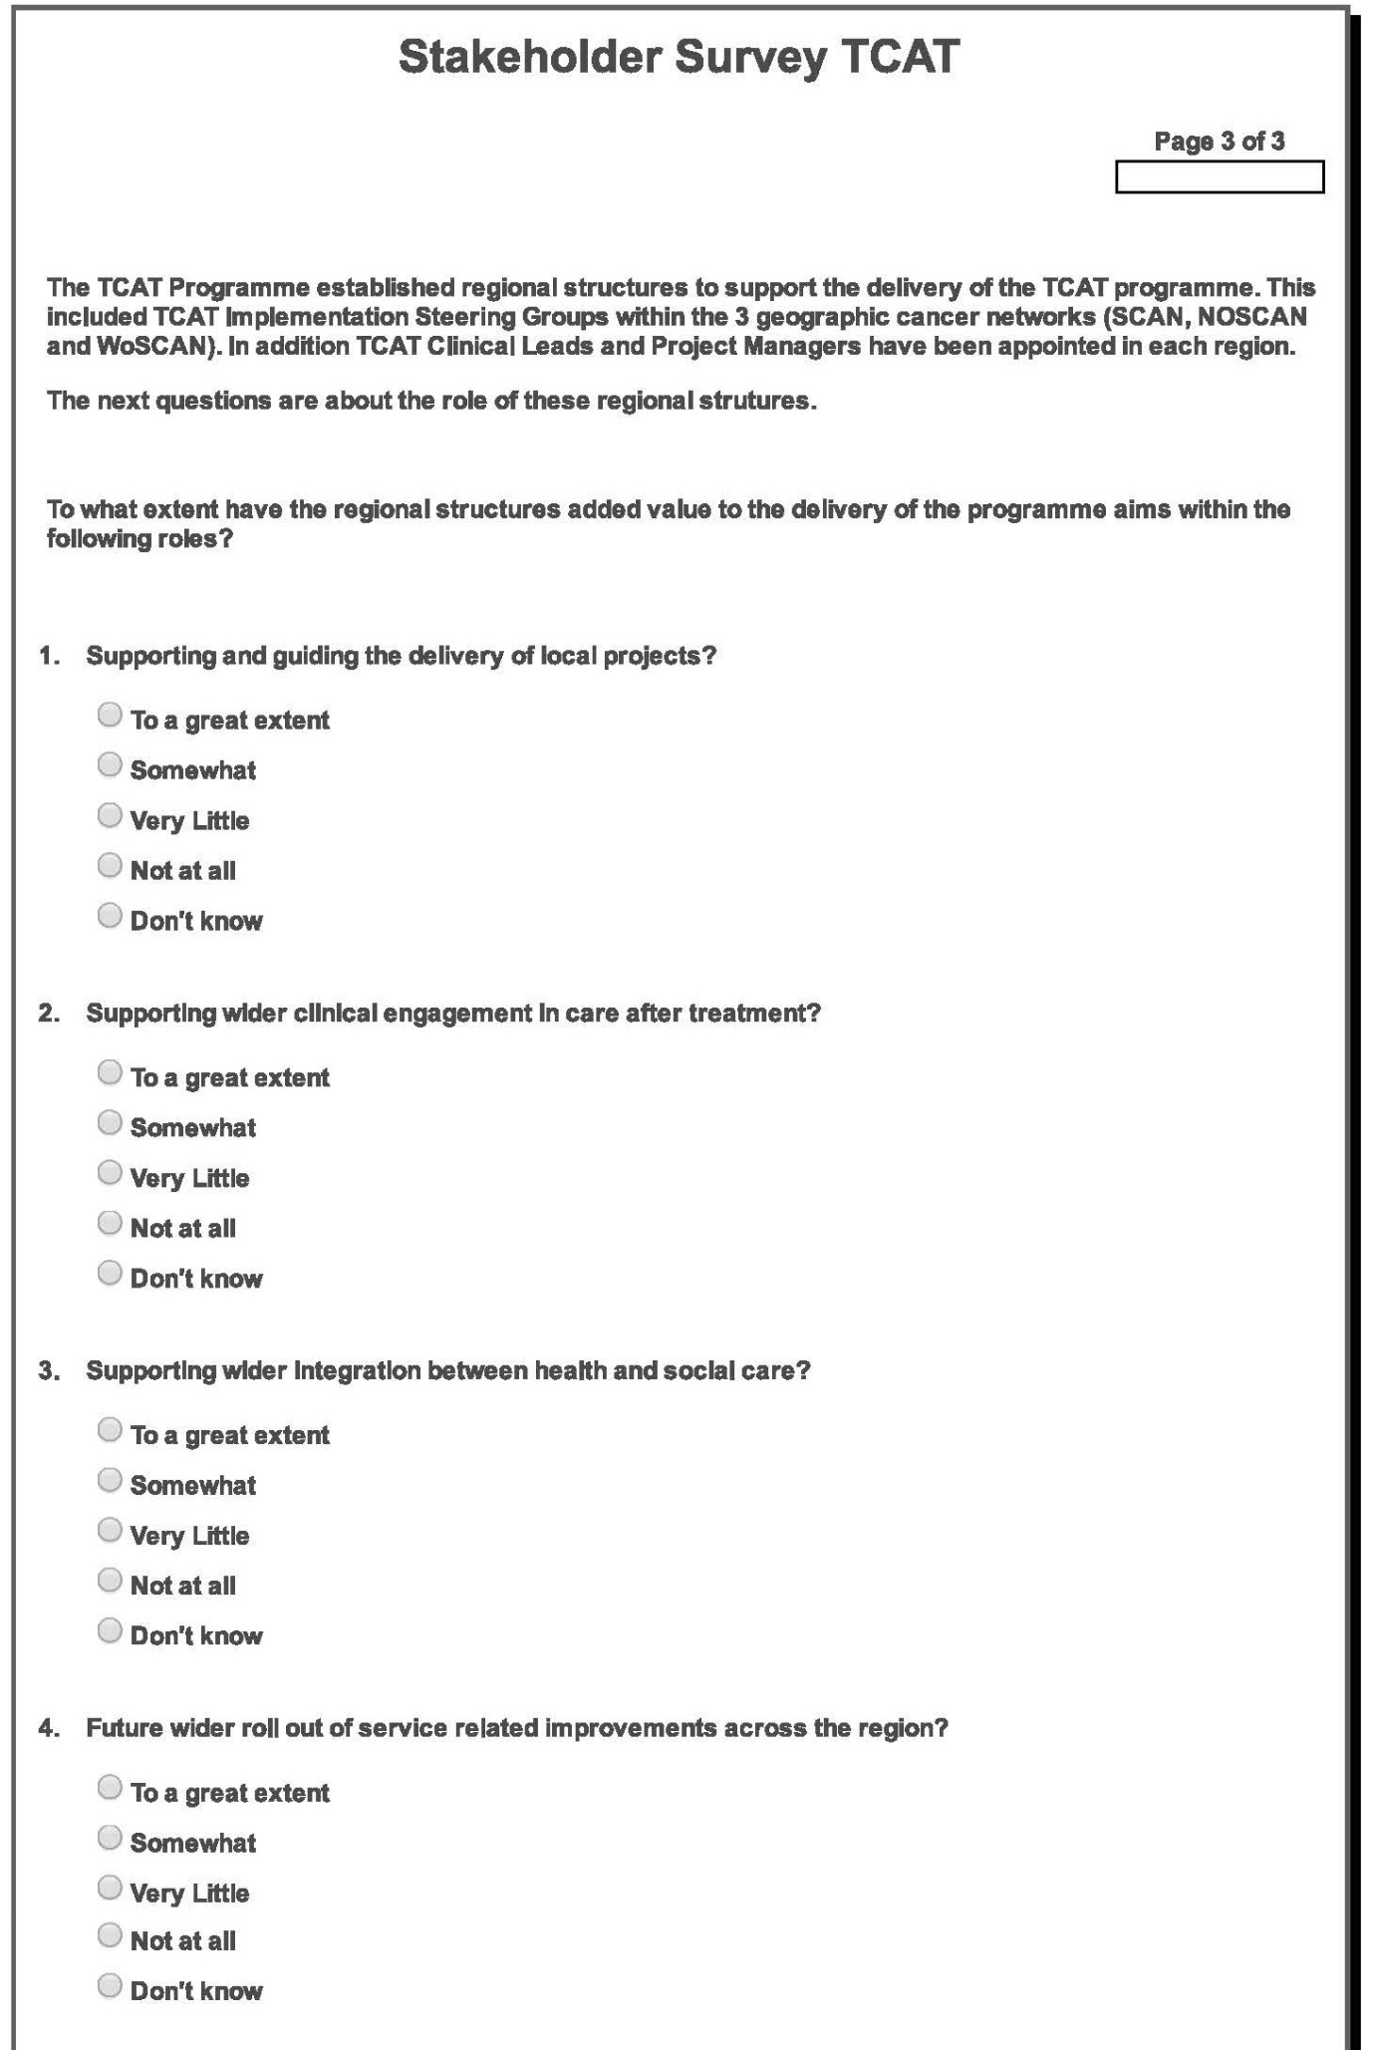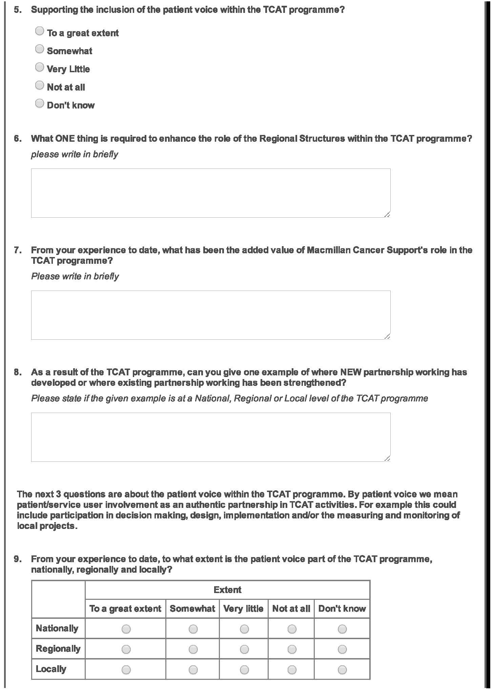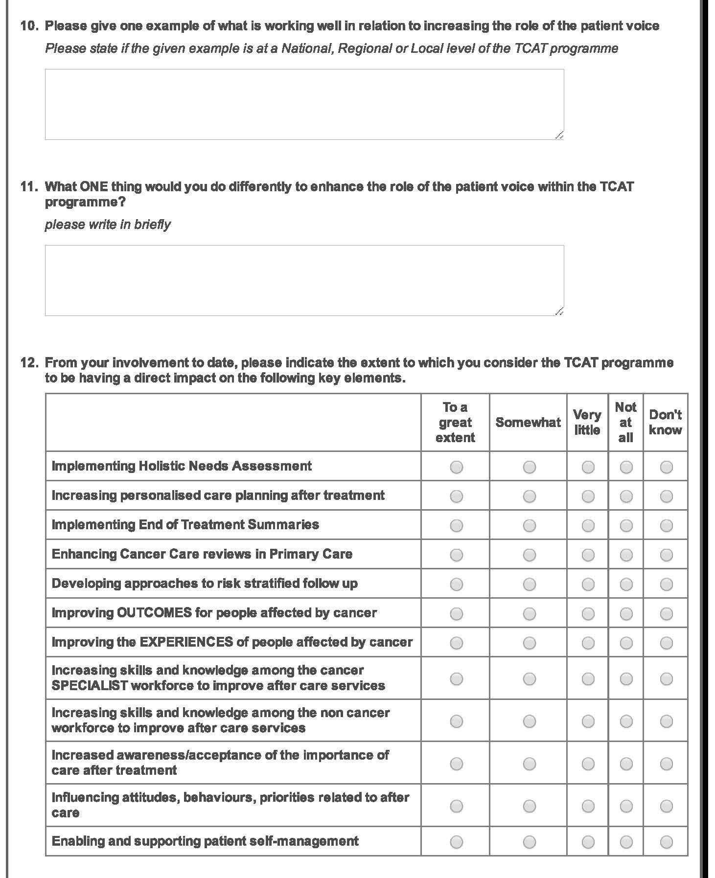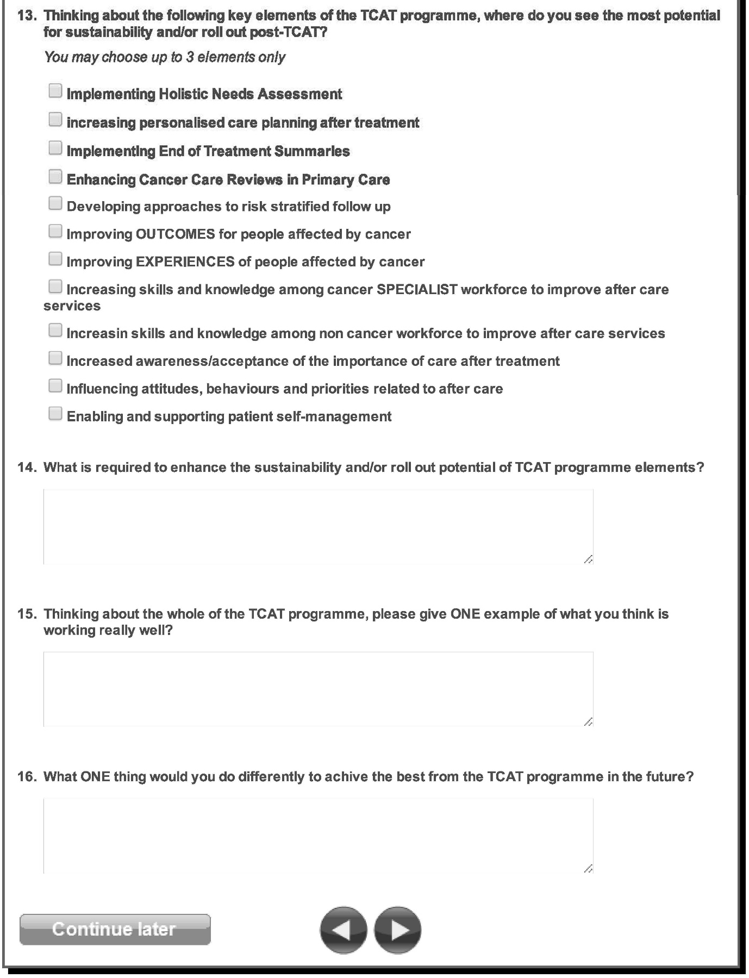

Cooperrider, D., Whitney, D., Stavros, J. (2008) Appreciative Inquiry Handbook: for leaders of change. 2nd ed. Berrett-Koehler. Brunswick Ohio
Pawson, R., Tilley, N. (1997) Realistic Evaluation. London. Sage Publications Ltd
Designing and evaluating complex interventions to improve health care. (2007) British Medical Journal; 334-455 doi: http://dx.doi.org/10.1136/bmj.39108.379965.BE

