Feasibility of Cross-Laminated Timber Production from UK Sitka spruce

David Crawford, Dr. Robert Hairstans & Ryan E. Smith
Centre for Offsite Construction +
Innovative Structures
Edinburgh Napier University
Edinburgh, Scotland. (cocis@napier.ac.uk)

Summary
Cross-Laminated Timber (CLT) is an innovative wood product, which can be used for almost all superstructure elements. It is generally produced from kiln dried, fast growing timber. Currently the majority of CLT used within the UK construction industry is manufactured in central mainland Europe and imported to the UK. The goal of this study is to establish the conditions required for implementing a CLT production and construction capability using available UK timber stock, thus offering a low carbon alternative to multi-story steel and concrete commercial constructions.

Introduction
The search for low carbon building products has led to an increase in timber usage in the UK construction industry however the majority of timber used for building in the UK is imported [1]. Locally grown and sourced timber is more economically and environmentally sustainable long term[2]. This project addresses the potential for wood building products that make greater use of UK grown timber resources. One such product is Cross-Laminated Timber (CLT) panels that can be used to form complete floors, walls and roofs. CLT is generally produced from industrially dried, quick growing softwood boards, stacked at right angles and glued together over their entire surface in generally 3, 5 or 7 layers. In an ever-changing regulatory environment, this prefabricated product is ideally suited to the creation of low-impact buildings. Currently, however, there is no UK manufacturer and as with most timber products, all CLT panels used within the UK are imported from central Europe or Scandinavia.

Given the above this European Regional Development Funded (ERDF) project, supported by Scottish Government, Scottish Enterprise and Forestry Commission Scotland, is to facilitate the commercial manufacture of CLT products in Scotland and add value to the Scottish timber resource. In order to determine the feasibility of manufacturing CLT from UK timber it was deemed necessary to research and develop a CLT production process and evaluate its associated mechanical properties in comparison to imported CLT.

Market Demand
First conceived in Switzerland in 1975, CLT manufacturing processes have been under continuous development ever since. Originating in central Europe, there are now a large number of CLT production sites within Austria, Germany, Czech Republic and Switzerland. Figure 2.1 provides an overview of the various manufacturers and a percentage breakdown for CLT production by volume (m³) in 2011. Of the manufacturers listed, BinderHolz, KLH, Mayr-Melnhof Kaufmann, Metsa Wood and Stora Enso are the larger volume producers who mainly supply the UK. Further, three of these five main manufacturers work, own or have alliances with UK formatting operations which act as a route to market for manufacturers.

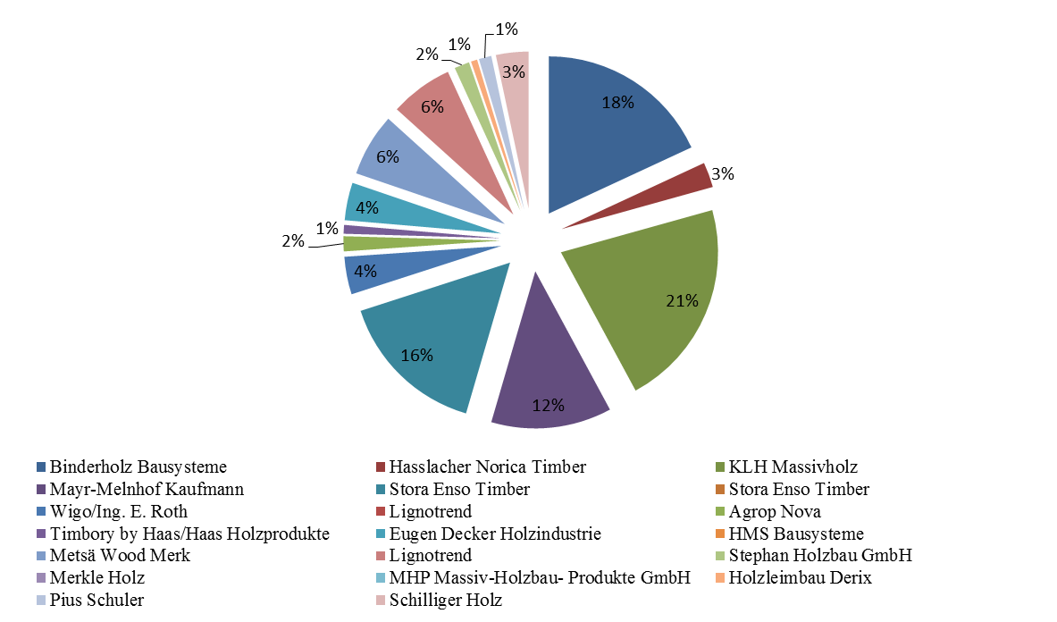
Figure 2.1 European CLT Manufacturers (2011)

Although CLT was first introduced to the UK in 2001, it wasn’t until the founding of Eurban in 2003 and KLH (UK) in 2005 that the product was an accessible form of construction and therefore capable of competing with concrete and steel. An assessment of the completed CLT projects in the UK from 2003 to 2011 illustrates that the demand for CLT has increased each year; over 50% more projects were completed in 2011 in comparison to the year prior[3]. Figure 2.2 shows the various construction sectors and the related number of completed projects between 2003 and 2011 in the UK. Education has been the most dominant building sector to date due to the introduction of the Government investment schemes such as the ‘Building Schools for the Future’[4] and the ‘Priority School Building programme’[5]. Given that CLT is still relatively new to the UK construction industry, its growth and recognition will only help to promote the use and specification of CLT in current and developing sectors.

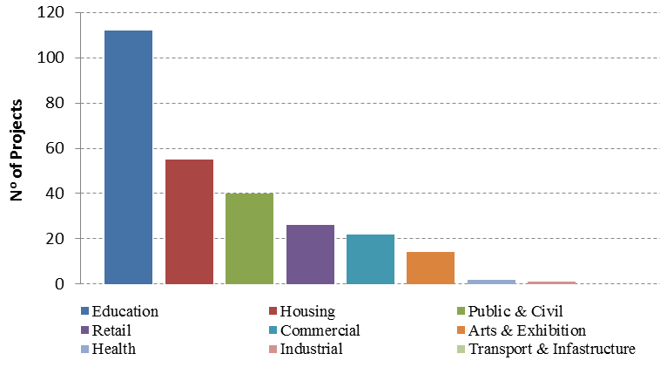
Figure 2.2 CLT UK Market data by sector (2003-2011) [3]
The commercial construction industry perceives CLT to be a more expensive product in comparison to traditional steel and concrete construction methods in the UK. However, when considering the various benefits of CLT (i.e. reduced foundation costs, reduced construction time etc.) and the overall life cycle analysis of a typical building, CLT has the ability to be a cost competitive low carbon alternative to traditional building materials[2]. However, for CLT to be truly sustainable, environmentally, socially and economically, it should utilise local resource and serve the local market to reduce transportation requirements, create security of supply and provide employment.

Currently CLT production facilities supplying the UK market are required to travel in excess of 700 miles (supplier and destination dependent). Various locations in Scotland could be considered for CLT production and the distance to London (≈400 miles), the nexus of building in the UK, is significantly less than that from Europe. In addition, transportation costs from central Europe and Scandinavia are variable depending upon the supplier and the final destination: between 30% and 50% greater than would be expected from within the UK. Another driver for CLT production in the UK is unpredictability in the fluctuating exchange rate that accompanies imported product. This results in large variations in total project cost that would be eliminated if UK manufacture were established.

UK Timber Resource
In order to determine the viability of UK timber and manufacture of CLT, suitability of resource needs to be assessed. Sitka spruce accounts for approximately 50% of the UK softwood resource and over 60% within Scotland. It is therefore anticipated that Sitka spruce would be the primary species considered for CLT production in the UK [6]. The Sitka spruce material selected for this study was typical of what is produced by the main sawmills in Scotland and thus the results give a fair representation of the available resource.

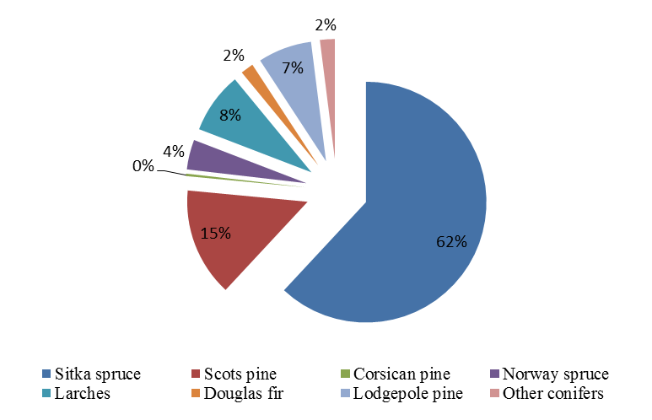
Figure 3.1 UK Timber resource (2011)[6]

Recent figures from the Forestry Commission suggest that the standing volume of timber felled in 2011 was in the region of 7.7Mm³ over bark standing (obs) which produced approximately 1.67Mm³ of sawnwood. A breakdown of this material is as follows:
- 27% Fencing
- 35% Pallet and packaging
- 33% Construction
  - Stress graded to C16 (95%)
  - Kiln dried to circa 20% moisture content.
Recent Forestry Commission forecast suggests opportunity for a significant rise in the volume of sawnwood production for at least the next 25 years evidence of this is shown in Figure 3.2.

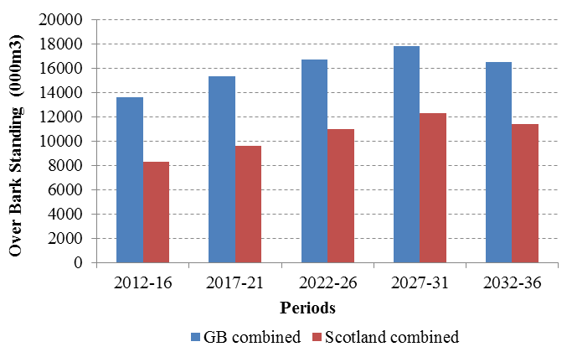
Figure 3.2 Forecast of standing timber availability from Scottish forests in comparison to GB[6]

The majority of sawmills in the UK only dry construction timber to circa 20% moisture content and currently there is little demand for timber dried beyond this level. CLT production requires 12±2% moisture content in large volumes and factors such as drying time, cost and material waste are critical as they will impact upon the overall product price. There are various methods that can be considered for drying timber and previous studies using small-scale humidifier type kilns have proved effective for UK Sitka spruce. However this is likely to be unsuitable for large volume production (i.e. < 10,000m³) and therefore the commercial viability of drying UK Sitka spruce to 12±2% moisture content is an area that requires additional research.

UK CLT - vIABILITY
The current barrier to the use of UK-grown CLT is availability of UK based manufacturing facilities and test data for specification. The viability process described here is intended to determine test data for future specification.
Manufacturers in Europe are currently aiming towards the standardisation of CLT panels by standardising lamella thickness at 20mm, 30mm and 40mm and it is anticipated that these dimensions will be adopted for UK CLT production. However, for this study the panel lay-ups manufactured required to be consistent with timber dimensions that are available from UK sawmills whilst taking into consideration the various specifications of European CLT manufacturers in order to allow relative comparison to take place.

Panels were fabricated from Scottish grown Sitka spruce and transported to an accredited test facility to undergo a series of structural assessments to determine local and global modulus of elasticity (stiffness in bending) and modulus of rupture (strength in bending) in accordance with BS EN 408. Information from this process has been used to assess the feasibility of application of these components in wall, floor and roof applications.

Manufacturing process
The manufacturing stage of the project took place at the premises of Nor-Build in Forres, Morayshire. The workshops at Nor-Build are well equipped, having two large woodworking machine shops, metal working equipment and a large floor area for setting up efficient production lines. Critical to this type of project was the existence of a cross cutting line capable of handling timber in lengths of over five metres. A five head planer moulder was also available, and ample covered storage space. Unfortunately it was not possible to control the climate within the production hall and this had implications for the quality assurance of the adhesive between lamination layers. A flow chart detailing the relevant work stages (Figure 4.1) was developed prior to any work being carried out in order to streamline the fabrication process.

Figure 4.1 Process flow chart – CLT fabrication

A precise specification was established for the CLT lamellae - all of the timber was required to have a moisture content of approximately 12±3%. This moisture content level was specified in order to be as close as possible to the anticipated equilibrium moisture content of the panels in service and is also compatible with the polyurethane (PU) adhesives used in the fabrication of the test panels. The lamella dimensions were based upon standard milling profiles produced by BSW Timber Ltd. Three Sitka spruce profiles were considered: a smaller 20 × 95mm cross section cut from the side of the logs, and a larger 40 x 95mm cross section cut from the core of the log and a larger 40 × 140mm profile.

As sawmills in Scotland are generally set up to produce timber with a moisture content of circa 20%, the desired specification of 12±3% moisture content required an alternative kiln cycle to be implemented in order to reduce the percentage of reject material. However this was a one off and conducted on a relatively small scale and at this stage requires further optimisation to make it commercially viable for larger volumes of timber.
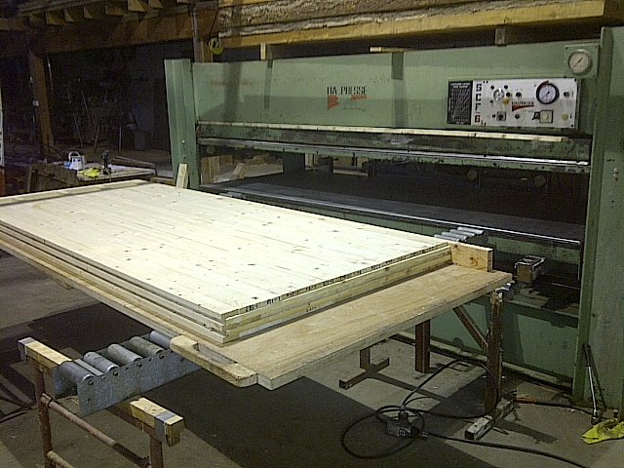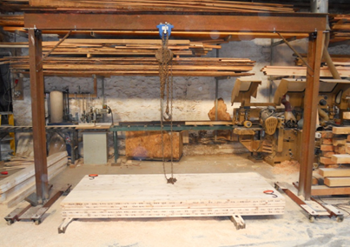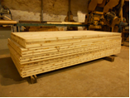
Figure 4.2 Method for moving panels in and out of the press

The Italepresse SCF/8 (Figure 4.2) provided by Edinburgh Napier University was originally manufactured for veneer lamination with maximum platen dimensions of 400mm × 1250mm × 3200mm and a maximum vertical pressure of 160 metric tonnes. Although not designed for CLT production some minor modifications to the press allowed the fabrication of both face and edge bonded panels. A number of screw-type clamps that could be bolted on to the machine were designed to provide horizontal clamping force for edge bonding.

TEST PROGRAMME
A key objective of the test work was to determine the relative mechanical properties of UK resource CLT for a range of panel configurations (i.e. timber species, lamella thickness, lamella width and number of layers). Currently CLT is manufactured and tested under the Common Understanding Assessment Procedure (CUAP) and various European Technical Approval (ETA) documents. It is stated within the CUAP that mechanical properties of CLT will be determined in accordance with BS EN 408 [7] and take into consideration the principles of BS EN 789 [8].

To undertake test work sufficient to determine compliance with these requirements a range of different permutations were considered, with two final panel types selected for structural testing. The details of these panel dimensions are shown in Table 5.1 and Figure 5.1.

Table 5.1 Panel type, test permutations
Sample Ref | Lamella dimensions |  | Make Up | Panel Dimensions
 |  |  |  | Edgewise |  |  | Flatwise
 | Depth | Width | No | Depth | Width | Length | Depth | Width | Length
 | mm | mm |  | mm | mm | mm | mm | mm | mm
HG-SS1 | 40 | 95 | 3 | 140 | 120 | 2550 | 120 | 380 | 2550
HG-SS2 | 20 | 95 | 5 | 140 | 100 | 2680 | 100 | 380 | 2680
HG-SS3 | 40 | 140 | 3 | 170 | 120 | 3200 | 120 | 420 | 3200

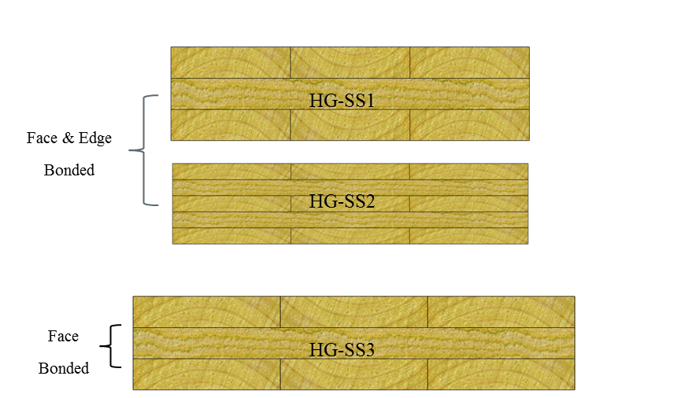

Figure 5.1 CLT panel types and dimensions

The samples shown in Figure 5.1 are representative of the final tests pieces. UK grown Sitka spruce 1 (HS-SS1) samples were fabricated using 40 x 95mm Sitka spruce graded to C16 specification prior to leaving BSW Timber Ltd sawmill. Home-grown Sitka spruce 2 (HG-SS2) samples were fabricated using 20 × 95mm sawn falling boards that were non graded material. Each of the HG-SS1 and HG-SS2 samples were face and edge bonded during the fabrication process. UK grown Sitka spruce 3 (HG-SS3) panels were formed using material supplied by John Gordon & Son’s sawmill, which was graded as standard C16 material. The HG-SS3 samples were face glued only.

The range of panels investigated varied in height due to lamella thickness and number, and correspondingly also varied in length and width. It should also be noted that due to the dimensional constraints of the CLT press the maximum size of panel to be tested was limited. In order to determine the structural performance of these panel configurations, testing was carried out in accordance with BS EN 408 [7] for strength and stiffness properties for both orientations of a beam (edgewise) and a floor/roof (flatwise) as shown in Figure 5.2.
- Flatwise (floor)
a) Edgewise (beam)
Figure 5.2 BS EN 408 – strength and stiffness in two orientations

Acoustic Analysis
Prior to fabrication, each of the boards was labelled, weighed and acoustically analysed using a Brookhuis MTG Acoustic Grader to determine dynamic MoE (Fig. 5.3). This technique forms a vital part of the process since it gives each board an identity to which characteristics can be attributed; in this case MoE was the characteristic of most importance.

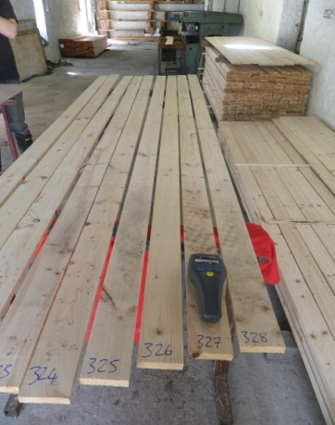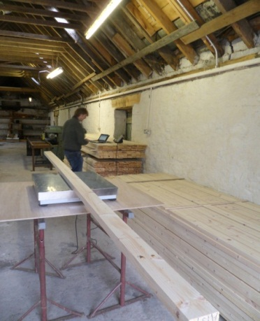
Figure 5.3 CLT - Lamellae analysis

This information is particularly valuable when assessing the performance of the CLT panels, since individual lamellae can be located within the panel. The mean dynamic MoE values for the lamellas within each panel type are summarised in Figure 5.4, the results of which were used to calculate the effective bending stiffness for each of the relative panel types. Further research would allow the contribution of each of the individual lamellas to the overall panel performance to be better understood.
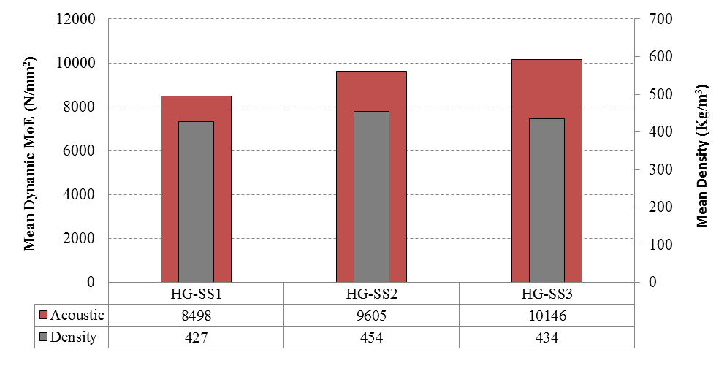
Figure 5.4 Mean Dynamic MoE and Density for varying sample group

The dynamic MoE results shown have been corrected for density but have not been corrected for moisture content (timber was supplied at 12±3% moisture content) and for this reason no adjustment factors have been applied. The HG-SS1 sample group has a value of 8498N/mm². This is comparable to the mean MoE value for C16 grade material as defined in BE EN 338 (7). This is to be expected, given that the material supplied by BSW Timber Ltd was standard C16 grade. Approximately 400 boards from the HG-SS2 sample group were measured and a mean dynamic MoE of > 9600N/mm² was obtained. The HG-SS3 sample group returned a mean dynamic MoE value in excess of 10000N/mm². Given that this material was graded as standard C16 by John Gordon & Son’s sawmill, the results are higher than might otherwise have been expected. It was noted that the mean density of the Sitka spruce analysed during this study is > 410 kg/m³. Bending strength, MoE and density are considered the most crucial mechanical properties of wood for this study as they are used to directly assign structural timber to a strength class according to EN338.

A recent study carried out by J.Moore found that the UK Sitka spruce resource is grade limited not by strength or density but by stiffness [9]. Stiffness is a key factor when considering the design of timber structures and has a direct influence on other critical parameters such as vibration. Less stiff timber is anticipated to be a suitable for CLT, this is due to the re-distribution of stresses within the lamellas via cross lamination resulting in an enhancement in performance. Material properties such as strength and density are also important factors when considering CLT design as current calculation methods for connection performance are directly related to the material density.

DATA ANALYSIS METHODS
A number of different methods exist for the analysis and design of CLT elements. The main methods have been considered during this study and a relative comparison made in order to determine which method is most suitable when considering CLT formed using UK grown timber. The methods considered during this study include the Simplified Design Method, the Timoshenko Method, the Shear Analogy Method and the Mechanically Jointed Beams Theory (Gamma Method). Each of these methods considers an effective moment of inertia (I_{eff}) where only the boards in the direction perpendicular to the action of the loading are taken into account.

Bending Strength and Stiffness
Four tests were carried out for each sample group in the edgewise (e.g. beam) and flatwise (e.g. floor) orientations. Given the limited number of tests undertaken, it would be misrepresentative to present 5th percentile characteristic values, therefore mean values are presented for bending strength. In the case of stiffness a mean modulus of elasticity (MoE) is shown for each sample group in each orientation. Values for density, moisture content, bending strength, and modulus of elasticity (MoE) were calculated and are presented within the subsequent sections of this report.

Edgewise
When considering the HG-SS1 sample group (Figure 6.1), a mean edgewise bending strength of 43N/mm² was obtained. A mean edgewise bending strength of 42N/mm² was achieved for the HG-SS2 sample group. The HG-SS3 sample group returned a mean edgewise bending strength value of 36N/mm².

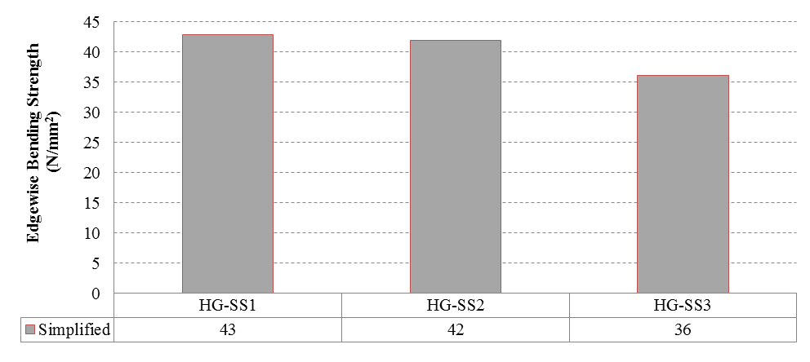
Figure 6.1 Edgewise Bending Strength

A mean edgewise MoE was determined for each sample group (Figure 6.2), for the HG-SS1 sample group a value of 9364N/mm² was achieved. When comparing this value to the mean dynamic MoE for the lamellas (8498N/mm²) an increase of approximately 10.2% is apparent. When considering the results from the 5-layer system (HG-SS2) a mean value of 10205N/mm² was obtained, an increase of approximately 6.2% over the mean dynamic MoE of the lamellas. The mean edgewise MoE achieved from the HG-SS3 sample group was 9385N/mm² and the mean dynamic MoE was 10146N/mm² a comparison of the two values indicated a decrease of approximately 7.5%.

Fully bonded CLT samples provided additional performance when considering edgewise strength and stiffness. Conversely, it was noted that samples which were only face bonded returned a mean MoE which was less than or relatively similar to the mean dynamic MoE of the material specified. The results of this study would suggest that fully bonded CLT panels (i.e. face and edge bonded) provide an increase in stiffness, compared with the raw material specified for use in the fabrication of CLT. However the study considered a relative small sample set and it is therefore recommended that a future programme of work be carried out in order to fully validate this statement.

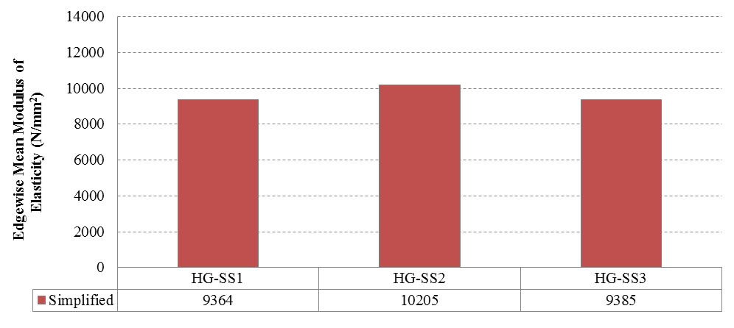
Figure 6.2 Edgewise Bending Stiffness

Flatwise
A direct comparison of the bending strength results using the three different analysis methods described in section 5.2 (Figure 5.2) shows that the results obtained using the Timoshenko and Shear Analogy method are directly comparable, however the Gamma method shows a marginal increase (≈4%) in comparison.

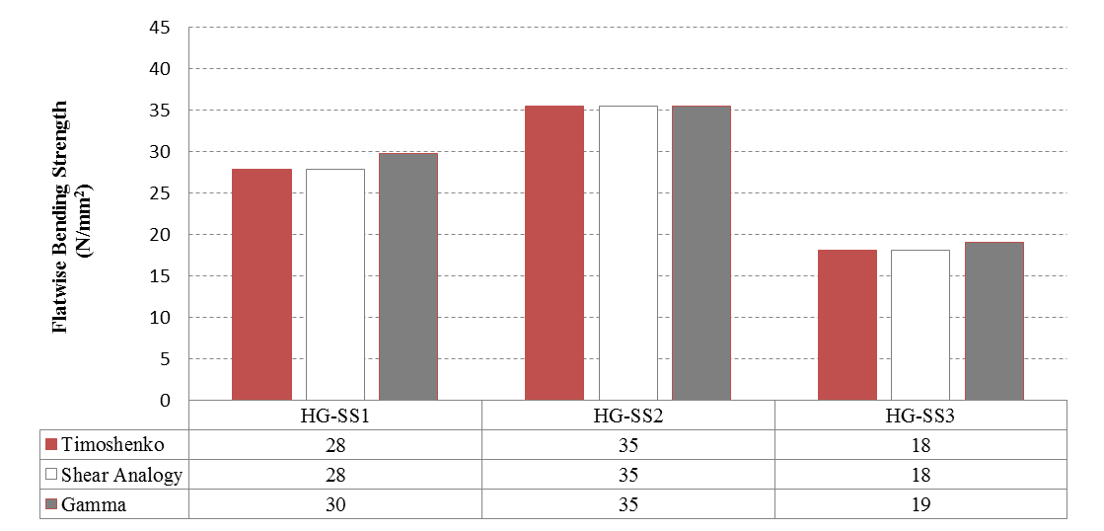
Figure 6.3 Flatwise Bending Strength

Compared in Figure 6.4 are the MoE results using the different analysis methods (Timoshenko, Shear Analogy and Gamma method). It is clear from the results obtained that there is a notable increase when MoE is calculated using the Gamma method. This is explained by the approach adopted during the calculations: the Gamma method does not take into consideration the influence of shear deformation and hence an over-estimated value is obtained.

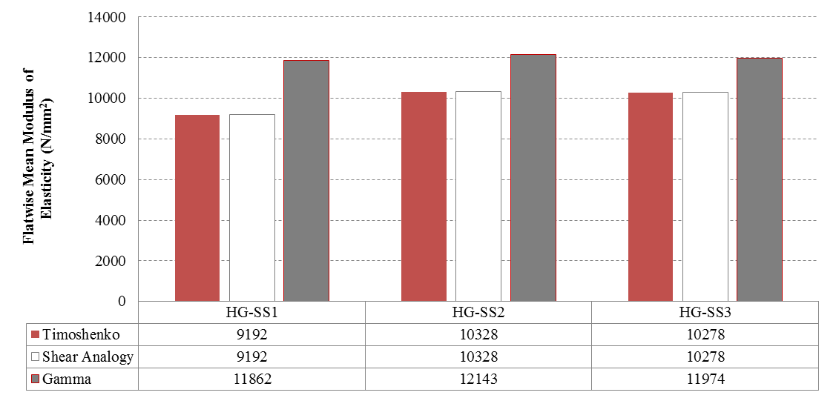
Figure 6.4 Flatwise Bending Stiffness

Another consideration is the influence of shear deformation when testing at varying span to depth conditions. It is suggested that the shear deformation of CLT panels loaded uniformly may be neglected for elements having a span to depth ratio higher than 20 [10]. However, other literature and CLT panel producers give as a boundary condition a minimum span to depth ratio of 30 before neglecting the shear deformation of the panel. A previous study carried out by Blass and Fellmoser [11], showed that shear deformation has a significant influence where the span to depth ratio is less than 30 evidence of which is provided in Figure 6.5.

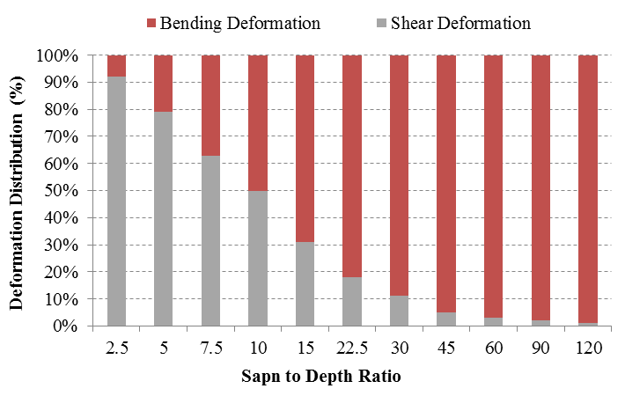
Figure 6.5 Influence of shear deformation at varying span to depth ratios (10)

Of the various tests carried out during this study, the span to depth ratio was approximately 19. Literature suggests that at this span to depth ratio the contribution of shear deformation would be in the region of 22%. If we compare the mean local MoE for the HG-SS1 sample group obtained using the Gamma method (11862N/mm²) with the mean local MoE obtained from the Timoshenko and the Shear Analogy method (9192N/mm²), a 25% decrease is apparent.

Effective Bending Stiffness
We know from previous studies that the UK Sitka spruce resource is typically limited by stiffness rather than strength or density[9]. The effective bending stiffness of CLT is a measure of the material stiffness in relation to the cross sectional make-up of the panel.

In order for a UK CLT product to be competitive in the market it will have to compete with imported CLT products. CLT products from Europe are fabricated largely from C24 graded material (90% C24 and 10% C16). In most cases this is simply because the material is widely available rather than as a specification of the designer. However, there are instances where a high degree of performance is required and thus a UK product must be competitive in this regard as well. Error! Reference source not found. shows EI_{effective} values for the HG-SS1, HG-SS2 and HG-SS3 samples which have been compared directly with imported products of similar dimensions.

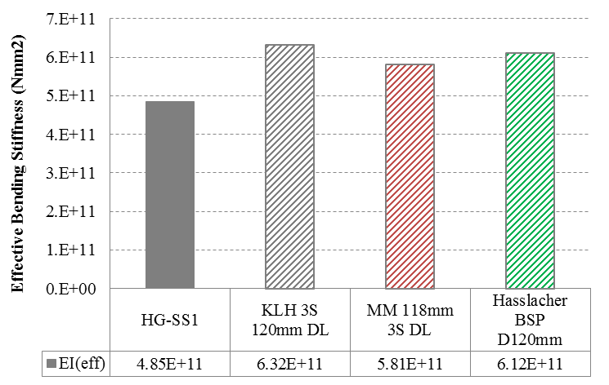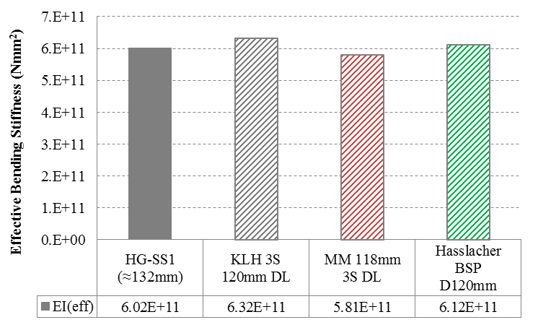
a) Home Grown SS1 b) Home Grown SS1 – Increased depth of section
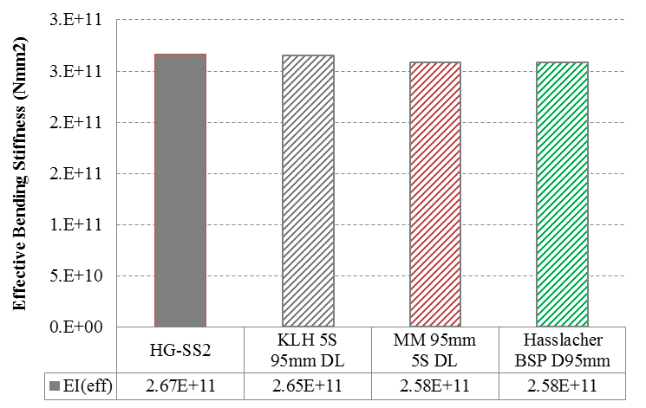
c) Home Grown SS2
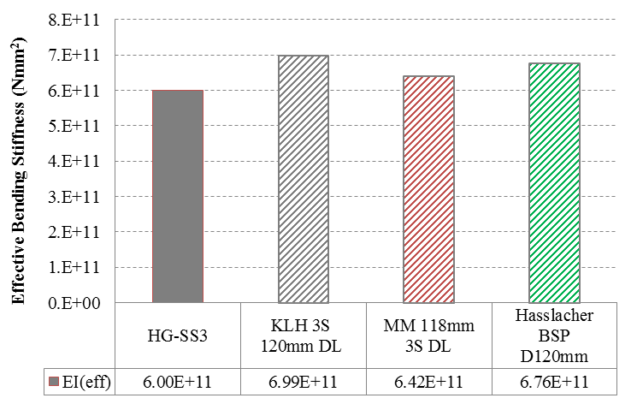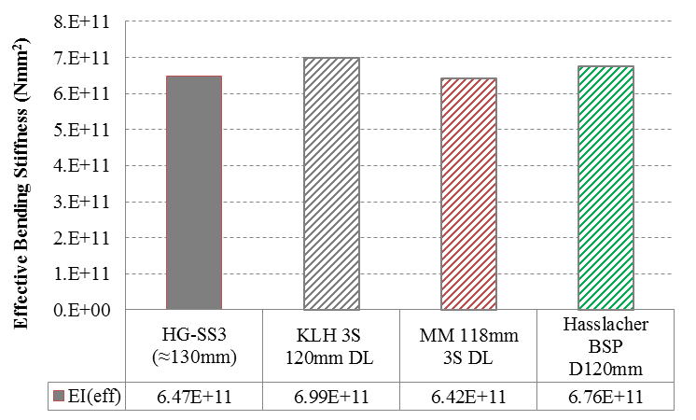
d) Home Grown SS3 e) Home Grown SS3 – Increased depth of section

Designation: KLH 3S 120mm DL = KLH 3 layer system (40/40/40mm), 380mm panel width
MM 118mm 3S DL = Mayr Melnholf 3 layer system (39/40/39mm), 380mm panel width
Hasslacher BSP D120mm = Hasslacher 3 layer system (39/40/39mm), 380mm panel width
KLH 5S 95mm DL = KLH 5 layer system (19/19/19/19/19mm), 390mm panel width
MM 95mm 5S DL = Mayr Melnholf 5 layer system (19/19/19/19/19mm), 390mm panel width
Hasslacher BSP D95mm = Hasslacher 5 layer system (19/19/19/19/19mm), 390mm panel width
KLH 3S 120mm DL = KLH 3 layer system (40/40/40mm), 420mm panel width
MM 118mm 3S DL = Mayr Melnholf 3 layer system (39/40/39mm), 420mm panel width
Hasslacher BSP D120mm = Hasslacher 3 layer system (39/40/39mm), 420mm panel width

Figure 6.6 EI_{effective} comparison

Error! Reference source not found. c) shows that the HG-SS2 samples fabricated from un-graded sideboard material (traditionally used for fencing and pallets) achieve a mean effective bending stiffness which is comparable to imported European products. Another way to increase the performance of these panels would be through the use of acoustic tools to segregate higher grade material for use within the outer layers and lower grade material for the outer layers.

When considering the HG-SS1 and HG-SS3 sample groups, it is clear that the imported European products achieve greater values. However, this would be expected given that the raw material used to fabricate the HG-SS samples were stress graded C16 and the other imported panels are produced using predominately C24 graded material. One simple way of increasing the effective bending stiffness is to increase the thickness of the panels (i.e. increase the thickness of individual lamellas or total the number of layers). By increasing the depth of section of the HG-SS1/HG-SS3 panels by approximately 10% (Error! Reference source not found. b) and e)) it is evident that a UK CLT product equals the level of performance of an imported product.

Conclusions and Recommendations
Sitka spruce accounts for approximately 50% of the UK softwood resource and it is anticipated that this would be the primary species considered for CLT production in the UK. Panels produced using UK Sitka spruce material show promising results in terms of both strength and stiffness, with panels fabricated using the sawfalling (sideboard) 20 × 95mm boards obtaining consistently good results.

Currently UK Sitka spruce sideboard material is not graded for structural purposes and is typically specified for use within pallets, fencing and other low value applications. Given the structural properties obtained from the HG-SS2 sample group (panels fabricated using sideboard material) it is particularly encouraging as there is potential to add considerable value to the UK timber resource. However in order to fully optimise the local resource available for application in the manufacture of CLT it will be necessary to carry out a further degree of grading (i.e. structural grading of sideboard material).

If the dynamic stiffness results from the acoustic grading process are considered (Table 7.1), it can be seen that approximately 28% of the HG-SS1 battens are greater than or equal to 9500N/mm². It was also noted that circa 50% of the HG-SS2 boards returned a dynamic MoE value which is greater than or equal to 9500N/mm².

Table 7.1 Potential Grading Yield
Sample Group | Dynamic Stiffness
 | 9500 – 11000 N/mm² | 11000 > N/mm²
HG-SS1 (40 x 95mm) | 19.76% | 8.30%
HG-SS2 (20 x 95mm) | 24.00% | 25.18%
Note: Acoustic grading results are based on average density and have not been corrected for moisture content.

Although these figures are only for a small sample range, they do show that the current UK resource has the potential to yield higher-grade material than C16 for CLT production. It is therefore considered that the implementation of an in-line grading device within a CLT production plant would allow material to be pre-selected and specified for optimum use within each panel i.e. higher grade material (sideboards) in the outer laminations and lower grade (centre cut) material in the inner laminations.
The findings from this basic research study show that CLT can be produced using UK Sitka spruce, further the structural performance is not dissimilar to the products which are currently imported from central Europe. However in order for CLT to be commercially feasible there are a number of aspects which require additional research.

For investment in UK CLT manufacture to take place a robust business plan is required to ensure investor confidence in the proposed new product and this requires market research, market testing and competitor analysis. One of the main areas which require additional research is the dimensional stability of UK Sitka spruce when drying (at a commercial scale) to levels below 20% moisture content. A programme of work is currently being devised to assess the distortion of varying sample dimensions at different target moisture content values.

Through Scottish Enterprise and European Regional Development Funding the Centre for Offsite Construction + Innovative Structures has developed knowledge transfer linkages from emerging (North America) and established (Austria & Germany) markets for flow of information and long-term strategic partnerships. As such we are currently evaluating the required facility capability and associated cost, time and funding requirements for UK CLT production.

Acknowledgements
This work is supported by European Regional Development Funding, Scottish Enterprise and Forestry Commission Scotland. The Centre for Offsite Construction + Innovative Structures would also like to acknowledge and thank BSW Timber Ltd, Norbuild Timber Fabrication & Fine Carpentry Ltd and Purbond for their continued support.

References
[1] Federation TT. Statistical Review; 2011.
[2] Suttie E. Five most effective ways of adding value to home grown timber. Building Research Establishment; 2011.
[3] TimberFirst. Market Report; 2012.
[4] Education Df. Building Schools for the Future. [cited; Available from: http://www.education.gov.uk/schools/adminandfinance/schoolscapital/funding/bsf
[5] Education Df. Priority School Building programme. [cited; Available from: http://www.education.gov.uk/schools/adminandfinance/schoolscapital/priority-school-building-programme
[6] Commision F. Standing timber volume for coniferous trees in Britain.: National Forest Inventory. ; 2011.
[7] BSI. BS EN 408:2010+A1:2012. Timber structures - Structural timber and glued laminated timber - Determination of some physical and mechanical properties: BSI 2011.
[8] BSI. BS EN789: 2004. Timber structures - Test methods - Determination of mechanical properties of wood based materials: BSI 2005.
[9] Moore J. Wood properties and uses of Sitka spruce in Britain. Edinburgh: Forestry Commission; 2011.
[10] Mestek P, Kreuzinger H, Winter S. Design of Cross Laminated Timber (CLT). Munich: Timber Structures and Building Construction Technical University Munich.
[11] Fellmoser P, Blass H. Influence of rolling shear modulus on strength and stiffness of structural bonded timber elements. Germany; 2004.

