**LIST OF FIGURES**

**Figure 1.** Light deflection using laser-cut panels.

**Figure 2.** Mirror facades darken the interior, making it necessary to switch on the lights during the day.

**Figure 3.** Mirror blinds open.

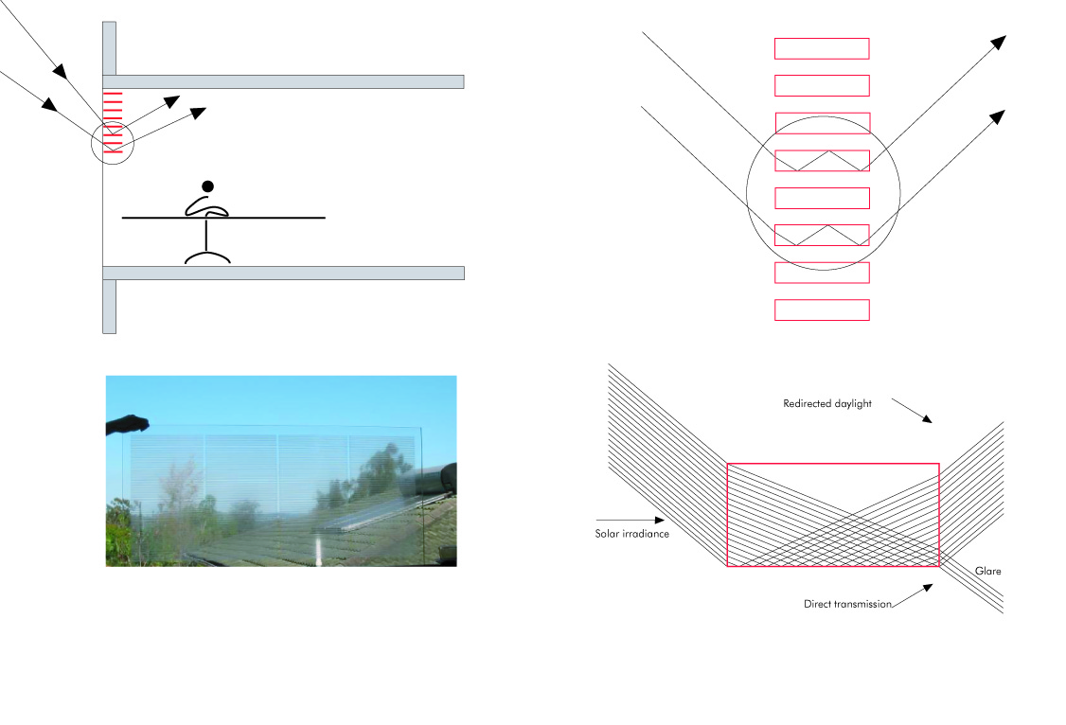

**Figure 1.** Light deflection using prismatic glazing [21]



**Figure 2**. Mirror facades darken the interior, making it necessary to switch on the lights during the day [21]

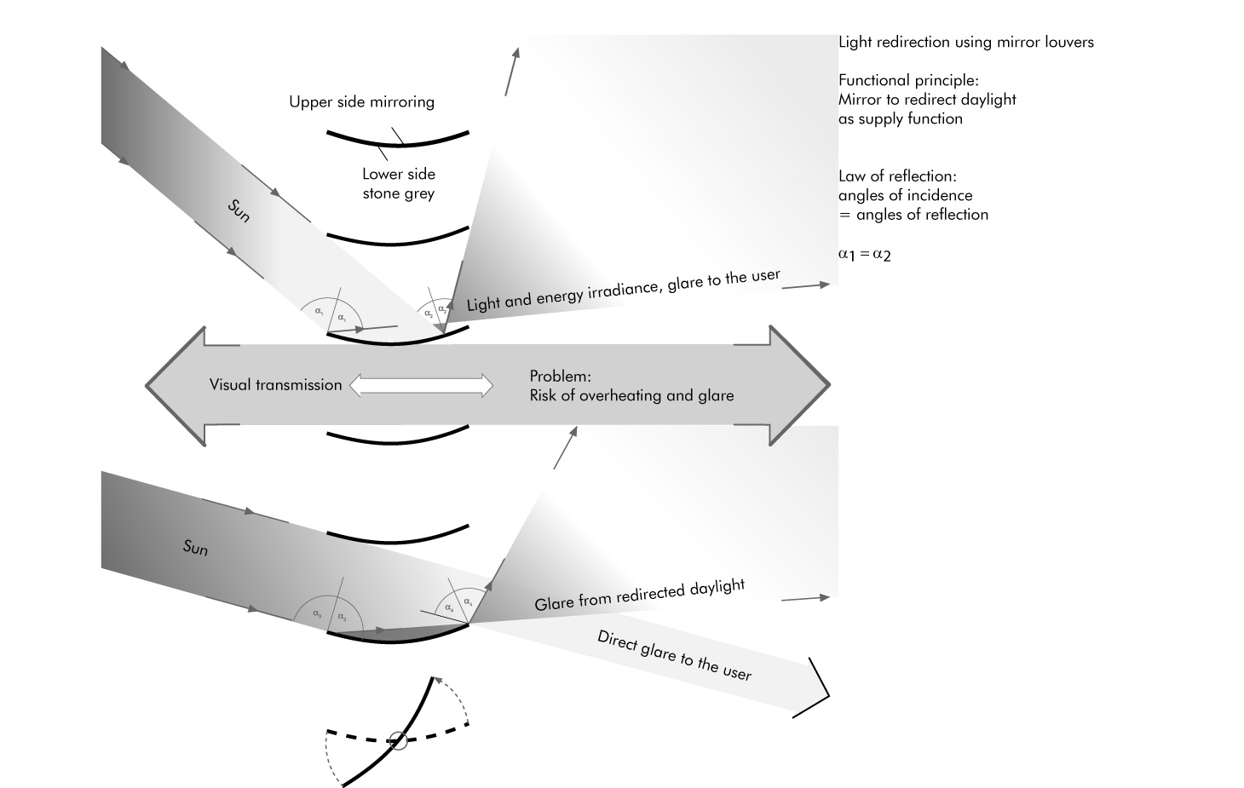

**Figure 3**. Mirror blinds open [21]