Hollins Martin., C.J., Kenney, L., Pratt, T., Granat, M.H. (2015). The development and validation of an activity monitoring system for use in measurement of posture of childbearing women during first stage of labour. Journal of Midwifery & Women’s Health. 1526-9523/09/$36.00 doi:10.1111/jmwh.12230

Caroline J. Hollins Martin, PhD MPhil BSc ADM PGCE RMT RM RGN
Laurence Kenney, PhD BSc (Hons) MIPEM CSci
Thomas Pratt, BSc
Malcolm H Granat, PhD, BSc

Address for correspondence:
Caroline J. Hollins Martin
Professor in Midwifery,
School of Nursing, Midwifery and Social Work,
College of Health and Social Care,
University of Salford
Frederick Road, Salford, Greater Manchester, UK, M6 6PU.
Email: C.J.Hollins-Martin@salford.ac.uk
Telephone: 0161 2952 522

Caroline J. Hollins Martin, PhD MPhil BSc ADM PGCE RMT RM RGN, MBPsS, is a Professor in Midwifery, School of Nursing, Midwifery and Social Work, College of Health and Social Care, University of Salford.
Email: c.hollinsmartin@napier.ac.uk.

Laurence Kenney, PhD BSc (Hons) MIPEM CSci, is a Professor, Centre for Health Sciences Research, University of Salford.

Thomas Pratt, BSc, is a research assistant, School of Health Sciences, University of Salford.

Malcolm H. Granat, PhD, BSc, is a Professor in Health and Rehabilitation Sciences, Centre for Health Sciences Research, University of Salford.

The development and validation of an activity monitoring system for use in measurement of posture of childbearing women during first stage of labour

Precis:
An activity monitoring system was validated to measure posture of women during labour and effects upon length of first stage, pain experience and birth satisfaction.

Abstract

Introduction: There is limited understanding of the type and extent of maternal postures that midwives should encourage or support during labour. The objective of this study was to develop an activity monitoring system existing commercial activity monitors to measure posture and movement. The aims were to identify a set of postures and movements commonly seen during labour, to develop an activity monitoring system for use during labour, and validate this system design.
Methods: Volunteer student midwives simulated maternal activity during labour in a laboratory setting. Participants (n=15) wore monitors adhered to the left thigh and left shank, and adopted13 common postures of labouring women for 3 minutes each. Simulated activities were recorded using a video camera. Postures and movements were coded from the video and statistical analysis conducted of agreement between coded video data and outputs of the activity monitoring system.
Results: Excellent agreement between the two raters of the video recordings was found (Cohen’s Kappa 0.95). Both sensitivity and specificity of the activity monitoring system were over 80% for standing, lying, kneeling and sitting (legs dangling).
Discussion: This validated system can be used to measure elected activity of labouring women and report on effects of postures upon length of first stage, pain experience, birth satisfaction and neonatal condition. This validated maternal posture monitoring system is available as a reference and for use by researchers who wish to develop research in this area.

Keywords: birth, first stage, movement, posture, ActivPAL,

QUICK POINTS

(1) Little is known about natural postures women elect for during labour, and thus objective data on postural choices, their advantages and disadvantages in terms of fetal and maternal outcomes, are not available.

(2) An activity monitoring system was validated to measure posture of women during labour and its effects upon length of first stage, pain experience and birth satisfaction

(3) Our validated maternal posture monitoring system is available as a reference and for use by researchers who wish to develop research in this area.

The development and validation of an activity monitoring system for use in measurement of posture of childbearing women during first stage of labour

INTRODUCTION
There is confusion over the postural activities that maternity care providers should encourage during labour. There is also conflict between protocols that advise use of movement limiting technology, and promoting choice and control for childbearing women.¹⁻³ As such, midwives are uncertain about how to guide women about physical postures during labour.

Some studies have examined the effects of maternal postures and movement during labour and their effects upon length of first stage.⁴ In 2009, a Cochrane Review of 21 studies about maternal activity during labour (n=3706)⁵ reported contradictory findings. Limitations included lack of focus on perinatal and maternal outcomes, with parameters of type, level and extent of physical activity and postures adopted poorly reported. One study by Bloom et al.⁶ reported use of pedometers, with a major criticism being that the system had not been validated. Hence, almost all objective data on postural choices and their advantages and disadvantages in terms of fetal/maternal outcomes remains unknown.

Hollins Martin and Martin⁴ report that ambiguity persists over whether maternal postural activity patterns affect length of first stage and if so, by how much? There is a need for high quality trials to compare postures adopted by labouring women relative to outcomes such as, length of first stage, pain, birth satisfaction and neonatal condition.⁵

To provide objective data, a validated monitoring system is needed to automatically record postural activity during labour. A system based on a monitor placed only on the thigh, as is the case in commercially available devices, allows for differentiation of standing from sitting or lying postures, but cannot provide information on orientation of the shank when kneeling or sitting. We concluded that a new system was required. Therefore, the aims of this study were 1: to identify a set of postures and movements which are commonly seen during labour, 2: based on these results, to develop an activity monitoring system for use during labour, and 3: to validate the system design.

METHODS:

Identification of a set of commonly adopted postures and movements
The first step was to conduct a survey to ascertain what postures midwives rated as most commonly adopted by women during labour. We created a draft list of common postures adapted from Childbirth Connection.⁷ Selected pictures representing these common postures were scanned and modified by a research assistant. These identified positions were classified by a group of student midwives into named categories and mapped into a survey for the purpose of eliciting a hierarchy of ratings from practicing midwives. After the survey was developed, content validity was checked by 5 members of the midwifery lecturing team for potential omissions. None were identified.

The survey was then distributed to participants (n=95) recruited from the midwifery lecturing team, postgraduate programs and third year students who had just completed the program. They were asked to rate the 20 postures for how commonly they perceived they were adopted by labouring women. Each illustrated posture was rated in a scale from 1-20, with 1 representing the most common posture observed, 2 the second most common posture observed, up to 20, which was the least common posture observed. Findings were entered into a spreadsheet (Microsoft Excel 2014 (v14.0); Microsoft Corporation, Redmond, Washington). For these data, the modal result for each posture was calculated and hierarchically presented in histograms (see Supporting Information: Appendix S1)

Following examination of the histograms, we opted to design and validate the system based on the 13 most commonly observed postures. This cut-off point was based on the clear rightward shift in distributions seen in the histograms for the postures ranked below 13th. The following postures were retained: 1) semi-recumbent, 2) sitting upright, 3) standing and leaning forward, 4) sitting and leaning forward. 5) semiprone, 6) standing, 7) walking, 8) sitting and rocking. , 9) slow dancing, 10) hands-and-knees, 11) kneeling and leaning forward, 12) open knee-chest position, and 13) sitting on toilet. The following postures were removed: 1) squatting, 2) standing lunge, 3) kneeling lunge, 4) dangle with assistance, 5) dangle, 6) on back legs drawn up, and 7) lap squatting

Development of the activity monitoring system
Commercial systems for monitoring physical activity are widely available. We selected activPAL (referenced as monitor throughout)(PAL Technologies Ltd, Glasgow, UK) because it is the only monitor specifically designed and validated to measure posture. In contrast, the others measure acceleration and energy expenditure, which was not our objective. In addition, one member of the team (MG) brought extensive experience working with these specific monitors. The device is a 53 x 35 x 7 millimetres monitor that weighs 20 grams and can store up to 7 days of data in real time. The device has been validated for use in measuring posture and motion in many everyday activities.^{9,10,11,12}

From the survey, it was clear that a suitable system would require information on the orientation of both shank and thigh to enable discrimination between certain postures (eg, hands & knees versus standing). A single device placed on the thigh was unable to provide information about orientation of shank. Therefore, we decided to use two monitors; one located on the (left) thigh, and one on the (left) shank (Figure 1), adhered to the skin using double-sided adhesive pads designed to render them stationary during vigorous physical activity.

To process data from the synchronised outputs from the two monitors, we developed heuristic rules to combine data from both shank and thigh-located monitors to produce an extended postural classification table. We assumed that output from the shank-located monitor would indicate standing when the shank was vertical, and lying when the shank was horizontal. This allowed us to identify rules to classify static outputs of the two monitors into 4 classes (standing, all fours, lying and sitting). We further assumed that accurate recognition of walking would only come from the thigh-located monitor and therefore, irrespective of the output of the shank-located monitor, when the thigh-located monitor output indicated stepping, we classified the output of the monitoring system as stepping. Both other conditions (thigh upright and shank stepping; and thigh horizontal and shank stepping) were classed as other. Table 1 summarises these rules.

Validation of the activity monitoring system
Experimental validation was conducted to record simulated labour activities using a video camera, coding of postures and movements from a video, and conducting statistical analysis of agreement between coded video data and outputs of the activity monitoring system. Observation was used as the criterion of measure.

Participants
Fifteen consenting healthy, injury free, female volunteers, aged 18-56 were recruited from the student/lecturer population of the midwifery team at the University of Salford (UK). The sample was purposive, given that selected participants had first-hand experience of postures adopted by women during labour. Data were collected July/September 2012 in the clinical skills laboratory. Approval was granted by the school ethics committee.

Test protocol
Participants were familiarised with the test protocol 2 days in advance. Check-lists were developed to ensure data-collection proceeded without omissions. The data collection protocol took around 1 hour to complete.

Equipment synchronisation
One portable laptop was used to download and initialise the activity monitors, and the digital timer clock. The video camera adopted the time of the laptop. Participants attached the two monitors to the midpoint of midline of the anterior left thigh and shin. They were shown the chart illustrating the 13 postures they were required to adopt for 3 minutes each. Sequence of postures was randomly assigned and transitions between postures were included in the data collected and analysed. The researcher prompted change between postures using the chart. A video camera recorded the full set of activities.

Data Analysis
Data from the monitors for each participant were downloaded for the 39 minute experiment and analysed using the classification table (Table 1). Each participant’s 39 minute videotape was analysed on a second-by-second basis by two independent raters who identified which of the 13 postures was adopted. Agreement between the two raters was assessed using Cohen’s Kappa.¹³

To assess agreement between observations from the video and outputs from the posture monitoring system, we associated each of the 13 postures with one of the 6 classes we could identify using the activity monitoring system (see Table 2).

The rater observations and measured classifications for each second of each trial were compared, allowing two confusion matrices to be assembled for each rater and participant. Based on these, an average confusion matrix was produced.

Each row of each confusion matrix represents the average observed classification from the video analysis (ie, the actual posture) and each column represents the classification based on the monitor data (ie, the measured posture). The diagonal elements in the matrix represent agreement between the actual and measured postures and the off-diagonal elements represent misclassification. Finally, specificity and sensitivity for each of the 6 classes of posture and movement were produced as compared to the observed posture.

Results
A total of 577 minutes (9.6 hours) of data were analysed. Agreement between the two raters was excellent (κ = 0.95). A confusion matrix containing information about actual and predicted classifications can be viewed in Table 3. The confusion values equal percentage of samples misclassified. Table 4 shows the sensitivity and specificity for each of the 6 postures. Sensitivity and specificity are the accuracy of classifications of lying, sitting, standing, all fours and stepping detected by the monitoring system. Sensitivity is the true positive rate that the monitoring system detected that participants actually adopted the named activity, and specificity is the true negative rate that the monitoring system failed to acurately detect that participants adopted the named activity. A perfect predictor is a monitoring system that is 100% sensitive to participants adopting a particular position, and 100% specificity indicates that all other postures are correctly excluded from the tested posture. In Table 4, lying was the most acurately detected position recorded by the monitoring system and sitting the second most, and so on.
Although there is generally good or excellent agreement between the observed and measured postures for standing, lying, kneeling (all fours) and sitting (legs dangling), stepping and transition were frequently confused with other postures. Both sensitivity and specificity were over 80% for standing, lying, kneeling and sitting. However, sensitivity was around 35% for transition and dropped to 7% for stepping.

DISCUSSION
This study is the first to show that it is possible to use contemporary sophisticated activity monitors on the shank and thigh to objectively monitor postures commonly adopted by women during first stage of labour. Previous studies have relied on use of pedometers (only one study)⁶ or direct observation¹⁴⁻¹⁶ , which has limited either the resolution of the data, or the practicality of carrying out large-scale and reliable studies of maternal activity during labour. The Cochrane Review ⁵ has recommended that more research be conducted to measure effects of maternal movement during labour on specified outcomes, since studies reviewed reported vague classifications of what constitutes postures and movement during labour.

We have now validated an effective system that uses sophisticated contemporary activity monitors to effectively measure posture. The monitors used in this system are sufficiently small to be unobtrusive during labour, and the results are straightforward to analyse. Also, synchronisation between monitors works well.
Nonetheless, two limitations were noted. The system was unable to accurately classify transitions between postures. Transitions are the very short periods during which the participant changes from one posture to another. These varied depending on particular postures the participant was moving between, and the approach they adopted towards making these changes. Also, our protocol was particularly dominated by transitions (12 in 39 minutes), which accumulated to approximately 5% of the total experiment. During normal labour it is reasonable to assume that most
women adopt particular postures for sustained periods of time, quite different to what
happened in our laboratory experiment.

The system also performed poorly in classifying stepping. There are two reasons for this. One was small errors in synchronisation between the video and monitor data. A second is that classification performance was likely to be affected by particular types of walking seen in our study. Most of the previous studies in which a single monitor has been used have focused on free-walking in adults and children at self-selected walking speeds.^{9,10,17-19} In contrast, participants in our study were requested to walk with low cadence and speed, and to make small inconsistent steps representative of women in labour. Observation of the videos show cadence to be typically 40-50 steps per minute, and in some cases lower. This drop-off in accuracy of stepping classification is reasonably consistent with a previous study.²⁰
In light of the limited performance, there is room to develop a further system to measure stepping independently.

Despite these limitations, the fact that we can accurately measure time spent in 4 positional groups opens up opportunities for large scale objective studies of the impact of maternal static posture on outcomes. Although the sample size was reasonable in this preliminary study, further validation as well as validation in a sample of laboring pregnant women will be important.

CONCLUSION
The activity monitor is the first to be validated in a simulated labour context and can be used to advance knowledge about intranatal care. This monitoring system has been shown to be a valid means of quantifying 4 common postures women adopt during labour (sitting, standing, kneeling and all fours). The ultimate goal is to use this validated system with labouring women and report on postures and how they influence length of first stage, pain, neonatal condition, and birth satisfaction. Comparisons of postures women naturally adopt in birthing units, at home, and obstetric led units could also yield potentially useful information.

REFERENCES

1. Hollins Martin CJ, Bull P. Measuring social influence of a senior midwife on
decision making in maternity care: an experimental study. Journal of Community
and Applied Social Psychology 2005;15:120-126.

2. Hollins Martin CJ, Bull P. What features of the maternity unit promote obedient
behaviour from midwives? Clinical Effectiveness in Nursing 2006; 952:e221-e231.

3. Hollins Martin CJ, Bull P. 2010. Protocols, policy directives and choice provision:
UK midwives views. International Journal of Health Care Quality Assurance
2010;22(1):55-66.

4. Hollins Martin CJ, Martin CR. 2013. A narrative review of maternal physical
activity during labour and its effects upon length of first stage. Complementary
Therapies in Clinical Practice 2013;19:44-49.

5. Lawrence A, Lewis L, Hofmeyr GJ, Dowswell T, Styles C. Maternal positions and
mobility during first stage labour. Cochrane Database of Systematic Reviews 2.
Issue 2. No: CD003934. DOI: 10.1002/14651858.2009; CD003934.pub2.

6. Bloom SL, McIntire DD, Kelly MA. Lack of effect of walking on labor and delivery.
New England Journal of Medicine1998;339:76-79.

7. Simkin P. Comfort in labour: how you can help yourself to a normal satisfying childbirth 2007. Childbirth Connection. Available at: http://www.childbirthconnection.org/pdfs/comfort-in-labor-simkin.pdf
Illustrations adapted from Shanna Dela Cruz 1994, 1999, 2005 in Ancheta RS, 1st and 2nd Editions. The labour progress handbook: early interventions to prevent and treat Dystocia (1st & 2nd ed) by Simkin P, Ancheta R. Oxford Blackwell Publishing 1999, 2005.

8. Godfrey A, Conway R, Meagher D, O’Laighin G. Direct measurement of human
movement by accelerometry. Medical Engineering &Physics2008;30(10):1364-
86.

9. Grant PM, Ryan CG, Tigbe WW, Granat MH. The validation of a novel activity
monitor in the measurement of posture and motion during everyday activities.
British Journal of Sports Medicine2006;40(12):992-997.

10. Ryan CG, Grant PM, Tigbe WW, Granat MH. The validity and reliability of a
novel activitymonitor as a measure of walking. British Journal of Sports Medicine
2006;40(9):779–784.

11. Maddocks M, Petrou A, Skipper L, Wilcox A. Validity of three accelerometers
during treadmill walking and motor vehicle travel. British Journal of Sports
Medicine2010;44:606-608.

12. Harrington DM, Welk GJ, Donnelly AE. Validation of MET estimates and step
measurement using the ActivPAL™ physical activity logger. Journal of Sports
Sciences2011;29(6):627-633.

13. Cohen J. A coefficient of agreement for nominal scales. Educational and
Psychological Measurement 1960;20:37-46.

14. Frenea S, Chirossel C, Rodriguez R. The effects of prolonged ambulation on
labor with epidural analgesia. Obstetric Anesthesia2004;98:224-229.

15. Karraz MA. Ambulatory epidural anaesthesia and the duration of labour.
International Journal of Gynecology and Obstetrics 2003;80:117-122.

16. MacLennan AH, Crowther C, Derham R. Does the option to ambulate during
spontaneous labour confer any advantage or disadvantage? Journal of Maternal
andFetal Medicine1994;3:43-48.

17. Godfrey A, Culhane KM, Lyons GM. Comparison of the performance of the
activPAL™ Professional physical activity logger to a discrete accelerometer-
based activity monitor. Medical Engineering & Physics 2007;29:930-934.

18. Grant PM, Dall PM, Mitchell SL, Granat MH. Activity-monitor accuracy in
measuring step number and cadence in community-dwelling older adults. Journal
of Aging and Physical Activity2008;16:201-14.

19. Ryan C, Gray H, Newton M, Granat MH. The convergent validity of free-living
physical activity monitoring as an outcome measure of functional ability in people
with chronic low back pain. Journal of Back and Musculoskeletal Rehabilitation
2008;21:137-142.

20. Mickelborough J, Kenney L, Moss S.Validation of a novel activity monitor.
Proceedings Recent Advances in Assistive Technology and Engineering
(RAATE).Conference, Birmingham, UK,10-11:2003.

(Supporting Information: Appendix S1): Histograms showing frequency of rating by (n=95) midwives of most commonly observed positions adopted by childbearing women during first stage of labour (1 most commonly seen – 20 least commonly seen)

Figure 1: The activPAL™ physical activity monitors in situ.

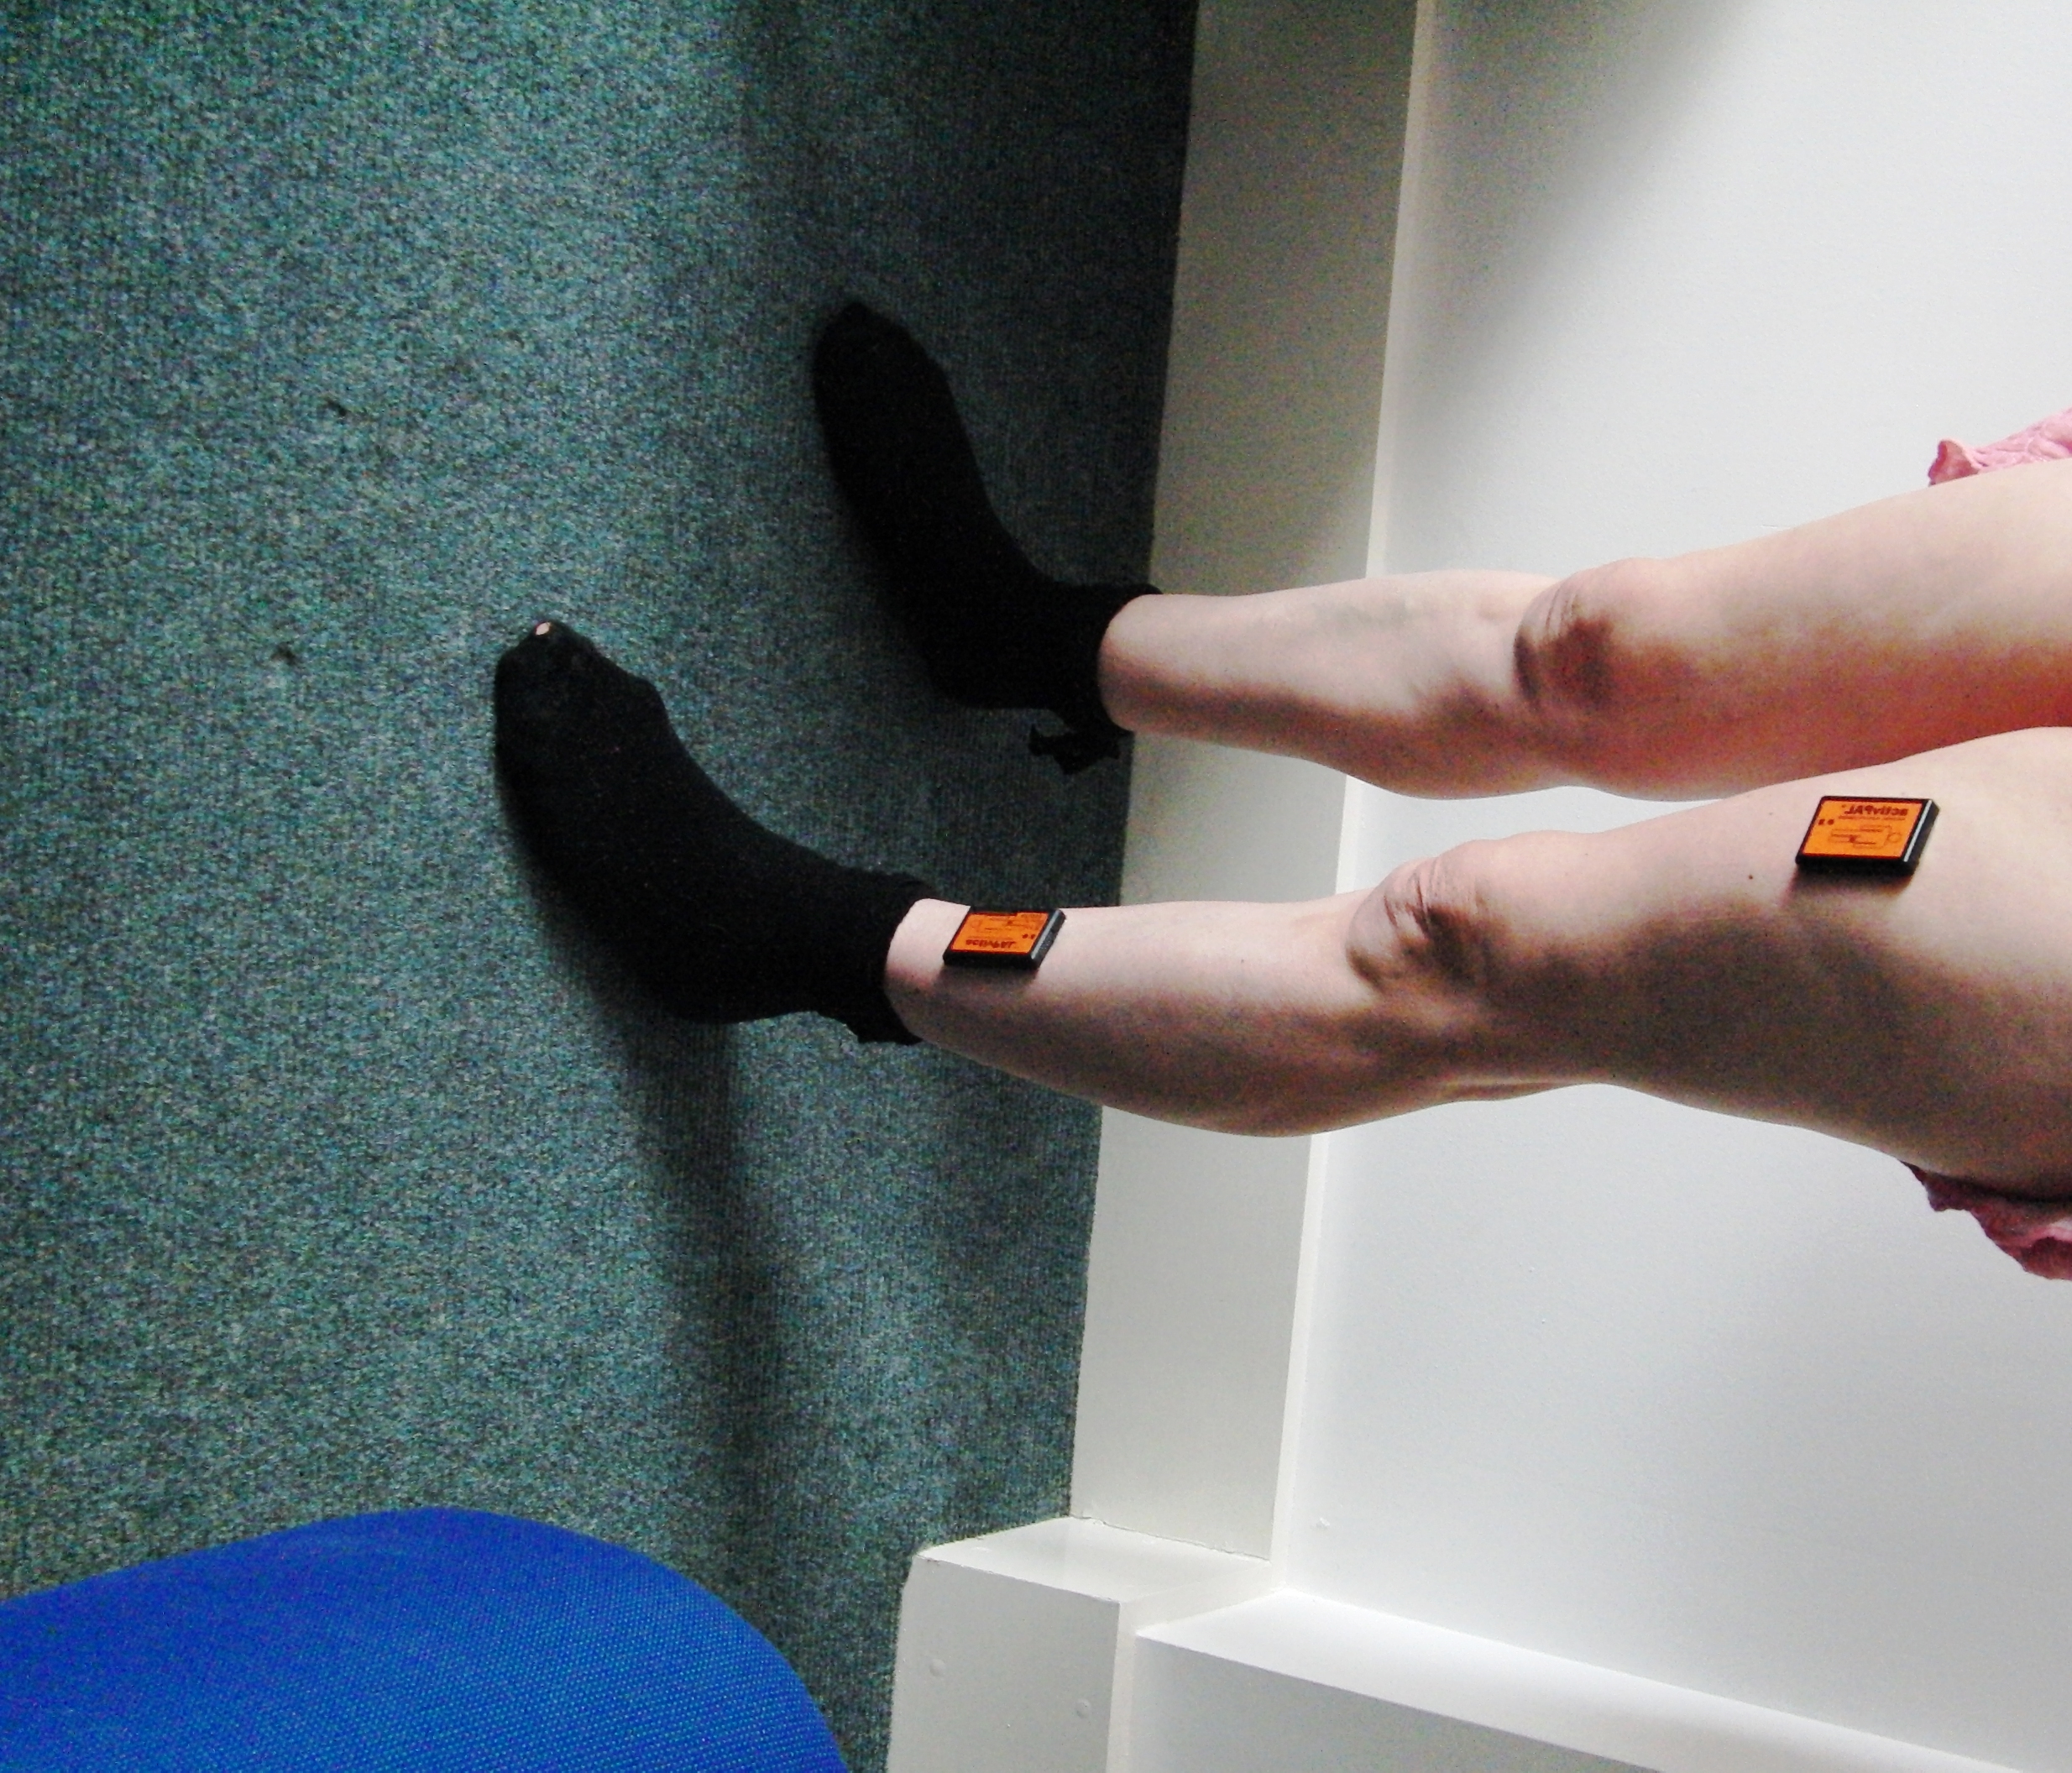

Table 1: Postural classification based on outputs of two monitors

 | Thigh  upright | Thigh horizontal | Thigh  Stepping
Shank upright | Standing | Sitting (legs dangling) | Stepping
Shank horizontal | All fours | Lying | Stepping
Shank stepping | Other | Other | Stepping

Table 2: Posture mapping of physical positions into activity classes

Actual posture/movement | Activity class
Sitting Upright | Lying

Semiprone
Semi-recumbent
Sitting on toilet | Sitting
Sitting and rocking
Sitting and leaning forward
Slow Dancing | Standing
Standing
Standing and leaning forward
Kneeling and leaning forward | All fours
Hands-and-knees
Open knee-chest position
Walking | Stepping
Other | Other

The left hand column shows the actual posture and the right hand column the associated class of activity.

Table 3: Confusion matrix describing the accuracy of classifications of lying, sitting, standing, all fours and stepping detected by the monitoring system

 | Lying | Sitting | Standing | All fours | Stepping | Other
Lying | 17.13% | 0.15% | 0.04% | 0.24% | 0.13% | 1.09%
Sitting | 0.00% | 19.53% | 0.19% | 0.28% | 0.22% | 1.42%
Standing | 0.19% | 0.53% | 20.60% | 0.10% | 3.13% | 1.10%
All fours | 0.13% | 0.01% | 0.29% | 20.11% | 0.26% | 1.19%
Stepping | 2.35% | 0.29% | 0.69% | 0.52% | 2.35% | 0.56%
Other | 0.45% | 0.82% | 1.27% | 0.10% | 2.19% | 0.36%

Footnote: Each row of each confusion matrix represents the average observed classification from the video analysis (ie, the actual posture) and each column represents the classification based on the monitor data (ie, the measured posture). The diagonal elements in the matrix represent agreement between the actual and measured postures and the off-diagonal elements represent miss-classification.

Table 4:Accuracy of the classifications of lying, sitting, standing, all fours and stepping detected by the monitoring system

Class (duration in minutes) | True  Positives | True  Negatives |  | False  Positives |  | False  Negatives | Sensitivity |  | Specificity
Lying (108.4) | 17.2% |  | 78.4% | 2.8% | 1.7% |  |  | 91.2% | 96.6%
Sitting (124.9) | 19.6% |  | 76.2% | 1.8% | 2.4% |  |  | 89.2% | 97.7%
Standing (148.0) | 20.7% |  | 71.8% | 2.5% | 5.1% |  |  | 80.3% | 96.7%
All fours (126.9) | 20.2% |  | 76.7% | 1.2% | 1.9% |  |  | 91.4% | 98.4%
Stepping (39.0) | 2.4% |  | 87.9% | 5.9% | 3.8% |  |  | 38.3% | 93.7%
Other (30.0) | 0.4% |  | 89.4% | 5.4% | 4.8% |  |  | 7.0% | 94.3%

