Blended Spaces for Collaboration

David Benyon and Oli Mival

Centre for interaction Design

Edinburgh Napier University

|  |  |
| --- | --- |
|  |  |

# ABSTRACT

In this paper, we reflect on our experiences of designing, developing, implementing and using a number of real world, functional, multi-touch enabled Interactive Collaborative Environments (ICEs). We created an ICE in our university in order to explore issues of interaction design and of user experience in these types of environment. This ICE has been in use for the last four years and has been the focus of a number of empirical studies and observations. In addition we have also undertaken considerable consultancy and contract research work for a range of commercial clients as they seek to deliver innovative environments for collaboration that suit their own needs for collaboration. These consultancies have included a mobile collaborative environment for a county police force in California, the redesign of a multinational pharmaceutical company’s meeting rooms, the design of an oil rig control system and an innovation centre for an international call centre. In this paper we aim to distill these experiences and to provide theoretical and practical advice for designers of ICEs. Our theoretical position derives from the application of conceptual integration, to create ‘blended spaces’ — environments where the design of physical and digital spaces are closely integrated. We have also identified five key themes of interaction in ICEs derived from our own observations and those of others who have been looking at collaboration over a number of years. We present these themes as a critical design framework, TACIT, that focuses on Territoriality, Awareness, Control, Interaction and Transitions in ICEs. We then present two case studies of the blended spaces and TACIT framework in use. The paper concludes by looking at the opportunities for creative collaboration that the next generation of interactive blended spaces provides.

## Author Keywords

Interaction Design, Collaboration, Multi-touch, Multi-surface Environment, Interactive Environments, Blended Spaces, TACIT framework

# Introduction

Over the past few years, a number of whole room environments have been developed equipped with various technological devices and combinations of interactive white boards and projection equipment. Early examples of such environments include ‘Roomware’ (Streitz, Rexroth and Holmer, 1997) where the focus was on developing integrated furniture, analogue media such as whiteboards and large shared displays to support collaboration. Another early version was electronic meeting rooms (Nunamaker, Dennis, Valacich, Vogel and George, 1991) that aimed to support larger scale collaborative decision making activities and Buxton’s mediaspace (Buxton, 2009) focused on explorations of video connections between spaces. Johanson, Fox and Winograd, (2002) describe iRoom, a meeting room that evolved over a number of years, but has now finished. The focus was primarily on the software infrastructure necessary to allow different devices to communicate with each other and on novel forms of interaction with large screens. The NiCE discussion room (Haller, Leitner, Seifried, Wallace, Scot, Richter, Brandl, Gokcezade and Hunter, 2010) is a more recent example of a room designed to support creative meetings with a mixture of analogue and digital media. The focus of this work is on the effectiveness of different techniques for sharing data across distance (e.g. from a local laptop to a shared whiteboard) and generally improving the user experience (UX) of such environments. Plaue, Stasko and Baloga, (2009) argue for the conference room as ‘toolbox’ allowing users to select from a range of analogue and digital media according to the task. Wespace (Wigdor, Jiang, Forlines, Borkin, and Shen, (2009) is a collaborative space with interactive tabletop and large interactive screen designed to support astrophysicists’ collaborative work.

Each of these raises important issues about collaboration and about the specific configuration of surfaces and devices that were brought together for particular purposes. Many of the concerns of the earlier systems, such as iRoom have now been solved with cloud-based services providing the functionality that was once envisaged as part of a room operating system. For example Dropbox supports file sharing across devices that are internet connected. Other projects such as NiCE allow for detailed exploration of improvements in the interaction design in such environments. These environments also have to deal with classic issues of computer supported cooperative work have been identified and described over the years, for example by Ackerman (2000), Schmidt, (2002) and Schmidt and Bannon (1992). These issues continue to be aired (Olsen and Olsen, 2008; Olsen and Olsen, 2014) and focus on the distributed nature of much collaborative work, the vagaries of different communication, coordination and information storage tools and computational resources. They also deal with fundamental human issues in collaboration such as awareness of others and the need for personal and public spaces in collaborative activities.

In this paper we describe our experiences in building and using an ICE and in designing ICEs for commercial clients. By doing this we highlight some general issues of collaboration that build upon knowledge of cooperative activity (e.g. Grudin, 1994; Schmidt and Bannon, 1991), but also take into account our view that meeting rooms need to be treated as blended spaces. Thus the design of the physical space and the design of the digital space should be undertaken together and the two types of space — digital and physical — need to be tightly integrated. In Section 2 we provide a brief introduction to the idea of blended spaces and section 3 describes the ICE, showing how the physical and the digital are brought together into a blended space. The second contribution that we make is to abstract from these experiences a set of five key themes that need to be addressed in the design of ICEs. Section 4 presents our TACIT framework for looking at blended spaces for collaboration. Section 5 provides two more case studies of designing ICEs for commercial clients. A short conclusion is provided in Section 6.

# Blended spaces

Benyon (2014) defines a blended space as a space ‘where a physical space is deliberately integrated in a close-knit way with a digital space’ (p. 79). Blended spaces are spaces where a digital space has been designed and integrated with a physical space with the purpose of creating a novel UX. Blended spaces have new properties that emerge from the particular combination of physical and digital and may give rise to a new sense of presence (Benyon, 2012).

The concept of blending has been in existence for many years. For example in education blended learning aims to design a learning experience for students that blends the benefits of classroom learning with the benefits of distance, on-line learning. O’Hara, Kjelsko and Paay (2011) refer to the distributed spaces linked by very high quality video-conferencing systems such as Halo as blended spaces because of the apparently seamless joining of remote sites. In systems such as Halo, great attention is paid to the design of the physical conference rooms and to the angle and geometry of the video technologies in order to give the impression that two distant rooms are collocated. Jetter, Geyer, Schwarz and Reiterer (2012) discuss their views of the related ideas of blended interaction. They develop a framework for looking at the personal, social, workflow and collaborative aspects of blended interaction. Other contributions to this workshop (at the AVI 2012 conference) and another workshop at the CHI2013 (Jetter, et al., 2013) conference highlight many design issues of blended interactions in a variety of settings.

For example, Benyon, Mival and Ayan (2012), Mokey, Nalbandian and O’Keefe (2013) and O’Keefe, Benyon, Chandwani, Menon and Duke (2014) apply the idea of blended spaces to the domain of digital tourism. Here the emphasis is on providing appropriate digital content at appropriate physical places (points of interest) in order to provide a good UX for tourists. The concept of blending has also been used for the design of ambient assisted living environments for older people (Hoshi and Waterworth, 209; 2011) and for the design of products including a blood taking machine (Markussen, 2009) and a table lamp (Wang, 2013).

A central feature about these latter examples is that they take as their theoretical basis the work of Fauconnier and Turner (2002) on blending theory (BT), or conceptual integration. Originally developed as a theory of linguistics and language understanding (Turner, 1996; Fauconnier, 1997), BT has been applied to a huge range of subject areas from mathematics to music to history to creativity (Turner, 2014) making it more a general theory of creativity than just a theory of language construction. BT is concerned with how people conceptualise new experiences and new ideas in terms of their prior knowledge. Imaz and Benyon (2007) originally applied BT to Human-Computer Interaction (HCI) and Software Engineering (SE) looking at how the metaphors in HCI and SE have changed over the years and how this effects how these disciplines are perceived. In their book they analyse many examples of user interfaces and interactive systems and suggest how BT could be used to design interfaces and interactions. Benyon (2014) provides an introduction to blended spaces.

The main principle of blending theory (illustrated in Fig. 1) is that people come to know things through taking projections from two mental spaces in different domains that share some structure with a more generic domain. The projections from the input spaces create new relationships in the blend that did not exist in the original inputs. Our background knowledge in the form of cognitive and cultural models allow the composite structure to be experienced in a new way. The blend has its own emergent logic and this can be elaborated to produce new ideas and insights. This blend may then go on to be blended with other mental spaces.



Figure 1 Concept of Blend

Fauconnier and Turner (2002) discuss different types of blend and provide guidance on what makes a good blend. Four types of blend are identified based on the way in which concepts from the input spaces are projected into the blended space. A mirror blend brings together one-to-one mappings from the two input domains. Other blends foreground the structure and content of one input domain over the other. The more complex ‘double scope’ blends creatively merge concepts from the input domains to produce a new experience. For example, Imaz and Benyon (2007) discuss the development of the ‘desktop metaphor’ that blends the domain of office work (and the use of physical files, folders and wastepaper baskets) with the structure and functions of a computer operating system (computer files, directory structures and deleting things) leading to the existence of icons for printers, folders, files, the trash can and other objects on the computer screen ‘desktop’. This new design of a human-computer interface (originating with the Xerox Star computer and subsequently dominating the interface for both Windows and Mac OS) was a double scope blend, creating a new structure from the different input domains.

Fauconnier and Turner (2002) devote a chapter of their book to the principles of blending and on the constraints and principles that will result in good blends that deliver designs “at a human scale”, which in terms of interaction design means that we should deliver designs that provide a good UX. They see the process of blending as consisting of three main processes: *composition* is the process of understanding the structure of the domains; *completion* is the process of bringing relevant background knowledge to the process; *elaboration* is the process of making inferences and gaining insight based on these relationships. They also suggest some ‘optimality’ principles that aim to ensure that blends are useful and understandable to people. An important part of blending theory is its grounding in an embodied cognition perspective (e.g. Dourish, 2001), hence the need to design for interaction in a way that best suits people (“at a human scale” as opposed to being dictated to by technology). This is reinforced by a significant contribution to blending theory by Ed Hutchins arguing for the importance of having a ‘material anchor’ in order to help people ground their new experiences in something concrete (Hutchins, 2005).

In looking at the sense of presence in mixed reality spaces, Benyon (2012) applies blending theory to the creation of mixed reality spaces. He develops a view of digital and physical spaces in terms of four characteristics; ontology, topology, volatility and agency. He argues that for the purpose of creating a good UX these four characteristics constitute the structure of a generic space that both physical and digital spaces share. Bringing blending theory together with the idea of physical and digital spaces leads to the position illustrated in Figure 2.

The ontology of the spaces concerns the objects in the spaces. In the domain of digital tourism, the objects are typically the points of interest for a tourist. In the domain of collaborative meetings the objects will be the physical layout of the room with tables, chairs and interactive surfaces and the windows, doors and so on. The topology of the spaces concerns how those objects are related to one another. Thus looking at topology means looking at spatial relations between objects, at distance, direction and at what things are in front of others, behind others and so on. The dynamics or volatility of the spaces concerns how elements in the spaces change over time and about movement through the space. The agency in the spaces concerns the people in the spaces, the artificial agents and the opportunities for action in the spaces.

Designing blended spaces involves designers considering these four attributes of the a digital space and a particular physical space. This is the composition of the blend in Fauconnier and Turner’s (2002) terms. By understanding these characteristics and looking at the correspondences between the physical and the digital spaces, designers will produce new blended spaces that have emergent properties. The designer needs to complete and elaborate the blend to produce a new space. In these blended spaces, people will not be in a physical space with some digital content bolted on. People will be present in a blended space and this will give rise to new experiences and new ways of engaging with the world.

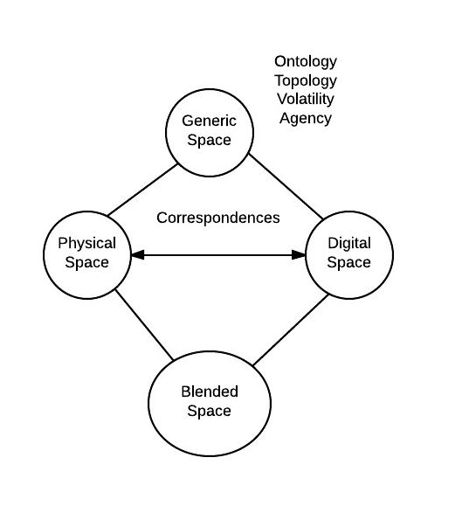

Figure 2 Conceptual blending in mixed reality spaces

Another consideration that is important in the design of blended spaces is that the physical and the digital spaces rarely co-exist. There are anchors, or touch points, where the physical is linked to the digital, but there are many places where the physical and the digital remain separate. In the context of digital tourism, for example, quick response (QR) codes and the global positioning system (GPS) are examples of anchor technologies that bring the physical and the digital together. For example, digital content can be automatically displayed when a person walks enters a particular physical location, thus bringing the digital space and the physical space together. In the context of an ICE people will be collaborating through some physical activity such as talking to each other, but then may access the digital space to bring up some media to illustrate what they are saying. The conversation may then continue with shared access to the digital content. In blended spaces, people move between the physical, the digital and the blended spaces. This movement through and between spaces is an important part of the blended space concept and leads on to issues of navigation in physical, digital and blended spaces.

Finally blended spaces encompass a conceptual space of understanding, making meaning and UX and this is where the principles of designing with blends are so important. People need to be aware of both the physical and the digital spaces, what they contain and how they are linked together. People need to understand the opportunities afforded by the blended space and to be able to unpack the blend to see how and why the spaces are blended in a particular way. People need to be aware of the structure of the physical and the digital, so that there is a harmony; the correspondences between the objects in the spaces.

# An Interactive Collaborative Envrionment (ICE)

Part of our approach to understanding the UX of new and emerging collaborative spaces is to build, prototype and evaluate. Accordingly we set about creating a meeting space that would be useful for faculty members, but would also allow us to explore collaboration. As with all real-world projects, our ICE had to comply with a number of constraints such as the existence of a physical room and a budget. It was also to be a ‘bring your own device’ (BYOD) environment. The philosophy underlying the design focused on providing an environment that would help people within it fulfill their activities and do so in pleasurable intuitive ways. Another key aim is to enable the blending of digital and analogue media. People bring notebooks, pens and paper to meetings and we were keen that such analogue media should co-exist happily alongside the digital spaces.

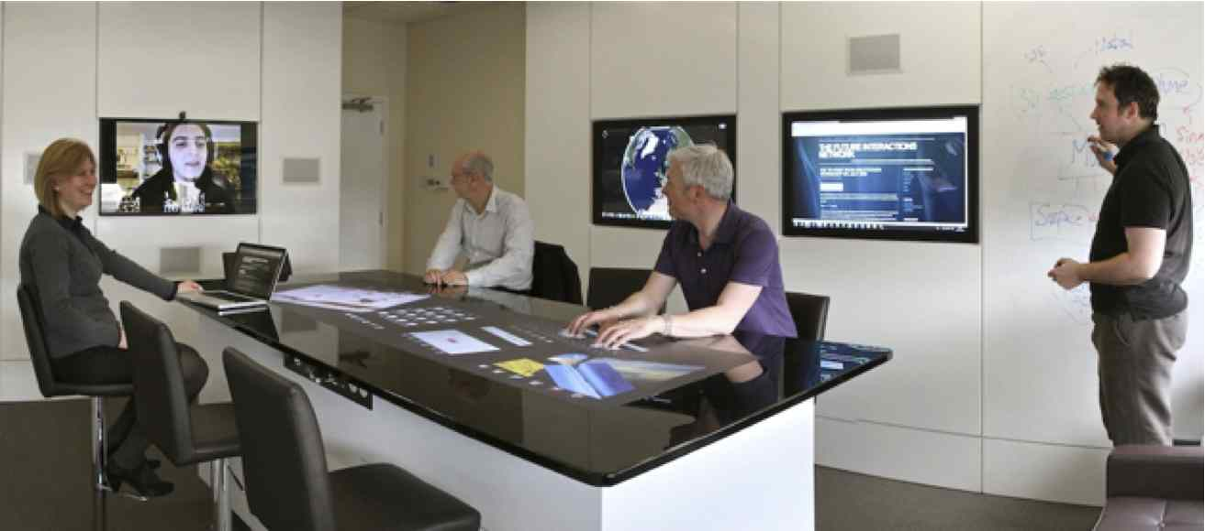

Fig.3 The ICE Showing the table, wall screens and interactive whiteboards

The ICE is a meeting room, with an interactive boardroom table, interactive whiteboard walls and five wall mounted multi-touch screens (Figures 3 and 4). The ICE is first of all a functioning meeting room and is used daily for meetings, presentations and teaching. However, it is also a space that brings together cutting edge technologies into a unique configuration. It is a glimpse into the future of meeting rooms and office spaces when multi-screen, multi-touch and multi-user spaces are increasingly common.

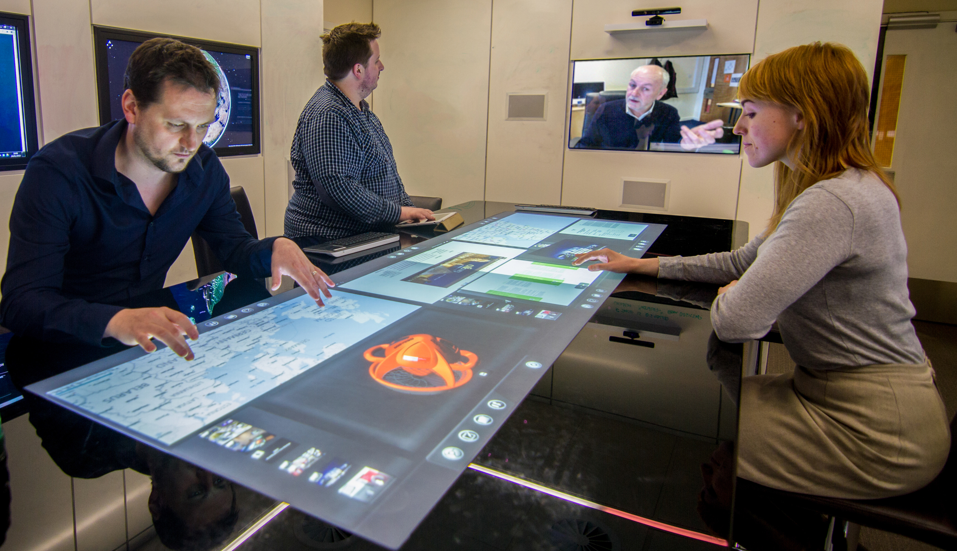

Fig. 4 The ICE in use showing zoned table interface and remote participant.

Our philosophy in creating the ICE was to provide a new space for interaction, a new physical space and a new digital space. From these new spaces, people would find a new conceptual space where they would be able to undertake new activities, or undertake traditional activities in new ways that would lead to new insights. We describe these as blended spaces because the aim is not simply to mix the physical (or the analogue) and the digital, but rather to design a space that brings the physical and the digital together to enable new user experiences. The blended space has new properties that emerge from the right physical-digital blend and people will do things in new ways and get new insights into situations.

## The physical space

The physical space that was available for the ICE was an empty office, so the design started with a room, a vision and a budget. After extensive research into the options available we settled on the following technologies. A 46” n-point HD (1080p) multi touch LCD screen mounted on the end wall of the room. This screen uses the diffused illumination (DI) method for detecting multi-touch and is capable of detecting finger and hand orientation as well as distinguishing between different users’ hands. A bespoke 108” n-point multi-touch rear projection boardroom table, also using DI is the centrepiece of the room. The table can recognize and interact with objects placed on its surface such as mobile phones, laptops or books using infrared fiducial markers. It has 2 patch panels on either side allowing the connection of USB peripherals and storage devices as well as any external DVI or VGA video source, such as a laptop or tablet, to any of the surfaces.

The table height is 900mm, which is the standard ergonomic height for stand up work surfaces (such as kitchen worktops). Eight swivel bar stools surround the table. Four 42” HD (1080p) dual point multi-touch LCD screens utilizing infrared overlays are mounted on the room’s side walls. The walls are augmented with the Mimio™ system to serve as digital whiteboards, thus when something is written on the whiteboard it is automatically digitally captured. The design encourages people to slip off the stool and stand up and move around, or swivel round to see the screen behind them. The end wall is a window with electrically controlled blinds and the lighting can be varied to create different atmospheres, all controllable via a Crestron™ control system available as a software application on any of the touch surfaces and by a dedicated panel by the room entrance.

## The digital space

The ICE hardware has been selected to offer the widest range of development and design opportunities and as such we have remained platform agnostic. To achieve this, all the hardware runs on multiple operating systems (Mac OS X, Windows 7 & 8, Linux). Alongside the standard development environments are the emerging options for multi-touch, central to which is the Tangible User Interface Objects (TUIO) protocol, an open framework that defines a common protocol and API for tangible multi-touch surfaces.

A key design issue for the software is that there is no complex software architecture required. All applications are available at the top level; the TUIO protocol means that any device running it can interact with other devices running it. This allows for easy integration of mobile devices into the room and sharing control across devices. Since everything in the room is interconnected through the Internet, the room demonstrates how such sharing of content and manipulation of content could be physically distributed.

In terms of software, the ICE makes extensive use of freely available 3rd party applications and services such as Evernote™, Skype™, etc. A key design decision for the ICE is to keep it simple and leverage the power of robust 3rd party services. One particularly important application is Dropbox™, which is used to enable the sharing of content across devices. Since the Dropbox™ service is available across most devices; any content put into one device is almost immediately available on another. For example, take a photo on an iOS or Android device and it is immediately available on the table and wall screens. Essentially Dropbox™ works as the synching bridge across all the separate computers driving each surface, which enables a seamless “shared repository” experience for users.

The room has 8-channel wireless audio recording for 8 wearable microphones as well as 2-channel recording for 2 room microphones. Each audio channel can be sent individually to any chosen destination (either a computer in the ICE or to an external storage via IP) or combined into a single audio stream. A webcam allows for high definition video (1080p) to be recorded locally or streamed over IP. A Microsoft Kinect mounted on the end wall allows for gesture-based interaction.

## The blended space

The blended space brings the physical and digital spaces together. It is where people have to conceptualise what this new space allows them to do and how they frame their activities in the context of that understanding. There are a lot of novel concepts to be understood. For example, people need to understand that the screens on the walls are not computers, but are windows onto data content in the cloud. They will recognise the Internet Explorer icon on a screen and rightly conceptualise that this gives them Internet access, but they may not realise that they can save files to a shared Dropbox™ folder and hence enable files to be viewed through different screens. They need to conceptualise the wall screens as input and output zones that can show different views at different times. People who have used the ICE a few times come to understand that they can see an overview of some data set on one screen and the detail on another and that this is useful for particular activities. The wall screens can be easily configured to mirror each other, or to show separate content. We can summarise our ICE through the lens of blended spaces as illustrated in Figure 5.

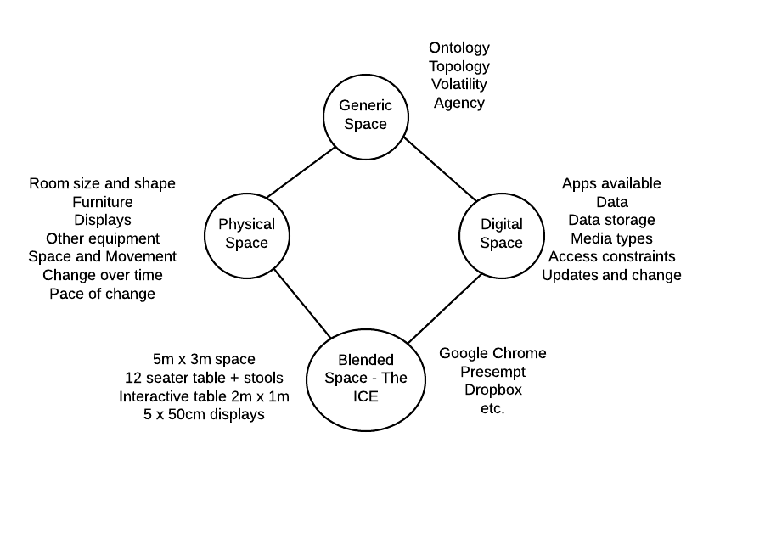

Figure 5 The ICE as a blended space

The challenge for spaces such as the ICE is that people do not have a mental model, a conceptualization, of the space when they first arrive. It is up to the designers to present an informative, coherent image of the system that enables people to develop an appropriate conceptual understanding of the opportunities. For example we developed a control room map (Figure 6) to help people conceptualise the interaction between the different screens and how any screen could be the source of an image displayed on any number of other screens. This is one example of an attempt to provide a way into the conceptual space. Restricting the functionality of the digital space and providing this through a few familiar icons is another.

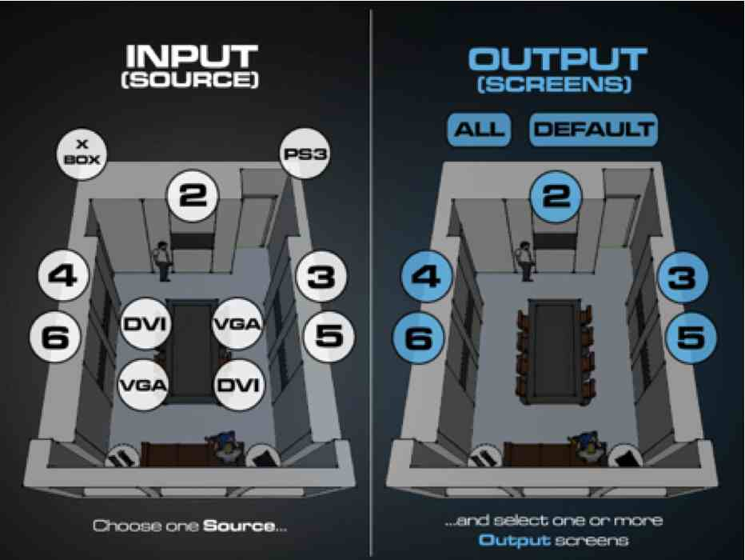

Figure 6. The control room interface to control inputs and outputs

# The TACIT Framework

We have now had the opportunity to observe many meetings of many different types in the ICE. It is a space that encourages people to get up and move to one of the screens to demonstrate something, or use the whiteboard capabilities of the wall surface to illustrate ideas. The room is highly flexible in terms of lighting, audio and the use of the blinds. Thus the atmosphere can be quickly changed as required. The ability of people to easily join in the room using internet-based video-conferencing has proved an important feature.

The room certainly encourages collaboration and participation. With five screens it is very natural to have documents displayed on one or two, web searches on another and perhaps YouTube videos on another. However, it is also true that many people find it difficult to conceptualize what the room can do and how they can make it do things. This serious challenge for interaction design — how to get people to understand the opportunities afforded by novel interactive spaces — remains stubbornly difficult to solve.

## Methodology

During the period of use of our ICE, we have used it for several undergraduate and post-graduate projects, focusing on specific interaction issues such as menu design for a large table, gesture design, allocation of control between users, the design of media browsers, designing for people (who have comparatively short arms and fat fingers) and exploring tangible interaction on the table and gesture interaction with the end wall screen. We have had data displays for micro chip manufacturers, looked at interactive visualizations of crime data and at medical image analysis and diagnosis. The meetings that we have observed have included conference organisation meetings, preparing research grant proposals, publicity preparation, teaching interaction design, remote viva voce examinations and numerous general business meetings. A controlled study of the ICE has been completed that included a grounded approach to analyzing video, interview and questionnaire data and a survey of user attitudes to the ICE has been completed. This study produced a list of nine constructs that applied to interaction in our ICE from an initial list of thirty-five codes.

We have, of course, experienced the ICE ourselves in our own meetings. We have formally interviewed users of the ICE and informally discussed issues with colleagues who have used it. We have dealt with the technical issues on changing university infrastructures that interfere with IP addresses and internet access. We have tried to balance ecologically valid investigations with the controlled study and with invented scenarios of use.

Against this background five themes have emerged from our analysis of the ICE in use that provide a way of structuring the issues that have arisen and that designers of room environments need to deal with. These reflect the main concerns identified in previous literature on collaborative environments but also highlight new issues with surface computing and BYOD environments. We present the issues of designing ICE type blended spaces in terms of territoriality, awareness, control, interaction and transitions between spaces; the TACIT framework.

## Territoriality

Territoriality concerns spaces and the relationships between people and spaces. Scott and Carpendale (2010) see territoriality as a key issue in the use of tabletops (both traditional and interactive) for cooperative work. They identify personal spaces, group spaces and storage spaces. They also point to the importance of orientation, positioning and proximity in addition to the partitioning of spaces into different regions. These all contribute to people’s sense of territory and their relationships with their space. Territory is also important on large multiuser displays (Peltonen, et al., 2008). There are many social and psychological characteristics of territories that designers need to consider such as proxemics (Greenberg, 2011) and how comfortable people feel when they are physically close to others.

Issues of territoriality are central to working in the ICE and we have witnessed many examples of groups configuring and reconfiguring their spatial relations depending on the task. We have observed incidents where people cluster around a wall screen watching one person working and commenting on what is going on before going back to work individually. Orientation is central to tabletop interaction as often some people will be viewing something upside down unless the screen can be configured in a suitable manner. People have commented that being able to work in different places in the room helps collaboration and moving around in the room makes collaboration easier. In our experience designing other collaborative environments, people may be moving through the physical space and issues of flow become important.

We have seen a number of incidents where the assignment of roles and tasks is influenced by location and proximity to a particular piece of technology. The role of penholder in brainstorming tasks may be assigned to the person sitting nearest to the whiteboard. Participants tend to use the wall-screen nearest to them and the person interacting with the tabletop applications at the table was the person sitting nearest the controls at the bottom edge of the screen. There is often a close connection between the control of physical space in the environment and the control of screen workspace, which in turn affects the assignment of roles and tasks.

The tabletop in the ICE can be configured in different ways and there is one setting that has six individual places each with a digital keyboard and media browser. This allows people to have their personal space and then to move work into a public sphere when they are ready. Haller, et al., (2010) emphasise the importance of these different spaces in their NiCE environment. Personal spaces are provided through individual PCs and through personal sketching spaces. These can be shared with the group through a large wall display. In earlier contributions to collaborative spaces, Buxton (2009) describes media space in terms of the person space, task space and reference space and provides a number of design guidelines for ensuring quality spaces. It is the intersection of these and the ease of moving between them that is important.

## Awareness

The issue of awareness is a common central theme running through the literature on cooperative work (e.g. Tang, 1991) and is a central issue for ICEs. The concept of awareness hides a large amount of complexity. Schmidt (2002) lists seven common adjectives often attached to the word ‘awareness’ such as peripheral, background, passive, reciprocal and so on. He goes on to explore the concept in detail, finally arguing that “the term ‘awareness’ is being used to denote those practices through which actors tacitly and seamlessly align and integrate their distributed and yet interdependent activities”. Awareness includes aspects of attention and focus, so explicit awareness of what others have done is also an important aspect. Awareness is much more than simple information, however. It is to do with the social aspects of how people align and integrate their activities. Awareness is an attribute of an activity that relates to many of the characteristics of a situation. Rogers and Rodden (2003) also emphasise the importance of dealing with different types of awareness and with the transitions between them (see section 4.6).

In the ICE, different tasks invite different degrees of awareness. For example, brainstorming tasks require shared attention whereas an individual searching the web on a wall screen does not. Tasks that can be undertaken in parallel may need support to keep others aware of progress and when the task is completed. Several people have commented that a shared Dropbox™ folder is useful for maintaining awareness as it gives real time information on the progress of the work of the other participants; images dragged into Dropbox™ on a screen soon appear in Dropbox™ on the table.

Even during individual tasks there are frequent shifts between shared and divided attention with people participating in discussions in a group across the room and then turning their backs to individually search for images and information on the wall screens. When collaborating in a shared physical environment like the ICE participants become aware of each other’s activity through direct perception. People are able to see and hear each other as they work at the surfaces, moving around the room or talking to other participants. Writing on the whiteboards enhances awareness and collaboration and allows people to use gestures to refer to specific objects or the organisation of objects on the surfaces.

The various surfaces support collaboration through awareness differently. There have been instances where participants grew silent while working on the wall screens and focused on their own tasks loosing awareness of what was going on in the room behind them. Working around the table creates a higher degree of shared awareness; one of the advantages of table displays with respect to collaboration as elaborated by Rogers and Lindley (2004).

## Control

Control refers both to the control of the software systems and to social control of the collaborative activity. Yuill and Rogers (2012) highlight the importance of control in their discussion of collaborative systems. This is related to the concepts of access points (see below). Rogers and Lindley (2004) also identify control as one of their factors describing collaborative environments along with awareness, interaction, resources, experience, progression, team and coordination.

In the ICE we have observed people taking turns to interact with the table with only one person touching it at a time in order to maintain control. However, some of the software on the table has a lack of support for multi user interaction and this creates issues with conflict of control. It is easy for one person to enlarge a display (often accidentally) so that it covers the whole of the tabletop and the whole workspace and all the objects on it are covered over. People have adapted to this by taking turns interacting with the table.

A common configuration of the input and output structure is to have two screens mirroring each other on opposite sides of the table. However, whilst this helps awareness, it can negatively impact control. One person may have started interacting with a screen without realising that another person was using the mirrored screen and hence takes over control of the pair of mirrored screens.

Often people sitting at the “bottom side” of the interface near the controls were also the ones who controlled and interacted with the application. However we also observed incidents where people are working at the table from both sides without regard to the orientation of the application. The location of the controls on the bottom edge at the lower left and right side of the screen demonstrated a “short arm problem”. Due to the size of the table’s screen, it is impossible for someone standing at the centre of an edge of the screen to reach the corners without actually moving his or her body to the left or right. This also gives rise to a mode of collaboration where the participant standing near to the controls would press buttons at appropriate times.

Control is a key component of Yuill and Rogers (2012) framework for collaboration. The locus of control is closely related to the access points provided by the technology. Their main focus is on aiming for equitable control in a collaborative setting and they emphasise that the location of access points and how people move between access points is critical.

Control, and people’s understanding of what they can control is key to ideas of appropriation and ‘tailoring culture’. People need to be encouraged to understand that tailoring is possible in an ICE organizationally, technically and socially. This tailoring, or customization is an essential part of the appropriation of technology and of spaces. People need to adapt, and shape the environment, the interactions, the content and the computational functions that are available to suit their ways of working. However, this is easier said than done. People have to be confident and capable to appropriate their technological spaces. They need a conceptual understanding of the digital and physical spaces so that they can change their ways of working, and designers need to design to support appropriation and the formation of an appropriate conceptualization of the space.

## Interaction

This theme concerns how people interact with each other and how they interact with the activities they are undertaking. It is concerned with the user interfaces, with usability, accessibility and the articulation of tasks between collaborating individuals and groups. Different surfaces in the room can be used for different tasks. The users’ familiarity with the room, their experience with working on touch screens, their prior knowledge of each other and experience in working together are all factors in producing the different conceptualizations of the ICE and hence the best ways to interact. People do things in different ways and the variation in the use of the room and its facilities indicates that the environment effectively supports this variety.

The ICE supports articulation as it affords the distribution and execution of subtasks. The physical layout of the room gives easy access to workspace and this makes coordinating tasks easy. We have also seen numerous, and at times very rapid, shifts in the social organisation of work. For example, people will shift between working individually at the wall screens and turning around to communicate across the room as a group. Shifts also occur when people go to the wall screens to search web for information during a discussion or the execution of a task only to return to the group when information is found. Also while working at the table there is a variety of ways to organise the work. The parallel tasks of searching and sorting can be accelerated if the group divides itself into subgroups. This may be contrasted with serial tasks such as putting collaborative projects together.

We have observed tasks being distributed by negotiation through verbal communication, but also seen people spontaneously go to a surface and start doing a task. We also observed how roles and tasks were handed over simply by turning around workspace on the table surface.

Interaction is one of the four components in the model of collaboration discussed by O’Hara et al. (2011) along with work, communication and service. They emphasise the importance of getting the granularity of the space right. The interplay between the spatial configuration, the social organisation and interaction is critical. O’Hara, et al. discuss their blended interaction space (BISi) as an example of workplace design, once again emphasising proxemics in design and the control and set up of work tools as an essential part of the interaction.

## Transitions

Blended spaces are rarely completely integrated (Benyon, 2012). Instead there are touch points where the digital and physical are brought together and where people transition from the digital to the physical or vice versa. In the context of blended spaces such as the ICE people transit from the physical to the digital and back again as they use personal and shared devices to access digital content and bring this into the physical world of displays and discussion.

Discussions with users of the ICE indicate that the physical layout of the room gives easy access to different workspaces. It seems to be less clear whether the individual platforms (whiteboard, wall screens or table) were easily accessible for all people. For example, the placement of the whiteboards at the corners of the room has been suggested as a problem limiting the physical access to the board, and others have argued that seeing objects from different perspectives when working on different sides of the table is a problem. However transitions between different digital spaces (e.g. personal laptop and shared screen) are often more difficult.

Transitions between spaces and between the physical and the digital are identified by Scott, Grant and Mandryk (2003) as a significant feature of tabletop interaction. Yvonne Rogers and her colleagues in a number of publications (Rogers and Lindley, 2004; Yuilli and Rogers, 2012) describe these transitions in terms of access points, or entry points. They find that people are excluded from equitable participation in collaborative activities because of difficulties in gaining access to the physical environment, or the digital environment or both, or in moving between the physical and the digital. In the Shared Information Space framework they offer advice on removing barriers to access and enabling entry points that provide a good overview of the space and the opportunities to move between locations in the spaces.

A series of transitions can be seen as a trajectory through the blended space in the sense that Benford et al. (2009; 2011) discuss in the context of spectator interfaces. Benyon (2014) discusses this in terms of navigation of blended spaces. Designers need to focus on the ease of transitions, on providing clear signposting that transitions are possible and on the overall UX of moving through the space.

## Summary

Many of the issues that we have witnessed and recognized as being key to collaborative activity in ICEs have been reported in the literature before. We think it is useful, though, to bring them together into the TACIT framework as a source of guidance for the designers of such spaces. We can also bring this framework together with the idea of blended spaces to look at the key design decisions that designers need to take on board. These are summarized in table 1.

The blended spaces framework encourages designers to think about the ontology (the objects in the digital and physical spaces), the topology, volatility and agency of all three spaces – the physical spaces, the digital space and the blended space.

|  |  |  |  |
| --- | --- | --- | --- |
|  | **Physical space** | **Digital space** | **Blended space** |
| **T**erritoriality | Design to ensure equitable access to the physical spaces and the physical location of technology spaces. Consider personal and social aspects of the spaces and proxemics. | Design so that people have private spaces, a public space and storage spaces. Distinguish single and multi-user spaces. Besides digital storage, provide easy access to applications to support communication and coordination. | Provide maps and other information resources to help people understand the ontology and topology of the spaces and how they are linked together. Provide clear indications for the different types of space and how to navigate the different spaces. |
| **A**wareness | Design so that people can monitor what others are doing and can attend to collaborative activities when they have to. Allow people to maintain awareness of changes in the situation. | Design so that people are aware of their collaborators’ progress. Provide a clear structure for access to appropriate functionality and media content. Provide alerts to indicate changes. | Understanding what others are doing and what opportunities for action the spaces offer are central. Make people aware of the volatility of the spaces, particularly how the digital spaces are changed. |
| **C**ontrol | Allow movement to enable people to move into positions of control. Design for access to the physical space and different parts of the interactive surfaces. Support different types of control for different activities. | Design software so people can see who is in control and to support multi-user interaction and shared digital areas. Allow people to keep control of their personal territories. Synchronization across digital spaces is an issue. | Understanding the relationships between multiple devices and shared digital spaces can be very difficult. Design clear and effective mechanisms to take and pass on control. Indicate clearly who can do what with which objects and what time. |
| **I**nteraction | Allocation of tasks between individuals in a group and providing access to interaction resources is central. Social aspects of physical interaction need to be considered, for example, maintaining private spaces. | Interacting with software tools and media content and how this is distributed across different people is the central concern. Design at a human scale to accommodate short arms, fat fingers and people’s height. Pay attention to the interfaces, consistency and usability. | This concerns understanding opportunities for agency such as what to use the digital and physical spaces for and understanding what alternatives there are. People need to develop a rich understanding of the opportunities of the blended space so that they can engage in interaction in appropriate ways. |
| **T**ransitions | Moving between physical spaces needs to be easy and understandable. Transitions between the physical and digital spaces need to be well sign-posted. | Getting access to the digital spaces depends on having shared access facilities (such as Dropbox or similar). Transitions between different devices remain a difficult problem. | Understanding how to move between physical and digital spaces and where this can take place is central. The topology needs to provide clear access points to provide opportunities to gain an overview of the space and to see clear paths to different locations. |

Table 1 Key issues for designers in developing ICE environments

# Case Studies

In order to illustrate our approach to designing ICE environments and the role that the blended spaces construct and TACIT framework play in this process, we provide two real-world case studies. The aim is not to show all the TACIT themes at work in all the situations, but rather to show how these themes provide a good coverage of the issues that designers of ICEs face. The case studies also demonstrate the importance of looking at the four characteristics of blended spaces when designing ICEs.

In March 2012, the authors were commissioned by a large multi-national pharmaceutical company to consult on their meeting space strategy and design a series of prototype spaces to enhance their creative and collaborative practice both locally and remotely. As dictated by our methodology (Mival and Benyon, 2013) before any design work was undertaken a period of ethnographically informed requirements gathering was undertaken via a series of observation periods, interviews and workshops. This process involved a wide range of staff from different departments within the organization (including scientists, administrators, project and finance managers as well as support staff from both IT and facilities services) across a period of 3 months and two of the UK campuses.

The first prototype ICE was intended as a real world test-bed to serve as a template for the development of subsequent similar spaces as the company rolled out refits of their various assets. Here we discuss two of the implemented spaces; the first, referred to as 11G2, was intended for use for collaborative meetings with external clients, the second, 11S8, for internal meetings.

## Meeting Room 11G2

Deployed in August 2012, 11G2 (shown in figure 7) had a physical space of a 10 person meeting room. The key objects in the pace were the tables, chairs and the walls. This afforded a design of the digital space that placed on 55” screen on the end wall and two 42” screens on either side wall. Wireless keyboards and mice were available to interact with the screens. A Crestron™ control panel was mounted on the left hand wall. Thus the blended space here used an immersive and interactive 3 zone, 5 multi-touch screen model which mirrored the source on zones 2 and 3 (of the 4, 42” wall screens) to enable interaction with multiple information from either side of the conference table. Zone 1 is the large 55” screen on the central feature wall and is for primary content such as traditional single person led presentations and video conferencing).

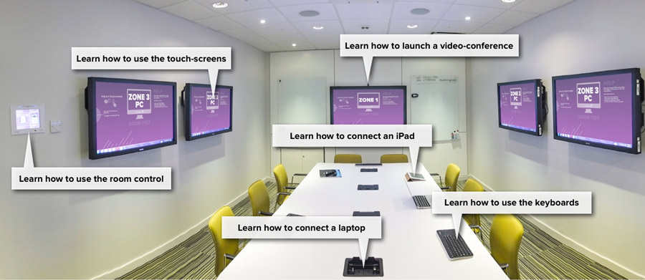

**Figure 7 Room 11G2: Screenshot from support site showing the physical layout and information access points.**

Each Zone used a dedicated high spec PC running Windows 7 locked in a cabinet to prevent unauthorized access. Above the large Zone 1 screen a 1080p HD webcam provided video-conferencing capability along with ceiling mounted speakers and microphones. The central table housed power sockets, plus integrated VGA, DVI and Ethernet cables to connect to the screens and organizational network. In addition to the, a BT HomeHub wireless network was installed enabling external clients to connect to the space and the internet but providing no access to the organisation’s intranet.

In terms of agency, one of the central functional briefs for 11G2 was to facilitate “on-the-fly” multi-party video conferencing with remote mobile participants who were potentially from other organisations. GoToMeeting™ was selected as the video-conferenceing software as it provided the most stable connection during testing with the organization and selected partners allowed up to 16 HD video streams plus up to 24 seperate party connections across a multitude of devices and OS platforms.

The Room Control interface was designed to be simple and focus on task activities that the room was designed for. The default setting was the three Zones, the wallpapers of which provided a clear, simple, graphical introduction to the room’s functionality (as illustrated in Figure 8).

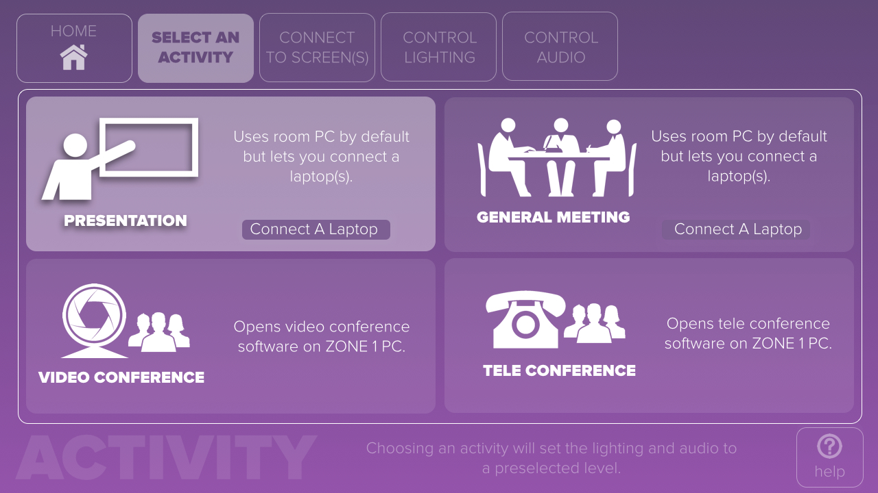

**Figure 8 11G2 room control interface available via dedicated touch panel or as an app.**

Lighting in both spaces were configured to enter default states automatically based on context (ie on entry if dark it goes to a default setting) as well as having physical buttons next to the screen based control panel. The capability of lighting to be used as an ambient notification system was deployed in 11S8 where a colour wash lighting effect behind the screens was used to indicate room state eg amber = “meeting nearing end of booking time”, red = “next meeting overdue”. The colour wash would flash red when the next participants arrived (initiated by a button on the outside door) thus communicating to the participants the difference between whether they were running over (red) or holding up the next meeting (flashing red).

## Meeting Room IIS8

The desired agency of IIS8 focused on high level management brainstorming and ideation activities. The physical space was designed to house a particular type of digital space, so in this case the physical and digital spaces could be designed together.

The table in 11S8 was specified to be at worktop height (similar to the our own ICE). Interestingly the organisation choose not to implement this specification on grounds that the space would be used by very senior external clients and they did not wish them to use stools but rather traditional meeting chairs. This profile alt was decided by the organization to deploy high quality glass whiteboards rather than the digitally enabled “write-anywhere” walls in the original ICE. Glass whiteboards were also deployed in 11S8 however they were much larger in size to facilitate multiple users working simultaneously. Indeed the ontology and topology of 11S8 (shown in Figure 8) differed in other important ways from 11G2 even though the overall functional agency in both spaces were similar.

The most significant differences are the use of 4 multi-touch screens in a linear rather than immersive arrangement, and the use of a worktop height standing desk with no chairs. The philosophy behind the space was to provide the organisation with an environment tuned more to short (1 hour maximum) brainstorming and ideation processes and less to the more traditional analysis and presentation activities served by 11G2. The three 55” 1080p optical multi-touch screens on the left of Figure 8 were split into 3 “information” Zones on which digital resources could be placed and manipulated and to which participant’s devices could be connected wirelessly. The larger 70” 4th multi-touch screen was a Smart 8070i that enabled digital inking and connection to similar devices across the organisation’s internal global network. An HD PTZ (pan tilt zoom) camera was present above the middle of the 3 smaller screens and could be used for video-conferencing via the organisation’s internal Polycom™ system or via 3rd party services such as Skype™ and Gotomeeeting™, the zoom enabled participants to show in high resolution anything written on the analogue glass whiteboards opposite. The provision of both analogue and digital inking options was a decision influenced by the role of 11S8 as a test-bed facility.

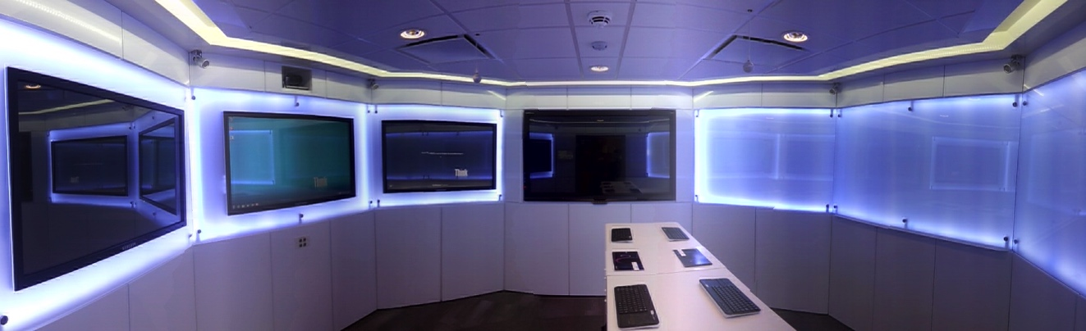

**Figure 8. 11S8: An internal collaborative space designed for “stand up” brainstorming and ideation meetings with remote participants.**

Whilst Room 11G2 provided wired connections for devices such as laptops to connect to the screens, a wireless solution was also provided in both 11G2 and 11S8 using the AirServer™ application. Running on the host PC of each Zone, the application allowed anyone on the guest wifi network to mirror the screen of their laptop or iOS mobile device where it would appear as an AirPlay resource in the same way as an Apple TV would be seen in a consumer’s living room.

To further aid the users of the spaces understanding of both topology and agency, a map model visualization was used in the Room Control interface (shown below for Room 11G2 in figure 9), similar to that used in the original ICE and discussed in section 3.3.

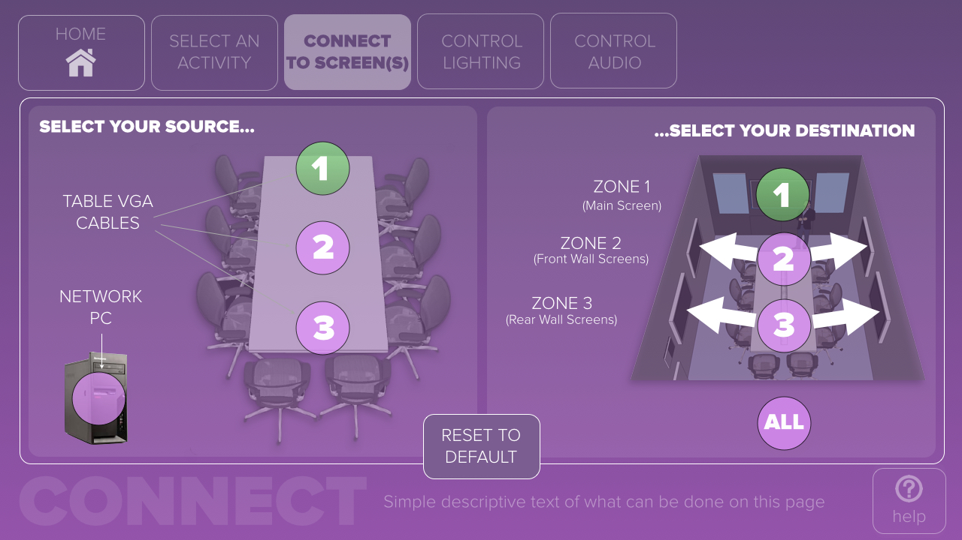

**Figure 10. 11G2 room control interface using a visualization of the spatial layout and conceptual connection of sources to facilitate topological and agency understanding of the space.**

The lighting in both spaces was configured to enter default states automatically based on context (ie on entry if dark it goes to a default setting) as well as having physical buttons next to the screen based control panel. The capability of lighting to be used as an ambient notification system was deployed in 11S8 where a colour wash lighting effect behind the screens was used to indicate room state eg amber = “meeting nearing end of booking time” (seen in Figure 11), red = “next meeting overdue”. The colour wash would flash red when the next participants arrived (initiated by a button on the outside door) thus communicating to the participants the difference between whether they were running over (red) or holding up the next meeting (flashing red).

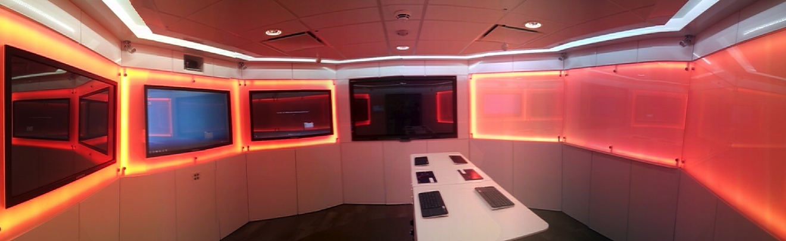

**Figure 11. Room 11S8 used a background colour wash created by LEDs to indicate the room’s current booking state, here I shown in amber to indicate “allocated meeting booking ending soon”.**

To further help with establishing the agency of each space, each made use of large format, simple and beautiful physical and digital signage to help facilitate and communicate the room functionality. Opening any web-browser showed the space’s home page with simple, clear instructions (see figure 7 for the example of 11G8). This included clear signage of the room control panel, the Zones, the Table (eg location of power sockets etc) and screen connections (eg “Plug in your USB key here” with an arrow). The digital signage was complemented by physical signage using vinyl lettering which is cheap to order and simple to implement and update but enables clear, immediate identification of certain functions (eg connect laptop).

## The Spaces from a TACIT perspective

In room 11G2 the issues of territoriality conform very much to the original ICE with the mirrored Zones enabling 3 discrete areas of simultaneous digital interaction. 11S8 has 4 digital zones rather than 3 but it does not have the mirrored configuration. This is because the division of the room is more explicitly about exploring and consuming digital media on the left hand side (as seen in Figure 8) and ideating with analogue territories (namely the whiteboards) to the right. The large digital Smart board in between the two areas in many ways serves as a transition between the two activities but in the reality of use, was found to more commonly be used as a central “control” territory where top level information would be shown (for example project briefs and details or meeting agendas).

The table in both spaces was a grounding point for the participants collective awareness of shared tasks (as is the case of many more traditional spaces), where if groups split to undertake different distributed tasks (such as ideating on a whiteboard and searching for relevant digital information and artifacts) the table was the “muster point” when communicating the output between groups. This was far more prevalent in 11S8 where such distributed activities were central to the usage of the space compared to 11G2 which tended to have different tasks been undertaken by all those present around the table.

The use of a contextually driven task focused design for the Room Control interface was explicitly intended to reduce the complexity of interaction and configuring the spaces for specific activities versus interacting “on-the-fly”. This proved particularly popular with users of both spaces who found this approach saved time and the requirement of technical knowledge on how to change lighting and audio levels etc. It was also clear to see that the standing room only approach of 11S8 actively encouraged direct touch interaction with the screens versus the more traditional keyboard-mouse interactions of the mostly seated participants in 11G2 meetings. This was likely to also be due to the more analytical and decision making activities undertaken in that space versus the more exploratory and ideating activities of 11S8, which in turn drove the types of interactions users had with the components of both spaces.

# Conclusions

ICE environments are examples of blended spaces that require designers to consider the digital space and the physical space together. In integrated room environments new experiences will be created if the blend is thoughtfully considered and if the principles of blends are applied to create emergent properties and a good UX. The TACIT framework — derived from our own experiences and those of other researchers and designers — orientates designers to the key issues that need to be considered in ICEs; territoriality, awareness, control, interaction and transitions.

Our own design methodology (Mival and Benyon, 2013) reflects the fact that every use case for an ICE is different. One reason for applying blending theory and the TACIT framework to the design of ICEs is to help designers deal with the variety of physical and digital spaces that they will be dealing with. Five general steps are needed to design ICE type environments. First, identify and understand the purpose of the ICE in terms of the types of activity that are to be supported. McCullough (2012), for example, provides a typology of activities such as deliberating, presenting and designing that can help designers focus on the overall purpose of an ICE. Examine the current practice and focus on the existing activities, the problems that people are having and the devices that people bring with them. Determine the project constraints. Determine appropriate technologies for the space (the digital space). Model and map the physical space including layout, furniture and lighting and environment control.

With this background designers can design the blended space. Understand the main objects in the spaces (the ontology) and how they are to be related to one another (the topology). Understand how things change within the spaces (the volatility) and understand what people need to do (the agency). Develop the space utilizing the concepts in designing with blends, aiming for an integrated blended space that deals with the known issues of collaborative environments of territories, awareness, control, interactions and transitions (TACIT). Recognize that your users will use conceptual blending when they come to use the space, bringing their background knowledge of computers, multi-touch domestic devices, domestic media players and naïve networking knowledge. Provide information to help people understand the opportunities afforded by the new blended space.

# ACKNOWLEDGMENTS

Grateful acknowledgements are extended to all those who have worked on and in the ICE.

# REFERENCES

Ackerman (2000) The intellectual challenge of CSCW: the gap between social requirements and technical feasibility Human-Computer Interaction 15 (2-3) 2000 pp. 181 - 205

Benford, A. Crabtree, M. Flintham, C. Greenhalgh, B. Koleva, M. Adams, N. Tandavanitj, J. Row Farr, Giannachi, G. and I. Lindt, (2011) Creating the spectacle: Designing interactional trajectories through spectator interfaces. *ACM Trans. Comput.-Hum. Interact.* 18, 3, Article 11 (July 2011)

Benford, G. Giannachi, B. Kolva and T. Rodden. (2009) From interaction to trajectories: designing coherent journeys through user experiences. In *Proc. CHI 2009*. ACM Press (2009), 709-718.

Benyon, D. R. (2014) *Spaces of Interaction, Places for Experience*. Morgan and Claypool.

Benyon, D. R. (2013) *Designing Interactive Systems* Pearson. 3rd edition

Benyon, D. R. and Mival, O. (2012) Designing Blended Spaces. In *Proceedings of Designing Collaborative interactive Spaces*. AVI Workshop, Capri, May. Available at <http://hci.uni-konstanz.de/dcis/> retrieved 12.12.14

Benyon, D. R. Mival, O. and Ayan, S. (2012) Designing Blended Spaces. *Proceedings of BCS-HCI '12****:***ewic

Benyon, D. R. (2012) Presence in Blended Spaces *Interacting with Computer*s 2012 24 (4) 219 - 226

Buxton, B. (2009) Mediaspace – Meaningspace – Meetingspace in Harrison, S. (ed) Media Spaces: 20+ years of mediated Life. New York: Springer

Dourish, P. (2001) *Where the Action Is*. MIT Press

Fauconnier, G. and M. Turner (2002) *The Way We Thin*k. Basic Books, NY, USA,

Fauconnier, G. (1997) *Mappings in Thought and Language*. Cambridge University Press, 1997

Greenberg S. (2011). Proxemics Interactions: The New Ubicomp? In Interactions volume XVIII.1 January + February

Grudin (1994) Groupware and social dynamics: eight challenges for developers. Communications of the ACM, 37, 1994, 93 - 105

Hall, E. T. (1966) *The Hidden Dimension*, Doubleday. New York

Haller, M. J. Leitner, T. Seifried, J. Wallace, S. Scot, C. Richter, P. Brandl, A. Gokcezade and S. Hunter, (2010) The NiCE Discussion Room: Integrating Paper and Digital Media to Support Co-Located Group Meetings In proc. CHI 10:

Hoshi, K. and J. Waterworth, J. (2009) Tangible Presence in Blended Reality Space. *Proceedings of Presence* conference

Hoshi, K. and J. Waterworth, J. (2009) Tangible Presence in Blended Reality Space. *Proceedings of Presence 2009* conference. Available t <http://ispr.info/presence-conferences/previous-conferences/presence-2009/>, retrieved 12.12.14

Hurtienne, J. and Israel, J. (2013) PIBA-DIBA or How to blend the digital with the physical. Proceedings of CHI workshop on Blended Spaces for interaction. Available at <http://hci.uni-konstanz.de/blendedinteraction2013/> retrieved 12.12.14.

Hutchins, E. (2005) Material Anchors for Conceptual Blends. *Journal of Pragmatics*, 37 1555 - 1577

Huynh, D., Xu, Y., Wang, S., (2006) Exploring User Experience in “Blended Reality”: Moving Interactions Out of the Screen, Work in Prog. CHI2006 893－898..

Imaz M. and Benyon, D. (2007) *Designing with Blends.* MIT Press, Cambridge, MA, USA.

Ishii, H. and Ulmer, (1997) Tangible Bits: towards seamless interfaces between people, bits and atoms. *Proceedings of CHI 97 conference* Atlanta ACM Press, New York. 234-241 .

Jetter, H-C, Dachselt, R., Reiterer, H. Quigley, A., Benyon, D. and Haller, M. (2013) [Blended interaction: envisioning future collaborative interactive spaces](http://dl.acm.org/citation.cfm?id=2468356.2479664&coll=DL&dl=ACM&CFID=379955790&CFTOKEN=23342562). In *Proceedings of CHI 2013, Extended Abstracts.* See also <http://hci.uni-konstanz.de/blendedinteraction2013/> retrieved 12.12.14

Jetter, H-C, Geyer, F., Schwarz, T., Reiterer, H. (2012) Blended Interaction – Toward a Framework for the Design of Interactive Spaces In *Proceedings of Designing Collaborative interactive Spaces*. AVI Workshop, Capri, May. Available at <http://hci.uni-konstanz.de/dcis/> retrieved 12.12.14

Johanson, B. A. Fox, and T. Winograd (2002) The interactive workspaces project: experiences with ubiquitous computing rooms *IEEE Pervasive Computing* 1(2), pp. 67-75.

Kendal, A. (1990) Spatial organization in social encounters: The F-formation system. In *Conducting Interaction: Patterns of Behavior in Focused Encounters*, A. Kendon Ed., Cambridge University Press, 209–237.

Markussen, T. (2009) Bloody Robots and Emotional Design: How emotional structure my change expectations of use in hospitals. *International Journal of Design* 3(2) 27- 39

McCullough, M. (2012) *Digital Ground.* MIT Press

Mival, O. and Benyon, D. R. (2013) A methodology for designing Blended Spaces. In Proceedings of Blended Spaces for Collaborative Spaces. CHI2013 Workshop, Paris, May 2013. Available at <http://hci.uni-konstanz.de/blendedinteraction2013/> retrieved 12.12.14.

Mokey, S., Nalbandian, A. and O’Keefe, B. (2013) Location as Interaction: Exploring Blended Spaces in the Global Village. *Proceedings of CHI2013 conference*

Nunamaker, JF. Dennis, A.R., Valacich, J., Vogel, D. & George, J. (1991). Electronic meeting systems to support group work. *Communications of the ACM,* vol *34, no. 7,* pp. 40

O’Hara, K., Kjelsko J., and Paay J., (2011) Blended Interaction Spaces for Distributed Team Collaboration *ACM Transactions on Computer-Human Interaction, Vol. 18, No. 1, article 3*

O’Keefe, B., Benyon, D., Chanwani, G., Menon M. and Duke II, R. (2014) A Blended Space for Heritage Storytelling. *Proceedings of BCS HCI conference*.

Olsen, J. and J. Olsen (2014) How to make distance work work. *Interactions* XX1_2 29 - 35

Olsen, J. and J. Olsen, (2008) Computer Supported Cooperative Work. In A. Sears and Jacko (eds.) *The Handbook of Human-Computer Interaction.* 2nd edition 2008

Peltonen, P. E. Kurvinen, A. Salovaara, G. Jacucci, T. Ilmonen, J. Evans, A. Oulasvirta, and P. Saarikko, (2008) "It's mine, don't touch": Interactions at a large multi-touch display in a city Center. In Proc. CHI'08 ACM Press, 1285-1294.

Plaue, C. J. Stasko and M. Baloga (2009) The conference room as a toolbox: technological and social routines in corporate meeting spaces. Proc. C&T 2009, ACM 95-104.

Rogers, Y. and Rodden, T. (2003). Configuring spaces and surfaces to support collaborative interaction. In *Public and situated displays: social and interactional aspects of shared display technologies*, K. O’Hara, ed., springer,

Rogers, Y. and S. Lindley, (2004) Collaborating around vertical and horizontal large displays: Which way is best to meet? *Interacting with Computers*, vol 16. No 6. 2004 pp. 11343 - 1152

Schmidt, K. (2002) The Problem with Awareness. *Journal of CSCW*, Volume 11, Issue 3-4, pp 285-298

Schmidt, K. and L. Bannon, L. (1992) Taking CSCW seriously *Computer Supported Cooperative Work* 1 (1): 7–40. 1992

Scott, S., Grant, K., and Mandryk, R. (2003). System guidelines for co-located, collaborative work on a tabletop display. In *Proc. ECSCW’03*. 159–178.

Scott, S.D., Carpendale, S. (2010). Theory of Tabletop Territoriality. In C. Müller- Tomfelde (Ed.) *Tabletops - Horizontal Interactive Displays*, Springer, 2010, pp. 375-406.

[Seow](http://portal.acm.org/author_page.cfm?id=81385592682&coll=ACM&dl=ACM&CFID=85261734&CFTOKEN=97863209), S. C. [D. Wixon](http://portal.acm.org/author_page.cfm?id=81416595092&coll=ACM&dl=ACM&CFID=85261734&CFTOKEN=97863209), [S. MacKenzie](http://portal.acm.org/author_page.cfm?id=81100367177&coll=ACM&dl=ACM&CFID=85261734&CFTOKEN=97863209), [G. Jacucci](http://portal.acm.org/author_page.cfm?id=81100644548&coll=ACM&dl=ACM&CFID=85261734&CFTOKEN=97863209), [A. Morrison](http://portal.acm.org/author_page.cfm?id=81331499954&coll=ACM&dl=ACM&CFID=85261734&CFTOKEN=97863209) and A. [Wilson](http://portal.acm.org/author_page.cfm?id=81350567780&coll=ACM&dl=ACM&CFID=85261734&CFTOKEN=97863209) (2009) [Multi-touch and surface computing](http://portal.acm.org/citation.cfm?id=1520340.1520736&coll=ACM&dl=ACM&CFID=85261734&CFTOKEN=97863209) In *Proceedings of CHI '09*:

Streitz, N. P. Rexroth and T. Holmer Does "roomware" matter? Investigating the role of personal and public information devices and their combination in meeting room collaboration *In Proc. CSCW 97,* 297-31, 1997

Tang, J.C. (1991). Findings from observational studies of collaborative work. International Journal of Man-Machine Studies, 34, pp. 143-160.

Turner, M. (1996) *The Literary Mind*. Oxford University Press

Turner, M. (2014) <http://markturner.org/blending.html#BOOKS> retrieved 14.03.14

Wang, H-H (2013) A case study on design with conceptual blending. *International Journal of Design Creativity*. Volume 1 pp 109 – 122

Wigdor, D., Jiang, H., Forlines, C., Borkin, M. and Shen, C. (2009) The WeSpace: The Design, Development, and Deployment of a Walk-Up and Share Multi-Surface Visual Collaboration System *CHI '09 Proceedings of the SIGCHI Conference on Human Factors in Computing Systems* 1237-1246

Yuill, and Rogers, Y. (2012) Mechanisms for Collaboration: A Design and Evaluation Framework for Multi-User Interfaces *ACM TOCHI*