EVALUATING, PREDICTING AND MAPPING BELOWGROUND CARBON STORES IN KENYAN MANGROVES
Selena K. Gress¹, Mark Huxham¹, James G. Kairo², Lilian M. Mugi², Robert A. Briers¹

¹School of Life, Sport and Social Sciences, Edinburgh Napier University, Sighthill Campus, Edinburgh, EH11 4BN, UK
²Kenya Marine and Fisheries Research Institute, P. O. Box 81651 Mombasa, Kenya

Corresponding Author: Selena K. Gress, School of Life, Sport and Social Sciences, Edinburgh Napier University, Sighthill Campus, Edinburgh, EH11 4BN, UK, selenagress@gmail.com

Keywords
Mangrove sediment, belowground carbon, mapping, coastal carbon stores, carbon loss

Type of Paper: Primary Research Article
Abstract
Despite covering only approximately 138,000 km², mangroves are globally important carbon sinks with carbon density values 3 to 4 times that of terrestrial forests. A key challenge in evaluating the carbon benefits from mangrove forest conservation is the lack of rigorous spatially resolved estimates of mangrove sediment carbon stocks; most mangrove carbon is stored belowground. Previous work has focused on detailed estimations of carbon stores over relatively small areas, which has obvious limitations in terms of generality and scope of application. Most studies have focused only on quantifying the top 1m of belowground carbon (BGC). Carbon stored at depths beyond 1m, and the effects of mangrove species, location and environmental context on these stores, is poorly studied. This study investigated these variables at two sites (Gazi and Vanga in the south of Kenya) and used the data to produce a country-specific BGC predictive model for Kenya and map BGC store estimates throughout Kenya at spatial scales relevant for climate change research, forest management and REDD+ (Reduced Emissions from Deforestation and Degradation). The results revealed that mangrove species was the most reliable predictor of BGC; Rhizophora muronata had the highest mean BGC with 1485.5t C ha⁻¹. Applying the species-based predictive model to a base map of species distribution in Kenya for the year 2010 with a 2.5m² resolution, produced an estimate of 69.41 Mt C (± 9.15 95% C.I.) for BGC in Kenyan mangroves. When applied to a 1992 mangrove distribution map, the BGC estimate was 75.65 Mt C (± 12.21 95% C.I.); an 8.3% loss in BGC stores between 1992 and 2010 in Kenya. The country level mangrove map provides a valuable tool for assessing carbon stocks and visualising the distribution of BGC. Estimates at the 2.5m² resolution provide sufficient detail for highlighting and prioritising areas for mangrove conservation and restoration.
Introduction
Coastal ecosystems, including seagrasses, salt marshes and mangroves, are an important carbon sink due to their high rates of primary production and their ability to bury carbon in refractory long-term stores (Nellemann et al. 2009). Mangroves cover approximately 138,000 km² globally (Giri et al. 2010).; although this accounts for less than 0.04% of the area of all marine habitats, 10-15% of marine organic carbon burial occurs in mangroves (Duarte et al. 2005; Breithaupt et al. 2012). Aboveground biomass usually accounts for a small proportion of the total carbon in mangrove ecosystems; the majority of it consists of stored organic carbon in the sediment (IPCC 2001). Mangroves typically grow in deep, tidally submerged sediments that support anaerobic decomposition pathways. These conditions facilitate slow decomposition rates and moderate to high sediment carbon concentrations. Whilst initial work suggested that mangroves typically store 3 to 4 times the sediment carbon of terrestrial forests (~800 Mg ha⁻¹ and ~250Mg ha⁻¹ respectively; IPCC 2001), more recent research shows that some mangrove forests may hold twice or more this quantity (Ezcurra et al. 2016 Fujimoto et al. 1999; Cuc et al. 2009; Donato et al. 2011; Kauffman et al. 2011).
Mangroves are receiving increasing interest as potential sites for carbon offset schemes such as those facilitated by REDD+ (reduced emissions from deforestation and degradation) in order to protect the large carbon stores within the sediment (Locatelli et al. 2014). However to do this, accurate estimates of the stores are required (Pendleton et al. 2012, Siikamäki et al. 2012). Since most studies to date consider sediment depths only down to 1m, the estimates for average mangrove sediment organic carbon (SOC) of between 479 t C ha⁻¹ and 1385 t C ha⁻¹ may be significant underestimates (Fujimoto et al. 1999; Cuc et al. 2009; Donato et al.2011; Kauffman et al. 2011). Tue et al. (2014) appears to be the only study that has attempted to estimate belowground carbon stores down to 4m (based on carbon concentration values at 1.5m – 2.5m).
At present the effects of variables influencing BGC are poorly understood, and further research is justified. Whilst some studies have treated mangrove sediments within forests as homogenous systems, others have found significant differences in BGC between different species (Lacerda et al. 1995; Alongi et al. 2000; Bouillon et al. 2003; Huxham et al. 2010; Liu et al. 2013; Wang et al. 2013; Sakho et al. 2014) and distances from the coast (Fujimoto et al. 1999; Donato et al. 2011; Kauffman et al. 2011). The geomorphological setting of a mangrove forest will potentially influence the import of allochthonous material, and the production and export of autochthonous material, through river discharge, tidal amplitude, wave power and turbidity (Adame et al. 2010; Saintilan et al. 2013; Yang et al. 2013) and therefore the effects of these variables may vary between sites. Fujimoto et al. (1999) and Donato et al. (2011) both found estuarine sites to have significantly higher average carbon stores down to 2m; approximately 250 t C ha⁻¹ more than coral-reef typesites (1074 t C ha⁻¹ and 1170 t C ha⁻¹ compared to coral-reef type sites with 990 t C ha⁻¹ and 750 t C ha⁻¹ respectively). Kauffman et al. (2011) found mangrove sediments closer to the seaward edge also had lower carbon stores; 479 t C ha⁻¹ and 1385 t C ha⁻¹ for seaward and landward sites respectively. Liu et al. (2013) reported highest BGC in Rhizophora stylosa forests compared to that of other species.
A key challenge in evaluating the carbon benefits from mangrove forest conservation is the lack of rigorous spatial estimates of mangrove sediment carbon stocks. Mapping the spatial distribution of belowground carbon has been of great interest as exemplified by the increasing number of publications in mapping (Saatchi et al. 2011; Baccini et al. 2012; Jardine and Siikamäki 2014; Viscarra Rossel et al. 2014). Attempts at modelling and mapping BGC stores in a variety of ecosystems have been made around the world: e.g. temperate forests/vegetation (Howard et al. 1995; Milne and Brown 1997; Arrouays et al. 2001; Wu et al. 2003; Tate et al. 2005; Guo et al. 2006, after initial work by Kern 1994; Yu et al. 2007; Bui et al. 2009; Rossel et al. 2014), tropical and subtropical forests (Bernoux et al. 2002; Batjes 2005 and 2008) and mangroves (Twilley et al. 1992; Siikamäki et al. 2012; Hutchison et al. 2013; Jardine and Siikamäki 2014). The most recent attempt to estimate mangrove belowground carbon at a global scale was by Jardine and Siikamäki (2014). Based on a compilation of sediment samples from 61 independent studies and using climatological and locational data as predictors, various predictive modelling alternatives were explored including machine-learning methods. Global mangrove BGC was estimated to be 5.00 ± 0.94 Pg C (assuming a 1 metre soil depth) however this was highly variable over space; BGC in carbon-rich mangroves was as much as 2.6 times the amount found in carbon-poor mangroves. Significant within-country variation was also present. In Indonesia, the most carbon rich forests contain 1.5 ± 0.12 times as much carbon per hectare as the most carbon poor forests. Liu et al. (2013) however did not find significant differences in BGC between mangrove sites within China. Whilst global models and maps are useful in informing a general understanding of theimportance of mangroves, assessments at the level of countries, regions and sites are required for practical management outcomes such as pin-pointing likely REDD+ locations and to better understand the drivers of variation in carbon storage.
Based on field work undertaken in two Kenyan mangrove forests (Gazi and Vanga), the current research had the following objectives:
1) To calculate belowground carbon stores (which we define to exclude live root biomass) down to 1 m and to mean sediment depths and to assess the relationships between a range of variables – including species composition, sediment depth, aboveground biomass (AGB) and location – and the amount of BGC present.
2) To compare results between Gazi and Vanga for site differences and to establish the significance and generality of environmental influences in order to develop a predictive model that allows estimates of carbon storage in other Kenyan mangrove forests.
3) To use spatial data to produce a map of belowground carbon stores throughout Kenya and an estimate of total belowground mangrove carbon stocks in the country.
4) To estimate the change in BGC in Kenyan mangroves between 1992 and 2010.

Methods
Study Sites
Sampling was carried out in Gazi Bay (latitude -4.43123, longitude 39.50346) and Vanga (latitude -4.65948, longitude 39.21847), Kenya. Gazi Bay sits 50km south of Mombasa and has a mangrove forest of 592 ha (Huxham et al. 2015). Nine of the ten mangrove species in East Africa are found in Gazi Bay; Avicennia marina, Bruguier gymnorrhiza, Ceriops tagal, Heritiera littoralis, Lumnitzera racemosa, Rhizophora mucronata, Sonneratia alba, Xylocarpus granatum and Xylocarpus molucensis. Gazi has been the site of many studies on mangroves including productivity, above and belowground biomass quantification, mangrove degradation and litter dynamics (Bosire et al. 2005; Kairo et al. 2008; Tamooh et al. 2008; Lang’at et al. 2012; Lang’at et al. 2014).
Situated at the most southern point of Kenya, the mangrove forest at Vanga is approximately 2351 ha (Huxham et al. 2015) and is dominated by Avicennia marina, Ceriops tagal and Rhizophora mucronata but has the same nine species present as at Gazi Bay.

Study Design
Data on above and belowground variables were taken from 10m x 10m forest inventory plots, selected to cover areas with differing species composition and distances from the seaward fringe. A total of 48 and 29 plots were sampled in Gazi (in 2012) and Vanga (in 2013) respectively; these were a mix of plots that had been established and sampled previously for other studies (Cohen et al. 2013; Lang’at et al. 2014) and that were established for the present work. Plot selection had a stratified random approach in order to cover the range of mangrove species and distance from the coast.
At each plot two sediment cores were taken using a 3m Russian peat corer (Van Walt) at random points from within the plot (although avoiding areas within 0.5m of the edge). All visible living roots were removed from samples, whilst any dead root material (necromass) was retained (see supplementary information for sampling methods). The mean sediment depth for each plot was calculated from 5 depth measurements taken at random points using a steel rod hammered down until resistance was met (with the aim to reach bedrock) or the maximum depth (2.97m) was achieved, in which case this depth was taken as the minimum estimate for that point (resistance was most commonly met due to roots or lack of strength hammering the rod down; see Supplementary Information for underestimated depths). A suite of aboveground variables were also recorded for each plot: the aboveground biomass (AGB), calculated from DBH, the GPS location to allow calculation of distance from the seaward fringe (subsequently Distance From the Coast; DFC) and the dominant tree species or species mix; plots were classified based on the percentage distribution of mangrove species present. If more than 80% of individual trees consisted of one species within the plot then this was considered a monospecific plot of that species. If, however, there was a greater mix of mangrove species with one single species not having a dominance of more than 80%, it was categorised as a mixed plot of the most dominant species. The species groups used were: Avicennia marina (Avicennia), Avicennia marina Mix (Avicennia Mix), Rhizophora mucronata (Rhizophora), Rhizophora mucronata Mix (Rhizophora Mix) and Ceriops tagal (Ceriops).

Sample Preparation and Loss on Ignition (LOI)
Samples were oven dried at 60ºC until a constant weight was achieved (generally between 24 and 48hrs depending on electricity shortages in the field) and then burned at 550^{O}C for 2 hours to measure organic matter. Based on results from carbon and nitrogen analysis using a Carlo Erba NA2500 CN analyser (see Supplementary Information), samples were converted to carbon concentration (CC) using the following regression equation:
[1]
Samples were then converted to carbon density:
[2]
where CD, DW and V represent carbon density, dry weight and sediment volume (35cm³) respectively.
The non-living belowground carbon (BGC) stores (t/ha) were calculated to two depths: a) 1m and b) sediment mean depths for each species group using the following equations:
[3]
[4]
where BGC_{1m}, BGC_{md}, mCD and mD represent BGC to 1 metre, BGC to mean depth, mean carbon density and mean sediment depth respectively.

Statistical Analysis
All analyses were performed using R Version 3.0.2 (R Core Team, 2013). Where required to satisfy assumptions of normality of residuals data were log₁₀ transformed.
With the aim of producing a predictive model it was necessary to assess the extent of site differences in the patterns observed. Therefore data from Gazi and Vanga were combined. The effects of species and site on mean sediment depth within plots were tested using two-way ANOVA. Carbon density was analysed using a mixed-model ANCOVA, with species and site as fixed effects, sediment depth as a covariate and core nested within plot as a random effect. A two-way ANOVA was used to test the effect of species and site on BGC to 1m and to mean plot depth. Analyses were performed with and without a spatial error term (linear and exponential models were fitted) included to assess whether accounting for plot spatial location improved model fit. In all cases including a spatial error term did not significantly improve the fit of the model (likelihood ratio tests, P > 0.05) so only results from non-spatial models are reported.
The effects of distance from the seaward fringe and AGB on BGC were analysed using ANCOVA analysis with site as a fixed effect to determine whether the relationship between BGC and distance from the coast and AGB varied between sites.
Model Validation
The BGC values obtained from the model were compared with reference data collected independently (Lilian Mugi, unpublished data) using a similar methodology from two mangrove sites near Mombasa in order to assess how well the model represented carbon levels from unknown sites. Only values for monospecific Rhizophora plots were compared as there were insufficient data to allow comparison with other species groups. The BGC values for the Mombasa data were originally calculated using a generic conversion factor from organic matter to carbon concentration (Dontato et al. 2011) so in order to be comparable to the data presented here, the regression equation established through C/N analysis was applied.

Source of mangrove distribution and composition data
Two Kenyan mangrove distribution maps were used for mapping the belowground carbon. Firstly a species composition map from 1992 (areal extent of 51,880 ha), based on visual interpretations of medium scale (1:25,000 resolution) black and white aerial photographs (Kirui et al. 2013) where individual mangrove areas for the entire coastline were classified in terms of the species present. Secondly a mangrove distribution map from 2010 (areal extent of 45,590 ha) based on 2.5m² resolution SPOT data (Rideout et al. 2013) where only distinction between mangrove and non-mangrove was made.
Calculations and Mapping
BGC estimates throughout Kenya were produced for both 1992 and 2010 data to estimate changes in mangrove BGC between these dates. The 1992 estimate was based on the original species composition data. For the 2010 BGC estimate the 1992 species composition layer was clipped to remove the areas of mangrove lost over this period, and also some areas of expansion accounted for. Based on the species composition recorded in the 1992 original polygon areas, species group codes were allocated to each polygon to be consistent with the species groups sampled in the field. For areas with a mixed species composition, the first species listed was assumed to be the dominant. Sediment depth for areas of each species group was taken as the mean value calculated from the fieldwork. As plots dominated by Xylocarpus granatum and Sonneratia alba were not present in Gazi and Vanga no species group was present for these. Based on the available literature (Muzuka & Shunula 2006), both these species were found to have carbon values most similar to Avicennia Mix and were therefore included in this group. Where species was unknown, either in the original data or where there were areas of expansion, a mean BGC and sediment depth calculated across all species groups was used.
This clipped layer with the species code field was then converted to a raster layer (2.5m² cell resolution) before being reclassified with the appropriate corresponding BGC (t ha⁻¹) figures scaled to the area of the raster cells. Total BGC across all Kenyan mangroves was then calculated by summing all the values in the raster layer. Calculations and estimates were based on 2.5m² resolution data. Differences in resolution between the 1992 and 2010 data could potentially influence the estimates and extent of change determined, but the results obtained by deriving estimates at a coarser resolution (5m²) did not differ significantly from those obtained from 2.5m² resolution data, so this was used throughout.
For clarity of presentation when dealing with such a large and linear resource a map at a scale of 1km² was produced for displaying BGC for the entire Kenyan coastline. This was done by summing all the values for individual cells within a 1km² area.

Results
Sediment Depth
Mean sediment depth across both sites was 2.53m; there were no significant differences in sediment depth between sites or species (Figure 1). Because sediment depth could only be measured to a maximum of 2.97m, due to the length of the rod, there was an underestimation of sediment depth in plots at both sites. The percentages of underestimated plots (a mean of both sites) were: Avicennia 43%, Avicennia Mix 50%, Rhizophora 58%, Rhizophora Mix 29%, Ceriops 38%. All plots with underestimated depths were recorded as 2.97m for the purpose of calculating mean sediment depth. Hence the depths given here, and used in the modelling, are underestimates, with values for Rhizophora the most conservative.

Figure 1: Sediment depth (mean ± 95% CI) for each mangrove species group in Gazi (n=120) and Vanga (n=29).

Carbon Density
Carbon density data from Gazi were obtained down to 3m where sediment extended this far. Analysis of changes with depth at this site indicated that there was no significant change with depth (see Supplementary Information for details) so at Vanga samples were only taken down to 1m. For combined analysis, only data to 1m was considered for both sites for comparability. An ANCOVA analysis with species and site as categorical factors and depth as covariate revealed a borderline significant interaction for carbon density between species and site (F=2.52, df=4,63, p=0.0498; Figure 2). Depth as a covariate had no effect on carbon density (F=0.38, df=1,263, p=0.3427), therefore quantification of BGC stores was based on a mean value calculated across all depths. The borderline site/species interaction was driven by Avicennia Mix and possibly Rhizophora which showed the strongest difference between sites (Figure 3). Analysis of the main effects revealed no species effect on carbon density (F=5.39, df=4, 63, p=0.1304). Although no species effect was evident in Vanga, carbon density was found to be significantly different between species of mangrove in Gazi (F=5.624, df=4,37, p=0.0012). The carbon density values were used to derive BGC in the predictive model, hence a judgement was needed on whether species identity should be retained as a factor. Given the high significance at Gazi (where plot number and statistical power were greater) and the similar trends found for the main species at Vanga, the species distinction was retained as a factor in the model.
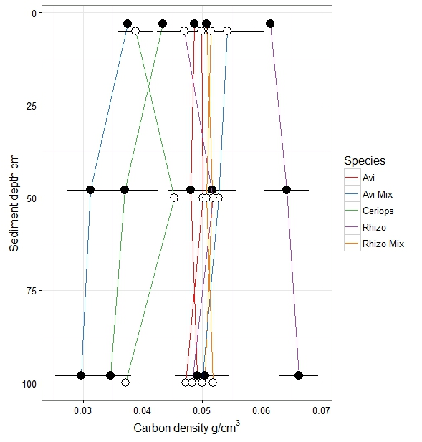
Figure 2: Depth profile of carbon density to 1m at Gazi (Black) and Vanga (White) for each species group (mean ± 95% CI).

Site and Species Effect on Belowground Carbon Stores
Belowground carbon stores to 1m depth did not differ significantly between sites but species had a significant effect on BGC_{1m} (F=3.92, df=4,59, p=0.0068, see Figure 3). In Vanga Avicennia Mix and Ceriops plots had the highest and lowest mean BGC_{1m}; 546 t C ha⁻¹ and 433 t C ha⁻¹ respectively. Rhizophora was the next highest to Avicennia Mix with a mean of 528 t C ha⁻¹ which is similar to the species differences found in Gazi where Rhizophora had the highest mean BGC_{1m} (637 t C ha⁻¹). Avicennia Mix however had the lowest BGC_{1m} in Gazi with a mean of 307 t C ha⁻¹.
Post-hoc Tukey test comparisons of species with combined data (as there was no site effect) revealed Rhizophora BGC to 1m to be significantly greater than Avicennia Mix and Ceriops (mean of 583 t C ha⁻¹; 427 t C ha⁻¹, p= 0.0017 and 396 t C ha⁻¹, p=0.0014 respectively).

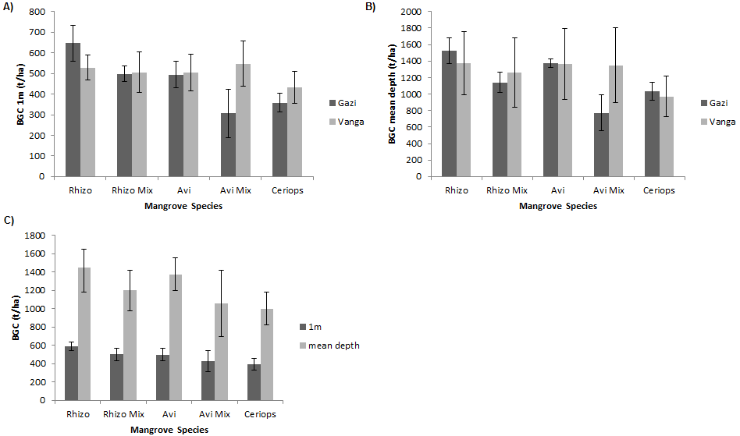
Figure 3: Belowground carbon (t/ha) for each species group at Gazi and Vanga, A) BGC to 1m sediment depth and B) BGC to mean sediment depth C) BGC for combined sites

Whilst there was no site effect, species had a significant effect on BGC_{md} (F=3.32, df=4,59, p=0.0162, see Figure 3). In both Gazi and Vanga, Rhizophora had the highest mean BGC_{md}; 1597 t C ha⁻¹ and 1374 t C ha⁻¹ respectively. The lowest BGC_{md} recorded in Vanga was for Ceriops (mean of 993 t C ha⁻¹) whereas in Gazi, Ceriops was second lowest (mean of 1032 t C ha⁻¹) and Avicennia Mix was lowest with a mean of 770 t C ha⁻¹.

For data combined across sites, Rhizophora had the highest mean BGC, with 1485 t C ha⁻¹ which was significantly higher than Avicennia Mix (Tukey test; mean of 1058 t C ha⁻¹, p=0.0102). Avicennia had the second highest BGC with a mean of 1363 t C ha⁻¹ (significantly greater than Avicennia Mix, Tukey test, p=0.0453). Ceriops had the lowest BGC to mean depth with a mean of 1013 t C ha⁻¹.

Effects of Environmental Context
There was a trend for BGC to increase with distance from the seaward fringe (DFC) at both sites, however this was more pronounced at Gazi than at Vanga (Figure 4), generating significant interactions between distance and site for BGC at 1m and mean plot depths (ANCOVA; F=10.1, df=1,65, p=0.0023 for BGC_{1m ;}F=6.12, df=1,65, p=0.0160 for BGC_{md}). Although DFC thus seemed to be a potentially important predictor of BGC, including the species group factor in the model showed that these two predictors were strongly confounded (Variance Inflation Factor = 684.19). The observed effect of DFC is highly correlated with differences in mangrove species composition. When assessed independently, species explained more variance than DFC (BGC_{1m} 41.5% vs. 23.1%, BGC_{md} 47.4% vs. 31.8%) suggesting that this variable had a greater predictive value for BGC. 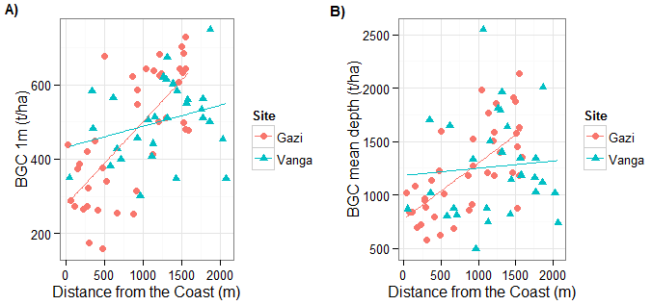
Figure 4: The relationship between distance from the coast (m) and A) belowground carbon to 1m and B) belowground carbon to mean depth (t/ha) at Gazi (red circles; n=40) and Vanga (blue triangles; n=29).

AGB had a significant, weak, positive relationship with BGC_{1m} and BGC_{md} (adjusted R²=0.8%, F=12.2, df=1,65, p=0.0009 and adjusted R²=4%, F=5.97, df=1,65, p=0.0173 respectively, Figure 5). There was no effect of site on this relationship.

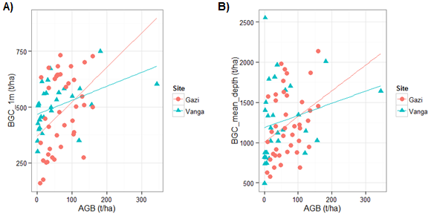
Figure 5: The relationship between aboveground biomass (t/ha) and A) belowground carbon to 1m and B) belowground carbon to mean depth (t/ha) at Gazi (red circles; n=40) and Vanga (blue triangles; n=29).

Predictive Model
We used the data from two sites to produce a model that could provide a first estimate of BGC in mangroves across Kenya, assuming that any variables that showed large differences in their effects between these two sites could not be included in a country-wide model. The following variables were examined:
Sediment Depth: No strong effect of species on sediment depth was evident. However, owing to the known underestimation of sediment depth to differing extents in different species plots (see Supplementary Information), the decision was made to retain the separate species groups for subsequent use in deriving BGC stores.
Species differences in BGC stores: There was a consistent effect of species on BGC; species groups showed broadly similar variation at both sites with the exception of Avicennia Mix (one of the less common species groups) so this factor was retained in the model. As carbon was not found to decline with sediment depth, BGC to mean sediment depth (rather than BGC to 1m) was used in the model. The estimates for carbon storage using mean sediment depth should be more accurate than if depth was limited to the top 1m, although they are still likely to be underestimates given the high percentage of plots with under-estimated mean depth.
DFC: Whilst DFC showed a positive relationship with BGC at both sites its effect was highly confounded with species group and hence only the latter was retained in the model.
AGB: Whilst the relationship between AGB and BGC was significant it was very weak, showing little predictive power. Only a small total area of Kenyan mangrove forest has been assessed for AGB using inventory approaches and there is large variability in the estimates of AGB based on allometric modelling (Cohen et al. 2014). Including AGB in the model would make little contribution to predictive ability and limit the areas to which it could be applied, so the variable was not included.
With only the species differences in BGC levels retained as a predictor, the final model for predicting BGC across the Kenyan coast was derived as a series of equations giving the mean BGC (t/ha) to mean depth for each species group (model adjusted R² = 51.4%). Where the mangrove species coverage was unknown, a mean BGC calculated across all species groups can be used:
[5]
[6]
[7]
[8]
[9]
[10]
Where BGC_{md} and A represent belowground carbon to mean depth and, mangrove area respectively.

Model Validation
When the BGC values for 74 reference sites in Mombasa were compared with the model BGC values for Rhizophora plots the 95% confidence intervals overlapped (Mombasa mean ±95% CI = 599.9±69.3, Model mean = 582.7±48.2) and therefore there was no significant difference between observed and predicted BGC figures, suggesting that the model predicted values at unknown sites adequately.

Calculations and Mapping
Using the predictive model, total mangrove BGC in Kenya was estimated to be 69.41 (± 9.15 95% C.I.) Mt C (Figure 6). Figure 6 shows the BGC distribution throughout the Kenyan coast at a spatial resolution of 1km² based on the mean values. Using an overall mean mangrove (no species differentiation) BGC model across all mangrove areas revealed similar BGC estimates; 68.39 Mt C (± 5.76 95% C.I.).
Areas of high belowground carbon storage, shown in red, are found throughout Kenya, especially in the North (Figure 6). Areas of low BGC stores (green) appear to be concentrated in the most southern region of Kenya. The inset map in Figure 6 shows the BGC stores in the southern mangrove area where the field work was undertaken.
Applying the species based predictive model to the 1992 mangrove distribution map produced a mean estimate of 75.65 Mt C (± 12.21 95% C.I.). Using the overall mean mangrove model produced a mean estimate of 67.9 Mt C (± 6.24 95% C.I.). Using the species based predictive model, this suggests a mean potential loss of 6.24 Mt C (8.3%) between 1992 and 2010 in Kenya.
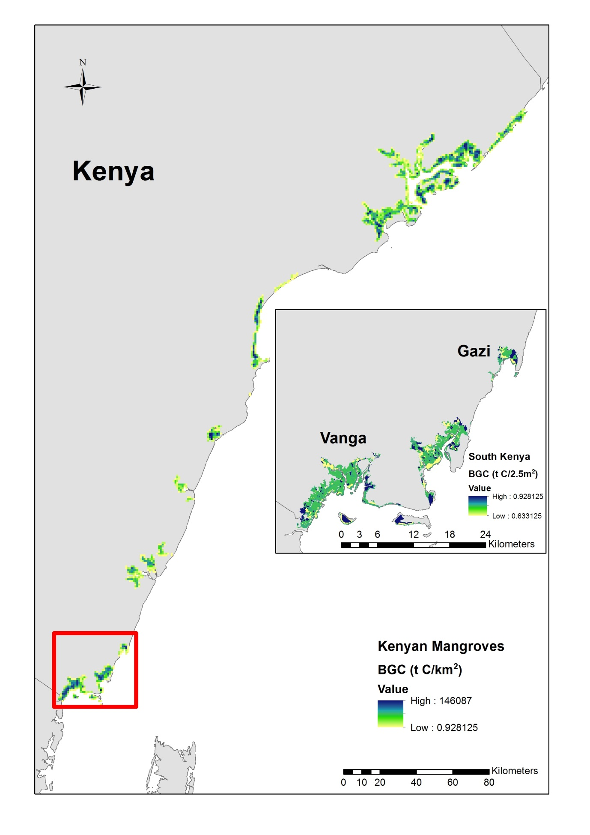
Figure 6: Mapping of spatial variation in mangrove BGC stores in Kenya at 1km² spatial resolution based on 2010 mangrove distribution. Inset map shows the study sites in the South of Kenya.
Discussion
Few studies have explored the variability in BGC across different mangrove sites. Differences in sediment type, biology, hydrology, and geomorphological settings can all contribute to variation in carbon dynamics and storage (Adame et al. 2010; Donato et al. 2011; Coronado-Molina et al. 2012; Saintilan et al. 2013; Yang et al. 2013; Jardine & Siikamaki 2014). Whilst coarse-grained global models are useful for understanding the broad role that mangroves play in the global carbon cycle this site-based variation must be accommodated in producing tools for local management. Here we used detailed information from two separate sites to derive a predictive model for Kenya as a whole, assuming that similarities and differences between our field sites would be representative for other forests in the country.

Sediment Depth
Sediment depth was found to be consistent across Gazi and Vanga with a mean depth of 2.5m. Most published BGC estimates assume a depth of only 1m hence it is likely that current figures are underestimates. The attempt at a global BGC predictive model by Jardine & Siikamaki (2014) also assumed a global sediment depth of only 1m, suggesting their work may substantially underestimate global stores. Whilst the work presented here shows a mean depth of 2.5m, Tue et al. (2014) reported mangrove sediment depths of >4m in Vietnam and studies in the Caribbean have shown depths of up to 8m (McKee et al. 2007). As shown in the methods and Supplementary information, the mean sediment depth of 2.5m is an underestimate as bedrock was rarely met (resistance from roots, lack of strength needed to core deeper and exhausting the full length of the rod often prevented this). Mean BGC figures presented here are therefore also underestimates; albeit an improvement on current estimates.
Carbon Density
No differences were found between our two sites in carbon density. This was an important finding; site differences here would remove any rationale for extrapolating to other sites, without taking site-specific data. Consistent with previous research, there were significant differences between species groups in carbon density at both sites (Alongi et al. 2000; Bouillon et al. 2003; Huxham et al. 2010; Liu et al. 2013; Wang et al. 2013; Sakho et al. 2014). Hence species identity was included as the key variable in the predictive model. . Some previous work has found carbon density to vary with depth (e.g. Alongi et al. (2000)). The absence of a depth effect here may suggest that a decrease in carbon concentration and an increase in bulk density with depth cancel out any depth effect in carbon density (Fujimoto et al. 1999; Donato et al. 2011; Tue et al 2012; Adame et al. 2013; Bianchi et al. 2013; Saintilan et al. 2013; Tue et al. 2014).

Belowground Carbon Stores and Predictive Modelling
The analyses presented here show no significant site effects on BGC (per unit area). This is in contrast with recent research carried out by Jardine & Siikamaki (2014) who found substantial within-country variation in BGC. In Indonesia, carbon rich mangroves were found to have 1.5 times as much carbon per hectare compared with carbon poor mangroves (Jardine & Siikamaki 2014). Indonesia however is made up of many small islands with varying geomorphology and climatic conditions which could explain the variation in carbon stores. Kenya is smaller and has a much more geomorphologically consistent coastline. The within-country variation may also be due to species differences in BGC storage which was not accounted for in the Jardine & Siikamaki (2014) research. As seen in Figure 3, mangrove species does influence BGC storage in the present study sites and hence needs to be incorporated in the predictive model. This is in accordance with previous research where species differences in carbon were evident (Alongi et al. 2000; Bouillon et al. 2003; Huxham et al. 2010; Liu et al. 2013; Wang et al. 2013; Sakho et al. 2014). At both sites Rhizophora has the highest carbon stores which is consistent with the findings by Liu et al. (2013). This may reflect varying C:N ratios in mangrove species (Bouillon et al. 2003). Cuc et al. (2009) reported sediments with low C:N ratios (Avicennia marina) had faster rates of decomposition. Rhizophora are often selected for forestry projects due high productivity and growth rate which may contribute to higher levels of organic matter input into the sediment (Kairo et al. 2008, 2009).
For BGC to 1m and mean depth there was a significant interaction between DFC and site. This may be confounded by species differences in BGC, as the variance inflation factor suggests. It is possible that DFC does not accurately account for the effects of varying geomorphological settings such as estuaries, creeks or landmass sheltering the coastline (such as an island or peninsula). These settings would experience different allochthonous input and therefore BGC variability (Adame et al. 2010; Saintilan et al. 2013; Yang et al. 2013). Ideally there would be a large enough sample size to test the effect of DFC on BGC within each species group separately. In accordance with Donato et al. (2011), Wang et al. (2013) and Tue et al. (2014) belowground carbon was positively but weakly correlated to aboveground biomass at both sites.
Comparisons with another site enabled assessment of the most robust set of predictors to include in the model of BGC being developed for application to the Kenyan coast. In accordance with previous research, species has consistently explained the majority of the variation in not only BGC stores but also sediment depth and is therefore included in the model (Alongi et al. 2000; Bouillon et al. 2003; Huxham et al. 2010; Liu et al. 2013; Wang et al. 2013; Sakho et al. 2014). The comparison with the reference sites in Mombasa confirmed this and suggests that the predictive model is representative of BGC stores throughout Kenya.

Mapping
The country level mangrove map provides a valuable tool for assessing carbon stocks and visualising the distribution of BGC. The fine-scale maps, based on 2.5m² SPOT data provide the detail required for highlighting and prioritising areas for mangrove conservation and restoration. Both models (with and without species distinction) provide similar BGC estimates, suggesting that any increased precision gained by incorporating species differences is potentially limited when considering other sources of error inherent in the estimates. The species dependent model had larger confidence intervals compared to the mean mangrove model; 9.2 Mt C and 5.8 Mt C respectively, due to the incorporation of the variability between each species group into the overall variability rather than that from the single mean BGC estimate on which the non-species model is based. The results suggest that BGC could be underestimated by 1.02 Mt C or as much as 4.43 Mt C if the mean mangrove model was used. However, mean mangrove BGC of 1,224 t C ha⁻¹ is consistent with figures found in other countries; 1,171 t C ha⁻¹ to 2m by Fujimoto et al. (1999) in Micronesia and 1,023 t C ha⁻¹ to 2m by Donato et al. (2011) in the Indo-Pacific region (bearing in mind these estimates are to 2m whereas mean BGC in the work presented here is based on different mean sediment depths for each species; mangrove mean sediment depth of 2.5m). This suggests that the model could be applied to mangroves in other countries to offer baseline estimates of BGC stores, albeit not country-specific.

Low BGC areas appear to be more concentrated in the south with medium to high BGC stores in the North. Human impact has been shown to shift forest dominance from Rhizophora to Ceriops (Kairo et al. 2002). This suggests that mangrove forests in the North have been less impacted and have retained the carbon rich Rhizophora dominant forests.
Estimates of BGC are of course influenced by the accuracy and resolution of the mangrove composition and distribution data that are used. As species composition information from the base map was in the form of species presence/absence data and not a species tree count, assumptions had to be made for the mixed species groups. Assuming the first species in the composition list from Kirui et al. (2013) is the most dominant seemed a justified assumption, however to what extent that species is dominant is unknown. Mangrove distribution may have changed since 2010, so BGC stores may be under- or overestimated. Although species composition is based on data from 1992, sediment sampling for this project in 2010 and 2012 essentially ground-truthed the species composition from 1992; i.e. the species composition recorded in 1992 is what was found in the field in 2010 and 2012. Figure 6 reveals relatively low BGC regions around the perimeter of mangrove forests. This relates to the fact that there is lower mangrove total extent within these areas. For areas where species was unknown (areas of forest growth since 1992) and the mean mangrove BGC was applied, carbon stores may be over or underestimated depending on which mangrove species is present.
A limitation of this work is that it implements a model based on sampling from only two sites, both of which are in the south of Kenya. The model validation, using data from forests near Mombasa (north of the study sites) demonstrated that the values were representative for these sites too, suggesting that in the absence of other data extrapolation to the rest of the country is justified. The independent data set consisted solely of Rhizophora plots. Ideally all mangrove species plots would have been used in the validation, however Rhizophora is the most common mangrove species and has been shown to have the highest BGC figures. Future work should consider sampling further north in Kenya to ground-reference the predicted estimates and improve the current estimates. As forests in the south of Kenya have been exploited to a greater extent, there is not only the potential for a species shift but also lower carbon densities due to degradation (Johnson & Curtis 2001; Vargas et al. 2013; Lang’at et al. 2014). This would also mean that the 6.24 Mt C lost through deforestation and degradation between 1992 and 2010 may be an underestimate. Interestingly, the BGC lost during this period was 8.3%, which is less than the reported spatial loss of 12.1% (Kirui et al. 2013). This suggests that the areas of mangrove forest lost due to human impact are predominately on the outer edges of the forest where carbon stores are lower. Areas of forest on the perimeter are generally more vulnerable due to ease of access via roads etc. (Rideout et al. 2013). However, with only a 3.8% difference, the estimate of spatial loss does provide a good indication of the potential BGC loss. The BGC store figure from the 1992 map provides an estimate of the potential of mangrove carbon storage in Kenya. The significance of mangrove loss since 1992 in Kenya has until now been unknown, however with these BGC estimates, the damage in terms of potentially lost carbon stores is now known and can be used for future reforestation and conservation projects.
The work here has provided a baseline mangrove BGC distribution map for the entire coastline of Kenya. Implementing a country-specific predictive model has provided the level of detail required for practical management outcomes such as pin-pointing likely REDD+ locations. Quantifying the change in BGC over time has given a valuable insight into the amount of carbon lost through human impact at the country-level, emphasising the need for mangrove conservation.
Acknowledgments
We thank all field and lab assistants for their contribution in data collection and processing, with a special thanks to Marta Godlewska. Forest inventory data was provided by the Blue Carbon Team, Kenya Marine and Fisheries Research Institute, P.O. Box 81651, Mombasa. Collection of some of these data was funded partly with support from the Ecosystem Services for Poverty Alleviation Programme (ESPA, Swahili Seas Grant numbers NE/I003401/1). The ESPA programme is funded by the Department for International Development (DFID), the Economic and Social Research Council (ESRC) and the Natural Environment Research Council (NERC). We would also like to thank Karin Viergever for the 2010 mangrove distribution SPOT data; originally provided by Planet Action. The manuscript benefitted from the detailed and constructive comments of the reviewers.

References
Alongi, D.M., Tirendi, F. and Clough, B.F. (2000) Below-ground decomposition of organic matter in forests of the mangroves Rhizophora stylosa and Avicennia marina along the arid coast of Western Australia. Aquatic Botany, 68, 97-122.

Adame, M.F., Kauffman, J.B., Medina, I., Gamboa, J.N. and Torres, O. (2013) Carbon Stocks of Tropical Coastal Wetlands within the Karstic Landscape of the Mexican Caribbean. PLOS ONE, 8(2), e56569.

Adame, M.F., Neil, D., Wright, S.F. and Lovelock, C.E. (2010) Sedimentation within and among mangrove forests along a gradient of geomorphological settings. Estuarine, Coastal and Shelf Science, 86, 21-30.

Arrouays, D., Deslais, W. and Badeau, V. (2001) The carbon content of topsoil and its geographical distribution in France. Soil Use and Management, 17, 7–11.

Batjes, N.H. (2005) Organic carbon stocks in the soils of Brazil. Soil Use and Management, 21, 22–24.

Batjes, N.H. (2008) Mapping soil carbon stocks of Central Africa using SOTER. Geoderma, 146, 58-65.

Bernoux, M., da Conceição Santana Carvalho, M., Volkoff, B., Cerri , C.C. (2002) Brazil’s Soil Carbon Stocks. Soil Science of America Journal, 66, 888-896.

Bianchi, F.J.J.A., Mikos, V., Brussaard, L., Delbaere, B. and Pulleman, M.M. (2013) Opportunities and limitations for functional agrobiodiversity in the European context. Environmental Science & Policy, 1164(27), 223-231.

Bosire, J.O., Dahdouh-Guebas, F., Kairo, J.G., Kazungu, J., Dehairs, F. and Koedam, N. (2005) Litter degradation and CN dynamics in reforested mangrove plantations at Gazi Bay, Kenya. Biological Conservation, 126, 287-295.

Bouillon, S., Dahdouh-Guebas, F., Rao, A.V.V.S., Koedam, N. and Dehairs, F. (2003) Sources of organic carbon in mangrove sediments: variability and possible ecological implications. Hydrobiologia, 495, 33-39.

Breithaupt, J.L., Smoak, J.M., Smith, T.J., Sanders, C.J. & Hoare, A. (2012) Organic carbon burial rates in mangrove sediments: strengthening the global budget. Global Biogeochemical Cycles, 26(3), GB3011, doi:10.1029/20012GB004375.

Bui E., Henderson B. and Viergever K. (2009) Using knowledge discovery with data mining from the Australian soil resource information system database to inform soil carbon mapping in Australia. Global Biogeochemical Cycles, 23, GB4033, doi:10.1029/2009GB003506.

Cohen, R., Kaion, J., Okello, J. A., Bosire, J. O., Kairo, J. G., Huxham, M., & Mencuccini, M. (2013) Propagating Uncertainty to Estimates of Above-Ground Biomass for Kenyan Mangroves: A Scaling Procedure from Tree to Landscape Level. Forest Ecology and Management, 310, 968-982.

Coronado-Molina, C., Alvarez-Guillen, H., Day Jr, J.W., Reyes, E., Perez, B.C., Vera-Herrera, F. and Twilley, R. (2012) Litterfall dynamics in carbonate and deltaic mangrove ecosystems in the Gulf of Mexico. Wetlands Ecology and Mangement, 20(2), 123-136.

Cuc, N.T.K., Ninomiya, I., Long, N.T., Tri, N.H., Tuan, M.S. and Hong, P.N. (2009) Belowground carbon accumulation in young Kandelia candel (L.) Blanco plantations in Thai Binh River Mouth, Northern Vietnam. International Journal of Ecology & Development, 12, 107-117.

Donato, D.C., Kauffman, J.B., Murdiyarso, D., Kurnianto, S., Stidham, M. & Kanninen, M., (2011) Mangroves among the most carbon-rich forests in the tropics. Nature Geoscience, 4, 293-297.
Duarte, C.M., Middelburg, J.J., Caraco, N. (2005) Major role of marine vegetation on the oceanic carbon cycle. Biogeosciences, 2, 1-8.

Ezcurra, P., Ezcurra, E., Garcillan, P.P., Costa, M.T., Aburto-Oropeza, O. (2016) Coastal landforms and accumulation of mangrove peat increase carbon sequestration and storage. PNAS, 113 (16), 4404-4409.

Fujimoto, K., Imaya, A., Tabuchi, R., Kuramoto, S., Utsugi, H. and Murofushi, T. (1999) Belowground carbon storage of Micronesian mangrove forests. Ecological Research, 14, 409-413.

Giri, C., Ochieng, E., Tieszen, L.L., Zhu, Z., Singh, A., Loveland, T., Masek, J., Duke, N., (2010) Status and distribution of mangrove forests of the world using earth observation satellite data. Global Ecology and Biogeography, 20, 154-159.

Guo, Y., Amundson, R., Gong, P. and Yu, Q. (2006) Quantity and spatial variability of soil carbon in the conterminous United States. Soil Science Scociety of America Journal, 70, 590-600.

Howard, P. J. A., P. J. Loveland, R. I. Bradley, F. T. Dry, D. M. Howard, and D. C. Howard (1995) The carbon content of soil and its geographical distribution in Great Britain, Soil Use Management, 11, 9-15.

Hutchinson, J., Manica, A., Swetnam, R., Balmford, A. and Spalding, M. (2014) Predicting global patterns in mangrove forest biomass. Conservation Letters, 7, 233-240.

Huxham, M., Emerton, L.,Kairo, J., Munyi, J., Abdirizak, H., Hillams, T., Nunan, F. and Briers, R. (2015) Envisioning a Better Future for Kenyan Mangroves: Business as Usual or Climate Compatible Development.

Huxham, M., Langat, J., Tamooh, F., Kennedy, H., Mencuccini, M., Skov, M.W. and Kairo, J. (2010) Decomposition of mangrove roots: Effects of location, nutrients, species identity and mix in a Kenyan forest. Estuarine, Coastal and Shelf Science, 88, 135-142.

IPCC, 2001:Climate Change (2001) The Scientific Basis. Contribution of Working Group I to the Third Assessment Report of theIntergovernmental Panel on Climate Change [Houghton, J.T., Y. Ding, D.J. Griggs, M. Noguer, P.J. van der Linden, X. Dai, K. IPCC, 2001:Climate Change 2001: The Scientific Basis. Contribution of Working Group I to the Third Assessment Report of theIntergovernmental Panel on Climate Change [Houghton, J.T., Y. Ding, D.J. Griggs, M. Noguer, P.J. van der Linden, X. Dai, K., Maskell, and C.A. Johnson (eds.)]. Cambridge University Press, Cambridge, United Kingdom and New York, NY, USA, 881.

Jardine, S.L. and Siikamäki, J.V. (2014) A global predictive model of carbon in
mangrove soils. Environmental Research Letters, 9, e104013.

Johnson, D.W. and Curtis, P.W. (2001) Effects of forest management on soil C and N storage: meta-analysis. Forest Ecology and Management, 140, 227-238.
Kairo, J. G., Dahdouh-Guebas, F., Gwada, P. O., Ochieng, C., and Koedam, N. (2002) Regeneration status of mangrove forests in Mida Creek, Kenya: a compromised or secured future? Ambio, 31, 562–568.

Kairo, J.G., Lang’at, J.K.S., Dahdouh-Guebas, F., Bosire, J. and Karachi, M. (2008) Structural development and productivity of replanted mangrove plantations in Kenya. Forest Ecology and Management, 255, 2670–2677.

Kairo, J.G., Bosire, J., Lang’at, J., Kirui, B. and Koedam, N. (2009) Allometry and biomass distribution in replanted mangrove plantations at Gazi Bay, Kenya. Aquatic Conservation: Marine and Freshwater Ecosystems, 19, S63-S69.

Kauffman, J.B., Heider, C., Cole, T.G., Dwire, K.A. and Donato, D. (2011) Ecosystem Carbon Stocks of Micronesian Mangrove Forests. Wetlands, 31, 343–352.

Kern, J. S. (1994) Spatial patterns of soil organic carbon in the contiguous United States. Soil Science Society of America Journal, 58, 39-455.

Kirui, K.B., Kairo, J.G., Bosire, J., Viergever, K.M., Rudra, S., Huxham, M. and Briers, R.A. (2013) Mapping of mangrove forest land cover change along the Kenya coastline using Landsat imagery. Ocean & Coastal Management, 83, 19-24.

Lacerda, L.D, Ittekkot, V. and Patchineelam, S.R. (1995) Biochemistry of Mangrove Soil Organic Matter: a Comparison Between Rhizophora and Avicennia Soils in South-eastern Brazil. Estuarine, Coastal and Shelf Science, 40, 713-720.
Lang’at, J.K.S., Kairo, J.G., Mencuccini, M., Bouillon, S. and Skov, M.W., Waldron, S. and Huxham, M. (2014) Rapid Losses of Surface Elevation following Tree Girdling and Cutting in Tropical Mangroves. PLOS ONE, 9(9), e107868.

Liu, H., Ren , H., Hui , D., Wang , W., Liao , B. and Cao , Q. (2013) Carbon stocks and potential carbon storage in the mangrove forests of China. Journal of Environmental Management, 133, 86-93.

Locatelli, T., Binet, T., Kairo, J., Patenaude, G., King, L., Madden, S., Upton, C. and Huxham, M. (2014) Turning the Tide: How payments for ecosystem services (PES) might help save mangrove forests. Ambio, 43, 981-995.

McKee, K.L., Cahoon, D.R. and Feller, I.C. (2007) Caribbean mangroves adjust to rising sea level through biotic controls on change in soil elevation. Global Ecology and Biogeography, 10, 1466-8238.

Milne, R., and Brown, T.A. (1997) Carbon in the vegetation and soils of Great Britain, Journal of. Environmental Management, 49, 413-433.

Muzuka, A.N.N and Shunula, J.P. (2006) Stable isotope compositions of organic carbon and nitrogen of two mangrove stands along the Tanzanian coastal zone. Estuarine, Coastal and Shelf Science, 66(3-4), 447-458.
Nellemann, C., Corcoran, E., Duarte, C. M., Valdés, L., De Young, C., Fonseca, L., and Grimsditch, G. (2009) Blue Carbon. A Rapid Response Assessment. United Nations Environment Programme, GRID-Arendal, www.grida.no

Pendleton L, Donato D C, Murray B C, Crooks S, Jenkins W A, Sifleet S, Craft C, Fourqurean J W, Kauffman J B and Marbà N (2012) Estimating global ‘blue carbon’ emissions from conversion and degradation of vegetated coastal ecosystems, PlOS one, 7, e43542.

Rideout, A.J.R., Joshi, N.P., Viergever, K.M., Huxham, M. and Briers, R.A. (2013) Making predictions of mangrove deforestation: a comparison of two methods in Kenya. Global Change Biology, 19, 3493–3501.

Saatchi S., Marlier, M., Chazdon, R.L., Clark, D.B. and Russell, A.E. (2011) Impact of spatial variability of tropical forest structure on Radar estimation of aboveground biomass. Remote Sensing of Environment, 115(11), 2836–2849.

Saintilan, N., Rogers, K., Mazumder, D., and Woodroffe, C. (2013) Allochthonous and autochthonous contributions to carbon accumulation and carbon store in southeastern Australian coastal wetlands. Estuarine Coastal Shelf Science, 128, 84–92.

Sakho, I.,Mesnage, V., Copard, Y., Deloffre, J., Faye, G., Lafite, R. and Niang, I. (2014) A cross-section analysis of sedimentary organic matter in a mangrove ecosystem under dry climate conditions: The Somone estuary, Senegal. Journal of African Earth Sciences, 101, 220–231.

Siikamäki J, Sanchirico J N and Jardine S L (2012) Global economic potential for reducing carbon dioxide emissions from mangrove loss. Proceedings of the National Academy of Science, 109(36), 14369-14374.

Tamooh, F., Huxham, M., Karachi, M., Mencuccini, M., Kairo, J.G. and Kirui, B. (2008) Below-ground root yield and distribution in natural and replanted mangrove forests at Gazi bay, Kenya. Forest Ecology and Management, 256, 1290–1297.

Tate, K. R., Wilde, R. H. , Giltrap, D. J. , Baisden, W. T., Saggar, S., Trustrum, N. A., Scott, N. A. and Barton, J. P. (2005) Soil organic carbon stocks and flows in New Zealand: System development, measurement and modelling. Canadian Journal of Soil Science, 85, 481–489.

Tue, N.T., Dung, L.V, Nhuan, M.T. and Omori, K. (2014) Carbon storage of a tropical mangrove forest in Mui Ca Mau National Park, Vietnam. Catena, 121, 119–126.

Twilley, R.R., Chen, R.H. and Hargis, T. (1992) Carbon sinks in mangroves and their implications to carbon budget of tropical coastal ecosystems. Water, Air, and Soil Pollution, 64, 265-288.

Viscarra Rossel, R.A., Webster, R., Bui, E.N. and Baldock, J.A. (2014) Baseline map of organic carbon in Australian soil to support national carbon accounting and monitoring under climate change. Global Change Biology, 20, 2953–2970.

Wang, G., Guan, D., Peart, M.R., Chen, Y. and Peng, Y. (2013) Ecosystem carbon stocks of mangrove forest in Yingluo Bay, Guangdong Province of South China. Forest Ecology and Management, 310, 539–546.

Wu, H., Guo, Z. and Peng, C. (2003) Distribution and storage of soil organic carbon in China. Global Biogeochemistry Cycles, 17(2), 1048.

Yang, J., Gao, J., Cheung, A., Liu, B., Schwendenmann, L. and Costello, M.J. (2013) Vegetation and sediment characteristics in an expanding mangrove forest in New Zealand. Estuarine, Coastal and Shelf Science, 134, 11-18.

Yu, D.S., Shi, X.Z., Wang, H.J., Sun, W.X., Chen, J.M., Liu, Q.H. and Zhao, Y.C., (2007) Regional patterns of soil organic carbon stocks in China. Journal of Environmental Management, 85(3), 680–689.

