Miniaturized Balanced Antenna with Integrated Balun for Practical LTE Applications
Issa ELFERGANI¹, Jonathan RODRIGUEZ^{1,2}, Fathi ABDUSSALAM ³, Chan H SEE ⁴, Read ABD-ALHAMEED³

¹ 1Instituto de Telecomunicações, Aveiro, Portugal
²Universidade de Aveiro, Portugal
³Antennas and Applied Electromagnetics Research Group, School of Engineering and Informatics, University of Bradford, Bradford, BD7 1DP, UK
⁴School of Engineering, University of Bolton, Bolton, BL3 5AB, UK.
i.t.e.elfergani@av.it.pt, jonathan@av.it.pt
r.a.a.abd, f.m.a.abdussalam @bradford.ac.uk
C.See@bolton.ac.uk

Abstract. A design of dual-band balanced antenna structure operating in the 700 and 2600MHz LTE bands is studied and investigated. The overall dimensions of the radiator are 50 × 18 × 7 mm3 allowing it to be easily concealed within mobile handsets. A broad-band balun is designed and integrated with the antenna handset in order to provide the feeding network and perform the measurements of the antenna radiation performance. Prototypes of proposed antenna with and without balun are fabricated and verified. The simulated and practical results with and without the hand held effect in terms of reflection coefficient, power gain and radiation pattern show good agreement.
Keywords
Balanced Antenna, Printed Dipole, Dual-band, LTE, Balun.

Introduction
The demand for multisystem handset equipment has increased rapidly in recent years. The design of a wireless transceiver in a smart phone or a portable device must support multisystem operations, since the forthcoming mobile networking ecosystem will constitute legacy and future 5G technology. This raises numerous challenges and requirements for mobile phone antenna designers [1]. Such antenna requirements lie in its incorporation into portable devices, and moreover it is required to be thin, light, compact design, reduced volume size, and low energy. Therefore, to meet these requirements of current mobile phone built-in antenna, several works have been recently dedicated to internal multiband antennas in mobile handset applications. The planar Inverted-F antennas (PIFA) [2-3], microstrip patch antennas [4-5] and monopole printed structures [6-7] have been considered as the most common internal mobile phone antennas. In particular, with the advancement of the LTE technology, smart phones are now broadly used, thus designing new LTE antenna for legacy and future releases of the LTE standard, catering for carrier aggregation and multiple wideband frequency bands are now of much interest in the research community. Numerous miniaturized LTE handset antennas have been reported [8-13].
By examining the work [8-13], one can note that these antennas have only a single terminal and driven against a local ground plane. Having an antenna along with the system ground plane may help in improving the bandwidth and gain performance. These unbalanced antennas have been exploited in commercial handsets, especially as the mobile device is quite small. However, these unbalanced structures are sensitive to user hand held effect, in that the user´s hand covers a large area of the antenna ground plane in which may change the impedance matching requirements of the antenna and lead in performance degradation. This is because the ground plane of the unbalanced antennas is being used as part of the radiator structure in which a large amount of current would be induced on the radiator as well as on the antenna ground. As a result, while the device is being held by the users’ hand, the current flows on the human hand/body and lead in depredating the antenna performance [14-16].
To avoid such degradation performance phenomena, a balanced antenna is deemed as a promising candidate for the mobile phone since the current induced on the ground is small or approximately neglected, which leads to minor influences on the performances of the antenna in the scenario of device being held by the user’s hand.
To exploit this beneficial property, a number of mobile phone balanced antenna structures operate in dual-band, multiband and wide band have been recently studied [16-29]. Table1 shows the differences between these antennas in terms of operating frequency band, antenna size, power gain and efficiency.
By investigating Table 1, it is clearly noticed that these available balanced antennas can only cover either the major existing mobile bands or/and UWB sepcturm, for example: antenna design in [17] can only cover GSM900, the antenna geometry in [18] is capable to work for GSM1800, fitting together GSM900/1800 was proposed in [19]; moreover, [16, 20-23] proposed to operate in WLAN, joining GSM and UMTS in [24], whilst [25] designed a balanced antenna to operate in GSM and WLAN, and authors in [26] offered balanced antenna that work in the full operation of three mobile radio bands of GSM900/1800, PCS/1900 and UMTS/2200.
On other hand, several work has been reported to operate over the UWB spectrum such as authors in [27] have proposed an antenna design that operates in both lower band of UWB from 2.36 to 2.56 and higher bands of UWB spectrum from 5.13 to 12 GHz. Furthermore, in [28-29] Vivaldi balanced antennas covers the whole range of UWB from 3.1-10.6 GHz have been designed and tested.
Tab. 1. Comparison of the performance of the published balanced antennas.
Ref | Operating Frequency Band (GHz) | Size mm³  including ground plane | Peak Gain Range (dBi) | Radiation efficiency %
16 | 2.4 | 118x62.5x0.8 | NaN | 75.3
17 | 0.9 | 100x50x10 | NaN | NaN
18 | 1.8 | 120x50x12 | 4 | NaN
19 | 0.9 and 1.8 | 100x50x6.6 | NaN
20 | 2.4 and 5 | 90x40x9 | 2.3 -4.3 and 3.5 -5.3 | NaN
21 | 2.4 and 5 | 90x40x9 | NaN | NaN
22 | 2.48,5,4 and 6.5 | 90x40x7 | 3.5-5.2 | NaN
24 | 0.9, 1.8 and 2.2 | 120x50x9.5 | 2.5 -3.5 | NaN
25 | 1.8-2.4 | 120x50x9.5 | 2.7-4.2 | 70-94
27 | 2.36 - 2.56 and 5.13 - 12 | 87x35x1 | 0.7- 5 | NaN
28 | 3.1-10.6 | 32 x 35 x1.6 | -3-5.25 | NaN
29 | 3.1-10.6 | 123.5x96.7x1.6 | NaN | NaN
proposed | 0.7-2.6 | 100x50x7 | 0.95-1.7and 3.8 -4.9 | 79-95
In contrast, due to the big demand for higher data rate as well as larger bandwidth in recent network of mobile communication; the new technology of the 4th generation namely long term evolution (LTE) has been developed and newly released. However, none of these balanced antenna designs in [16-29] have the capability to operate in the range of LTE bands and in particular the lower band of 700MHz. To address this, we propose a miniaturized printed folded dipole balanced antenna, which operates at dual-band frequency of LTE, these are 700 and 2600MHz for a mobile communication device.
By compromising the bandwidth, antenna size and frequency bands, some approaches were proposed by previous author’s works [18, 20-22,23-24] to enable wide-band and dual-band functional operation, as shown in Table I. In comparison to [16–29], this version of the proposed balanced antenna has come up with such advantage of covering the dual-band of LTE namely 700/2600MHz as well as achieving a size reduction compared to previous work in [16-18,24-25]. Moreover, this version has obtained a better efficiency in contrast to [16,25]. Furthermore, it accomplishes an improved gain compared with works in [18, 24-25,27-28].

Proposed Antenna Structure
The full configuration of the present dual-band LTE mobile balanced design is shown in Fig. 1. The present design has a simple structure. The antenna is printed over a FR4 material permittivity of 4.4, tangent loss of 0.025 and with a thickness of 1.6mm. The overall size of the antenna and handheld device is 100 × 50 × 7mm³, where the antenna size is 50 × 18 × 1.6mm³. A balanced voltage source was used to feed the proposed design. The folded printed arms have a uniform width of 1mm.
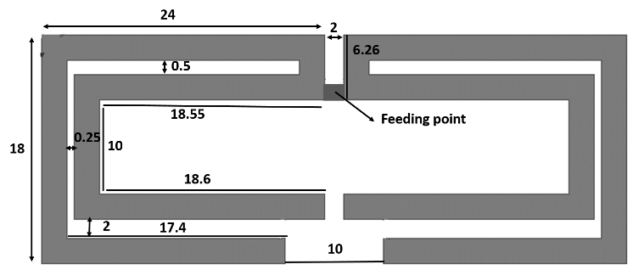
a
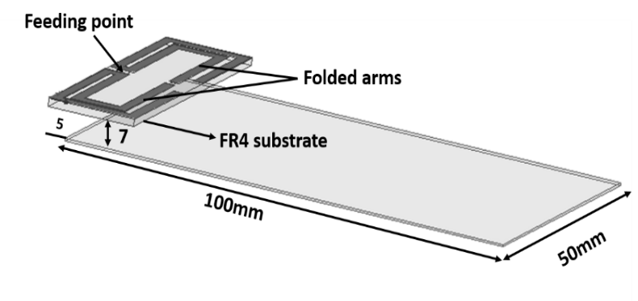
b
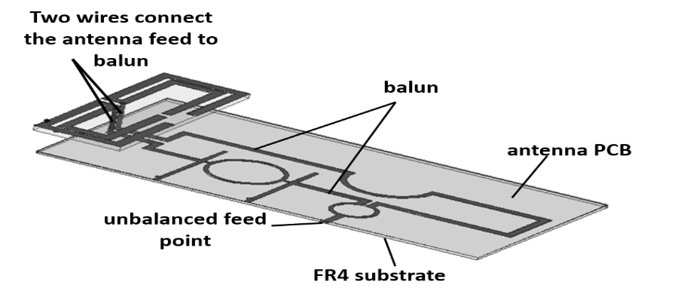
c
Fig.1. Antenna structure; (a) Top view (b) antenna without balun (c) antenna with balun. Unit in mm
The ground plane was shifted backward by 5mm. This has created a defected area under the radiator which has contributed to accomplish and improve the bandwidth of the LTE lower frequency of 700MHz The proposed antenna comprises of two printed dipoles arms with separation slot of 2mm width. Each dipole arm is patterned in a way to create two joint U shapes. The formation of such printed dipole shapes has not only contributed towards the antenna miniaturization, but has also effectively achieved the dual-band LTE frequencies defined within this work in particular the lower band of 700MHz. It should be noted that different set/shapes of folded arms were attempted on the top of the substrate in which it can pave the path towards the targeted dual-band frequencies of 700/2600MHz.
To further understand the contribution of the printed folded arms technique in size miniaturization, different antenna designs with several printed folded arms shapes were modelled. In this analysis, four standard different printed arms including L-shaped, U-shaped, L-U shaped and 2U shaped were studied. The dimensions of L, U and L-U shapes are depicted in Fig.2, while the proposed structure of 2U shapes are already shown in Fig.1. The variation of the printed folded arms against the response of S₁₁ was investigated within this study as depicted in Figure 2. The simulated S₁₁ of L-shaped, U-shaped, L-U shaped and 2U shaped arms of proposed antenna shown in Figure 2. As can be seen, by implementing L-shape radiator on each arm, the proposed antenna can only operate at 4200MHz, but, when the U-shape was applied, the current path length of the antenna will be changed in which will make the antenna operates at 3500MHz. On the other hand, by joining L and U shapes together on each side of the radiator, the dual-band paradigm started taking a place in which the proposed design will be able to cover the dual-band of 1000/3400MHz. However, by employing 2U shapes configuration on each arm, the present antenna would be tuned to meet the targeted dual-band of 700/2600 proposed within this study.

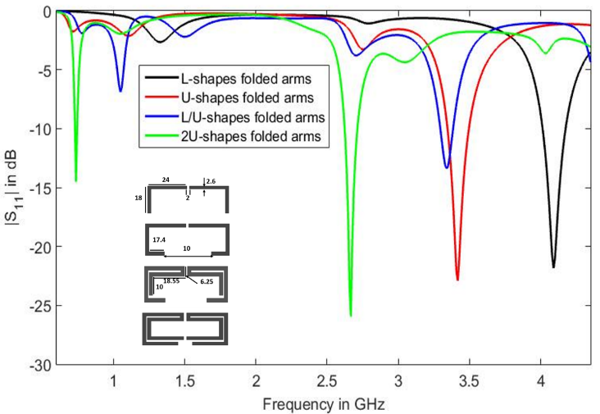
Fig.2.The variation of the printed folded shapes against the response of S_{11.}
Same planar balun as in ref [30] is used and integrated on the handset of proposed antenna to support the balanced feeding network that is fed by unbalanced source, as illustrated in Fig.1c. The full geometry of the used balun is depicted in Fig.3, while the full dimensions are stated in Table 2. One can note that, the ground plane of the antenna was placed on one side of the FR4 dielectric with a thickness of 0.8 mm, permittivity of 4.4, and tangent loss of 0.025, while the planar balun was located on the opposite side as depicted in Figure 1c. The proposed antennas were modeled using HFSS software package [31].

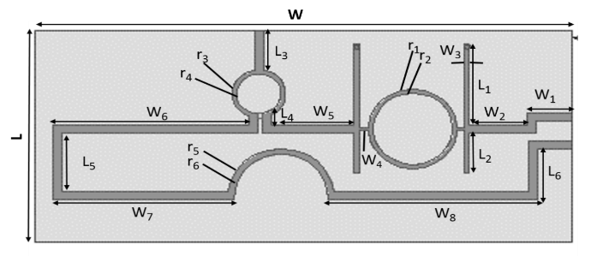
a
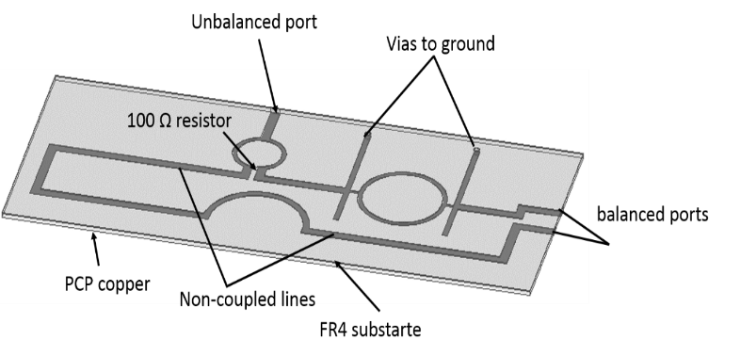
b
Fig.3. Geometry of proposed balun (a) Top view. (b) 3D View
As depicted in Fig.1c, the location of two balanced ports of the balun were wisely designated to be exactly in direct position underneath the antenna feeding point on the upper sheet of the substrate. Dual thin cables were exploited in order to join the wide band balun to the antenna feeding point via holes. In this manner, the integration of both the antenna and its balanced feeding system were successfully accomplished. The proposed balun operates over a wider frequency range from 700MHz to 3200MHz in which the targeted frequency bands of 700 and 2600MHz proposed in this work can be easily met.
Tab .2. The overall dimensions of proposed balun.
Parameters | Value in mm | Parameters | Value in mm
W₁ | 10 | L₂ | 10
W₂ | 13 | L₃ | 10.5
W₃ | 1.2 | L₄ | 2.25
W₄ | 2.2 | L₅ | 16
W₅ | 18.5 | L₆ | 17.75
W₆ | 43.5 | r₁,r₂ | 10, 9
W₇ | 40 | r₃,r₄ | 6,5
W₈ | 44 | r₅,r₆ | 12,11
L₁ | 21 | L,W | 50,100
To further investigate the physical behavior of the antenna, the input impedance of the proposed antennas with and without balun in free space and hand held are studied and investigated as shown in Fig.4. The values of the input impedance of the proposed antenna in the above-mentioned five cases were summarized in Table 3. As can be observed in Table 3, the proposed antenna in both scenarios of free space and handheld exhibits a resistance of around 50 Ohm (fluctuated between 46 and 50 Ohm) at 700MHz and 2600MHz.
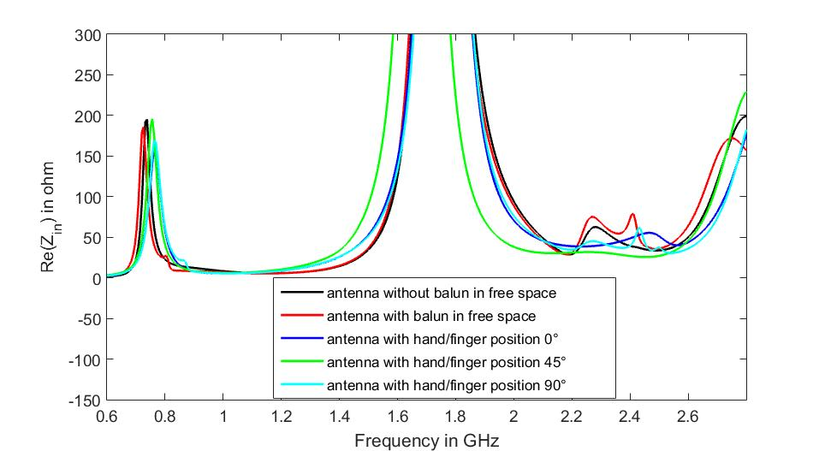
a
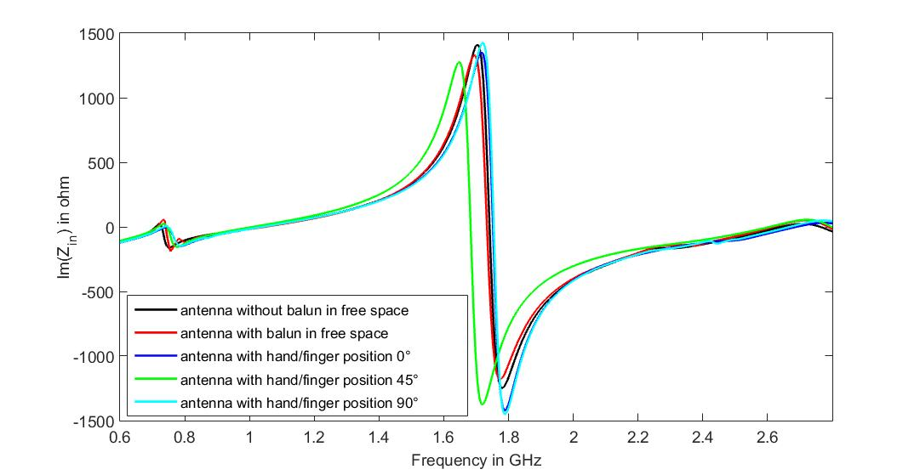
b
Fig.4. Input Impedance of the proposed antenna.
The reactance values of the five version for the both scenarios at the dual targeted frequencies of 700/2600MHz were varied between -3 and 0 ohm. In summary, the responses of the present antennas in both scenarios of frees pace and held hand satisfy the good impedance matching condition to a 50 Ohm load.

Tab. 3. Input impedance of the proposed antenna in free space and handheld scenarios.
Input Impedance | Antenna without balun in free space | Antenna with balun in free space | Antenna with hand/finger  position at 0° | Antenna with hand/finger  position at 45° | Antenna with hand/finger  position at 90°
Resistance 700MHz | 50 Ohm | 50 Ohm | 46 Ohm | 47 Ohm | 49 Ohm
Reactance 700MHz | 0 Ohm | 0 Ohm | -3 Ohm | -3 Ohm | -2 Ohm
Resistance 2600MHz | 46 Ohm | 49 Ohm | 47 Ohm | 46 Ohm | 48 Ohm
Reactance 2600MHz | -2 Ohm | -3 Ohm | -3 Ohm | -3 Ohm | -3 Ohm

Measurement and Simulation Results
The simulated reflection coefficient of proposed designs was studied and investigated in the free space and close vicinity to human hand scenarios. The hand model that includes the proposed antenna has the dimensions of 50 × 80 × 110 mm³. The antenna and hand model are illustrated in Fig.5. For simplicity and reasonable estimation, the proposed hand model is considered to be a muscle tissue of only a single layer, having a relative permittivity material of 54 and a conductivity of 1.45 S m-1 [24-25].
As depicted in Fig.5, the hand model takes three typical different methods of holding the handset, while taking the finger positions into account, i.e., 0° (Left), 45° (middle), and 90° (Right) which are the most common talk positions.
Fig.6 depicts the computed S₁₁ for the balanced antenna (i.e., the antenna with/without balun) in free space scenario and including the human hand effect. Observing Fig.6 plots, it is obviously seen that the |S₁₁| remains below -10 dB over the targeted operational dual-band of 700/2600MHz for the analyzed antenna in free space scenarios.
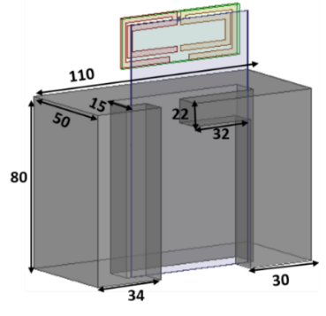 | 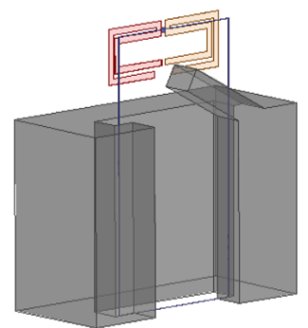
a | b
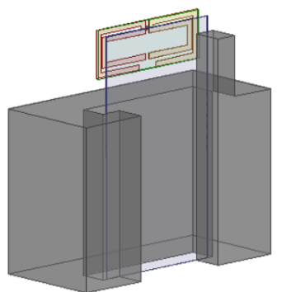

c
Fig.5.Simulated hand model, with finger positions, 0° (a), 45° (b ), and 90° (c).
On the other hand of Fig.6, the S₁₁ of the antenna in hand effect paradigm in the three positions shows approximately a stable performance in term of S₁₁ and in good agreement with the free space scenario. This proves that such a balanced antenna is ground plane independent and can be a good candidate for practical mobile applications.
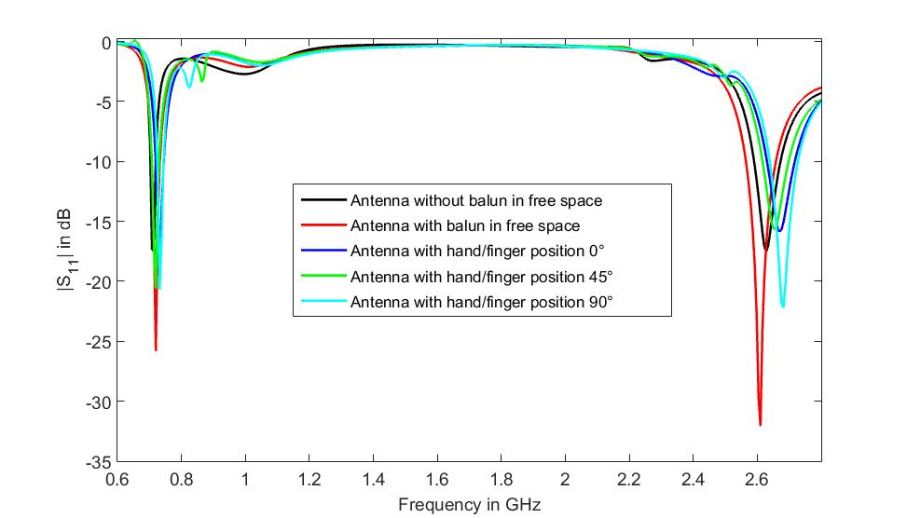
Fig.6.Simulated reflection coefficients |S₁₁| of proposed antennas.
For validation purposes of the simulated S₁₁ results of the antenna system without balun, a prototype of the antenna without the inclusion of balun is shown in Figure 6a and b. It was initially fabricated based upon on the structure and dimensions as clarified in Figure 1b, and then tested. Fig.7e shows the measured S₁₁ of the present balanced antennas. The S₁₁ of the antenna without balun was achieved by utilising the method of two port network analyser whereby the integrated balun is not needed.

a
b
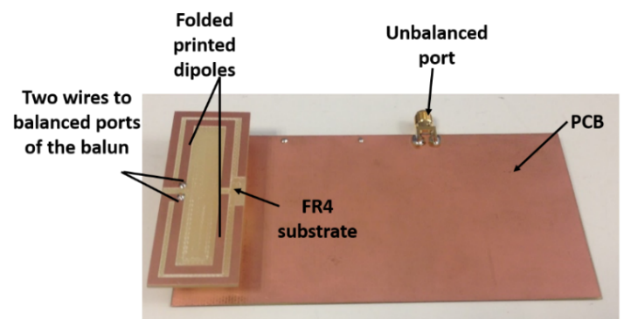

c
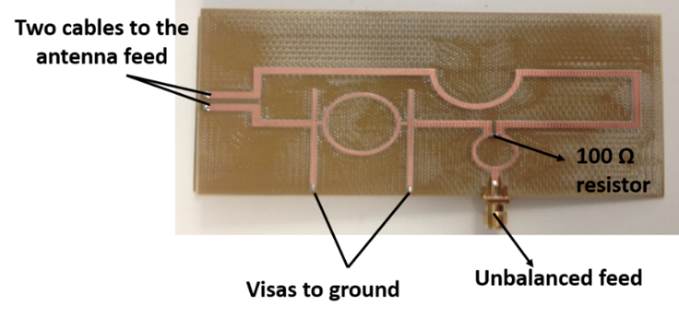
d
Fig.7.The antenna prototypes, (a) 3D without balun (b) bottom without balun (c) 3D view with balun, (d) bottom view with balun.
Practically, this would be accomplished by direct connection of the balanced antenna two ports into the two inputs ports of a calibrated vector network analyser. One can clearly observe that, the experimental results of S₁₁ are said to be in fair agreement with the computed results presented in Fig.6, where the targeted LTE dual-band, namely 700/2600MHz was accomplished.
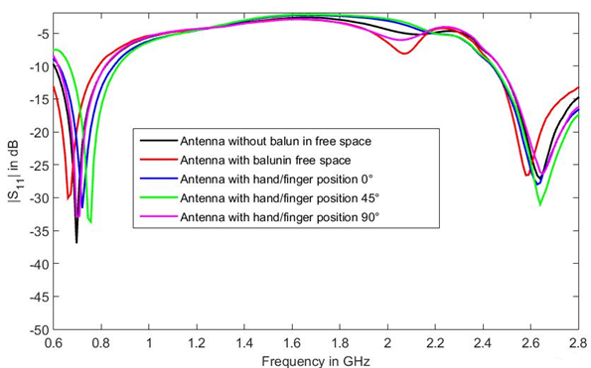
Fig.8. Measured reflection coefficients |S₁₁| of proposed antennas.
For verification purposes, the full antenna prototype assembly (antenna & balun) has been also manufactured and measured as depicted in Fig.7c, d. The measured S₁₁ of the antenna with the integrated balun is indicated in Fig.8.
As can be observed, the measured S₁₁ of the full antenna assembly shows a good result that covers the suggested dual-band frequency spectrum. The results agree well with the computed results as demonstrated in Figure 5.
The effect of hand holding scenario on the S₁₁ performance of the prototype antennas was also studied and investigated in which the ground plane was considered as being held in a hand and positioned in the above-mentioned “talk” positions, shown in Fig.5. It was found that, from Fig.8, slight discrepancies were noted on the antenna S₁₁ compared to the measured S₁₁ of the antenna in free space cases within the envisioned operating bands.
To further explain how the balanced antenna is a ground plane independent, a study of the current intensity of the present design in both free space and hand holding scenarios are shown in Fig.9. The current surface of this antenna in free space was demonstrated and analyzed over the dual-band of 700/2600MHz. In this circumstance, the surface current induced on the antenna ground plane is strong in the area exactly underneath the feeding point for both frequency bands, while it is neglected over the rest of ground plane as indicated in Fig.9a, which is comparable to the results obtained from [21]. It also shows some advantages comparable to the current in which induced on the ground of the unbalanced antenna in [32].
700MHz a 2600 MHz
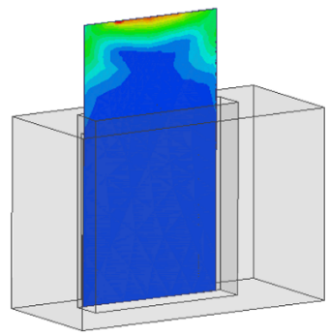 | 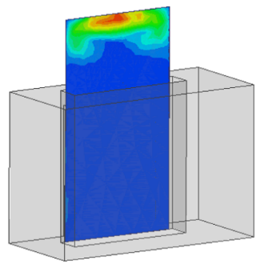
0° finger position @700MHz b 0° finger position @2600MHz
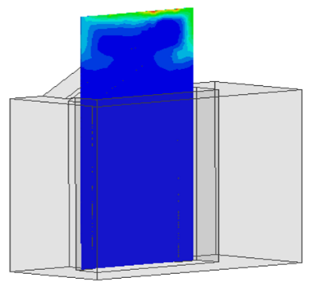 | 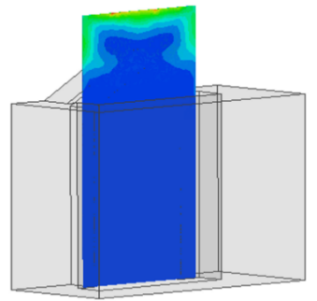
45° position @700MHz c 45°position @2600MHz

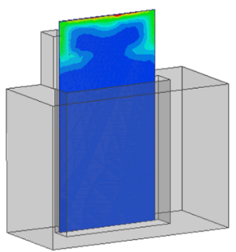 | 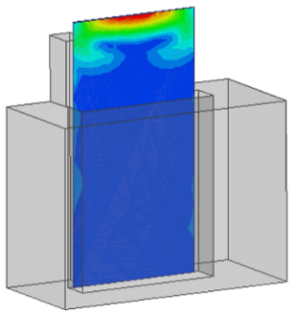
90° position @700MHz d 90°position @2600MHz
Fig.9. Current surface for (a) antenna in free space, (b) antenna with hand finger 0° position (c) antenna with hand finger 45° position (d) antenna with hand finger 90° position.
In the hand model scenario for all finger/talk positions, 0°, 45° and 90°, the major current appears around more or less the same area in the example of free space, whereas the current only exists in the area below the antenna and gradually tapers as we head further away over the whole ground as shown in Fig.9b, 9c and 9d. From the above-mentioned scenarios, this antenna proves the fact that the balanced antenna is ground plane independent. This also suggests that the antenna design has an advantage of being insensitive when it is held by the hand user.
Fig.10a illustrates both computed and measured gain of full assembly antenna for the 700/2600MHz of LTE frequencies. The computed antenna gain varies from 0.9 dBi and 1.62 dBi over the lower band of 700MHz and between 3.5 dBi and 4.4 dBi over 2600MHz band. On other hand, the measured gain fluctuated roughly between 0.85 dBi and 1.4 dBi over the bandwidth of 700MHz, and fluctuated from 3.45 dBi to 4.3 dBi over the band of 2600MHz as observed in Fig.10a. These minor variations may be attributed to the introduction of the physical integration of the balun with ground of the device, and moreover the existence of the connector pin during the fabrication and testing procedure has not been taken into account in the simulation steps.
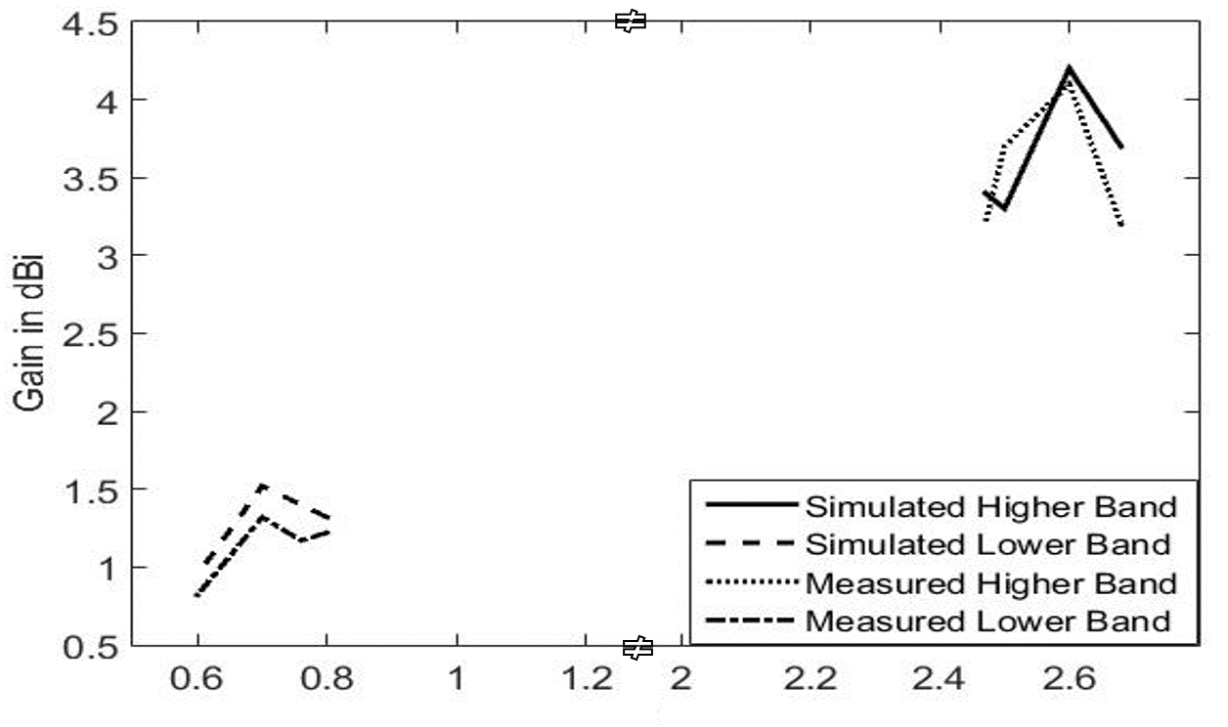
a
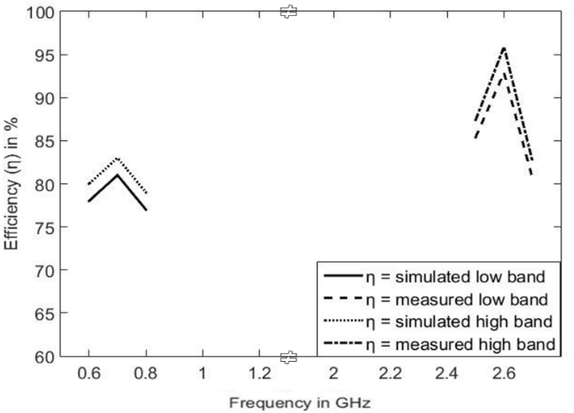
b
Fig.10. (a) Simulated and measured gain of the proposed antenna, (b) Simulated and measured radiation efficiency of the proposed antenna.
Fig.10b shows the radiation efficiency of full assembly antenna. It is observed that the results of the efficiency are in good correspondence with the gain results which obtained in Fig.10a. The Wheeler Cap method [33] is used to evaluate the radiation efficiency of the present antenna. The Wheeler Cap method is considered as a practical method to test efficiency [34-36].
The basic concept about Wheeler’s method is to use the "radiansphere" which is the boundary between the near field and the far field of any small antenna to measure the radiation efficiency of antenna under test. The simulations will be separated into two procedures that the radiation efficiency can be evaluated from the S11 magnitude with and without Wheeler cap by using the following equation [36].
$η=\frac{P_{Rad}}{P_{Rad+}P_{loss}}=\frac{\left(1-Γ_{1}^{2} \right)-\left(1-Γ_{2}^{2} \right)}{\left(1-Γ_{1}^{2} \right)}=\frac{Γ_{2}^{2}-Γ_{1}^{2}}{1-Γ_{1}^{2}}$ (1)

where ,$Γ_{1}$is the S₁₁ in free space (without Wheeler cap) ,$Γ_{2}$ is the S₁₁ with Wheeler cap, $P_{Rad}$ is radiation power of antenna and $P_{loss}$ is loss power.
To verify the Wheeler cap method, the prototype model of the cavity model in Figure was used, in which the fabricated antenna was place inside it. Again, the measured radiation efficiency is obtained by performing measurement in two steps i.e. measuring the antenna under test (AUT) without and with conducting radiation Wheeler cap metal shield.
One can obviously note that, the simulated efficiency varies from 76 to 81 % over the lower band of 700MHz and from 81 to 91 % over the 2600MHz. On the other hand, the measured efficiency over the 700MHz fluctuates from 80 to 83.6%, while it varies from 85 to 95% over the higher band of 2600MHz.
The far-field radiation patterns of both simulated and fabricated full antenna assembly (antenna & balun) were presented in Fig.11. Two pattern planes at xz and yz were taken at 700/2600MHz, respectively. The computed patterns were produced from HFSS software for the aforementioned planes. The normalized two patterns were considered and the fabricated antenna was measured in a far-field anechoic chamber. From Fig.11, a reasonable agreement was observed between computed and measured ones. The accomplished results indicate that the radiation patterns are nearly omnidirectional.
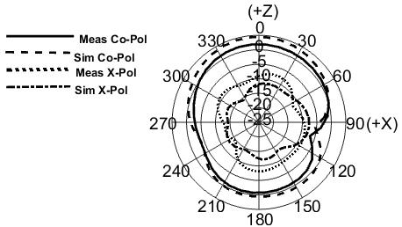 | 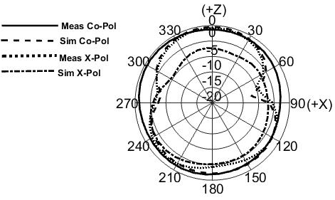
700MHz | 2600MHz
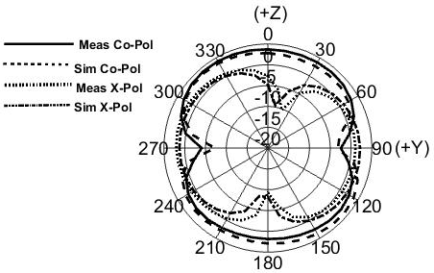 | 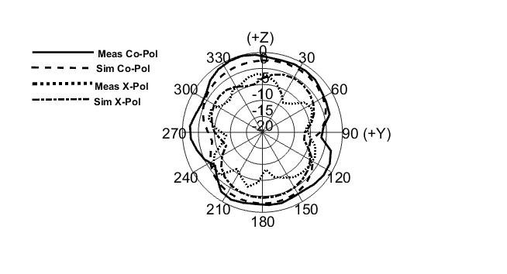
700MHz | 2600MHz
Fig.11.Normalized antenna radiation patterns for two planes (left: xz, right: yz) at 700MHz, 2600MHz, ‘____’ measured co-polarisation ‘– – –’ simulated co-polarisation ‘------’ measured cross-polarisation ‘.......’ simulated cross-polarisation

Conclusion

A design of dual-band balanced antenna has been designed and presented. The proposed design was operated in the required LTE dual-band of 700/2600MHz with sufficient impedance matching (S11 ≤ -10 dB). Computed and measured results of S11 showed good agreement for free space and hand held (with/without balun) scenarios. Furthermore, the antenna was demonstrated near-omnidirectional radiation features over the two operating bands. The surface current of the proposed antenna proves that the currents are diminished over the entire ground plane, except underneath the feeding point where there is improved immunity to the hand-held in which can enhance the stability of the present mobile antenna in real operating environments. This makes the present antenna as desired candidate for practical applications in mobile phones.

Acknowledgements

This work is carried out under the grant of the Fundacão para a Ciência e a Tecnologia (FCT - Portugal), with the reference number: SFRH / BPD / 95110 / 2013 and funded by national funds through FCT/MEC (PEst-OE/EEI/LA0008/2013 - UID/EEA/50008/2013). Also, financially support by the Engineering and Physical Sciences Research Council (EPSRC) in the UK under grant EP/E022936/1.
References
- J. Anguera, A. Andújar, M.C. Huynh, C. Orlenius, C. Picher , and C. Puente, “Advances in Antenna Technology for Wireless Handheld Devices”, International Journal on Antennas and Propagation, Volume 2013, Article ID 838364.
- Issa Elfergani, Raed Abd-Alhameed, M.S. Bin-Melha, Chan See, Da-Wei Zhou, Mark Child, and Peter Excell “A Frequency Tunable PIFA Design for Handset Applications” MOBIMEDIA 2010, LNICST 77, 2012, pp. 688–693.
- Cabedo, A., J. Anguera, C. Picher, M. Ribo, and C. Puente, \Multi-band handset antenna combining PIFA, slots, and ground plane modes," IEEE Trans. Antennas Propag.,n, vol. 57, no. 9, 2526-2533, Sep. 2009.
- Gandara, T., Peixeiro, C. “Compact double U-slotted microstrip patch antenna element for GSM1800, UMTS and HIPERLAN2”. IEEE Antennas and Propagation Society Int. Symp, Monterey, California, June 20-25 2004, pp. 1459–1462.
- J. Brissos and C. Peixeiro, "Triple-Band Microstrip Patch Antenna Element for GSM1800, UMTS and HiperLAN2", Proc. 2003 IEEE Int. Antennas and Prop. Symp, Columbus, OH, USA, 22-27 June 2003, pp. 130-133.
- I.T.E. Elfergani, T. Sadeghpour, R.A. Abd-Alhameed, A.S. Hussaini, J.M. Noras S.M.R. Jones and J. Rodriguez, “Reconfigurable antenna design for mobile handsets including harmonic radiation measurements”, IET Microwaves, Antennas & Propagation, vol. 6, Iss. 9, pp. 990–999, July 2012.
- I.T. E. Elfergani, R.A. Abd-Alhameed, C.H. See, T. Sadeghpour, J.M. Noras and S.M. R. Jones "Small Size Tuneable Printed F-Slot Antenna for Mobile Handset Applications,” Microw. Opt. Technol. Lett., vol. 54, no. 3, pp. 794-802. March 2012.
- I. Ang, Y. X. Guo, and Y. W. Chia, “Compact internal quad-band antenna for mobile phones” Microwave Opt Technol Lett , Vol. 38, No. 3, Aug.5 2003
- C. Lee and K. Wong, “Planar monopole with a coupling feed and an inductive shorting strip for LTE/GSM/UMTS operation in the mobile phone,” IEEE Trans. Antennas Propag., vol. 58, no. 7, pp. 2479–2483, Jul.2010.
- Ding-Bing Lin, Jui-Hung Chou, Son-On Fu, and Hsueh-Jyh Li “A Compact Dual-Band Printed Antenna Design for LTE Operation in Handheld Device Applications” International Journal of Antennas and Propagation, vol 2014, pp,1- 9 , Jun. 2014.
- Issa Elfergani, Abubakar Sadiq Hussaini, Jonathan Rodriguez, Chan H See, Read Abd-alhameed "Wideband Tunable PIFA Antenna with Loaded Slot Structure for Mobile Handset and LTE Applications ", Radioengineering , vol. 23, no. 1, pp. 345 - 355, April. 2014.
- L. Lizzi and A. Massa, “Dual-band printed fractal monopole antenna for LTE applications,” IEEE Antennas Wireless Propag. Lett., vol. 10, pp. 760–763, 2011.
- K.-L. Wong, C.-A. Lyu, and L.-C. Chou, “Small-size multiband planar antenna for LTE700/2300/2500 operation in the tablet computer,” Microw. Opt. Technol. Lett., vol. 54, no. 1, pp. 81–86, Jan. 2012.
- R.A. Abd-Alhameed, P.S. Excell, K. Khalil, R. Alias, and J. Mustafa, “SAR and radiation performance of balanced and un-balanced mobile antennas using a hybrid computational electromagnetics formulation,” IEE Proc Sci Meas Technol , vol.151,no.6,pp. 440 – 444.Nov,2004.
- Vainikainen, P., J. Ollikainen, O. Kivekas, and K. Kelander, “Resonator-based analysis of the combination of mobile handset antenna and chassis," IEEE Trans on Antennas and Propagation, vol. 50, no. 10, 1433-1444, Oct. 2002.
- J. J. Arenas, J. Anguera, and C. Puente, “Balanced and single-ended handset antennas: free space and human loading comparison”, Microwave and Optical Technology Letters, vol.51, nº9, pp.2248-2254, Sep 2009
- J. Ilvonen, O. Kivekäs, A.A.H Azremi, R. Valkonen, J. Holopainen, and P. Vainikainen “Isolation Improvement Method for Mobile Terminal Antennas at Lower UHF Band” The 4th European Conference on Antennas and Propagation, Barcelona, Spain, April 12-16 ,2010, pp.1238-1242.
- D. Zhou, R. A. Abd-Alhameed, and P. S. Excell” Bandwidth Enhancement of Balanced Folded Loop Antenna Design for Mobile Handsets Using Genetic Algorithms” PIERS ONLINE, vol. 4, no. 1, pp, 136-139.2008.
- J. Ilvonen, J. Holopainen, O. Kivekäs, R. Valkonen, C. Icheln, and P. Vainikainen “Balanced Antenna Structures of Mobile Terminals” The 4th European Conference on Antennas and Propagation, Barcelona, Spain, April 12-16 ,2010, pp,1-5.
- A. G. Alhaddad, R. A. Abd-Alhameed, D. Zhou, I. T. E. Elfergani, C. H. See, P. S. Excell, and M. S. Bin-Melha, "Low Profile Balanced Handset Antenna with Dual-Arm Structure for WLAN Application", IET Microw. Antennas Propag., vol. 5, Iss. 9, pp. 1045–1053, Jun. 2011.
- A. G. Alhaddad, R. Abd-Alhameed, C. S. D Zhou, E. Elkhazmi, and P. Excell, "Compact dual-band balanced handset antenna for WLAN application," The Electromagnetics Academy, PIERS Online, vol. 6, pp.11-15,2010.
- I.T.E.Elfergani, R.A.Abd-Alhameed, A. G. Alhaddad, C.H.See, and E.H.Cabongomueba, "A Novel Dual Band Frequency Tunable Balanced Handset Antenna for WLAN Application", 18th IEEE International Conference on Electronics, Circuits and Systems , Beirut, Lebanon, December 11-14, 2011. pp. 516-519.
- S. K. Behera, D. R. Poddar and R. K. Mishra “DESIGN OF SEQUENTIALLY FED BALANCED AMPLIFYING ANTENNA FOR CIRCULAR POLARIZATION” ICTACT JOURNAL ON COMMUNICATION TECHNOLOGY, VOL.1, ISSUE: 04, pp. 213-217. DECEMBER 2010
- D. Zhou, R. A. Abd-Alhameed, C. H. SEE, and P. S. Excell “Design of Wideband Balanced Folded-Arms Dipole Antenna for Mobile Handsets” Electromagnetics, vol. 29, pp, 641-651, Nov. 2009.
- Zhou, D. Abd-Alhameed, R.A. See,C.H , Alhaddad, A.G. ;Excell, P.S. “Compact wideband balanced antenna for mobile handsets” IET Microwaves, Antennas and Propag, vol. 4, Iss.5, pp. 600-608, May.2010.
- B.S. Collins, S.P. Kingsley, J.M. Ide, S.A. Saario, R.W. Schlub, and S.G. O’Keefe “A multi-band hybrid balanced antenna” IEEE International workshop on antenna technology: Small antennas and novel metamaterials, White Plains, New York, March 6 – 8. 2006. pp.100-103.
- Wen-jun Lu,Ya-ming Bo,Hong-bo Zhu “ Novel Planar Dual-Band Balanced Antipodal Slot- Dipole Composite Antenna with Reduced Ground Plane Effect”International Journal of RF and Microwave Computer-Aided Engineering/Vol. 22, No. 3, pp. 3319-328. May 2012.
- F. Jolani M. Naser-Moghadasi and A. Dadgarpour “DESIGN AND OPTIMIZATION OF COMPACT BALANCED ANTIPODAL VIVALDI ANTENNA” Progress In Electromagnetics Research C, Vol. 9, 183-192, 2009.
- N.Vignesh G.A.Sathish Kumar R.Brindha “ Design and Development of a Tapered Slot Vivaldi Antenna for Ultra-Wide Band Application” International Journal of Advanced Research in Computer Science and Software Engineering 4(5), May - 2014, pp. 174-178.

- Issa T. E. Elfergani1, Abubakar S. Hussaini, Jonathan Rodriguez, Ammar H. Ali, Chan H. See, and Raed A. Abd-Alhameed “A Compact and Broadband Balun Design for LTE Applications” Progress In Electromagnetics Research C, Vol. 67, 85-95, 2016.
- HFSS version 14, Ansys Inc, USA, 2013, Available at:http://www.ansys.com/. Accessed on October 10, 2014.
- Yun-Wen Chi and Kin-Lu Wong “Very-Small-Size Printed Loop Antenna for GSM/DCS/PCS/UMTS Operation in The Mobile Phone” Microw. Opt. Technol. Lett., vol. 51, no. 1, pp, 184-192. January 2009.
- Schantz, H. G., “Radiation efficiency of UWB antennas,” IEEE Conference on Ultra-Wideband Systems and Technologies, May 2002.
- E. H. Newman, P. Bohley, and C. H. Walter, “Two methods for the measurement of antenna efficiency,” IEEE Trans. Antennas Propag., vol. 23, pp. 457–461, 1975.
- H. A. Wheeler, “The radiansphere around a small antenna,” Proc. IRE, Aug. 1959, pp. 1325–1331.
- D. Agahi and W. Domino, “Efficiency Measurements of Portable-Handset Antennas Using the Wheeler Cap”, Applied Microwave and Wireless, June 2000.

About the Authors ...
issa ELFERGANI received his B.Sc. degree in Electrical and Electronic from The High and Intermediate Centre for Comprehensive Professional (Libya) in 2002 and his MSc, and PhD in Electrical Engineering with Power Electronics (EEPE) from University of Bradford (UK) in 2008 and 2012, with a specialization in Tunable Antenna design for mobile handset and UWB applications as well as Tunable Filters. He is now a Senior Researcher at the Instituto de Telecomunicações - Aveiro (Portugal), working with European research funded projects. He is IEEE member anda member of American Association for Science and Technology (AASCIT). He is a TPC member and reviewer for several IEEE international conferences. He is the author of several journal and conference publications. His research interests are multi-disciplinary and have a number of cross cutting themes that include research in antenna design with the application of theoretical, computational analytical approaches, RF MEMS filter technologies and Power amplifier. Specific themes include: Antenna/tuneable antenna/MIMO antenna designs for wireless communication systems, UWB antenna with tuneable notch, Beam steering antenna, Harmonics Rejection Antenna Techniques. Balanced and Unbalanced Antenna, Electromagnetic hybrid numerical methods, such as, (MoM/FDTD) and (FEM/FDTD) for complex electromagnetic problems, High Q RF MEMS bandpass filter design for mobile handset and wireless communication applications, Power amplifier design.

jonathan RODRIGUEZ received his Master’s degree in Electronic and Electrical Engineering and Ph.D from the University of Surrey (UK), in 1998 and 2004 respectively. In 2002, he became a Research Fellow at the Centre for Communication Systems Research and was responsible for coordinating Surrey involvement in European research projects under framework 5 and 6. Since 2005, he is a Senior Researcher at the Instituto de Telecomunicações (Portugal), where he founded the 4TELL Wireless Communication Research Group in 2008. He was the project coordinator and technical manager of the FP7 ICT C2POWER and the FP7 COGEU projects, and currently acts as coordinator of several national and international projects. He is the author of more than 200 scientific publications, and has served as general chair for several prestigious conferences and workshops, and has carried out consultancy for major manufacturers participating in DVB-T/H and HS-UPA standardization. He is a Chartered Engineer (IET) and an IEEE Senior Member. His research interests include green communications, antenna design, cognitive radio, cooperative networking, radio resource management, and cross-layer design.

fathi ABDUSSALAM was born in Bin-Waleed, Libya. He received the BSc from AL Fatah University, Tripoli, Libya in 1992. After graduation, he had worked at Ministry of education from 1992 to 2002, and then he joined University of West of England, Bristol, UK to do his MSc degree from 2003 to 2004. He has appointed as lecturer at Higher Institute of Electronics, Tripoli, Libya from 2004 to 2009 and then appointed as senior lecturer at Azzaytuna University from 2009 to 2014. Since Oct 2014, he joined the School of Engineering and Informatics at University of Bradford to pursue his PhD research degree. The main objective of his PhD research is to model and analyse complex electromagnetic problems by means of a new hybridised computational technique combining the frequency domain Method of Moments (MoM) and Finite-Difference Time-Domain (FDTD) with the optimisation process of GA, PSO and FF methods. Fathi has published three conference papers and also contributed to other three since his registration to Bradford University.

chan h. SEE received the first-class B.Eng. Honors degree in electronic, telecommunication and computer engineering and a Ph.D. degree from the University of Bradford, Bradford, U.K., in 2002 and 2007, respectively. Currently, he is a Lecturer in Electrical and Electronic Engineering at Engineering, Sport, and Sciences (ESS) Academic Group, University of Bolton, Bolton, U.K. He is also appointed as an Honorary Visiting Research Fellow in the Radio Frequency, Antennas, Propagation and Computational Electromagnetics Research Group within the School of Electrical Engineering and Computer Science, University of Bradford. He has published over 100 journal articles and conference papers. He is a co-author for one book and one book chapter. Dr. See was a recipient of two Young Scientist Awards from International Union of Radio Science (URSI) and Asia-Pacific Radio Science Conference (AP-RASC) in 2008 and 2010, respectively. He is a Chartered Engineer and Member of the Institution of Engineering and Technology (MIET). He has an NVQ level 4 in Management from the Chartered Management Institute.
raed ABD-ALHAMEED received the B.Sc. and M.Sc. degrees from Basrah University, Basrah, Iraq, in 1982 and 1985, respectively, and the Ph.D. degree from the University of Bradford, West Yorkshire, U.K., in 1997, all in electrical engineering. He is a Professor of electromagnetic and radio frequency engineering at the University of Bradford. He is the senior academic responsible for Radio frequency and electromagnetics research in the University of Bradford, for which new antenna design configurations and computational techniques have been developed including several patents. The expertise includes in particular the highly realistic analysis of antenna design process in the presence of large multilayer scatterers, using the Bradford-developed hybrid modelling techniques including MoM, FEM, FDTD and subgridding FDTD methods. Currently, he is the leader of the Communication Research Group and head of RF and electromagnetics research in the School of Engineering and Informatics, Bradford University. He is Principal and co-Investigator for many funded projects from EPSRC, Department of Health, Mobile Telecommunications, and Health Research Programme, EU research organizations; in addition to be a leader for several successful knowledge transfer programmes such as Pace plc, YW plc, IETG Ltd and Datong plc. He is the chair of several successful workshops on energy efficient and reconfigurable transceivers (EERT) approach towards energy conservation and CO reduction that addresses the biggest challenges for the future wireless systems. He was invited as keynote speaker for several international conferences such as, ICST, ITA and EPC; in addition to chair many research sessions. He was appointed as guest editor for the IET Science, Measurements and Technology Journal in 2009. He is also a research visitor for Wrexham University, Wales, since September 2009, covering the wireless and communications research areas. He has published over 400 academic journal and conference papers and is co-author of two books and several book chapters. He has many years of research experience in the areas of radio frequency, antennas, and electromagnetic computational techniques. His current research interests include hybrid electromagnetic computational techniques, EMC, antenna design, low SAR antennas for mobile handset, bioelectromagnetics, RF mixers, active antennas, beam steering antennas, MIMO antennas, energy efficient PAs, and RF predistorter design including biological cell modelling for breast cancer applications. Dr. Abd-Alhameed is a Fellow of the Institution of Engineering and Technology, Fellow of Higher Education Academy, and a Chartered Engineer in the U.K.

