Getting in, getting on: fragility in student and graduate identity

Abstract Over a period of three years this longitudinal study explored new approaches to consider student identity during the transition from university to employment. Students were followed through a new portfolio-based final year course and beyond university into the workplace. With universities increasingly recognising the employment aspirations of their students, facilitating self-awareness of graduate attributes and the development of employability skills are becoming integral to the higher education proposition; however the impact of employability initiatives is not well understood. The aim of the study was to examine changes in self-identification through the development of a portfolio of work using Holmes’ Claim Affirmation Model of Emergent Identity as the conceptual framework. Data was collected through student questionnaires and graduate interviews. The study uncovered the ways in which role models, developmental networks, and imaginings of a possible self were used in identity work. A fragile re-construction of identity was observed as graduates faced the labour market, with this fragility continuing to be experienced while navigating an uncertain work landscape. We used these findings to allow us to refine Holmes’ Model by (a) adding a dynamic element and (b) grounding it on longitudinal data.

Keywords— student identity, graduate identity, fragile identity, portfolio, employability, curriculum design

Introduction
Universities are being challenged to equip students with both academic and employability skills (Cumming, 2010; Jackson, 2016; Tymon, 2013), where employability can be seen as ‘a set of achievements – skills, understandings and personal attributes – that makes graduates more likely to gain employment and be successful in their chosen occupations’ (Yorke, 2004, p. 7). As a result, there has been interest in the development of graduate or employability attributes in undergraduates (for example, Barrie, 2004; Coetzee, Botha, Eccles, Holtzhausen, & Nienaber, 2012). Student perspective studies have explored whether the development of these attributes effect a transformation in self-identity (for example, Daniels & Brooker, 2014; Tymon 2013). To date, attempts to measure impact have focused, in the main, on student perceptions of ‘graduateness’ (Coetzee, 2014),‘work-readiness’ (Kinash, Crane, Schulz, Dowling, & Knight, 2014) or traits such as resilience (Yorke & Knight, 2007). However, gaining graduate employment is not as straightforward as being ready for work, instead the context is a demand for graduate jobs that exceeds availablility (Abel, Deitz, & Su, 2014; Green & Zhu, 2010). Some sectors are turning to evidence beyond degree classification, such as portfolios of evidence which have been found to impact positively on graduate destinations (for example, Oliver 2013; Jing, Patel, & Chalk, 2011).
Of course, success in finding a graduate position is only one measure of employability. The transition from student to employee as a lived experience through self-identification offers another window onto graduation and job seeking. Identity can provide evidence of the effectiveness of work-integrated learning (Smith, Smith, Taylor-Smith, & Fotheringham, 2017), which includes internships, industry-based projects and employer mentoring (Jackson, 2016). The aim of this study was to explore the impact on student identity of a new work-integrated learning portfolio course designed to assemble a professional body of work targeted towards a career in digital media. Before starting the course, students had amassed examples of assessed work from earlier in their programme they exercised and developed professional skills to assemble in a portfolio. This allowed students to present sample work which included video, animation and web resources to tutors and employers. In addition, the course invited students to consider their sense of self as a means of supporting identity re-definition as a skilled graduate. Student identity reconstruction comprises initiation events, leading to a transitional status, followed by a redefinition of identity (Costello, 2005). The course initiated identity re-construction through self-reflection and the effort of orientating their portfolio towards employers. In this study, the Claim Affirmation Model of Emergent Identity (Holmes, 2015) is used to conceptualise identity transition as experienced through the portfolio-based course and into the workplace. Over a period of three years, data was collected from two cohorts in their final year of study. To consider the longer-term impacts, later interviews with the first cohort were conducted to move beyond perceptions of employability into experiences of employment. The main contribution of this work is assessing the impact of a portfolio-based course on student identity re-construction. Further, the study maps graduate trajectories to re-conceptualise Holmes’ (2015) model for this context. The paper is structured as follows: the identity literature and Holmes’ model are introduced, the context is described and the method detailed. The findings are then presented, followed by a discussion.
In consideration of identity
Identity theory holds that identity is considered to be ‘parts of a self composed of the meanings that persons attach to the multiple roles they typically play’ (Stryker & Burke, 2000, p. 284). We construct a self-concept based on the roles we enact, and multiple co-existing identities are recognised (Korte, 2007). Role identity proponents believe that the core of an identity is the categorisation of self as a role holder (McCall & Simmons, 1978). People behave in a somewhat predictable way based on the roles that they carry out, so studies focus on role enactment and role performance, such as the role of student (or worker) with subsequent expectations of typical behaviour (Langendyk, Hegazi, Cowin, Johnson, & Wilson., 2015). As such, self-identification can shed light on the transition between education and work through roles of student and graduate (Hinchliffe & Jolly, 2011).
Holmes proposes a model based on identity claims and affirmation (Holmes, 2001; Holmes, 2013; Holmes, 2015). Figure 1 shows Holmes’ four zones of identity, or identity positions. An employable agreed identity is claimed by the individual and affirmed by academics within an institution (or by employers within the workplace) (Zone 4).

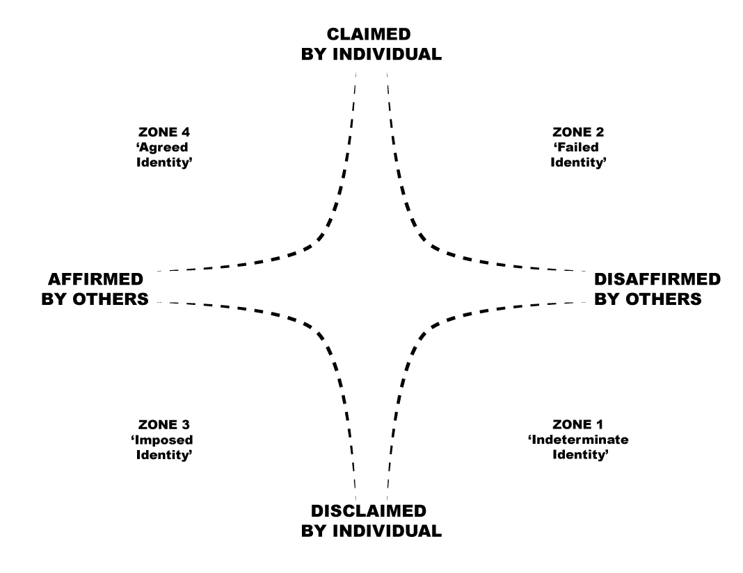

Figure 1: Claim Affirmation Model of Emergent Identity (Holmes, 2015)
This figure is available under the Creative Commons Attribution-Noncommercial-ShareAlike Licence

At the centre of the model lies an undetermined identity with outer zones for indeterminate, imposed, agreed and failed identities. Transition between zones is largely determined by agentic claims and external affirmation (support for the identity claim) or disaffirmation (acting to repel the claim). As an example, a student makes an identity claim through work-related learning activity in a simulated work environment, tutors give affirmation through feedback and an ‘agreed identity’ is achieved (Zone 4). A student approaching a similar activity in a casual, disorganised manner, whose work is not considered suitable, is likely to remain in Zone 1 (‘indeterminate identity’). Using this model, Holmes (2013) calls upon universities to provide an environment wherein each student is asked to formulate their ‘claim on the identity (of being a graduate worthy of employment) in such a way that it stands a good chance of being affirmed by those who make the selection decision on job applications’ (p. 551). The portfolio course was designed to create such an environment for digital media students.

Identity work, identity adaptation and the transition from student to professional
For many students, the purpose of attending university is to gain graduate work; a professional role. Professional identity, one possible emergent identity, is considered to be a self-definition constructed from skills, experience, capability, values and attributes in the context of a professional role (Ibarra, 1999). In a university setting, the term pre-professional identity has been used to encompass the skills and capabilities of students together with ‘conduct, culture and ideology of a student’s intended profession’ (Jackson, 2016, p. 926), and has been observed through meaningful discipline-based experiences such as real-world problem solving, and simulated work environments (Pierrakos, Beam, Constantz, Johri, & Anderson, 2009). As students transition to the workplace they are called on to think about who they will be as a graduate, the type of work they place value in, and the skills and attributes they can demonstrate. As a result, they are likely to experience identity disruption (Ashforth & Schinoff, 2016), involving ‘a fundamental questioning of who one is when one’s sense of self is challenged . . . [creating] a meaning void that must be filled’ (Pratt 2000, p. 464). Identity work is considered to be the means by which the ‘meaning void’ is filled. Identity work has been defined to be the construction of identity through interaction with others (Sveningsson & Alvesson, 2003). In a university setting, significant interactions include those with tutors, the career services and peers. Identity work draws upon social processes which can be facilitated by work-integrated learning (Trede, 2012). These include interaction with role models (Felstead, 2013; Singh, Vinnicombe & James, 2006), developmental networks (i.e. those who take an interest in an individual’s development or progression) (Sweitzer, 2009; O’Shea, 2014) and experimenting with possible selves (enacting and testing new versions of self) (Markus & Nurius, 1986; Ronfeldt & Grossman, 2008).
Such social processes create the conditions for negotiated professional or pre-professional identities which are claimed by the individual and affirmed by academics (Holmes, 2015). Recent employability studies have focused on employable self-identification by students and graduates (Tomlinson, 2010; Holmes, 2015). This perspective is less about what universities do to students and more with how employability initiatives such as work-integrated learning affect students’ self-concepts. The story of transition from university to work is increasingly problematic: getting in to the workplace is one challenge, getting on once there is another. Holmes’ model is reliant on both self and others, however the interplay is not fully explained, and there is, as yet, little empirical evidence to support the model. Using Holmes’ Claim Affirmation Model of Emergent Identity as the conceptual framework, the questions for this study were i) to what extent did the portfolio course facilitate a change in student identity, and ii) how was identity experienced subsequently, some time after graduation.

The study context
A final year course was introduced at a UK university, designed to nurture professional identity, combined with an opportunity for portfolio development. The digital technologies sector overall increasingly relies on sample work when making recruitment selection decisions (Mietzner & Kamprath, 2013). The aim was thus to support digital media students transitioning from university to the workplace. In addition to developing/ expanding their portfolio of sample work, the course included embedded careers activities such as CV preparation workshops, an assessed job application, mock interviews, employer-led masterclasses, a networking workshop and a careers fair. Producing a portfolio enables students to showcase examples of their work, highlighting their professional capabilities and their underlying work ethic (Wakimoto & Lewis, 2014). In effect, the portfolio represents how graduates wish to portray themselves and their work to a prospective employer and, to some extent, reveals something of who they are (Trede & McEwen, 2012). As such, developing a portfolio of work reflects an emerging self-narrative. The course also included writing a reflective essay that allowed them to consider their experiences of higher education (Luehmann, 2007), and the extent to which they had developed skills, generic graduate attributes, and self-concept as a professional.

Method
A longitudinal study was designed to run over three years. It involved a pre and post-course questionnaire distributed to two separate cohorts. Participants from the first cohort, once in work, were then invited to take part in a semi-structured interview. Table 1 details the full data set.
Table 1: Type and quantity of data collected during the three-year study
Year of study | Questionnaire pre-course (n) | Questionnaire post-course (n) | Completed both pre and post questionnaires (n) | Graduate interviews  (sampled from cohort 1) (n)
2014 (Cohort 1) | 43 | 34 | 27 | 7
2016 (Cohort 2) | 50 | 37 | 20 | -

The pre-course questionnaire was drafted by the authors who drew on a summary of identity data collection approaches (Cowin, Johnson, Wilson & Borgese, 2013) to explore the nature of identity in relation to study and wider student experiences, together with perspectives on their portfolio of work. It was distributed during the first week of the course. The post-course questionnaire re-iterated most questions to reveal changes in identity, observe aspects of identity work, and re-visit participants’ attitudes to their portfolios. The questionnaire returns were indexed and anonymised. The initial study of the first cohort has been previously reported (AUTHOR, 2014). Two years later the questionnaires were used with a new cohort (Cohort 2).
At that time Cohort 1 participants, who had graduated 18 months previously, were contacted through social media and invited to reflect through a semi-structured interview upon their experiences of transitioning to work. The interviews (2 females, 5 males volunteered) were conducted over video conferencing by a single researcher, and the average time per interview was 30 minutes. Graduates were asked about their current employment activities and the process of adjustment following university. The interviews were transcribed, coded based on identity adaptation literature, then analysed thematically (King, 2012).
Findings

Identity in transition
To explore self-identification, undergraduates were asked if they agreed with statements such as ‘Being a student is important to me.’ Participants were able to select one of five possible responses ranging from strongly agree to strongly disagree. Table 2 summarises participant responses to questions of identity. The values show the percentage of students who either agreed or strongly agreed with the statements.
Table 2: Student and practitioner identities
 | Student responses as %
 | Before the course |  | After the course |  | Difference
 | Cohort 1 | Cohort 2 | Cohort 1 | Cohort 2 | Cohort 1 | Cohort 2
Being a student is important to me | 65 | 85 | 88 | 80 | +23 | -5
Being a student makes me feel good about myself | 85 | 70 | 92 | 65 | +7 | -5
I strongly define myself as a digital media student | 92 | 80 | 88 | 75 | -4 | -5
I strongly define myself as a digital media practitioner | 61 | 85 | 73 | 75 | +12 | -10

In both cohorts the majority of students placed importance on their student identity at the end of the course (88%, 80%). For the first group the percentage agreeing or strongly agreeing that being a student was important increased from 65% to 88%. A statistical analysis did not reveal reliable differences between cohorts.
Respondents also felt good about themselves as students at the end of the course (92%, 65%). Strong identification as a digital media student tended to decrease slightly from the start of the course to the end (-4%, -5%). Our conjecture is that this was due to increasing specialisation of portfolio work leading to more explicit associations, for example as animators. Self-identification as practitioners was strong, but the experience of the course had different effects on the cohorts (+12%, -10%). Overall, however, the percentage of the group at the end who defined themselves as practitioners was similar (73%, 75%).
Students were asked about role models in the industry and what support they offered. In the pre-questionnaire returns a number of responses suggested that they could identify role models but were unsure how they could make use of them (for example, ‘I have some friends working in the industry but do not see how I could benefit from them’). The question was posed again in the post-questionnaire and the same student responded: ‘I have friends and peers that work in the industry and there is a definite level of support.’ This student’s response to having a strong practitioner identity changed from ‘neither agree nor disagree’ to ‘agree’.
The post-questionnaire asked which aspects of their university experience had moved the participants on in terms of their professional development. The most common factor mentioned in the open responses (at 47%) was the mock interview, which provided an opportunity to experiment with a possible self. As one student commented: ‘the mock interviews were a great tool for me, it gave me a good outlook on my professional development.’ Specific skills development was also cited, along with project-based courses, credit-bearing internships and student exchanges. The importance of creating a significant body of work before graduation was in general recognised and one of the students reported having ‘sacrificed marks for professional work.’ During the course, students were encouraged to start developing professional networks and they mentioned employer-led masterclasses as ways of meeting people in the industry. Course leaders, project supervisors and tutors were mentioned in most responses as not just providing academic guidance but as enablers for identity adaptation through the affirmation afforded by facilitating student development of new self-narratives as digital experts, for example through portfolio design and planning.

Examining portfolio development
To observe the impact of the course on the students’ portfolios, they were asked how they might describe the content of their portfolios. Table 3 represents the percentage of students who agreed or strongly agreed with the statements.
Table 3: Portfolio content description
 | Student responses as %
 | Before the course |  | After the course |  | Difference
My portfolio is composed entirely of coursework | 48 | 40 | 37 | 25 | -11 | -15
My portfolio reflects extra-curricular work | 55 | 55 | 70 | 80 | +15 | +25
My portfolio reflects my ability | 55 | 85 | 74 | 85 | +19 | 0
I am proud of my portfolio | 26 | 45 | 63 | 85 | +37 | +40

One of the aims of the course was to encourage students to add content to their portfolios that had not been generated as part of their university assessed work. Examples included embedding any extra-curricular work (such as participation in filming competitions, creating digital content for charities and freelance work) or personal projects. In both cohorts the numbers of students relying only on university work for their portfolios fell. The proportion of students who felt that their portfolios reflected their extra-curricular work rose, giving them an opportunity to develop a story of competence beyond their course. Less than half of the cohort in each year group expressed pride in their portfolio at the start of the course and both cohorts reported a substantial increase (+37, +40) in pride over the semester. The variance between the cohorts could be due to facilitative staff gaining experience of running the course and awareness of the course increasing among staff and students.
Students were asked about the state of their portfolios; the responses are shown in Table 4.

Table 4: Perception of portfolio state
Which best describes your portfolio. | Student responses as %
 | Before the course |  | After the course |  | Difference
Ready to share with potential employer/client | 7 | 22 | 30 | 54 | +23 | +22
In need of some further work | 52 | 40 | 67 | 43 | +15 | +3
In need of substantial development | 41 | 40 | 4 | 6 | -37 | -34

Although the year groups started from substantially different baselines (Cohort 1 started with only 7% stating their portfolio was ready to share, compared with 22% of Cohort 2), both felt their portfolios were substantially improved at the end of the course. In both cohorts a greater percentage felt that their portfolio was ready to share with potential employers at the end of the course compared with at the start (+23, +32). Many students felt that their portfolios still required improvements at the end of the course, perhaps understanding the portfolio development as an ongoing process.
The post-questionnaire asked students to comment on what they felt their portfolio said about them, inviting identity claims. Undergraduates mentioned professionalism but also confidence and motivation: ‘That I have the motivation to do well; my portfolio is well designed and reflects me as a person.’ Students cited horizons beyond specific skills and capabilities: ‘I believe my portfolio demonstrates my ability to work not just as a graphic designer but as a digital professional who can approach a task confidently.’ There were no unqualified negative comments but some self-awareness evident in: ‘As always it could be improved, but I am comfortable with it.’

Findings from the graduate interviews
The results above describe the identity development of two cohorts of students shortly before graduation. In order to investigate identity construction and how attitudes to portfolios evolved after graduation, interviews with seven participants from Cohort 1 were arranged between 18 months to two years after graduation. Analysis revealed four emergent themes: i) technical skills as a component of professional identity; ii) agency and discomfort in building professional networks; iii) the use of role models; iv) portfolio pride and use. These are described in turn below. As one would expect, the experiences of the cohort varied significantly after they graduated. Two were in graduate digital media jobs (DM), two in IT roles (IT), two were day-job strivers (DS) - in non-graduate roles but continuing to seek graduate roles - and one was resigned to a non-graduate role (NR). The two DM graduates revealed self-concepts as competent professionals; however they looked to their organisations for identity affirmation, including further training. They also acknowledged the need for self-development outside working hours, in particular accessing free online training materials. The two graduates in IT roles had embarked on somewhat more traditional software development careers in medium to large companies. They had therefore constructed new IT professional identities; although they no longer showed interest in digital media careers, for each there was a sense that they would look for jobs in digital media, if their work eventually proved uninteresting. Of the three interviewees who were in non-graduate employment, two (DS) continued to develop their skills through freelance creative projects. Both considered their full-time employment to be ‘day-jobs’ that did not reflect their aspirations or how they saw themselves. Both were actively seeking digital media related work. The final interviewee, in non-graduate employment (NR), was highly disillusioned and not actively pursuing a digital media related career. In her words:
The applications were quite long and tedious and then I never ever heard back from anyone, so then I applied for less and less and less until it got the point to where I just started applying for things that weren’t relevant at all.

Technical skills as a source of professional identity
Participants made statements that strongly linked technical knowledge and skills to their identity as professionals. For example, when reflecting on professional development over the past two years, one graduate expressed pride in professional certificates, another that his company had ‘a great interest in developing me as a professional person.’ Others considered technical skills in utilitarian terms, for example, ‘you see a lot of personal study time which, you know, it’s paying off’. These participants continued to see technical skills as a resource for positive identity claims, for example, ‘I think just being able to use the skills that I want to use and having successes with those is nice.’ Where skills had improved, earlier portfolio work was removed. In one case early work now made the participant ‘cringe’.

Agency and discomfort in building professional networks
Professional networks emerged as an important factor in career progression, and were mentioned by all participants. Agency, as the sense that respondents perceived professional networks could help them achieve their goals together with some associated action, was observed. Respondents focused on their value in terms of practical benefits, in particular to gain access to professional opportunities (‘you just got to put yourself out there’). The lines between professional and social networks were blurred, especially when project work or new contacts were offered by friends. Some expressed views related to their own behaviour: ‘I kind of made myself known for those opportunities that arise’ and ‘I am not too ashamed to say, I was just starting pestering folk, finding people who I thought were, you know, the best in their industries.’
Although all participants acknowledged professional networks as important, not all expressed comfort operating within them, for example, describing attempts to network as necessary, but finding themselves ‘not in a comfortable situation.’ Indeed, learning to operate within a professional network was revealed as an important part of working within the industry that had not been recognisably covered in their programme. Participants conveyed a picture of being resigned, for example, to push themselves to network and seeing themselves as ‘pestering.’ Students had had varied prior opportunities to network, and the experience gained on the course appeared to have more impact on motivation to network than confidence in their ability to do so.

Role models
Little self-conscious use of role models was observed; however, there was evidence of participants looking to those already acting as industry professionals. One summed this up;
I was kind of stepping into a bit of the unknown, so there was a lot of time, you know looking to my peers, my colleagues, kind of getting a feel for how they worked and adopting certain aspects of that.
Another mentioned colleagues who were ‘really clued up tech-wise’ as role models. However, not all of them were used for positive identity adaptation. Indeed, at times graduates recognised the status of the role model but choose not to model their behavior;
I asked what they thought of me doing [a project], it doesn’t necessarily mean I agreed with them or followed their advice, but it was still good to have.
Attitudes to role models were often utilitarian, i.e. they were appreciated for their feedback on technical skills or valued for their industry connections.

Portfolio pride and use
Attitudes to portfolios were mixed within the respondent group. A common sentiment was that the portfolio had been useful in obtaining employment, but was less relevant two years on, for example, ‘I haven’t really developed [it] that much since, because it kind of served its purpose at the moment.’ Respondents that considered themselves to have a successful career viewed the portfolio as instrumental in getting early opportunities, and mentioned it as being of interest at interviews. Those who had not yet found graduate jobs, but were still actively looking for both full-time roles and projects, were keeping their portfolios up to date and this included significant investment in their own time, costly equipment and software licenses.
Although the data we have reported comes from a small sample, we are confident that the diverse experiences shed light on an uncertain post-graduation labour market for this group of digital media students.
Discussion
The findings of the study are now discussed in terms of the students’ construction of an ‘employable’ identity. Finally, through graduate trajectory mapping, a re-conceptualisation of Holmes’ (2015) Claim Affirmation Model of Emergent Identity is proposed for this context.

The course: initiating identity re-construction
The course introduced identity disruption, constituting an initiation event (Costello, 2005). It increased consideration of identity both through engagement with teaching materials and reflection. For Cohort 1, student identity unexpectedly increased between pre and post-course questionnaires, and this was explored through their open comments in the post-questionnaire returns. Factors included the intensity of the university experience in the final semester of the four-year degree which increased student workloads and independent work, together with anxiety about the future. The course called for undergraduates to consider the transition from student, to life beyond university, and was found to be disrupting their self-identification. From our participant responses, student identity represented a coherent self-image. The increase in self-identification as both students and practitioners could signal the start of a process of letting go of a cherished identity to find a new self-identification (Conroy & O'Leary-Kelly, 2014), although the extent differed between cohorts.

Transitional status – towards a pre-professional identity
The questionnaires provided evidence of a tentative transitional status. Students showed an increased awareness of the nature of industry contacts and professional networks, and had used these to enhance their online profile, inform their decisions about job searching or further study, and provide external projects. These types of interactions have previously been linked to the construction of a professional identity (for example, Sweitzer, 2009) . However, some were uncomfortable about leveraging professional networks, echoing Abrahams’ (2016) finding that some students believe networking for personal gain to be ‘cheating’ (p. 8). In terms of developmental networks, many mentioned the need to explain to people what it meant to be studying digital media, and observed that family and friends asked to see their work; not all these interactions strengthened a sense of identity!
Undergraduates generally expressed increased pride in their portfolios at the end of the course which led to increased confidence in showing their work to others, including potential employers, described elsewhere as ‘the kinds of beings and doings that will make [graduates] more, not less, employable’ (Hinchliffe & Jolly, 2011, p. 20). It was clear from the responses that the course was affording students an opportunity to consider strategies for self-development (Qenani, MacDougall & Sexton, 2014). There was evidence of them constructing a pre-professional identity (Trede, 2012; Jackson, 2016) through improved skills and capabilities, and many students mentioned the opportunity to specialise in one aspect of digital media, for example animation. Similarly Jackson (2016) found such inculturation to contribute to the construction of a pre-professional identity. Identity adaptation resources mentioned by participants included academic staff affirmation of identity claims when presenting completed portfolio pieces. Their portfolio self-evaluation reported in questionnaire responses, with tentative claims of professionalism, represented evidence of emerging identity coherence (Sveningsson & Alvesson, 2003). Students were positive about the mock interviews arranged as part of the course and used this opportunity to be viewed as a digital media practitioner in a safe environment, a phenomenon observed elsewhere in professional identity construction (Ibarra, 1999). For some students the portfolio was a chance to develop a new way of describing what they were capable of, of who they were.

Graduates and a fragile re-definition
The seven graduates interviewed were observed to have re-constructed identities; however, the re-construction was generally fragile, as detected through tentative identity claims and recognition of the need for ongoing skills development. Those in relevant careers had worked hard to obtain their graduate roles and it was clear that, when applying for jobs, they viewed the process as not just their work being judged, but also what their work revealed about their inner selves. Rejection by employers was experienced as a personal disaffirmation (Holmes 2013), and lack of interest shown in applications eroded identity claims as a skilled graduate. Indeed, their sense of personal competence was affected by both, the lack of response from employers, and erosion of mastery through lack of opportunities for professional practice, affecting resilience (the ability to bounce back after adversity) (Wagnild & Young, 1993) . The day-job strivers were ‘sticking it out’ (Finn, 2017, p. 426), holding on to their ambition of relevant graduate-level work. Echoing findings elsewhere (for example, Bathmaker, Ingram, & Waller, 2013), both day-job strivers had families that facilitated periods of work with unpaid or low-paid project work running between day-jobs.
Contrary to previous studies (for example, Felstead, 2013), little evidence was found of role models, other than workplace colleagues, being used in identity construction. Near role models surfaced when prompted, but were experienced as a limited resource for identity adaption, and also on occasions as anti-role models whose behaviour was not modelled. Graduates still remembered trying while a student to imagine a future possible self. In their graduate roles, there was evidence of enactment that did not feel entirely authentic, especially where their career represented opportunistic compromise. Indeed, the imaginings of possible selves and enactment were suggestive of tentative or fragile identity construction; ‘rehearsing’ rather than asserting the professional role (Costello, 2005, p.31).

Re-conceptualising Holmes’ Claim Affirmation Model of Emergent Identity by mapping graduate data

Once graduated, a picture of identity claims and affirmation leading at times to a fragile redefinition emerged. Mapping the lived experiences of the four graduate groupings onto Holmes’ Claim Affirmation Model (2015) leads us to a tentative re-conceptualisation as proposed in Figure 2. In particular, we suggest replacing the ‘failed’ identity of Holmes’ model (claimed by the individual, disaffirmed by others) with a new concept of ‘fragile’ identity to recognise the porous nature of the affirmation/ disaffirmation axis observed in this study, and the somewhat faltering identity claims made by the graduates. The fragile identity also represents a starting point for most of our respondents as they approached graduation. Furthermore, we suggest that while affirmation/ disaffirmation is influenced by others (Figure 1), it is also affected by circumstances (Figure 2). In the case of this study, circumstances included the challenges of the job market.
Individual experiences and dispositions led to different trajectories. Graduate trajectories for the three groupings identified in this study (digital media professionals (DM), IT professionals (IT), day-job strivers (DS) and the graduate in a non-graduate role (NR)) are plotted on axes comparing individual identity and affirmation/disaffirmation according to different circumstances. Identities at a particular time point are shown as circles labelled with the graduate categorisation. Transitions are shown as arrows between two time points and marked with the stated cause of the transition.
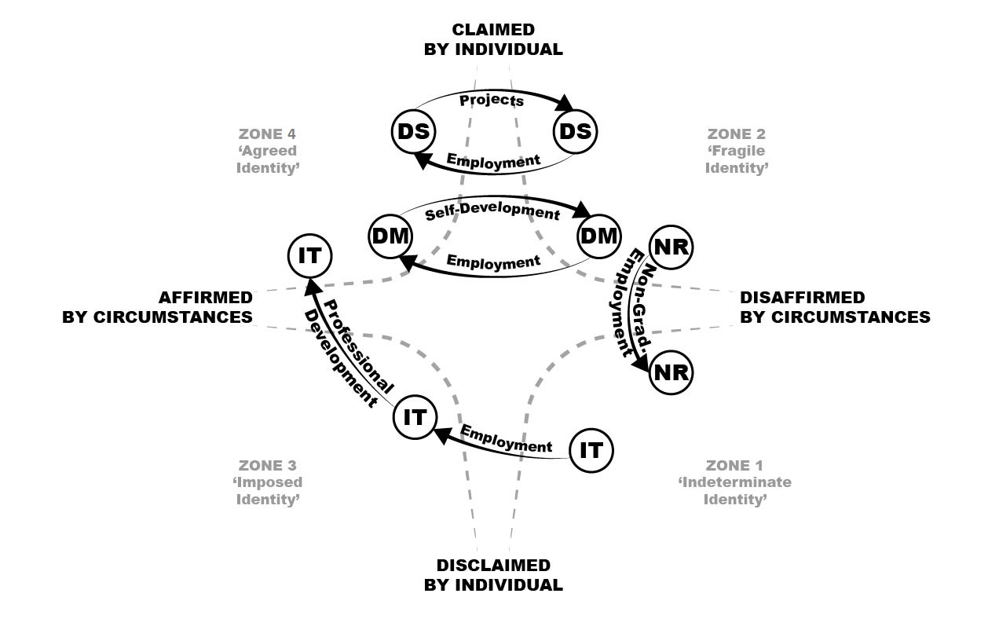

Figure 2: Re-conceptualisation of Claim Affirmation Model with Mapping
DM-In digital media employment; IT-information technology employment; DS- day-job strivers; NR-non-graduate role.
In this study, those working as digital media professionals (DM) were experiencing agreed identities through considerable effort and self-development – identities claimed by them and affirmed by their organisations and colleagues (Zone 2 to Zone 4). Those in an IT, rather than digital media role, had accommodated a new self-image in a positive, though tentative, way: ‘just a development of me, rather than not what I did at university’ (Zone 1 to Zone 4). Both of the day-job strivers (DS) had experienced periods of unsuitable employment and developed new or enhanced skills beyond the degree course, in order to construct fragile practitioner identities that relied on the affirmation afforded by relevant employment, thus experiencing regular transitions. Periods of relevant employment/ meaningful projects acted as an affirmation by circumstance (Zone 2 to Zone 4). While less valued project work fitted around paid non-graduate work acted in reverse. Finally, the graduate in a non-graduate role had ‘applied for everything’ she could see relating to her specialism. Her experience acted as disaffirmation, with identity positioning in ‘deficit, outsider terms’ (Badenhorst & Kapp, 2013, p. 474) (Zone 2 to Zone 1).
Conclusion
Students in their final year face the challenge of transitioning between university and a fast-changing workplace. In terms of the students in the study, a new portfolio-based course secured space for further development of technical skills and offered opportunities for identity affirmation. Where academics had provided affirmation through job and internship recommendations, or through events which brought students and industry together, self-identification as skilled practitioners was better consolidated, and less fragile. We observed digital media practitioner identity construction as students refreshed, renewed and developed technical skills and capabilities. For many, meaningful identity work included imagining possible professional selves facilitated by the course. The importance of building and leveraging networks should not be underestimated by universities, together with a recognition that not all students experience the same levels of access (or attitudes) to such resources. Two years post-graduation, an initial but still fragile self-identification was observed, with identity claims made through enhanced skills development and affirmed by the circumstances of relevant employment. We have re-conceptualised Holmes’ Claim Affirmation Model of Emergent Identity for these graduates, adding a dynamic component, introducing identity fragility for graduates and recognising circumstances beyond those in receipt of the identity claim. The sample size was small; however the observed fragility of graduate self-identification highlights the challenges for universities in supporting student transitions to graduate work, and established the need to pursue this aspect of self-identification.

Acknowledgements
The authors gratefully acknowledge the reviewers’ helpful and constructive comments.

References
Abel, J. R., Deitz, R. & Su, Y. (2014) Are recent college graduates finding good jobs? Current Issues in Economics and Finance, 20(1).
Abrahams, J. (2017). Honourable mobility or shameless entitlement? Habitus and graduate employment. British Journal of Sociology of Education, 38(5), 625-640.
Ashforth, B. E., & Schinoff, B. S. (2016). Identity under construction: How individuals come to define themselves in organizations. Annual Review of Organizational Psychology and Organizational Behavior, 3, 111-137.
AUTHOR (2014)
Barrie, S. C. (2004) A research based approach to generic graduate attributes policy. Higher Education Research & Development, 23(3), 261-275.
Bathmaker, A. M., Ingram, N., & Waller, R. (2013). Higher education, social class and the mobilisation of capitals: Recognising and playing the game. British Journal of Sociology of Education, 34(5-6), 723-743.
Coetzee, M. (2014) Measuring student graduateness: Reliability and construct validity of the graduate skills and attributes scale. Higher Education Research & Development, 33(5), 887-902.
Coetzee, M., Coetzee, M., Botha, J., Eccles, N., Holtzhausen, N. & Nienaber, H. (2012) A framework for developing student graduateness and employability in the economic and management sciences at the university of south africa. Developing student graduateness and employability: Issues, provocations, theory and practical guidelines, 119-152.
Conroy, S. A., & O'Leary-Kelly, A. M. (2014). Letting go and moving on: Work-related identity loss and recovery. Academy of Management Review, 39(1), 67-87.
Costello, C. Y. (2005). Professional identity crisis: Race, class, gender, and success at professional schools. Vanderbilt University Press.
Cowin, L. S., Johnson, M., Wilson, I., & Borgese, K. (2013). The psychometric properties of five Professional Identity measures in a sample of nursing students. Nurse education today, 33(6), 608-613.
Cumming, J. (2010) Contextualised performance: Reframing the skills debate in research education. Studies in Higher Education, 35(4), 405-419.
Daniels, J. & Brooker, J. (2014) Student identity development in higher education: Implications for graduate attributes and work-readiness. Educational research, 56(1), 65-76.
Felstead, I. (2013). Role modelling and students' professional development. British Journal of Nursing, 22(4), 223-227.
Finn, K. (2017). Relational transitions, emotional decisions: new directions for theorising graduate employment. Journal of Education and Work, 30(4), 419-431.
Green, F. & Zhu, Y. (2010) Overqualification, job dissatisfaction, and increasing dispersion in the returns to graduate education. Oxford Economic Papers, 62(4), 740-763.
Hinchliffe, G. W., & Jolly, A. (2011). Graduate identity and employability. British Educational Research Journal, 37(4), 563-584.
Holmes, L. M. (2015). Becoming a graduate: The warranting of an emergent identity. Education+ Training, 57(2), 219-238.
Holmes, L. (2013). Competing perspectives on graduate employability: possession, position or process?. Studies in Higher Education, 38(4), 538-554.
Holmes, L. (2001) Reconsidering graduate employability: The'graduate identity'approach. Quality in Higher Education, 7(2), 111-119.
Ibarra, H. (1999) Provisional selves: Experimenting with image and identity in professional adaptation. Administrative Science Quarterly, 44(4), 764-791.
Jackson, D. (2016) Re-conceptualising graduate employability: The importance of pre-professional identity. Higher Education Research & Development, 1-15.
Jing, Y., Patel, P. & Chalk, P. (2011) Facilitating the impact of graduates on student employability. Innovation in Teaching and Learning in Information and Computer Sciences, 10(2), 23-31.
Jorre de St Jorre, T., & Oliver, B. (2018). Want students to engage? Contextualise graduate learning outcomes and assess for employability. Higher Education Research & Development, 37(1), 44-57.
Kinash, S., Crane, L., Schulz, M., Dowling, D. & Knight, C. (2014) Improving graduate employability: Strategies from three universities.
King, N. (2012). Doing template analysis. Qualitative organizational research: Core methods and current challenges, 426.
Korte, R. F. (2007) A review of social identity theory with implications for training and development. Journal of European Industrial Training, 31(3), 166-180.
Langendyk, V., Hegazi, I., Cowin, L., Johnson, M. & Wilson, I. (2015) Imagining alternative professional identities: Reconfiguring professional boundaries between nursing students and medical students. Academic Medicine, 90(6), 732-737.
Luehmann, A. L. (2007) Identity development as a lens to science teacher preparation. Science education, 91(5), 822-839.
Markus, H., & Nurius, P. (1986). Possible selves. American Psychologist, 41(9), 954.
Mccall, G. J. & Simmons, J. L. (1978) Identities and interactions: An examination of human associations in everyday life (rev. Ed.). New York, ao.
Mietzner, D., & Kamprath, M. (2013). A competence portfolio for professionals in the creative industries. Creativity and Innovation Management, 22(3), 280-294.
O’Shea, S. (2014). Transitions and turning points: exploring how first-in-family female students story their transition to university and student identity formation. International Journal of Qualitative Studies in Education, 27(2), 135-158.
Oliver, B. (2013) Graduate attributes as a focus for institution-wide curriculum renewal: Innovations and challenges. Higher Education Research & Development, 32(3), 450-463.
Pierrakos, O., Beam, T. K., Constantz, J., Johri, A. & Anderson, R. (2009) On the development of a professional identity: Engineering persisters vs engineering switchers. 2009 39th IEEE Frontiers in Education Conference. IEEE.
Pratt, M. G. (2000). The good, the bad, and the ambivalent: Managing identification among Amway distributors. Administrative Science Quarterly, 45(3), 456-493.
Qenani, E., MacDougall, N., & Sexton, C. (2014). An empirical study of self-perceived employability: Improving the prospects for student employment success in an uncertain environment. Active Learning in Higher Education, 15(3), 199-213.
Ronfeldt, M. & Grossman, P. (2008). Becoming a Professional: Experimenting with Possible Selves. Teacher Education Quarterly, 41-59.
Singh, V., Vinnicombe, S., James, K. (2006) Constructing a professional identity: how young female managers use role models. Women In Management Review, Vol. 21 Issue: 1 pp. 67 – 81.
Smith, S., Smith, C., Taylor-Smith, E., & Fotheringham, J. (2017). Towards graduate employment: exploring student identity through a university-wide employability project. Journal of Further and Higher Education, 1-13.
Smith, S., Sobolewska, E. & Smith, I. (2014) From employability attributes to professional identity: Students transitioning to the workplace. Frontiers in Education Conference (FIE), 2014 IEEE. IEEE.
Stryker, S., & Burke, P. J. (2000). The past, present, and future of an identity theory. Social Psychology Quarterly, 284-297.
Sveningsson, S. & Alvesson, M. (2003) Managing managerial identities: Organizational fragmentation, discourse and identity struggle. Human relations, 56(10), 1163-1193.
Sweitzer, V. B. (2009) Towards a theory of doctoral student professional identity development: A developmental networks approach. The Journal of Higher Education, 80(1), 1-33.
Tomlinson, M. (2010). Investing in the self: structure, agency and identity in graduates' employability. Education, Knowledge & Economy, 4(2), 73-88.
Trede, F. (2012). Role of work-integrated learning in developing professionalism and professional identity. Asia-Pacific Journal of Cooperative Education, 13(3), 159-167.
Trede, F., & McEwen, C. (2012). Developing a critical professional identity. In Practice-based education (pp. 27-40). SensePublishers.
Tymon, A. (2013) The student perspective on employability. Studies in higher education, 38(6), 841-856.
Wagnild, G. & Young, H. (1993) Development and psychometric. Journal of nursing measurement, 1(2), 165-178.
Wakimoto, D. K., & Lewis, R. E. (2014). Graduate student perceptions of eportfolios: Uses for reflection, development, and assessment. The Internet and Higher Education, 21, 53-58.
Yorke, M. (2004) Employability in the undergraduate curriculum: Some student perspectives. European journal of education, 39(4), 409-427.
Yorke, M. & Knight, P. (2007) Evidence-informed pedagogy and the enhancement of student employability. Teaching in higher education, 12(2), 157-170.

