Death of an Online Grey Market Vendor or Simply A Phoenix Awaiting Resurrection
“You can fool all of the people some of the time, and some of the people all of the time but, you can’t fool all of the people all of the time.” Abraham Lincoln
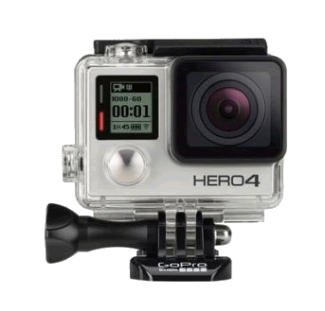
On 16th June 2016 an order was placed for a GoProHero4 Silver camera from Simply Electronics Limited (SE) through their web site. Forty days later it had still not been delivered. During the intervening days between placing the order and taking out a dispute through the credit card provider the realisation dawned, that the purchaser had fallen foul of an elaborate grey market operation that was, if not an outright fraud certainly bordered on it. Moreover the purchaser felt, not simply cheated but foolish for falling for such a scam. How had Simply Electronics convinced him to part with his money and what did this reveal about their business model?
While discussing these developments with the research director of mbahep4u.com it was decided that this was an interesting case study in which an analysis of the communications with the company could yield valuable insights that might inform the production of a case study of Simply Electronics. Specifically their business model and supply chain.
Examination of Simply Electronics’ sales pitch and their subsequent handling of the order placed should allow a clearer understanding of their modus operandi to emerge. To achieve this, scrutiny of the communications between the company and purchaser was undertaken whilst an examination of the numerous on-line forums that commented on Simply Electronics Limited was juxtaposed with the purchaser’s experience. An experience that was embedded in the machinations of the grey market vendor whose strategies circumvent in general the objectives of original equipment manufacturer (OEM).
Globally the grey market, or parallel imports, has been estimated to account for over $40 billion in revenue each year (Kotler and Keller, 2009, p.617), much has been written about this area but the bulk of this has concentrated on manufacturer’s, whereas, the focus of this examination is the Grey Market supply chain and in particular the smaller grey market vendor of goods operating through the internet. The intended outcome is to provide both an interesting business case study and an article for publication.

The starting point was, as with most investigations, accepting the view of Socrates that “…..the only thing I know is that I know nothing”. So the trigger question was where do we start and where do we go with this? The most obvious point would be to start with a definition of the Grey Market, build a picture of its associated supply chain, show why it is attractive through its value accruals and then examine the business models associated with it.
Finally, the target company Simply Electronics Limited should be examined in terms of its business model, its sustainability and its ultimate demise.
Grey Goods and their Causal factors
The Grey Market may be defined as the legal import of genuine products (legitimate trademark products) leaked into the market via non-official trade routes (Anita, & Bergen & Dutta, 2004, p. 63). Grey goods are therefore those goods that are traded through unofficial, unauthorized, and unintended routes of distribution thereby circumventing the manufacturer's own policy and pricing guidelines. They are not illegal goods; they are merely goods being sold with taxes paid but not as the manufacturer intended. Moreover, they are generally limited to popular, high-end, high-demand, high margin branded products that are relatively easy to ship.
Original equipment manufacturers often have extended supply chains with complex pricing, distribution and control mechanisms which effectively open the door to arbitrage opportunities that grey marketers are able to leverage (diagram 1). Essentially OEMs create price differentials between markets e.g. the application of product life cycle (PLC) strategies -skimming and these plus international exchange rate fluctuations help exacerbate market price differentials. This combination of arbitrage opportunities and PLC manipulation provided the primary stimulus for Simply Electronics and its business model. The fundamental opportunities for Simply Electronics Limited were therefore supply/demand balancing for cash flow optimization and the manipulation of arbitrage between channels, regions and distribution models.
Route To The Grey Market
The difference between grey market goods and black market/counterfeit goods is that where grey market goods are imported legally black market goods are imported secretly and without payment of any customs duties. In addition counterfeit goods are fraudulent imitations of genuine goods.
Grey goods reach the retailer through a chain of semi-legal operators or they may originate simply as a result of theft, such as a distributor misreporting damaged or destroyed product that is then sold into the market; it can also include forms such as the unreported sale of goods. However, probably the easiest explanation for how goods reach the grey market is that there is leakage from the manufacturer’s channel of distribution. Essentially, an authorised distributor sells the goods at a low price into the market especially through the leaking of items that are excess inventory (Hu & Pavlin & Shi, 2013, p. 3) e.g. in a businesses with short PLCs, excess product can soon become a write-off if not sold or old stock or not the latest version, to a grey market vendor who can then re-introduce them back into the market, though perhaps not necessarily the same geographical one.
For the manufacturer there are a number of threats from grey market activity not the least of which is the erosion of brand reputation.
Simply Electronics Limited
The Internet provided a tremendous opportunity to grey market vendors to source products globally for prices less than those in markets they hoped to sell into, as well as to reach out to a potentially large number of customers who would be willing to buy these products at substantially lower prices than they could find at manufacturer-authorized retailers (Berman, 2004). As a global medium the Internet makes physical distance and locational barriers irrelevant, and electronic commerce transcends time zones and can take place round the clock (Strauss and Frost, 2009).
Simply Electronics Limited was a small business built by an entrepreneur who was not an authorized retailer of the goods being sold. It traded from 2008 to 2016 ultimately employing twenty people with sales of $55million. In a sense Simply Electronics Limited capitalised on manufacturers’ adoption of skimming strategies which allowed it to exploit price differentials between countries and regions allowing it to buy low in one country and then legally import them into another where the authorised channel was selling the product on offer at a higher price thereby allowing SEL to make a profit.

Example of Manufacturer’s Markup to Distributors
Most retailers benchmark their pricing decisions by essentially doubling the cost of the product to arrive at about a 50% markup (Diagram 1).
Imagine a product priced at £360 retail. Potential pricing for a three-tier distribution model might be:
 | Cost | Markup | Selling Price
Manufacturer | £186.21 | 15% | £214.17
Wholesaler | £214.17 | 20% | £257.14
Retailer | £257.14 | 40% | £360
Table 1
In this example, the manufacturer’s price to the wholesaler is 87% of the retail price. Let’s assume that the manufacturer’s cost includes an allocation of all his overhead, so his 15% markup is pure profit. The total markup by all three players is £173.79, or 93% of the manufacturer’s cost (Table 1).
With these markups there is ample scope for the grey market vendor to enter the market and undercut the retailer in the final market as the grey market vendor’s costs are substantially lower as a result of fewer functional costs (Table 2).

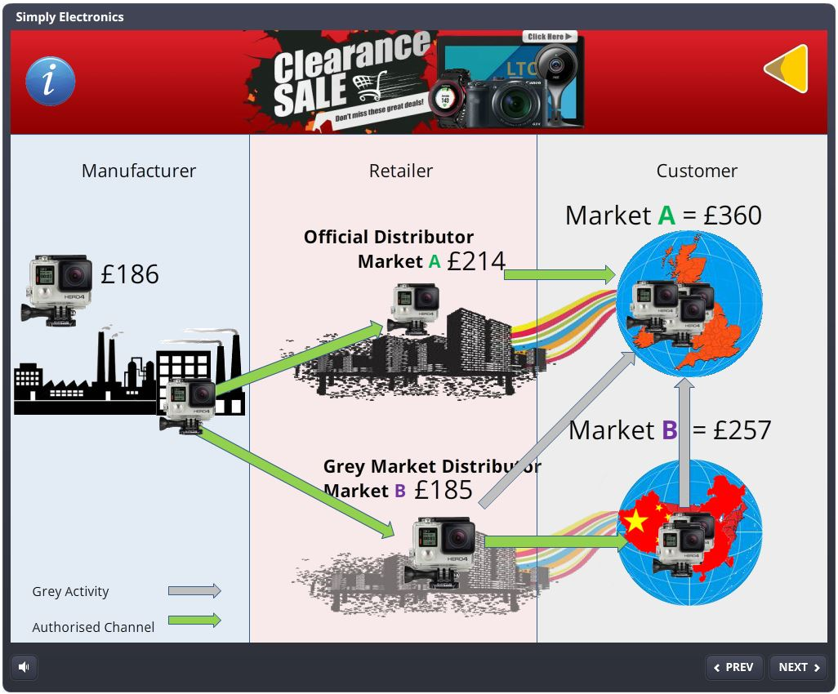
Diagram 1

Wholesaler Functions | Retailer Functions | Grey Market Vendor
Buying the product | Buying the Product | Buying the Product
Promoting/Contracting with Retailers to Sell It | Promoting/Contracting with Consumers to Buy It | Contracting with Consumers to Buy It
Inventory Risks & Facility Costs | Inventory Risks & Store Costs | Negligible Inventory
Assembling Product Assortments | In-store Merchandising | N/A
Sorting: Break down into small quantities | Shelving | N/A
Delivery to Retailers | Delivery to Customers | Delivery to Customers
Financing Retailer Buys | Financing Customer Buys | N/A
Grading the Product | Handling Returns | Handling Returns
Market Info Feedback to Manufacturer | Market Feedback to Wholesaler | N/A
Table 2
Negative and Positive Impact Of The Grey Market On The Manufacturer
Negative

The grey market can also create customer dissatisfaction which can impact adversely on the brand and its image especially if products that normally command premium prices are offered at a discount by grey market vendors. Many customers will desert the official retailer and purchase from grey market vendors who are free-riding on the manufacturer’s reputation and brand image (Table 2).

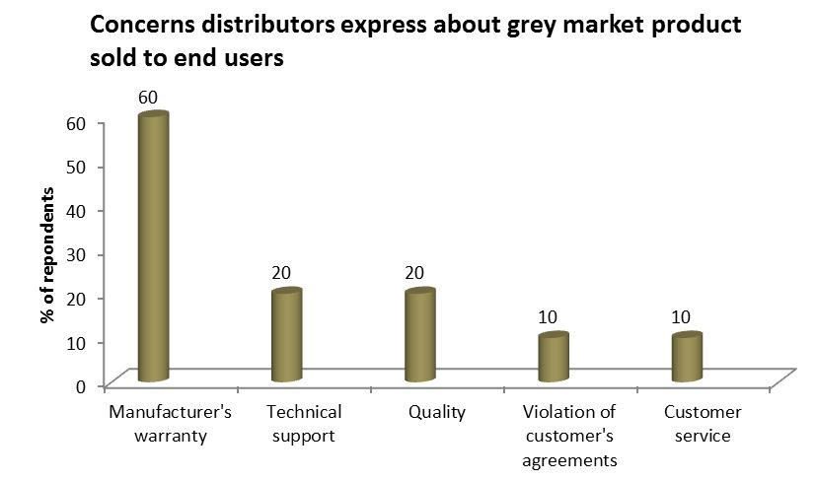
Diagram 2: Source: A K P M G Study I n Cooperation With The Anti - Gray Market Alliance 2002
Overwhelmingly authorised distributers placed manufacturer’s warranty as their major concern when goods are bought through the grey market (Diagram 2).

Positive
Grey market goods however force product prices down because the movement of grey market goods zeros out arbitrage opportunities. Moreover, as local manufacturers face competition from imported grey goods, they have to bring prices down to stay competitive in the market place. This could be seen as a method of smoothing global pricing.
Timeline of SE Case

The first interaction with SE occurred on the 16th of June 2016. Having Googled GoPro cameras, one of the suppliers produced was Simply Electronics Limited (Diagram 3).
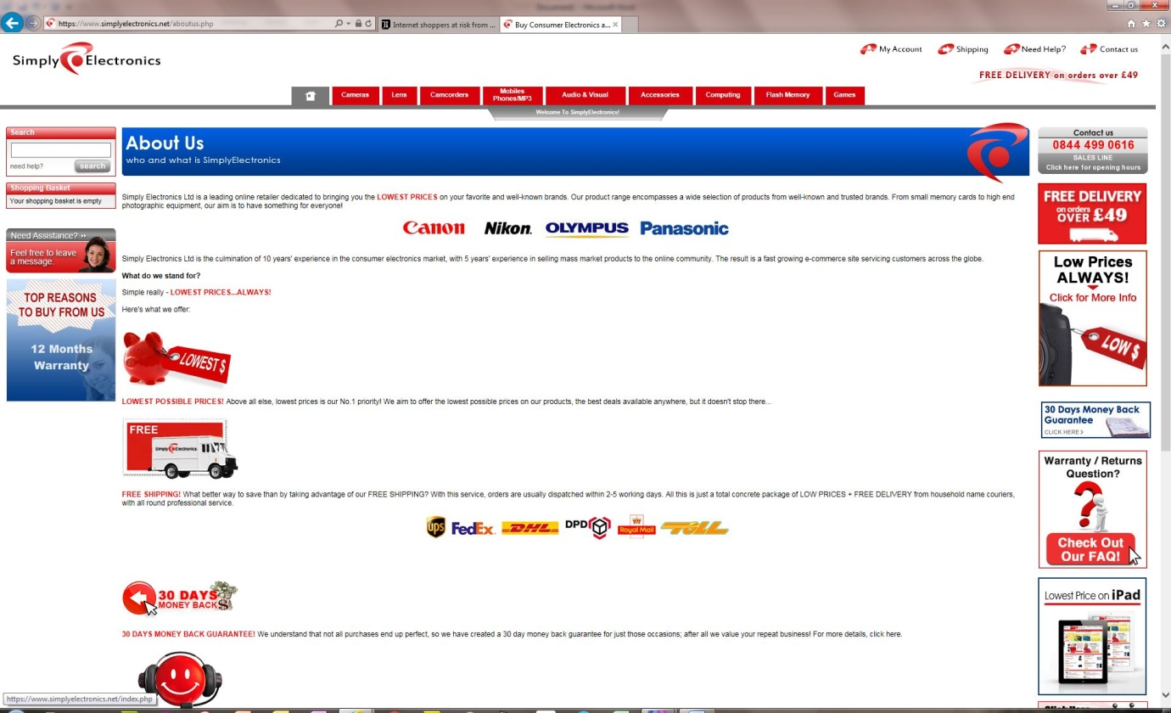
Diagram 3

To all intents and purposes the web site (Diagram 3) appeared to be a normal British web site for a British company selling well known branded products. With the order placed on the 18th of June notification was received from Skrill, SE’s vehicle for processing payments that payment had been taken successfully (Diagram 4).

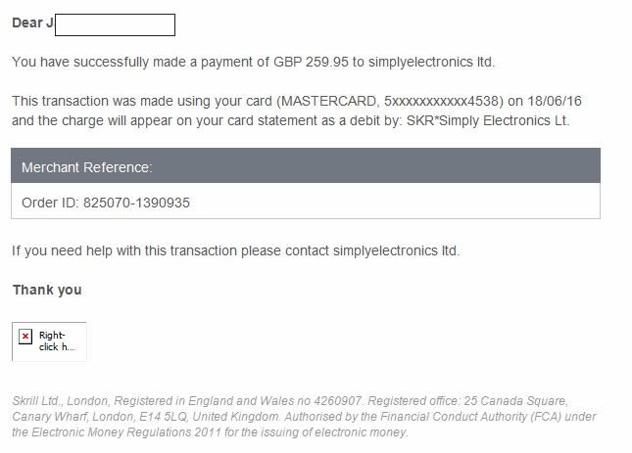
Diagram 4:18/06/2016

The interesting point here is that both SE and Skrill gave every indication that SE was a U.K. limited company but this was not the case. They were actually based in Hong Kong. Visiting their website and clicking on "Terms and Conditions" the small print at the bottom of each page revealed their Hong Kong address: 1501-1508, Millennium City 5, 418 Kwun Tong Road, Kwun Tong, Kowloon, Hong Kong.

More worryingly, further down that page in the "Disputes" paragraph states that "Any dispute, controversy or claim relating in any way to products you purchase through the Site shall be submitted to confidential binding arbitration in Hong Kong conducted under Hong Kong law... Arbitration shall be conducted under UNCITRAL Arbitration Rules by Hong Kong International Arbitration Centre."

In other words, there is no protection under the UK Sale Of Goods Act or any other UK trading standards legislation. Furthermore, SE is based in Hong Kong which means that any electronics purchased from them are classed as "grey imports" and a UK warranty will not be valid.

As to the domain simplyelectronics.net is registered to Contact Privacy Inc., based in Canada (found via the public WhoIs database) The domains simplyelectronics.co.uk and implyelectronics.net are registered to Simply Electronics Limited, which in turn is registered to a Serviced Office in Hong Kong. (again according to the public WhoIs database) Both simplyelectronics.co.uk and simplyelectronics.net are hosted on the same server.

By the twenty-fourth of June, some eight days after placing the order there was no sign of the GoPro. The SE website had said that delivery would be between 3 and 5 days accordingly an information request was made through the SE website as to when the GoPro would be delivered. This elicited an automatic response some three days later on the following Monday, stating that the order had been upgraded to “expedite” and was being dealt with and that I should check my account for a dispatch date and tracking.

More than a week passed without delivery and nothing mentioned on my account. So a further request was made through SE’s website on 7th July with the following response (Diagram 5):

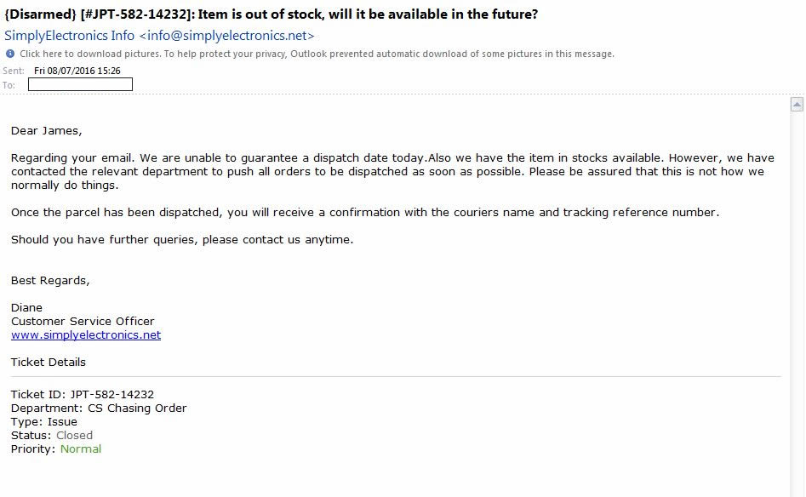
Diagram 5: Diane 08/07/216
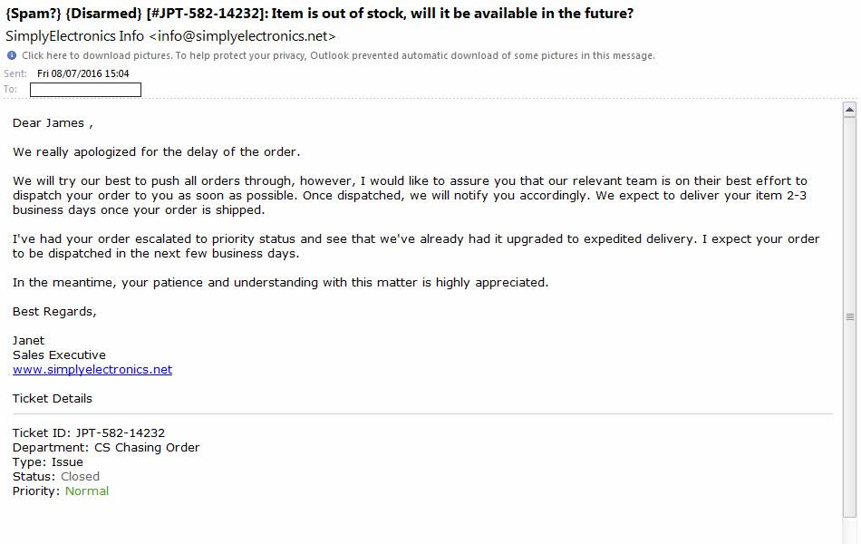
Diagram 6: Janet 08/07/2016

Again SE had tried to ameliorate the situation by increasing the order status to ‘priority’ (Diagram 6) thereby attempting to create the illusion of progress. According to the email sent by Diane on Friday 8th July 2016 timed at 15:04 the order was now classed as being both ‘upgraded’ to expedited delivery and ‘escalated’ to priority status. This begs the question of how SEL treats customers who have not been fortunate enough to have been ‘upgraded’, ‘expedited’, ‘escalated’ and ‘prioritised’. Given that, just 22 minutes later, at 15:26 Janet sent an email informing the customer that “we are unable to guarantee a despatch date today”, and, as Diane and Janet were no doubt well aware SE does not answer e-mails at the weekend or public holidays. For an online business this could be seen as at best an inappropriate/inefficient business practice and at worst a built in time lag on complaints, refunds and delivery dates. This would certainly help out with supply chain sourcing time lags.

Additionally, the enquiry/complaints system is such that the only category that can be used to query non-delivery is that of ‘out-of-Stock’ and once the enquiry has been responded to but not necessarily answered, it is considered closed. In other words there is no progression of follow through with an enquiry and this is only exacerbated by the number of sales executives who answer the queries –

08/07/2016 Janet (Diagram 6)
08/07/2016 Diane (Diagram 5)
18/07/2016 Genelyn (Diagram 8)
22/07/2016 Fherlie (Diagram 9)

SE use different named responders to obfuscate the situation, break continuity of dialogue between customer and company, terminate the enquiry at first opportunity and to give the impression of a large operation.

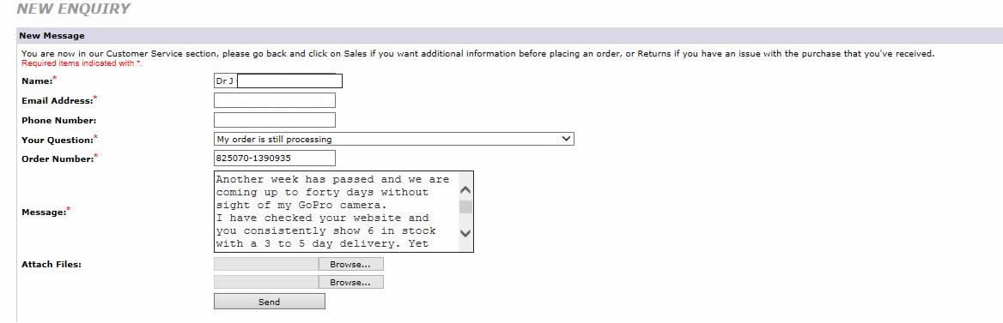
Diagram 7:

On the 18th July a further response from SE offered the reason for the continued delay as ‘still suffering from a backlog due to the influx of sales from our latest promotions and they are currently doing their best to despatch all orders as soon as possible’. The flaw in this excuse is that the GoPro was ordered at a time when it was not part of a promotions campaign (Diagrams 7,8).

The question here must be how a company dealing with high volume sales could fail to plan for an increase in sales? The answer may be very simple

SEL Backlog

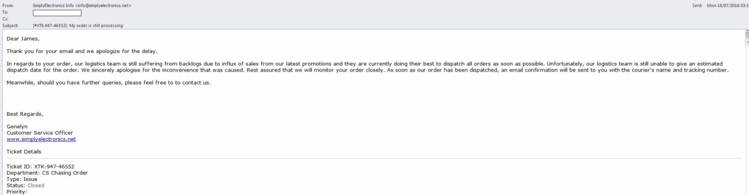
Diagram 8: Genelyn 18/07/2016 Promotions Backlog

The "Order backlog" status change came more than two weeks after payment had been taken. This coincides conveniently with Skrill's policy of not cancelling transactions after 14 days. If it's less than 14 days since the order was placed Skrill can be contacted and a dispute and charge-back opened. If it's more than 14 days, all that can be done is to make a complaint about SEL’s Merchant account: “simplyelectronics ltd”. Skrill are regulated by the Financial Conduct Authority (FRM is 900001), and the FCA have specific objectives regarding the reduction of the risk of financial crime and consumer protection.

Should a customer wish to cancel the order this can only be done by asking for a cancellation form by e-mail through the SE website.

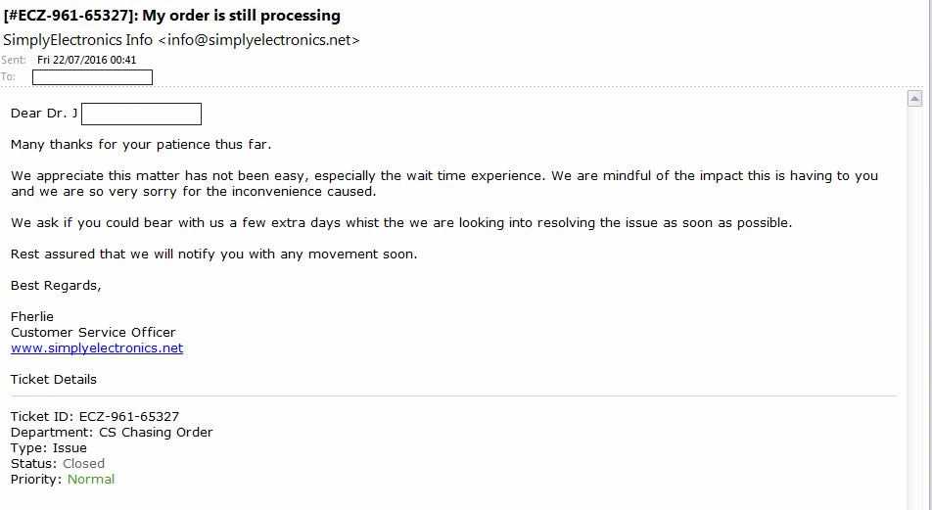
Diagram 9: Fherlie 22/07/2016

A few further days passed and still no GoPro camera.

Forums

The question now is how representative is this experience with SE and are their actions part of a business model or simply a company going through its death throes? There is no official benchmark for the performance of online companies. A substitute for this may however lie in online forums. These forums are flawed in a variety of ways not the least of which is the tendency of people to write reports based on their poor experience rather than a good one.

However, the experience of others does influence the purchaser’s actions who seek these out. Examination of on-line forums gave an indication of SE’s operating practices and although flawed and not definitive they are nevertheless a good indicator. After all, reviews of the experience with a company, are a powerful stimulus on purchasing patterns, for example the SE website notes that an order can only be cancelled by using their cancellation form and submitting it to them. However, many forums show complaints that after orders were cancelled and then waiting the necessary seven day’s for the refund which did not materialise, the banks were then contacted but said they required a refund voucher from the supplier for them to raise a charge back under Refund Not Received. SE however, either did not respond to the cancellation or was simply parsimonious in supplying these refund vouchers.

Promotional Codes

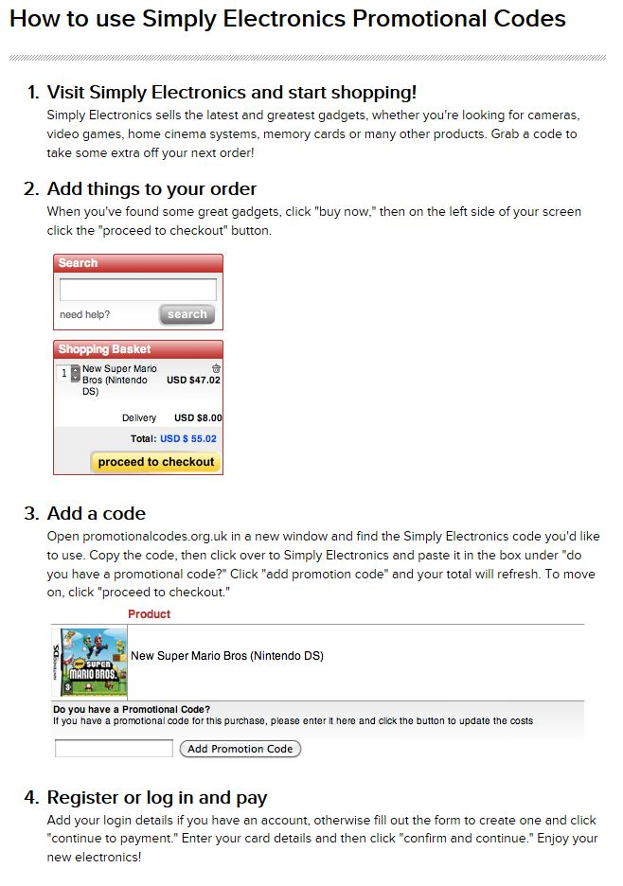
Diagram 10

Part of SE’s sales strategy is to partner with promotional code providers (Diagram 10). Here they offer a discount on their products e.g. 10%-20% off (Diagram 12). However, it is interesting to view the satisfaction levels associated with SE through online sites such as Reevoo (Diagram 11).

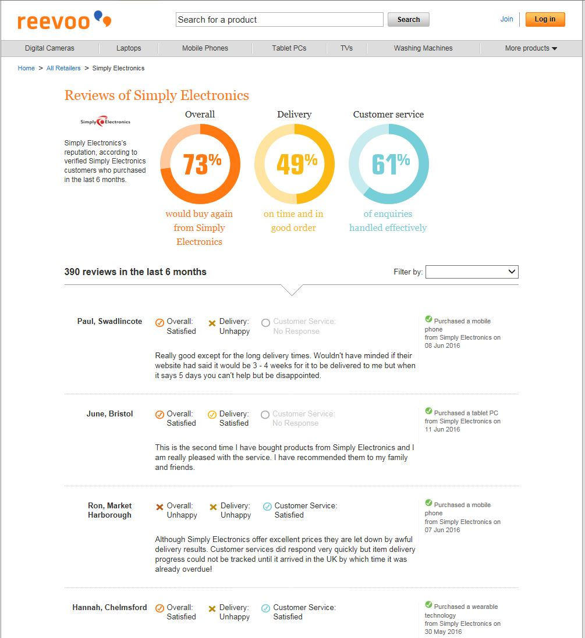
Diagram 11: https://www.reevoo.com/retailer/317-simply-electronics

Given the REEVOO rating it would appear that SE is a reasonable company with an overall rating of 73% which is not too bad if your main motivation as a customer is price sensitivity.

Nevertheless, online reputation services that feed into search engine algorithms - particularly the one displayed on SE’s website, do not count e-mail feedback links until after a sale has been completed which may help explain why SE’s feedback rating was so high. Some review sites moreover, are vendor-centric, making it difficult for negative feedback to be processed.

Furthermore, examination of the REEVOO diagram shows that the figures given are based on ‘…..verified Simply Electronics customers who purchased in the last six months’ the question here concerns the meaning of the word ‘verified’, who verified these customers REEVOO or SE? Are the customers’ contacts supplied by SE, if yes then an opportunity exists for SE to prioritise its Coupon customers and their shopping experience thereby boosting their online review ratings especially if they also prioritise their deliveries in favour of coupon purchases.

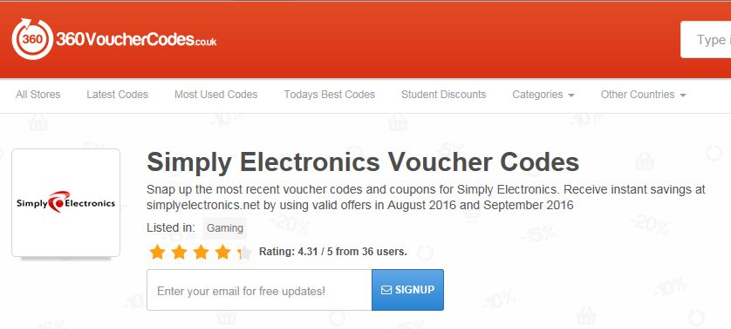
Diagram 12:https://www.360vouchercodes.co.uk/simplyelectronics.net accessed: 16 Aug 2016

Other review sites paint a different picture of SE. Trustpilot in particular allows a company to manage and respond to the reviews it gets in order to enhance its performance. However, whether it is used by the company or not customers may still access Trustpilot for reviews on the company. In the case of SE this does not paint a pretty picture of its overall rating (Diagram 13).

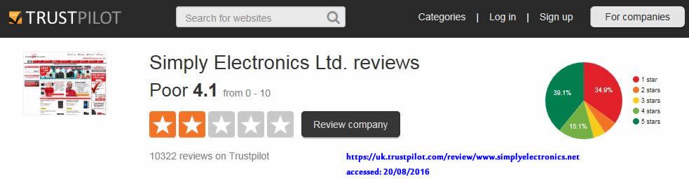
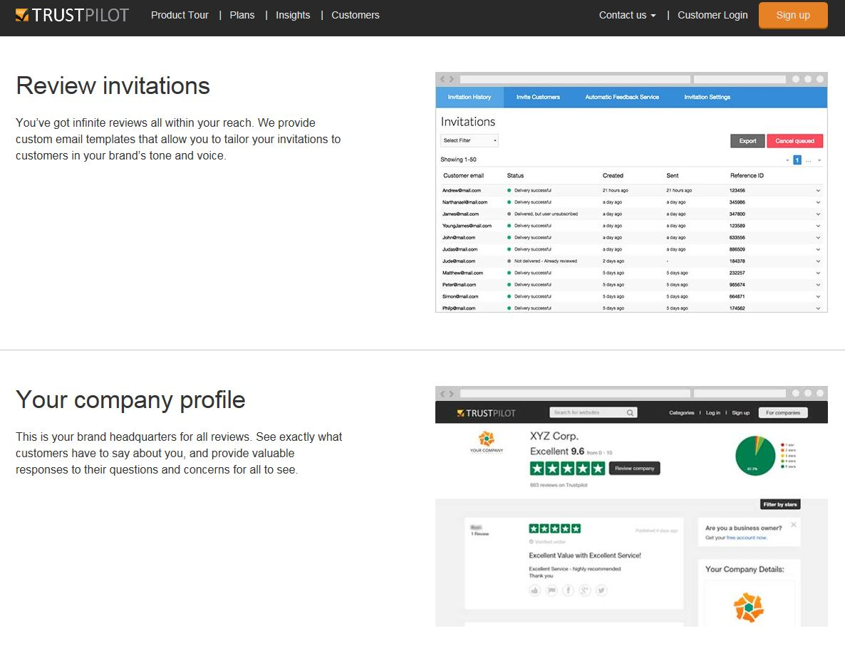
Diagram 13

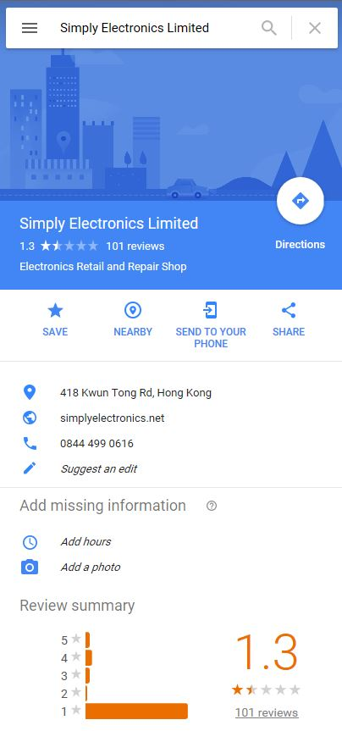
Diagram 14: https://www.google.co.uk/#q=simply+electronics+Limited&lrd=0x340400f201705489:0xe335390b64aab8d2,1, accessed: 3 Aug 2016

Other ratings for SE, which are generally lower, may be found on other sites not linked to discount vouchers, click through payments or any other performance linked offering. These paint a more disturbing picture of SE for example, Google rate SE at 1.3 out of a possible score of 5 (Diagram 14).

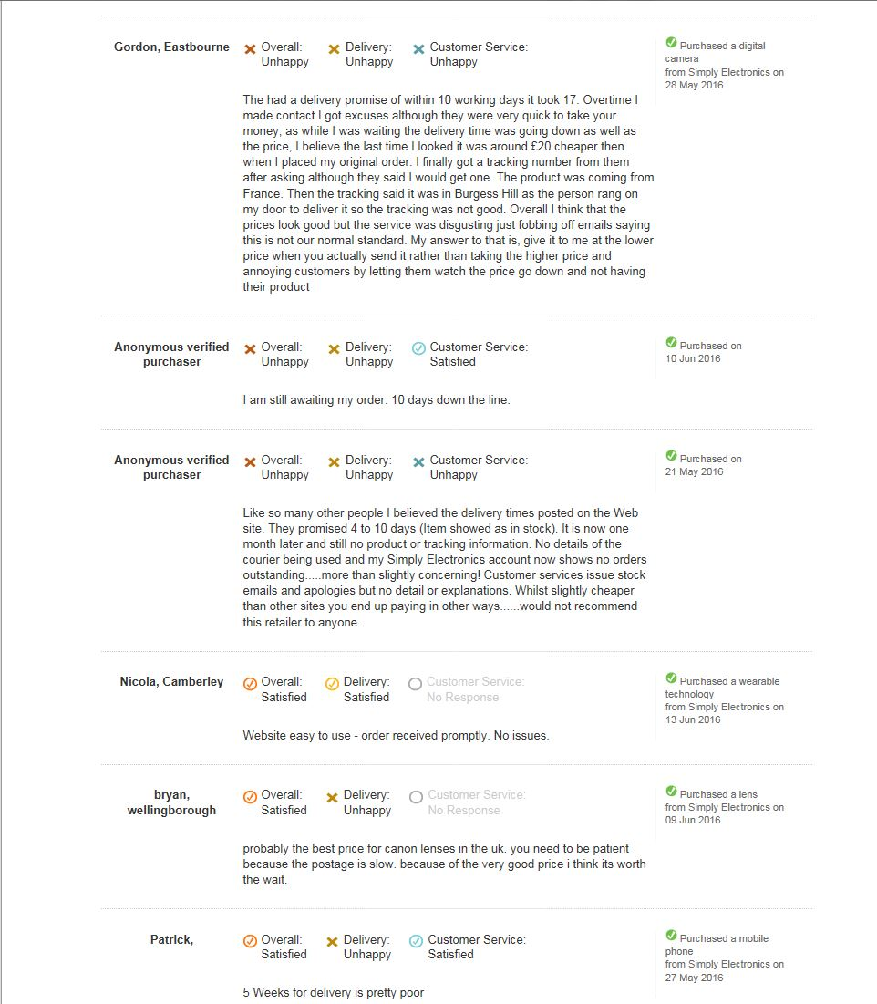
Diagram 15

Further examination of web forums stretching back to 2008 threw up a plethora of reviews the general tone of which was highly negative. Moreover, a quick examination of these showed that problems arose with missed delivery dates, refunds delayed or ignored and warranty issues (Diagram 15).

Bankruptcy

By the 29th of July a final e-mail was sent to SE informing them of the decision to open a dispute through the credit card company. However, events had overtaken SE and their website displayed the following screen:

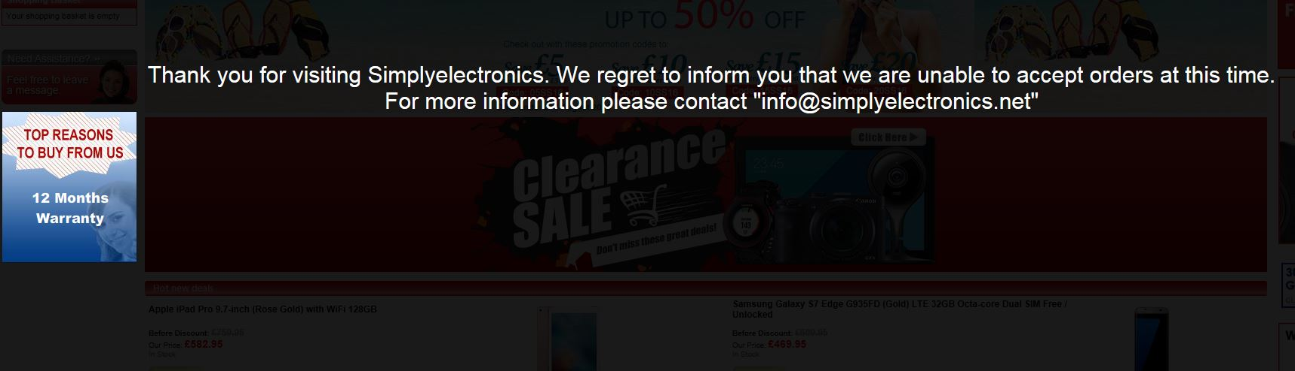
Diagram 16

The next day an e-mail was received from SE as follows:
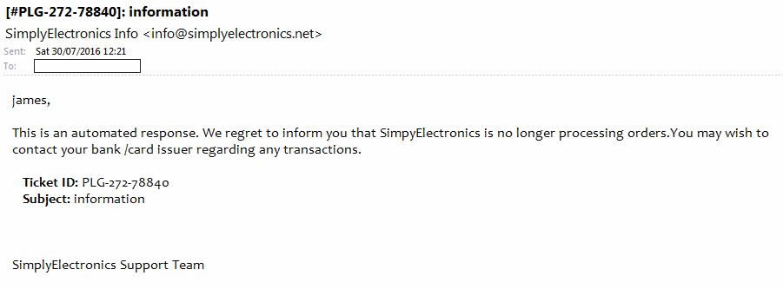
Diagram 17

Simply Electronics Limited had ceased to exist but recourse to the Credit Card company resulted in a swift refund under section 75 of the Consumer Credit Act 1974. A piece of legislation that pays dividends for the British consumer (Diagram 17).

Consumer rights

Manufacturers rail against the grey market by arguing that consumers who buy through these unofficial channels can water down their possible financial savings by losing the advantages of appropriate accessories such as the manuals, chargers and warranty cards for their region, in this case the UK/EU region. Many goods are not produced to uniform specifications worldwide. Grey market goods may not have safety features or components required for the market to which they have been diverted.
Moreover, purchases from the grey market may be older models. Manufacturers may also refuse to recognise a warranty for such grey products bought within the UK but outwith their official suppliers. Also, consumers may have damaged their legal rights by buying grey goods. For example, if things go wrong the consumer may have different rights depending on which country they buy from, but buying from countries inside the EU should give them the right to a repair or replacement. They have rights under a contract with the retailer but they need to know where it is based.
So, how can the consumer protect themselves? In the UK if they pay by credit card they may be able to get a refund from their card issuer so long as they contact them within 120 days. This is applied under Section 75 of the Consumer Credit Act 1974 which states:
75. — (1) If the debtor under a debtor-creditor-supplier agreement falling within section 12(b) or (c) has, in relation to a transaction financed by the agreement, any claim against the supplier in respect of a misrepresentation or breach of contract, he shall have a like claim against the creditor, who, with the supplier, shall accordingly be jointly and severally liable to the debtor.
Section 75 simply means that the credit provider must take the same responsibility a retailer does if things go wrong with a purchase. So if the consumer buys something or orders tickets or flights worth more than £100 but less than £30,000, and pays for some or all of it on a credit card they are protected under Section 75.
The Business Model
In terms of SE’s business model there is a strong advantage to appearing as a British company when selling into the British, European and US markets. It seems that SE had gone out of their way to project the image of being a British company from the design of their website to using the word Limited in their title. In addition SE makes it very difficult to determine the address of their HQ. It was only in their Terms & Conditions that one could find their address; Kowloon, Hong Kong. Even a search for the domain name owner through the ‘WhoIs’ website only elicits that the owners are Hong Kong based. Likewise, searching Hoovers Online or DueDil show that SE is Hong Kong registered with a staff of 20 and one named director and sales of $55m.

Simply Electronics Limited source their products from the grey market this is the essence of their supply chain (Diagram 18). If this is interrupted or fails their business collapses.

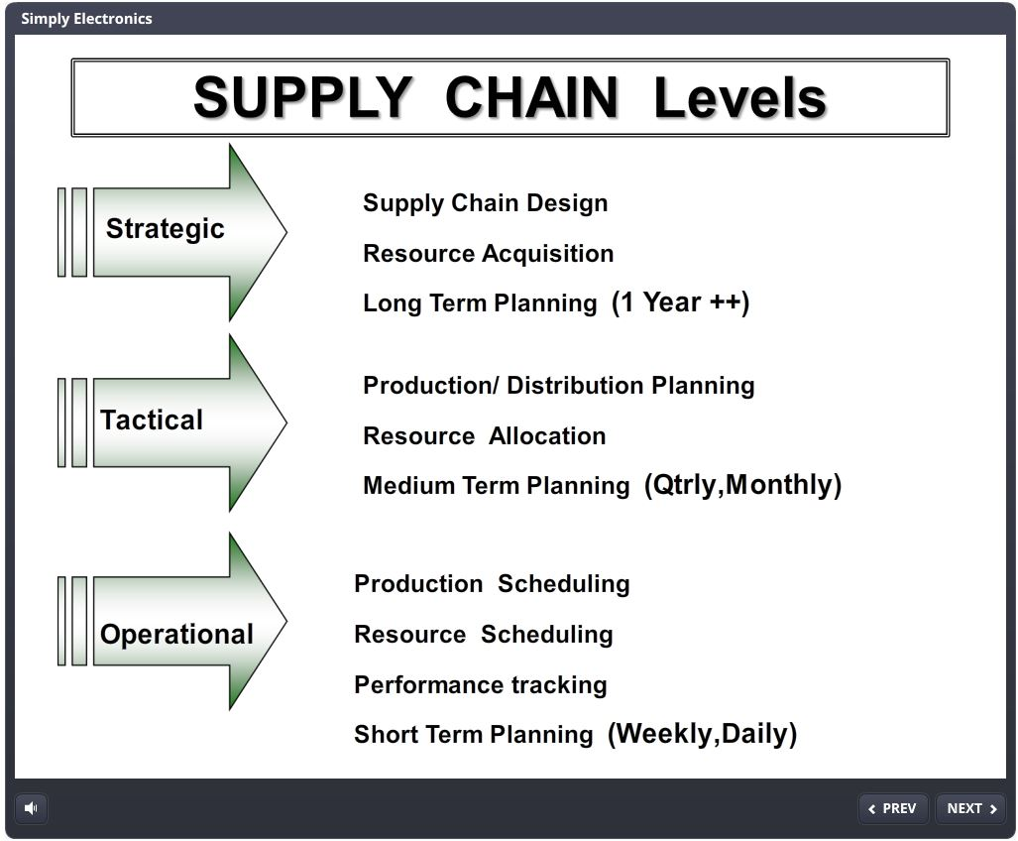
Diagram 18

Under Strategic Level SE has little real input as once its initial construction of the supply chain is made it is so short that as a grey vendor little may be further developed. Likewise, Resource Allocation is loaded towards discount purchasing and web oriented selling with both activities being essentially pre-set. Finally, Long Term Planning is the problem for SE. Acquiring their products from the grey market implies that they must of necessity be reactive rather than proactive, that they cannot effectively change or influence their up-stream supplies.

SE’s supply chain activities centre more on the Operational Level where the focus is on weekly/daily activities.

SE’s is a high risk strategy based upon a business model that reacts on a daily basis but introduces buffers to order completion to create a monthly plus time-lag (Diagram 19).

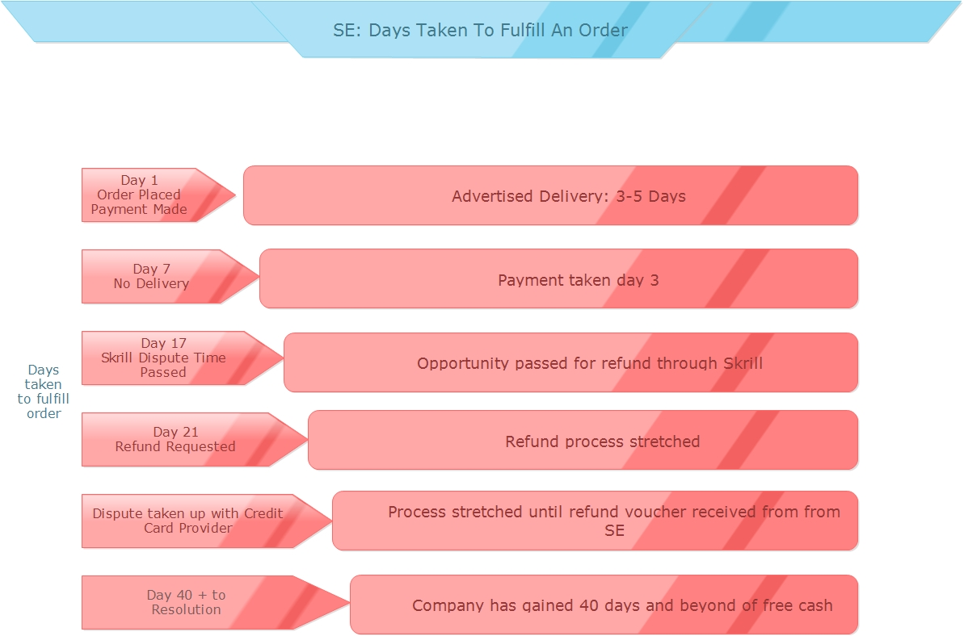
Diagram 19: SE: Order Completion Buffers

SE’s Value Chain and Business Model shows how the company may manipulate its inherent supply chain flaws by developing a strategy which enables it to seek sourcing solutions after orders are placed or order critical mass is reached (Diagram 20).

Simply Electronics Limited earns a triple profit on their activities:

Profit 1: arbitrage
Profit 2: cost or near cost purchases plus undercutting margins discounts
Profit 3: internal cash flow manipulation (retained cash over 43 days, as in GoPro example, before refund or goods dispatched)

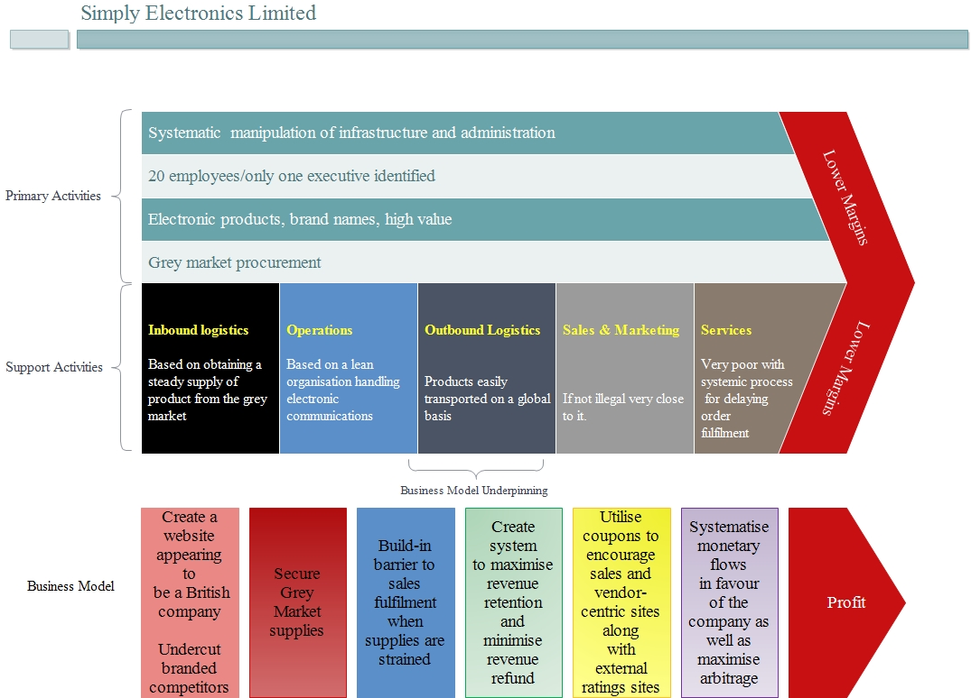
Diagram 20

Examination of SE’s website shows that he overwhelming majority of its advertised products are claimed to be in stock with a dispatch time of 3-5 working days. If this were truly the case it would be an outstanding control of logistics.
Against SE’s claim of held stock and 3-5 working days dispatch are the impressive amounts of complaints laid at their door and stretching back to its origin in 2008.
Moreover, the use of manipulated reviews may well play a role in the business operations of SE.
Conclusions
It would be all too easy to condemn the grey market and parallel imports as wholly unethical and anti-competitive. But the reality may be that for the consumer grey products may counter the segmentation and differential pricing that some companies engage in.

With the advancement of the internet and its varied applications it is possible for anyone to set up a website and sell both grey and counterfeit goods. In the case of SE their products were grey market products but were marketed at the questionable end of the honesty spectrum.
The Abraham Lincoln quote at the start of the article to a great extent sums up the philosophy behind Simply Electronics Limited. SE consistently fooled a great deal of people most of the time. For the consumer defense against this form of exploitation is simple - check companies out on online forums before purchasing from them.
The grey market is not a reliable source of supply for both the grey market vendor and the consumer as ultimately reliance on sourcing a steady flow of grey products is an extremely precarious strategy as crystallisation of product scarcity must inevitably occur. This in turn led to the GoPro appearing to be in stock on SE’s website. However, contacting SE’s support via their website only lead to a quick and polite, but generic reply that sounded convincing and reassuring, but without mentioning any dates or details specific to the order. Enough plausible reassurance was given to take the order over the two weeks dispute period for Skrill in which a dispute could be opened.
As the investigation proceeded suspicion grew that SE were not simply exploiting price differentials and arbitrage opportunities but were also exploiting the customer through a consistent basis of manipulating cash flow receipts and delayed refunds allied to risky product acquisition, scheduling and dispatch

SE manipulated customers’ expectations by informing them that their order was being upgraded to ‘expedited’ followed by ‘made a priority delivery’ some weeks later. If a customer progresses through this upgrading process they will in effect have been in the system, given that communications cease at the weekends, at a minimum somewhere between two and three weeks and perhaps a great deal longer.

SE did not sell counterfeit goods. While the counterfeiters make profit, the original brand name and reputation gets tarnished and incurs revenue loss as well. Gray market goods are expensive and just as damaging to any manufacturer. Their sales also have a negative influence on the buyers who are expecting the warranty and features of the original products. For the OEM perhaps tightening supply/value chain controls and associated processes is the critical element in mitigating Grey market leakage - unless such leakage is planned.
Furthermore, the grey market destabilises pricing policies among the manufacturer’s distributors especially if prices and margins erode. In this instance dealer support and point-of-sale services may be harder to maintain especially if after-sales services are eroded whilst exclusivity is also diluted and existing business relationships are damaged. The manufacturer is completely unaware of where their product has ended up. For the consumer, there is no traceability and no protection.

Many companies are attracted to the Internet because of the opportunity to reach a global market inexpensively, with minimum effort, a high potential for anonymity and few restrictions to inhibit their activities. In the case of SE it clearly employed misleading information as well as a high degree of deception as a strategic element of its business model.
The strategic imperative of SE’s business model was product sourcing in a market that was riven by volatility and scarcity.
Perhaps however, the last word on consumer online purchasing should be:

"Never attribute to malice what can adequately be explained by incompetence"
Robert J. Hanlon
but to be sure, pay by credit card!
Bibliography

Antia K, Bergen M, Dutta S. Competing With Gray Markets. MIT Sloan Management Review [serial online]. Fall 2004;46(1):63-69. Accessed July 12, 2016.

Kotler, P. & Keller, K.L. (2009). Marketing Management, 13th Edition. Upper Saddle River, NJ: Prentice Hall.

Berman, B. (2004). Strategies to Combat the Sale of Gray Market Goods. Business Horizons, 47 (4), 51-60.

Strauss, J. & Frost, R. (2009). E-Marketing, 5th Edition. Upper Saddle River, NJ: Prentice Hall.

http://www.shopsafe.co.uk/shop/simply-electronics/4813
Accessed; 21/08/2016

https://www.360vouchercodes.co.uk/simplyelectronics.net accessed: 16 Aug 2016
https://www.google.co.uk/#q=simply+electronics+Limited&lrd=0x340400f201705489:0xe335390b64aab8d2,1, accessed: 3 Aug 2016
https://uk.trustpilot.com/review/www.simplyelectronics.net accessed: 20 Aug 2016

http://www2.napier.ac.uk/depts/imp/case/index.html

