Mass Customisable Roofing Solutions for the New Build and Retrofit Markets in the UK

Wojciech PLOWAS1*, Robert HAIRSTANS2 and Jonathan FELLINGHAM3

1 Consultant, Institute for Sustainable Construction, Edinburgh Napier University  
2 Associate Professor, Institute for Sustainable Construction, Edinburgh Napier University

3 Managing Director, Donaldson Timber Engineering, United Kingdom

*Corresponding author’s e-mail: **W.Plowas@napier.ac.uk**

# Abstract

Major house builders and contractors in the UK are seeking alternative solutions to form the structural frame of pitched roofs for various reasons; speed, health and safety, quality ease of use. They are exploring the use of offsite systems, which arguably provide all of the above benefits. However, these systems are typically considerably more expensive, often difficult to scale-up and limited in their design scope compared to traditional roof truss solutions. The strategic aim of the research reported on in this paper was therefore to develop a mass customisable roofing solution to allow the UK’s largest roof truss manufacturer to enter into the off-site construction sector without reinventing their business architecture. The research considered both the new build and retrofit market. The first roof solution for the new build market is a ‘sliding roof’, a roof truss installation method which includes a pre-prepared system created under factory conditions. The system is delivered to the construction site where it is lifted onto one end of the structure. After the system is in placed it is opened the length of the roof. The second system investigated, to be used for the retrofit market, is a self-supporting and thermally insulated roof panel, designed and developed for a multitude of pitched roofs. Working with the industry partner the suitability of the roof systems as effective off-site solutions has been trialled. The full process was monitored from a design, manufacture and construction perspective with a critical appraisal undertaken for evaluation purposes. These finding are reported.

# Keywords

Modern methods of Construction, Offsite roof systems; Sliding roof; Roof panels;

# Introduction

Timber roof trusses have been the preferred choice for forming pitched roof structures in the UK for the last 25 years and make up a 80%+ share of the roof market. Given the drivers for change in the market, primarily speed of construction, improved H&S and lack of available skilled labour house builders and contractors are looking for new solutions including various panelised and modular systems. The aim of this research work was to identify and develop an offsite roof system that can be mass customised, is cost competitive and responds to these identified drivers. The project was carried out was a collaboration between Edinburgh Napier University and Donaldson Timber Engineering (DTE), the UK's leading and longest-established supplier and manufacturer of roof trusses, I-joists, open web joists, gable and spandrel panels. The company has a regional network of eight branches in the UK primarily supplying national and regional house builders, building contractors, offsite manufacturers, builders' merchants and self-builders. A key objective of DTE was that any solution was compatible with their current business architecture.

# Donaldson Timber Engineering

DTE’s primary manufacturing facility is based in Buckhaven, Fife. The site includes the offices linked closely with assembly floor enabling information to be transferred quickly and efficiently, such as timber take off lists which can be sent directly to the saw for accurate cutting and fast assembly. There are over 50 design technicians and 250 skilled joiners/machine operators currently working at the manufacturing plants throughout the UK.

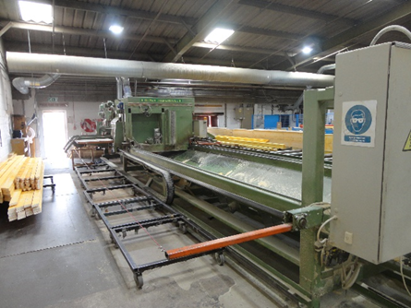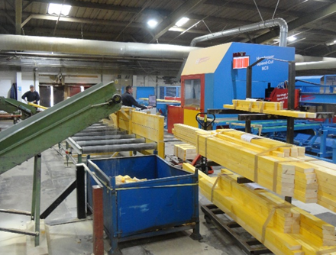

**Figure 1.** Hundegger computerised saw **Figure 2.** DeSaux computerised saw

Computerised saws (Figures 1 and 2) are used in the factory which allows for accurate cutting of components of roof trusses and other timber products at maximum speed. In 2014, the factory has been equipped with Hundegger Speed-Cut SC-3 saw (Figure 1). The machine uses two conveyors systems working independently, allowing for fast and precise handling of wood without the need for re-setting or retooling. It uses minimal variations of timber lengths which reduce the amount of raw material required in stock.

**UK Construction Market**

Construction is key sector to the UK economy contributing nearly 7% of UKs value add of which construction related products and services account for about 1% each and contracting accounts for about 4.7%. Some 3 million jobs are based in construction; 10% of total UK employment (HM Government, 2013). The current value of offsite construction in the UK is £1.5bn and it is projected to grow to £6bn. This equates to a 7% share of constructions £90bn annual contribution to the UK economy (UKCES, 2013). The manufacturing output of the Scottish offsite sector in 2012 was £125million with the potential to grow to £230million by 2018 without additional facilities (Smith et al, 2012). Both the UK and Scottish Governments have identified the offsite sector and timber construction systems as major growth and critical areas over the next decade as cited in the UK Construction Strategy and the Construction Scotland strategy documents published in 2012/13. In particular offsite has been identified as a solution to the UK housing crisis. By 2035, the Office of National Statistics (ONS) has projected that the UK population will grow by 9.5 million to 73.6 million and it is estimated that the UK needs to build 337,000 homes a year to accommodate the population, demographic and net migration changes.

# comparison of roofing solutions

A typical trussed rafter (commonly known as a roof truss) is made of top chords, webs, bottom chord and connector plates. Trussed rafters can be designed in almost any shape or size trusses provide a rigid strong framework that will carry the weight of a roof to the outside walls. Roof trusses can form a symmetrical and asymmetrical roofs, monopitch roofs, roofs with sloping ceilings, and also be formed to act as attic trusses allowing the roof space to be used to provide habitable accommodation. Apart from a traditional trussed rafter method various panelised/modular systems have been developed by companies throughout the UK, including Smartroof, Roofspace I-roof and Moduroof (see Figure 1). Each of those roof construction techniques have been described and analysed (see Tables 1 & 2) in terms of their strengths, weaknesses, opportunities and threats (SWOT analysis) in order to identify a preferred roofing solution to the current trussed rafter system which forms the majority of the market.

**Table 1** Panelised/modular roofing systems in the UK

|  |  |
| --- | --- |
| **Roof System** | **Overview** |
| **Smartroof** | Panelised roof system for room in-room-roof applications aimed for national and large regional house builders. The unique thing about Smartroof is that the panels span of gable to gable. This means the house builders have an unobstructed space available within the attic to configure whatever way they want because they are not constrained by any roof supporting structure. |
| **RoofSpace I-roof** | An offsite panelised room-in-roof solution developed for the UK’s new build residential housing market. Pre-manufactured roof cassettes, span from ridge to eaves and are supported by glulam purlins located in pockets formed in spandrel panels resulting in a complete habitable roof system. The RoofSpace I-Roof solution is fully insulated, with CE marked products, to ensure a consistent warm envelope. |
| **Moduroof** | UK’s only complete modular roof system currently available on the market. Moduroof can be used in conjunction with most systems of build including concrete panel, timber frame or steel frame. All roofs are fully assembled in the factory including all bracing, strapping etc. A standard truss construction with fascia and tiling fitted during assembly can accommodate various covering options, roof windows and dormers. Structurally, every module is considered as an individual roof for bracing and tile purposes. |

|  |  |  |
| --- | --- | --- |
| Image result for smartroof   1. Smartroof | 1. Roofspace I-roof | 1. Moduroof |

**Figure 1.** Panelised/modular roofing systems in the UK

**Table 2**. Summarised results from SWOT analysis

|  |  |  |
| --- | --- | --- |
|  | **Trussed Rafters** | **Offsite systems currently available in the UK** |
| **Strengths** | - Suitable for a wide range of roof structures; - Relatively inexpensive; - Good quality processes and procedures; - Can span over large distances. | - Suitable for projects with large build programmes, and those on a tight deadline; - Reduction of risks when working at heights; - Guarantees a fixed price for the job; - No delays due to bad weather a conditions. |
| **Weaknesses** | - Poor access when installing ridge and bracing elements; - Time which is generally required to construct; - Do not leave much space for a usable attic. | - Significant material usage; - Price; - Complicated design; - Systems are very often not scalable; - Many parties involved in the design process. |
| **Opportunities** | - Research on new scaffolding system improving safety; - Development of standardised method of installing bracing elements. | - Demand for offsite building systems is increasing; - Potential to meet future government targets related to EPD. |
| **Threats** | - New products emerging in the form of offsite systems with improved speed and on-site H&S; - Shift towards MMC and offsite techniques | - Price war with competitors. - New products emerging in the form of offsite systems with improved speed and on-site H&S; |

## Lessons learned

Upon the review of the SWOT analysis, DTE’s senior management team agreed that best way to move forward is to develop the systems which would protect current timber roof truss business and expand into new markets, such as retrofit. It was also recognised that despite the increase in demand for warm roofs (insulate attic spaces) in the form of panelised systems, cold roofs (insulated at ceiling level with roof space unutilised) are still preferred options and account for approximately 90% of all roofs constructed in the UK. As such, the development of offsite systems for both cold and warm roofs would increase the chances of reaching the desirable market penetration. The first roof solution for the new build ‘cold roof’ market is a Vetokatto ‘sliding roof’, a roof truss installation method which includes a pre-prepared system created under factory conditions. The second system investigated, to be used for the retrofit ‘warm roof’ market, is a self-supporting and thermally insulated roof panel.

# Vetokatto

Vetokatto is a roof truss installation method which includes a pre-prepared system created under factory conditions. The system is delivered to the construction site where it is lifted onto one end of the structure. After the system is in place it is opened up using winches fixed to the main structure and braced, creating a weatherproof envelope in few minutes after lifting. Vetokatto has been developed for both small home-building and terraced house-building industries. The perceived main advantages of the system were:

* No major investment from implementation on the basis that it could fit into the existing business architecture of DTE including truss design and assembly.
* Skills and training requirements are minimum whilst offering productivity improvements on-site.

## Factory trials

In order to fully assess the system the first UK demonstrations of Vetokatto took place in DTE manufacturing facility in Buckhaven, Scotland during September 2017 (see Figure 2). Vetokatto demonstrations took 3 days, during this time a number of house builders, timber frame companies and contractors were invited to attend to witness the process and provide feedback. The response from the industry was generally positive, there were however several elements of the system, which were pointed out during demonstrations, that would require some improvements.

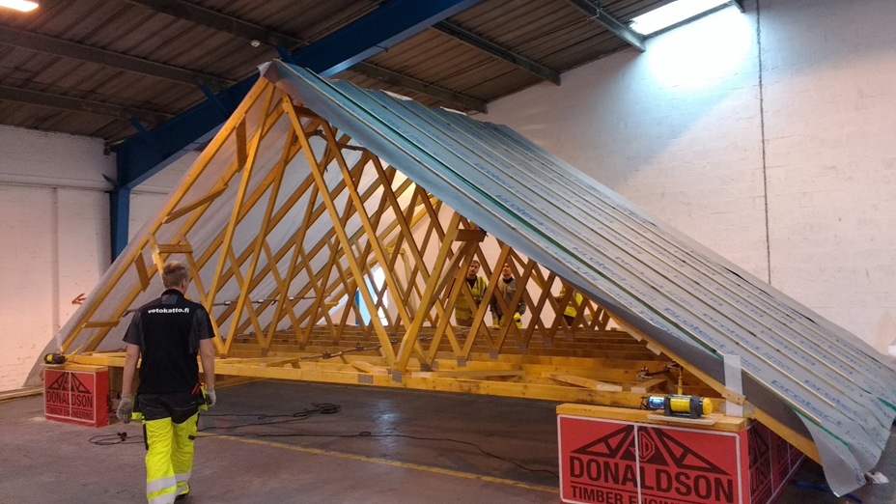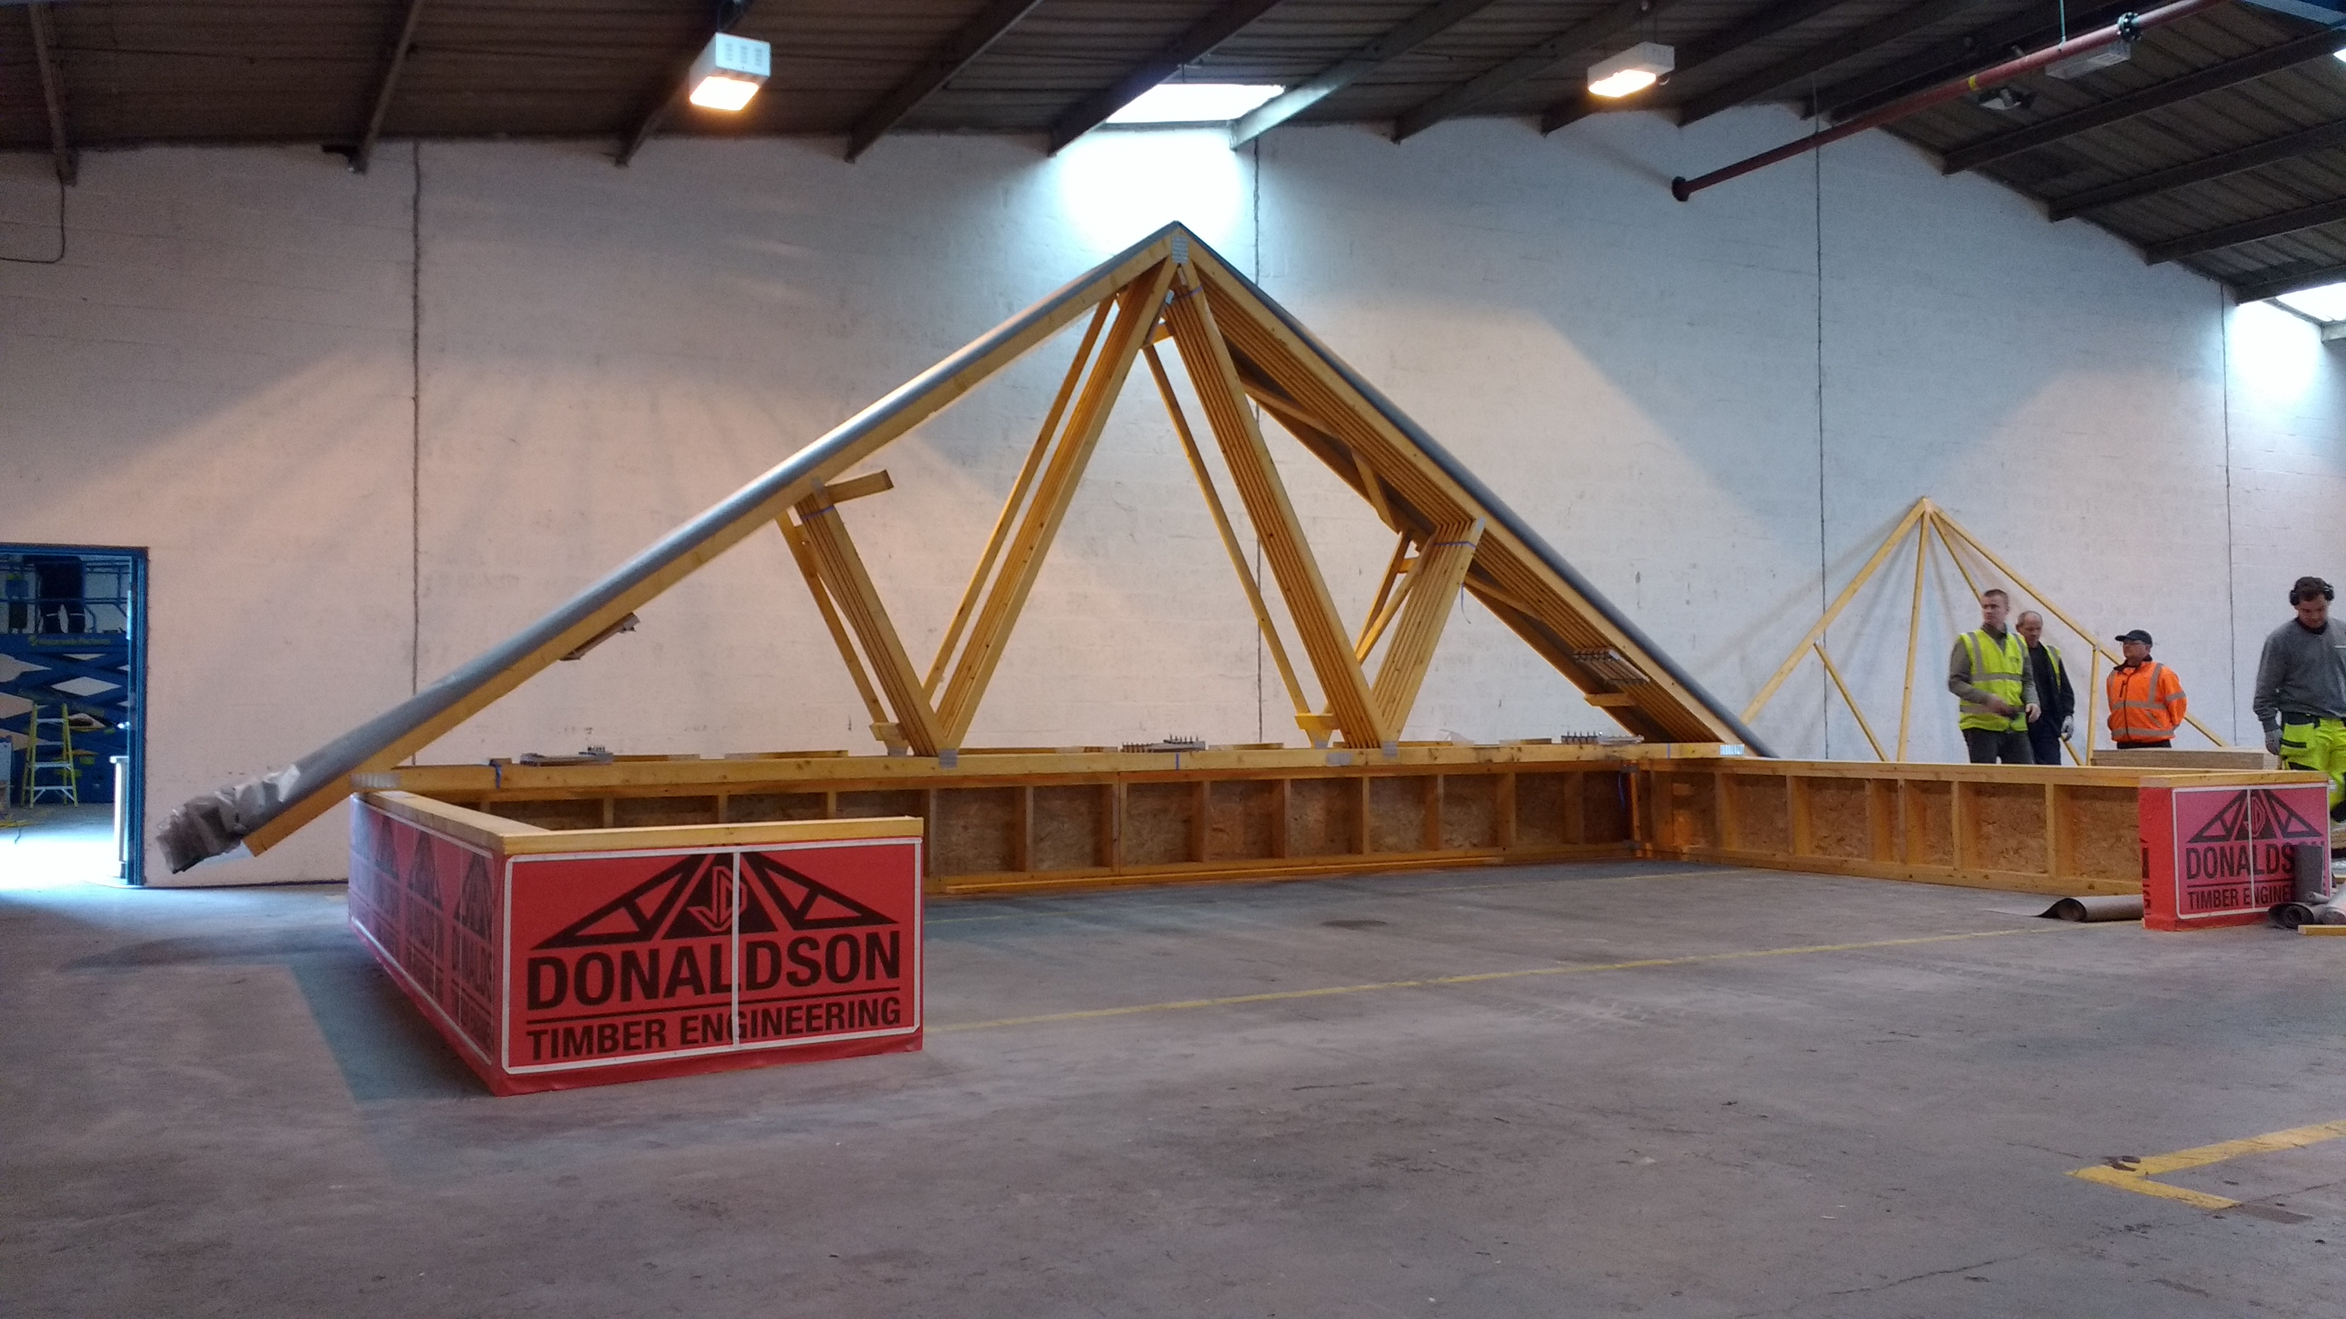

**Figure 2.** Vetokatto sliding roof trial

As a result of the trials and feedback provided by the industry, the next stage of the project focussed on the adaptation of Vetokatto for the UK. The main purpose of this part of the research was to eliminate any working at height and if possible, to remove the need for a fall arrest system, to maximise the advantage over traditionally constructed roofs. The main technical challenge was to design a bracing system which could be pre-fitted in factory, as currently the design of Vetokatto requires bracing elements to be fixed once the system has been installed. Each optimised element of the system resulted in the price increase of the product. In order to rationalise the ‘upgrades’ which are planned to be made to Vetokatto a series of different building scenarios had to be considered. This is to allow for accurate estimation and comparison of cost and time required to construct the roof using traditional techniques and Vetokatto with various ‘upgrades’. The model selected for the analysis is shown in Figure 3.

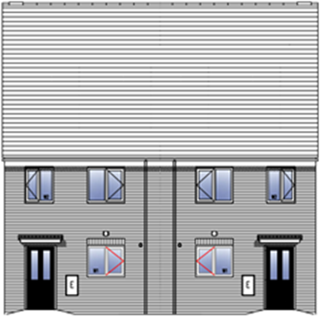

**Figure 3.** House model selected for analysis

The model consists of two semi-detached dwellings (house type that occur on most construction sites in the UK), each of them is approximately 8.4m long and 4.8m wide. The roof comprises of fink trusses spaced at 600mm c/c with 35˚ pitch, spandrel panels and gable ladders. During the analysis all roof construction stages were taken under consideration including site preparation, erection of roof structure, felting and battening.

Based on the findings from the analysis it is estimated that the overall roof construction cost can be reduced by approximately 15% when using optimised Vetokatto, while traditionally constructed roof will come at the same price as the roof consisting of not optimised Vetokatto. The biggest advantage of the system is its time saving potential. The trusses can be erected in as little as 30 minutes, which has a positive impact on overall timescale of the project. It is estimated that by using Vetokatto, the roof structure for the building shown in Figure 3. can be completed in 3 days, which gives a 1,5 days saving when compared to the roof constructed using traditional techniques. With further optimisation of the system, the time needed to construct the roof will go down to 1¾ of a day.

# L-ments

L-Ments® is a self-supporting and thermally efficient roof element, suitable for pitched roofs (slope between 15° and 60°) that can be topped with tiles, slates or corrugated sheet. The panels were designed and developed for a multitude of pitched roofs, they can span from 2.78 m for 30° roof pitch up to 3.69m for 60° roof pitch. The rapid assembly of these roof elements is facilitated by their lightweight and relatively straight forward method of connecting to each other and the existing structure. The systems is therefore well suited to the refurb market, where loft conversion works are often carried out by a self-builders or small contractors, without heavy machinery and specialist knowledge.

The research work undertaken was therefore concerned with the implementation of L-ments into Donaldson Timber Engineering business architecture with a view to the commercialisation of the product. L-ments are currently manufactured in Belgium, to introduce them into UK market, DTE would take the responsibility for the distribution and logistics of the product. In order to deliver a finished roof solution consisting of L-ments, a variety of panels will have to be stored in the factory prior to delivery to site. During the design process the other structural elements that will be included in the transport such as purlins, wall plates and fixings will determined. This will allow DTE to deliver a complete roof solution. Currently a software solution which support the design, manufacturing and distribution of L-ments panels is under development to improve this process. The software will be combined with Continued Professional Development (CPD) events in order to provide additional technical insight of the product to develop an improved understanding of its use and applications for specifier confidence.

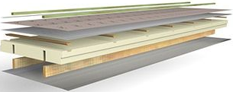

1

2

3

4

5

1 – underlay screen (film shelter)

2 – wooden battens

3 – multilayer coating (aluminium)

4 – polyisocyanurate insulation (PIR)

5 – integrated wooden stiffeners

**Figure 4.** L-ments roof panels

# Conclusion

The aim of this paper was to report on the development of a mass customisable roofing solution which will allow the UK’s largest roof truss manufacturer to enter into the off-site construction sector without reinventing their business architecture. The research work undertaken derived a SWOT analysis based on the UK construction market and business drivers of the industry partner. Apply this SWOT analysis to currently available offsite roof solutions identified the barrier to uptake of current methods was significant material usage, price and complicated design process resulting in the systems not being scalable. The research has therefore identified to suitably alternative roofing solutions, the Vetokatto sliding roof for new build and the self-supporting roof panel (L-ments) for retrofit. Vetokatto, has real potential to reduce the cost (15%) and time (3 times faster) without the need for high levels of upskilling. L-ments is particular suited to the retrofit market on the basis that it is highly insulated, lightweight, simple to install without requiring an over specification of materials. Further optimisation of the L-elements roof systems presented in this paper will consider renewable integration such as a collector storage - solar water heater. Successful application renewable technology will not only add value to the offsite roof solutions but also put Donaldson Timber Engineering at forefront of roof system innovation in the UK.

# Acknowledgements

The authors would like to thank the Construction Scotland Innovation Centre and Scottish Funding Council for their funding support of this work.

**REFERENCES**

HM Government. (2013). *Industrial Strategy: government and industry in partnership –*

*Construction 2025*, URN BIS/13/955.

UKCES. (2013). *Technology and skills in the Construction Industry Evidence,* Report 74,

ISBN 978-1-908418-54-8.

Smith, S. Hairstans, R. MacDonald, R. and Sanna, F. (2012). *Strategic Review of the Offsite Construction Sector in Scotland*, The Scottish Government, ISBN 978-1-78256- 394-5.

UK Government Department of Business Innovation and Skills (BIS) (2013). *UK Construction: an economic analysis of the sector,* London, 2013.

HM Treasury. (2015) *Annual Report and Accounts 2014-15*, HC 34, ISBN 9781474123624