Sediment temperature impact on population structure and dynamics of the crab Austruca iranica Pretzmann, 1971 (Crustacea: Ocypodidae) in subtropical mangroves of the Persian Gulf

Hanieh Saeedi^{a,b*}, Ehsan Kamrani^{c,d}, Inga Nordhaus^{e}, Karen Diele^{f,g}

ªSenckenberg Research Institute and Natural History Museum, Department of Marine Zoology-Crustaceans, Senckenberganlage 25, 60325 Frankfurt am Main, Germany, hanieh.saeedi@senckenberg.de*
^{b}Goethe University Frankfurt, FB 15 Biological Sciences, Institute for Ecology, Diversity and Evolution, Biologicum, Campus Riedberg, Max-von-Laue-Str. 13, 60438 Frankfurt am Main
^{c}Fisheries biology department, Islamic Azad University, Bandar Abbas, Iran
^{d}Faculty of Marine Biology, Hormozgan University, P O Box 3995 Bandar Abbas, Iran
^{e}Leibniz Centre for Tropical Marine Research (ZMT), Fahrenheitstr. 6, D-28359 Bremen, Germany
^{f}Edinburgh Napier University, School of Applied Sciences, Sighthill Court, Edinburgh, EH11 4BN, UK
^{g}St Abbs Marine Station, St Abbs, TD14 5QF, UK

…………………………..
* Corresponding author
Phone: +49-174-6210915
Email: hanieh.saeedi@gmail.com*
Abstract
Ocypodid crabs inhabit intertidal sandy/muddy flats of tropical and sub-tropical mangroves. Iran has three species of the genus Austruca. Compared to Austruca sindensis and A. lactea, almost nothing is known about the population dynamics and its driving factors in A. iranica. Thus, population ecology and reproductive biology of the latter species were studied in relation to sediment temperature and rainfall in a sub-tropical Iranian mangrove forest over a period of 13 months. Crab density and Gonado Somatic Index (GSI) were significantly correlated with sediment temperature (r²=0.87, p≤0.05). Reproduction was restricted to spring and summer and ovigerous females appeared when both sediment temperature and rainfall had their maximum values. Rainfall triggered crab reproduction, but did not significantly correlate with crab density. Symptotic width (L∞, carapace width) and growth constant (k) were 16.9 mm and 1.0 yr ⁻¹ in females (n = 251), and 18.5 mm and 0.9 yr ⁻¹ in males (n = 325), respectively. Size frequency distributions in both females and males had a common asymmetrical bi-modal pattern with two cohorts. Total mortality was higher in females (2.74) than in males (2.29). The overall sex ratio did not differ significantly from the expected 1:1 proportion (χ²=20.50, p> 0.05). Size at the onset of maturity was 10.2 mm in females. In contrast to most other ocypodid species, this study revealed that A. iranica is a relatively slow growing crab, with low fecundity and mortality rates, and with a relatively long life expectancy of about two years. The results of this research are key for establishing a management plan to conserve the population of A. iranica along the Iranian coasts.

Keywords: sediment temperature, population structure; reproduction; Austruca iranica; planted mangrove forest; Qeshm Island; the Persian Gulf.
Introduction
Ocypodid crabs (Decapoda: Brachyura: Ocypodidae) inhabit intertidal sandy-muddy to muddy sediments in tropical and sub-tropical areas world-wide, especially in or adjacent to mangrove forests, and coastal marshes. Ocypodid species with narrow-range distributions evolved in the Indo-West Pacific (Rosenberg, 2001). Species with wide-ranging distributions have then evolved from their Indo-Pacific ancestors by expanding into America and West Africa (Rosenberg, 2001). Ocypodid crabs can reach densities of up to 260 individuals per m², with juvenile densities reaching 140 crabs per m² (Carlson, 2011).
Ocypodids have significant ecological roles in their ecosystem. For example, they are an important link to the higher trophic levels of the intertidal and shallow waters as they contribute to the diet of many crustaceans, birds, fish, and mammals (Wolff et al., 2000). They are also important consumers of detritus, bacteria, fungi, and benthic micro algae (Weis, J. and Weis, P. 2004). Some species feed in flocks (droves) at the edge of the water, while others feed on the small areas around their burrow entrances. These semi-terrestrial crabs dwell in burrows and forage outside their burrows during low tides (Mouton and Felder, 1996). Ocypodid crabs’ bioturbation aerates the sediment and increases the growth of marsh plants and the amount of meiofauna in salt marshes (Mokhtari et al., 2008). During high tides, the crabs retreat into their burrows and plug the entrances. Burrow plugging also prevails at night and on a hot day when the sediment is dry (Crane, 1975; Mokhtari et al., 2008). Mokhtari et al. (2008) found strong interactions between Sirik mangrove estuary, Austruca lactea crabs and bacteria, which increased the primary production in the estuary.
The genus Austruca is comprised of small to medium size species (~ 15 mm in carapace width in adults) with smooth dorsal carapace surfaces. Males have greatly enlarged chelae, as typical for Ocypodidae (Shih et al., 2016). Austruca includes 11 species which are mostly distributed in the Indo-West Pacific areas and three species, including A. sindensis (reported as Uca sindensis in Mokhlesi et al., 2010), A. iranica (Shih et al., 2016; Davie, 2017), and A. lactea (reported as Uca lactea annulipes in Mokhtari et al., 2008 and Lavajoo et al., 2014) have been reported from Iran. The genus Austruca has been widely misplaced and/or mis-identified with Uca, a diverse genus with almost 100 species (Shih et al., 2016; Ng et al., 2008). In many tropical environments, several species of Ocypodidae coexist in the same habitat, but display different densities and behavior (e.g., feeding and mating) as well as microhabitat preferences which specify their ecological niches (Koch and Wolff, 2000; Weis and Weis, 2004). Species of Austruca seem to share common habitats as A. sindensis and A. iranica also coexist in Bandar Abbas and Qeshm Island, Iran (personal observations).
The Iranian Austruca species occupy a range of substrates and constitute a significant component of the brachyuran fauna of the mangrove forests in the Persian Gulf (Shin et al., 2009). Lavajoo et al. (2014) studied the population dynamics of A. sindensis in Pohl port mangrove forest in Bandar Abbas, Iran. They found that the number of males and females in A. sindensis are equal, with a seasonal recruitment pattern. In the study of Mokhtari et al. (2008), male crabs were the dominated sex around the year with a density significantly correlated with sediment temperature. A. iranica is very abundant in sandy-muddy mangroves in Iran (specifically Qeshm Island), United Arab Emirates (UAE), Kuwait, and Pakistan (Apel and Türkay 1999; Saher et al., 2014; Shin et al., 2015). In contrast to A. lactea and A. sindensis, almost nothing is known regarding the ecology and population dynamics of endemic species A. iranica. Determining the growth patterns and spawning activities of a species is required to preserve its populations and to establish management plans if are under pressure from over-fishing or pollution. It is not known whether the crab populations of A. iranica are affected by environmental factors, in particular annual mean air temperature which varies highly over the year (16 – 45 °C) in Qeshm Island.
The impacts of environmental factors such as sediment temperature and rainfall on reproduction, activity, and density of Ocypodid crabs have been reported in tropical and sub-tropical areas (Yamaguchi, 2001a; Litulo, 2004; Diele and Koch, 2005, 2010; Mokhtari et al., 2008; Mokhlesi et al., 2010; Darnell et al., 2015; Fusi et al., 2015). Most of these studies showed that most importantly temperature and in some cases rainfall positively trigger the reproductive activities and increase crab densities. However, rainfall was the most important factor triggering the reproduction in some species such as U. annulipes in southern Mozambique (Litulo, 2004).
The study area, Qeshm Island, is located in a semi-arid area and is specific due to its highly variable temperature over the year and its low average annual rainfall (200 mm). The impacts of sediment temperature and rainfall on Austruca crabs have not yet been examined in this area (and elsewhere). The present study thus aims to study the relationship between A. iranica density and reproduction and environmental factors at Qeshm Island. We hypothesize that crab density and GSI (an index for the reproductive activity) are significantly and positively correlated with 1- sediment temperature, and 2- rainfall. This study also aims at providing for the first time information on several understudied aspects of the population structure and dynamics of A. iranica. Thus, density, handedness, growth and mortality rates, sex ratio, fecundity, reproductive periodicity, Gonado Somatic Index (GSI) were assessed.

Materials and methods Study area and crab sampling
The study area (about 0.7 ha) is located in a high intertidal area covered by planted mangrove stand (about 5 ha) in Qeshm Island, the Persian Gulf (Latitude 26˚ 58ʹ 592" N; Longitude 56˚ 04ʹ 722" E) (Figure 1). The mangrove stands were 2 to 3 years old at the time of the sampling from June 2008 to June 2009. This area is 300 ha in size where local people planted mangrove seedlings in 2006, as part of the project "Sustainable development of coastal jungles (Mangrove)”. The grey mangrove, Avicennia marina, is the dominant mangrove tree species at the study area (Mohammadizadeh et al., 2009). At the time of the study, the trees were 60-100 cm high and 3 m apart from each other. Qeshm Island is mostly rocky and has an average annual rainfall of 200 mm (Mohammadizadeh et al., 2009). The climate is subtropical with an annual mean air temperature ranging from 16 in winter to 45˚C in summer (Saeedi et al., 2009). The biome of the area is warm desert and semi-desert, with a relative annual air humidity of 64% (Mohammadizadeh et al., 2009). The sediment is slightly alkaline (pH=7.67) and consists of loam, sand, and clay which can retain 56.8% of humidity when are saturated with water (Mohammadizadeh et al., 2009). Tides are a mixture of diurnal and semidiurnal with a mean tidal range of 2.5 m.
Samples of A. iranica were collected monthly at spring tide days from June 2008 to June 2009 during low tides. Ten 50 cm ×50 cm (0.25 m²) quadrats where randomly chosen from a fixed spot at the beginning of the shoreline and excavated by a spade to a depth of 30 cm every 600-700 meters perpendicular to the shoreline. This sampling method was used instead of direct observations as the latter does not allow for an accurate density determination due to human error (Mazumder and Saintilan, 2003). In addition, specimens were required to be collected for morphometric analyses. Sediment samples were sieved with a 100 µ mesh and all crabs which were found by naked eyes were bagged, labeled, and preserved in 70% ethanol for further laboratory analysis.
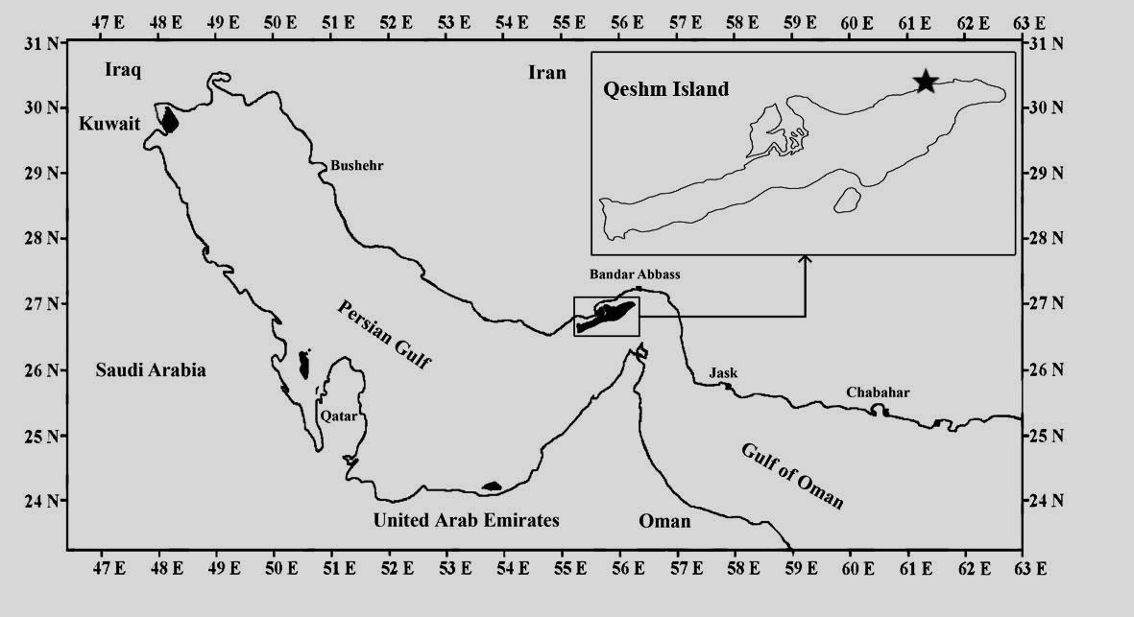
N
Fig. 1. Study area in Qeshm Island, the Persian Gulf. The black star shows the planted mangrove. The solid black areas show the islands.
Environmental factors and sediment characteristics
Sediment temperature was measured (with three repeats at the same quadrat) at 3 cm depth using a Brannan thermometer and was recorded monthly at the same time of the day. Monthly rainfall from June 2008 to June 2009 was obtained from the Meteorological Station in Qeshm Island. Sediment samples were taken from the 10 selected quadrates using a core sampler inserted into the sediment to a depth of 15 cm in June, September, December 2008, and March 2009 for grain size analysis and total organic matter (TOM) analysis (Mokhlesi et al., 2010). Percentages of sand, silt, and clay were measured following Shepard (1954) and Saeedi et al. (2009). Graphical techniques were used for grain-size classiﬁcation of the sediments (Mokhlesi et al., 2010). For TOM analysis, sediment samples were dried to a constant mass at 60˚C, then weighed (to the nearest 0.1 mg) to determine the dry mass (Mokhtari et al., 2008). Dried sediment samples were incinerated at 540˚C for 3 h and then weighed again to measure the ash-free dry mass. Finally, TOM was calculated as the percent massloss after the incineration (Mokhtari et al., 2008).
Morphometrics and handedness
In the laboratory, A. iranica specimens were identified (species identification was verified by Peter Ng, National University of Singapore), sexed, and studied for the presence of egg-masses and the handedness in males.
The carapace length (CL) (dorsal distance between the anterior and posterior margins of the carapace), carapace width (CW) (maximum distance between the anterolateral margins) (Thurman, 1985), large cheliped length (ChL) in males, and feeding cheliped length (FChL) in both sexes were measured using a vernier caliper (±0.1 mm accuracy). Body fresh mass (BM) and egg batches mass (EM) were weighed to the nearest 0.01g with a digital balance.
Carapace width and body massParameters of the relationship between carapace width and body mass were estimated using regression analysis:
W = a L ^{b}
Where W is the body mass (g), L is the carapace width (mm), a and b are constants. The mean value of the allometric coefficient (b) for one year was tested by the Student’s t-test at the 95% confidence limit in order to identify the growth pattern (where b=3 was considered as isometric growth pattern, b<3 negative allometric, and b>3 positive allometric (Saeedi et al., 2009).
Age groups were determined for each sex and their mean body size calculated using Bhattacharya’s method (Bhattacharya, 1967; Mokhtari et al., 2007) with the FAO-ICLARM stock assessment Tools II, FiSAT II. Male and female size frequency distributions were plotted by grouping specimens into 2 mm size class intervals from 3 to 21 mm of CW. The period of time when ovigerous females were observed in the population was considered as the breeding season (Colby and Fonseca, 1984; Bezerra and Matthews-Cascon, 2007). Size frequency distributions were tested for normality using Kolmogorov–Smirnov (KS) test (Zar, 1984; Bezerra and Matthews-Cascon, 2007).
The von Bertalanffy Growth Function (VBGF) was applied to estimate growth parameters as follows using FiSAT:
L_{t} = L∞ [1 – e ^{–k [t – t}₀]] L_{t} refers to the crab width at time t, L∞ is the asymptotic carapace width, k is the annual growth coefficient, t₀ (age at zero length) was set to zero as no data for larval and early post-larval development time were available to estimate the absolute age of this species. ELEFAN 1 was used to estimate the size frequency distributions using L∞ and k.
Natural mortality (M) (mortality caused by natural sources such as predation, disease and old age) and total mortality (Z) (a combination of fishing and natural mortalities) rates were determined for each sex by carapace width converted catch curves. The average size frequency distribution and the parameters k and L∞ of the Von Bertalanffy growth equation were used to estimate the total mortality rate (Mokhtari et al., 2008). The mean annual sediment temperature used in the estimation was set as 28.23˚C which was measured during the study.
Sex ratio and fecundity
Sex-ratio departures from 1:1 were tested using a Chi-square test (Zar, 1999; Bezerra and Matthews-Cascon, 2007). To estimate fecundity from June 2008 to June 2009, pleopods of a total number of 51 stage I ovigerous females were removed and put in petri dishes for egg counting. Four subsamples from pleopods of each individual were taken and egg numbers counted under a dissecting microscope. Then, the total number of eggs in the clutch was extrapolated from the value obtained for the four subsamples (Litulo, 2004). To analyze fecundity, data were processed using the power function (Y=aX+b) of egg number (EN) vs. CW and BM (Bezerra and Matthews-Cascon, 2007).
GSI (Gonado Somatic Index) was determined monthly as follows:
GSI = Egg mass (g) / Body Mass (g)
Correlation between GSI and sediment temperature was tested by a Pearson correlation coefficient. Size at the onset of maturity of females was determined from the average size of the five smallest ovigerous females sampled during the 13-month study (Koch et al., 2005). All crabs which were smaller than the smallest egg-bearing female were considered as immature (Mokhtari et al., 2008).
Statistical analyses
Correlations between CW of the crabs, sediment temperature, and rainfall were determined using the Pearson correlation coefficient. A multivariate analysis of variance (MANOVA) was performed to determine the relationship between crab density (dependent factor) and sediment temperature and rainfall (independent factors). The level of significance for all analyses was fixed at α=0.05.
A chi-square test was used to estimate departures from 1:1 enlarged cheliped handedness ratio (Zar, 1999; Bezerra and Matthews-Cascon, 2007).

Results
Crab density related to environmental factors
The MANOVA test between crab density and environmental factors (sediment temperature and rainfall) showed that only sediment temperature was significantly correlated with crab density (r²=0.72, df=11, p<0.05), but not rainfall (r²=0.00, df=11, p>0.05) (Figure 2). There was no significant correlation between carapace width and sediment temperature in both sexes (r²= -0.20 - -0.28, p>0.05). Carapace width in females was positively significantly correlated with rainfall (r² =0.55, p<0.05), but not in males (r² =0.10, p>0.05).
Ovigerous females appeared when sediment temperature and rainfall had their highest values during the year (Figure 2). The maximum density of non-ovigerous and ovigerous females was observed in June 2008, and their minimum density recorded in November 2008 and between October 2009 to March 2010, respectively (Table 1 and Figure 2). Maximum and minimum densities of males were observed in May and October 2009, respectively.
The proportion of sand was higher than that of clay and silt (Supplementary Figure 1). The percentage of sand was almost constant througout the year, while the proportion of silt and clay fluctuated between seasons. Maximum and minimum values of TOM were recorded in spring and winter, respectively. There was no significant correlation between TOM and all sediment types (r²=0.02, p>0.05) (Supplementary Figure 1).

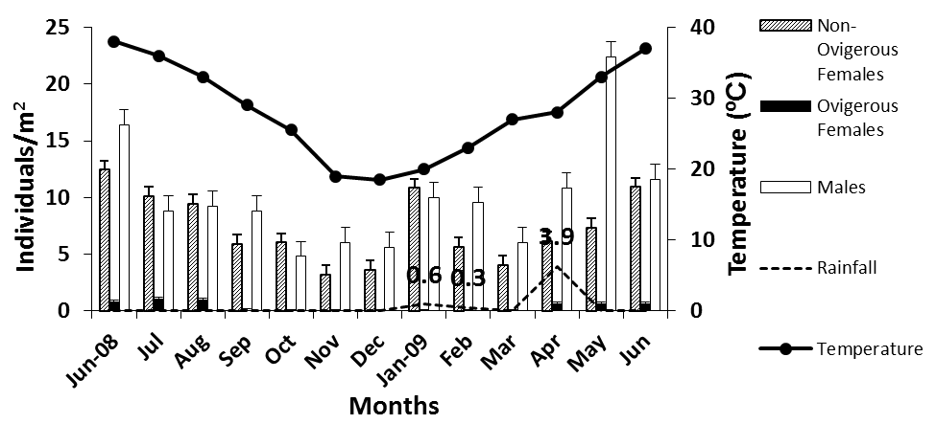
Fig. 2. Density of A. iranica individuals, sediment temperature, and rainfall recorded from June 2008 to June 2009 (Error Bars: SE). Rain only fell in January, February, and April 2009 . Apirl was the month with the highest rainfall (3.9 mm). In other months the rainfall was 0 mm.
Morphometrics and handedness
A total of 576 specimens of A. iranica were collected during the study period (56.42% males and 43.58% females) (Table 1). Males had a significantly larger carapace width than females (t=84.36, p<0.05) (Figure 3). Amongst male crabs, 158 were left-handed (48.61%) and 167 were right-handed (51.39%). The proportion of males having the right or left chelae hypertrophied did not differ significantly from an expected 1:1 ratio (χ²=19.49, p>0.05).
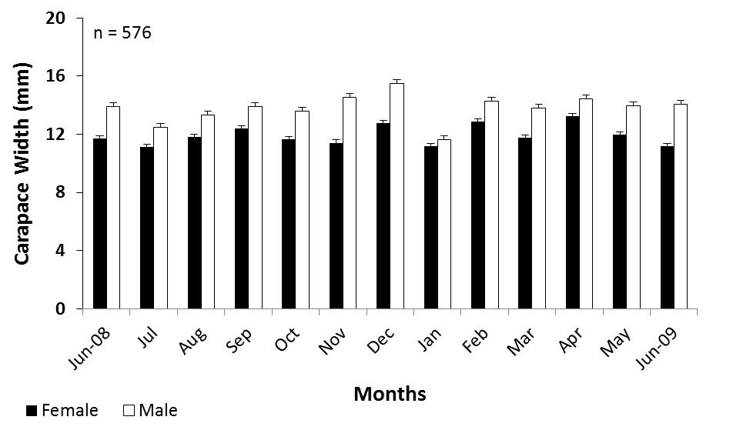
Fig. 3. Mean carapace width of female and male A. iranica (Error Bars: SE).
Table 1. Density and morphometric measurements of A. iranica (n = 576) collected from the sub-tropical mangroves in Qeshm Island, Iran. CL, carapace length; CW, carapace width; ChL, large cheliped length in males; FChL, feeding cheliped length; BM, body fresh mass.

Sex | Total NO. | Density  (ind/m2) |  |  | CL (mm) |  |  | CW (mm) |  |  | FChL (mm) |  |  | ChL (mm) |  |  | BM (g)
 |  | Min | Max | Mean±SD | Min | Max | Mean±SD | Min | Max | Mean±SD | Min | Max | Mean±SD | Min | Max | Mean±SD | Min | Max | Mean±SD
Male | 325 | 4.80 | 22.40 | 10.00±4.83 | 3.30 | 12:00 | 8.53±1.68 | 5.50 | 19.00 | 13.77±2.70 | 2.30 | 8.35 | 5.58±1.19 | 3.75 | 36.00 | 21.18±7.09 | 0.06 | 2.95 | 1.16±0.64
Female-non-ovigerous | 200 | 3.20 | 12.40 | 7.33±3.06 | 2.00 | 13.00 | 7.44±1.50 | 3.40 | 16.00 | 11.78±2.28 | 1.50 | 7.70 | 4.71±0.93 | … | … | … | 0.01 | 1.36 | 0.53±0.28
Female-ovigerous | 51 | 0.00 | 1.10 | 0.39±0.44 | … | … | … | 9.55 | 15.45 | 10.20±2.05 | … | … | … | … | … | … | … | … | …

Carapace width and body mass
The relationship between carapace width and body mass of females was W = 0.0002 L^{3.1534} (r²= 0.96, p<0.05), and W = 0.0001 L^{3.477} in males (r²= 0.94, p<0.05) (Figure 4). The width-body mass relationship in both sexes was significantly different from b = 3 (t=9.85; df=12; P<0.05).
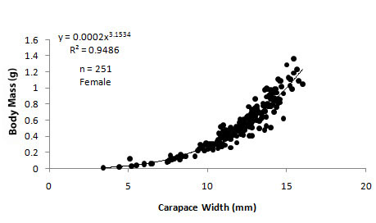 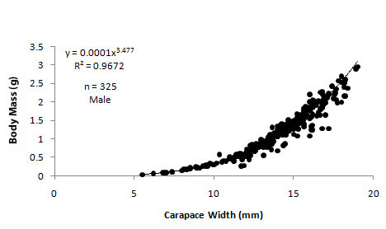 Fig. 4. Length-body mass relationship in females (left) and males A. iranica (right).
Medium size classes were the most abundant among both sexes (11-13 mm in females and 13-15 mm in males) (Figure 5). The smallest size class (3-5 mm) was only observed in females; whereas, the biggest size classes (17-21) were only observed in males. Smallest size classes of both sexes were observed in January.
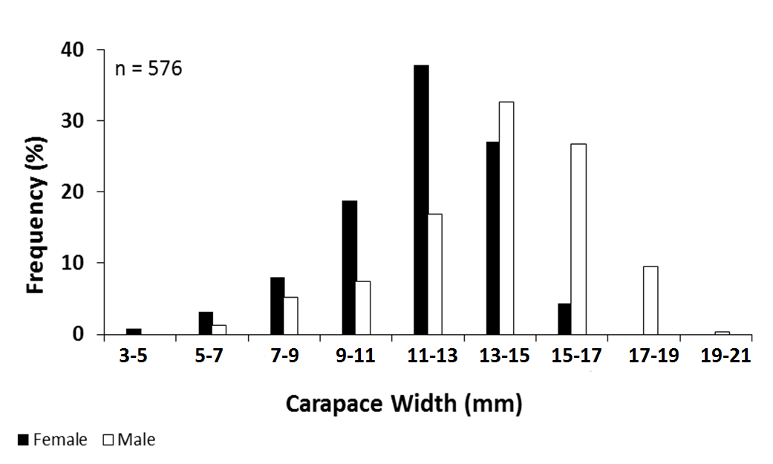
Fig. 5. Annual overall size frequency distribution of both sexes in A. iranica.
Size frequency distribution patterns were bi-modal in both sexes, (KS=0.84, p<0.05) (Figure 6) unlike the overall size frequency pattern for classified size groups (Figure 5). In general, two complete cohorts were observed during the 13-month study (Figure 6). Cohort 1 disappeared when cohort 2 emerged. L∞ was higher in males than in females (Table 2). By contrast, the growth rate (k) and total mortality rate (Z) were lower in males than in females (Table 2).
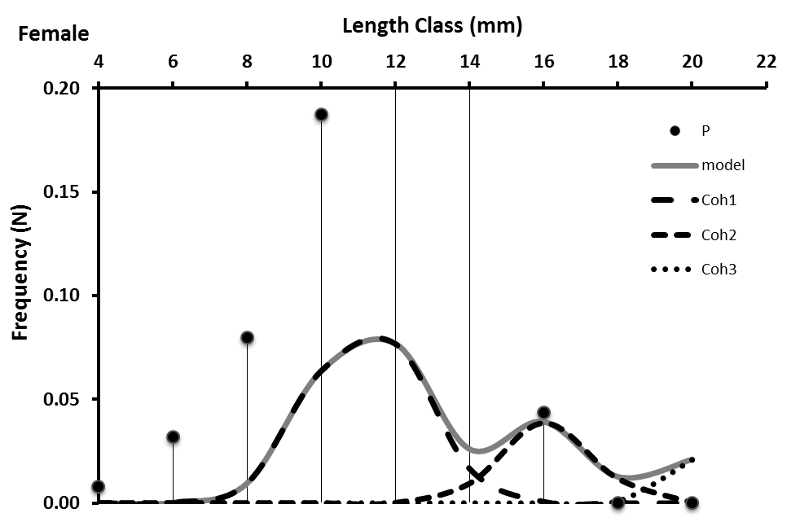
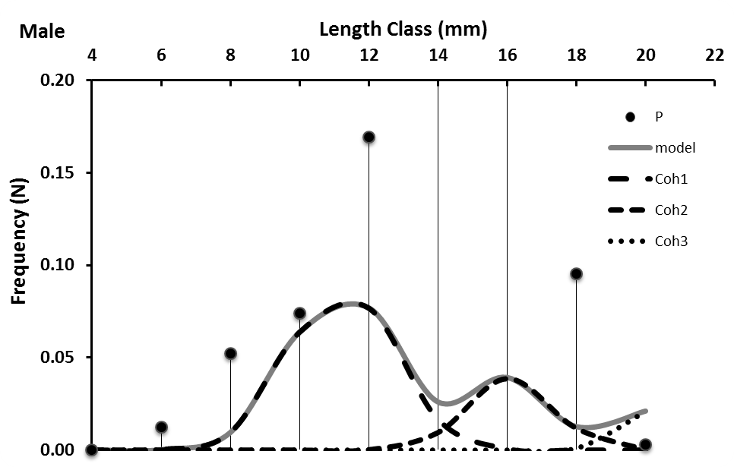

Fig. 6. Annual width - frequency distribution graph of females (top) and males (bottom) in A. iranica. Both female and males’ size frequency distributions show only two complete cohorts.

Sex ratio and reproductive cycle
The overall female:male sex ratio was 1:1.30 and did not differ significantly from the expected 1:1 proportion (χ²=20.50, p>0.05). Egg-carrying females were restricted to spring and summer (from April to September) when mean sediment temperature was highest, ranging between 29 and 39 ˚C (Figure 7). Highest values of GSI were recorded in July and August whereas GSI was zero when sediment temperature dropped below 29 ˚C, GSI and sediment temperature were significantly (positive) correlated (r²=0.87, p≤0.05).
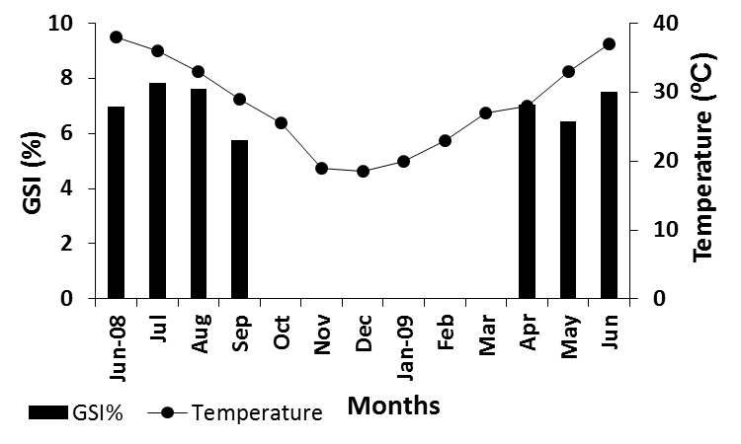
Fig. 7. Gonado Somatic Index (GSI) of A. iranica and sediment temperature from June 2008 to June 2009.
Fecundity
The number of eggs ranged from 2,160 (CW=11.45 mm) per individual in September to 11,664 (CW=15.20 mm) in April. Egg number was positively correlated with female carapace width (r²=0.59, p<0.05) and its body mass (r²= 0.69, p<0.05) (Figure 8).
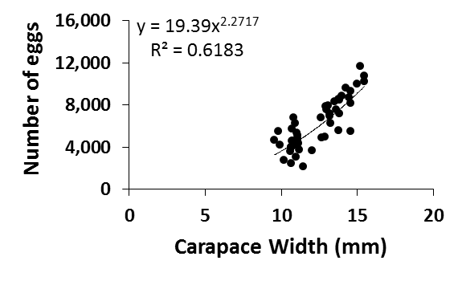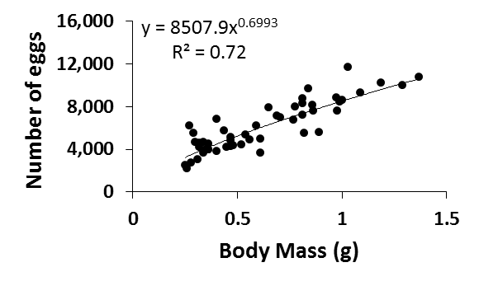
Fig. 8. Fecundity and carapace width (left) and body mass (right) of 51 ovigerous individuals of A. iranica. Number of eggs is per individual.

Discussion
Crab density in relation to environmental factors
As sediment temperature and rainfall impacts on Austruca crabs have never been studied in Qeshm Island, our research questions were designed to investigate the relationship between environmental factors and A. iranica density and reproduction. The population structure and dynamics of A. iranica were studied as fundamental requirements for any potential conservation plan in the future.
Correlation between A. iranica density and sediment temperature showed a significant positive relationship in line with our first hypothesis. Environmental factors (e.g., sediment temperature and rainfall), tidal regimes, and physiology of the crab could all affect the ocypodid crabs’ density and activity (e.g., burrowing, feeding, and reproduction) (Bertness and Miller, 1984; Yamaguchi, 2001a; Bezerra and Matthews-Cascon, 2007; Mokhtari et al., 2008; Mokhlesi et al., 2010). However, temperature has been reported as the most important contributing factor affecting density of other Ocypodidae species as higher temperatures can trigger the reproduction in these crabs (Yamaguchi, 2001a; Mokhtari et al., 2008; Mokhlesi et al., 2010; Darnell et al., 2015; Fusi et al., 2015).
Ovigerous females appeared when sediment temperature and rainfall had their maximum values (Figure 3). The frequency of ovigerous females in U. annulipes in southern Mozambique was also significantly correlated with sediment temperature and rainfall, and rainfall was the most important factor regulating their reproductive activity (Litulo, 2004). However, in A. iranica there was no significant relationship between crab density and rainfall in contrast to our second hypothesis. In our study ovigerous females were less abundant than non-ovigerous and males in the reproduction seasons. Ovigerous females of many species prefer to dig deep burrows to provide a stable thermal environment that yields constant embryonic developmental rates (Bezerra and Matthews-Cascon, 2007). Hence, the low number of collected ovigerous females in this study might be due to the fact that they hid inside deep burrows to incubate their eggs, reducing their catchability.
Crab density and GSI values reached their maxima in spring, coinciding with the highest TOM concentration. In winter when sediment temperature and rainfall were low, TOM and density showed the minimum values. Crabs can modify the organic matter concentration of the soft bottoms by their burrowing activities since their burrows trap detritus and organic matter and thereby enrich the sediment (Fanjul et al., 2015). The observed higher crab density (and resulting higher burrow numbers) of the crabs in spring probably explains the high concentration of TOM in this season.
Handedness, growth and mortality
Studying handedness is common in ocypodid crabs as it can show if being right or left handed is heritable (Backwell et al., 2007), or if it is due to claw loss and regeneration (Juanes et al., 2008). It has also been reported that handedness affects the fighting behavior of Uca (Backwell et al., 2007). Handedness of A. iranica was not significantly different from an expected 1:1 ratio. It suggests that, as in many other ocypodid crab species [e.g., U. uruguayensis, Leptuca thayeri, and U. arcuate (Spivak et al., 1991; Yamaguchi and Henmi, 2001; Bezerra and Matthews-Cascon, 2007)], in young specimens of A. iranica, both chelipeds have an equal chance of growing into the giant one found in adults. A difference in frequency-dependent advantage of a handedness associated with fighting experience is therefore unlikely (Backwell et al., 2007).
In this study, male crabs were larger (L∞ = 18.5 mm) compared to the females (L∞ = 16.9± mm), typical for ocypodid crabs(Table 2). Smaller female sizes may be caused by higher energetic investment into reproduction compared to males, resulting in slower growth and smaller maximum size (Mokhtari et al., 2008; Colpo and Negreiros-Fransozo, 2004). Austruca iranica in this study had the highest L∞ in both sexes (16.9 mm in females and 18.5 in males) compared to other Iranian species including U. annulipes (doubtful identification, it might be A. iranica) in Bandar Abbas and A. lactea in Sirik (Mokhtari et al., 2008; Lavajoo et al., 2014) (Table 2). However, the growth rate was higher in male A. lactea from Sirik (k=1.40 yr⁻¹) (Mokhtari et al., 2008) compared to A. sindensis (k=0.33 yr⁻¹) and A. iranica (k=0.90 yr⁻¹). Food availability, feeding techniques, feeding time, hydrological features, sedimentology, and infauna composition have been suggested as important factors in explaining size differences and growth rates among the different species of ocypodids (Colpo and Negreiros-Fransozo, 2004; Peer et al., 2016). For example, foraging times are influenced by tidal patterns and diel rhythms which vary between species and habitats affecting the growth and maximum sizes of different crab species (Kronfeld-Schor and Dayan 2003; Peer et al., 2016).
Table 2. Growth, mortality and reproduction parameters of different species of family Ocypodidae in different countries.
Species | Sex | L∞  (mm) | k±SE  (yr ⁻¹) | Mean mortality rate±SE | Mean size at onset maturity±SE  (mm (CW)) | Sex ratio  (female: male) | Study area | Reference
Uca rapax [accepted as Minuca rapax (Smith, 1870)] | Female  Male | 23.8  23.9 | 0.21  0.16 | ---- | ---- | ---- | Southeast Brazil | Castiglioni and Negreiros-Fransozo, 2004
Uca rapax [accepted as Minuca rapax (Smith, 1870)] | Female  Male | 20.4  21.3 | 0.15  0.16 | ---- | ---- | ---- | Southeast Brazil | Castiglioni and Negreiros-Fransozo, 2004
Uca cumulanta [accepted as Leptuca cumulanta (Crane, 1943)] | Female  Male | 11.1  13.1 | 4.24±0.49  4.22±0.14 | 9.1±2.10  10.1±2.60 | 6.2±0.1 | ---- | North Brazil | Koch et al., 2005
Uca maracoani (Latreille, 1802) | Female  Male | 31.0  35.2 | 2.44±0.29  2.03±0.14 | 6.0±0.90  4.9±0.40 | 18.0±0.3 | ---- | North Brazil | Koch et al., 2005
Uca rapax [accepted as Minuca rapax (Smith, 1870)] | Female  Male | 20.0  20.5 | 2.15±0.28  2.08±0.22 | 5.5±0.80  7.4±0.20 | 7.4±0.2 | ---- | North Brazil | Koch et al., 2005
Uca vocator [accepted as Minuca vocator (Herbst, 1804)] | Female  Male | 20.6  21.6 | 2.97±0.28  2.71±0.27 | 7.6±3.20  5.7±1.50 | 9.9±1.0 | ---- | North Brazil | Koch et al., 2005
Uca inversa [accepted as Cranuca inversa (Hoffmann, 1874)] | ---- | ---- | ---- | ---- | ---- | 0.8:1.0 | Mozambique | Litulo, 2005
Uca maracoani (Latreille, 1802) | Female  Male | 19.4  21.2 | ---- | ---- | ---- | 0.8:1.0 | Southeast Brazil | Hirose and Negreiros-Fransozom, 2008
Uca lactea annulipes [accepted as Austruca lactea (De Haan, 1835)] | Female  Male | 10.7  11.9 | 1.33±0.58  1.40±0.58 | 1.1±0.33  1.2±0.36 | 7.8 | 1.0:1.7 | Iran, Sirik | Mokhtari et al., 2008
Uca rapax [accepted as Minuca rapax (Smith, 1870)] | ---- | ---- | ---- | ---- | 6.1* | 1.0:1.3 | Southeast Brazil | Costa and Soares-Gomes, 2009
Uca thayeri [accepted as Leptuca thayeri (Rathbun, 1900)] | Female  Male | ---- | ---- | ---- | 13.8  12.7 | 0.9:1.0 | Northeast Brazil | de Almeida Farias et al., 2014
Uca sindensis [accepted as Austruca sindensis (Alcock, 1900)] | Female  Male | 16.28  17.3 | 0.36  0.33 | 0.95  1.05 | ---- | 1.0:1.0 | Iran, Bandar Abbas | Lavajoo et al., 2014
Austruca iranica | Female  Male | 16.9  18.5 | 1.0  0.9 | 2.74  2.29 | 10.2 | 1.0:1.3 | Iran, Qeshm Island | Present study
*calculated as the smallest ovigerous female
Females of the ocypodid species reviewed in Table 2 had generally 15 to 20% higher mortality rates than males, except in Leptuca cumulanta in Brazil (Koch et al., 2005) (Table 2). Austruka sindensis and A. iranica from Iran had lower growth and mortality rates than the Brazilian species (e.g., L. cumulanta, Uca maracoani, Minuca rapax and M. vocator from the Caeté mangrove estuary), which are fast-growing crabs with short life spans (0.7–1.5 years) and high mortality rates (Diele and Koch, 2010; Koch et al., 2005). In summary, Austruka sindensis and A. iranica both had the lowest mortality rates of all other ocypodid crabs worldwide (Table 2). Since ocypodids are rarely harvested, differences in total mortality in this genus are likely to relate to natural mortality. For instance, predation pressure by intertidal fish and wading birds may vary from location to location, as a function of hydrodynamics, tidal regime, and mangrove complexity.
The growth pattern of A. iranica was positively allometric as reported for other ocypodid species (e.g., A. sendensis, Uca burgersi, U. maracaoni and U. uruguayensis) (Benetti and Negreiros-Fransozo, 2004; Masunari et al., 2005; Lavajoo et al., 2013; Martins and Masunari, 2013). The observed positive allometric pattern suggests that as crabs grow, their body mass increases at a rate of three times more than their carapace width.
Reproduction
The population structure of A. iranica in Qeshm Island showed a bi-modal size frequency distribution pattern with two complete cohorts. A bi-modal distribution pattern was also found in other studies (e.g., U. subcylindrica, Cranuca inversa, A. lactea and A. sindensis (Thurman, 1985; Litulo, 2005; Mokhtari et al., 2008; Lavajoo et al., 2014). Such pattern reflects seasonal reproductive activities including distinct spawning and recruitment event per year (Bezerra and Matthews-Cascon, 2007; Mokhtari et al., 2008; Lavajoo et al., 2014). Southern Iran has a sub-tropical climate where at least five months of a year have high temperatures (more than 33˚C). Thus, the marked drop in temperature may have triggered the spawning in these invertebrates. In contrast, uni-modal distribution patterns have been observed in some tropical Uca species such as C. inversa from Mozambique and L. thayeri and U. maracoani from Brazil, due to multiple breeding during a year, with continuous recruitment (Litulo, 2005; Bezerra and Matthews-Cascon, 2007; de Almeida Farias et al., 2014). Bezerra and Matthews-Cascon (2007) suggested that tropical species show a continuous breeding season throughout the year because near the tropics environmental conditions (e.g., temperature and rainfall) are usually favorable allowing an investment in gonad development throughout the year. However, some tropical locations such as North Brazil have marked rainy and dry seasons which can cause seasonal breeding in Uca crabs in that area causing a bi-modal distribution pattern (Diele and Koch, 2005, 2010).
The overall sex ratio in A. iranica was not significantly different from the expected 1:1 (F:M) which agrees to that reported for L. thayeri (Bezerra and Matthews-Cascon, 2007) and M. rapax (Costa and Soares-Gomes, 2009) from Brazil. However, in some species such as C. inversa, M. rapax, U. maracoani, and A. lactea the sex ratio of the population was male dominated and significantly different from the expected 1:1 (Litulo, 2005; Costa and Soares-Gomes, 2008; Hirose and Negreiros-Fransozom, 2008; Mokhtari et al., 2008). Such an unequal sex ratio could be due to biased-sampling (Johnson, 2003), or a result of the diverging maximum sizes/slower growth of the females (Wenner, 1972; Diele and Koch, 2005).
Size at the onset of sexual maturity was bigger in A. iranica (10.2 mm) from Qeshm Island compared to A. lactea (7.8 mm) from Sirik (Mokhtari et al., 2008) (Table 2). The egg number of A. iranica was positively correlated with female size and body mass as reported from many other species such as C. inversa from Mozambique (Litulo, 2005a) and U. virens from Mexico (del Caostillo et al., 2015). Size at the onset of maturity and fecundity rate of ocypodids in the temperate and tropical areas can vary widely in different latitudes due to differences in environmental conditions (Thurman, 1985; Bezerra and Matthews-Cascon, 2007).
Smallest size classes of A. iranica were observed in January for both sexes, due to the recruitment of the juveniles in fall (from November to December). Likewise, courtship and mating behavior in A. annulipes occurred from February to September in Abi estuary of Bandar Abbas, Iran (Mokhlesi et al., 2010). Reproduction was restricted to spring and early summer in A. lactea in Sirik, Iran with juvenile recruitment at the end of summer (Mokhtari et al., 2008). The reproductive period of both males and females in A. lactea in Japan was also observed in the warm season (early June to August) (Yamaguchi, 2001a; Yamaguchi, 2001b). However, there were two peaks in the number of ovigerous females of A. lactea, which presumably led to two larval releases during its reproductive season. It suggests that the differences in the reproductive seasons and larval release peaks of different species might be related to temperature, photoperiod, rainfall, and food availability (Bezerra and Matthews-Cascon, 2007). For example, when temperatures are warmer, Uca terpsichores mates earlier in the tidal amplitude cycle (Kerr et al., 2014). Likewise, U. terpsichores also courted earlier at locations where sediment temperature declined seasonally but not where sediment temperature remained elevated throughout the year (Kerr et al., 2014).

Conclusion
We hypothesized that density and GSI of the crab Austruca iranica are significantly and positively correlated with 1- sediment temperature and 2- rainfall. Our first hypothesis was accepted as high sediment temperature was the most important factor for the high density and gonadal ripeness in A. iranica. However, in contrast to our second hypothesis and other studies, our results showed that rainfall does not affect the crab densities in Qeshm Island where the annual average rainfall is very low. Our results also showed that A. iranica is a slow growing crab compared to other ocypodid species, with low fecundity, low mortality rates, and a relatively long life expectancy of about two years. These results are crucial for establishing a management plan to help preserve the population of A. iranica along the Iranian coasts. However, further research on age estimation, interaction with other macro-benthic animals, and larval ecology are necessary to fully understand the ecology and life cycle of endemic A. iranica.

Acknowledgement
We would like to thank F. Seraji, H. Raesi, Mr. Parshan, and local people of Qeshm Island for their assistance in the field works and sampling. We thank R. Naderloo for confirmation of the crab scientific name change. We would also like to thank the anonymous referees for their helpful comments.

References
Apel, M. and Türkay, M. (1999) Taxonomic composition, distribution and zoogeographic relationships of the grapsid and ocypodid crab fauna of intertidal soft bottoms in the Arabian Gulf. Estuarine, Coastal and Shelf Science 49(Suppl A), 131–142.
Backwell, P. R. Y., Matsumasa, M., Double, M., Roberts, A., Murai, M., Keogh, J. S., and Jennions, M. D. (2007) What are the consequences of being left-clawed in a predominantly right-clawed fiddler crab? Proceedings of the Royal Society of London B: Biological Sciences 274(1626), 2723-2729.
Benetti, A.S. and Negreiros-Fransozo, M.L. (2004) Relative growth of Uca burgersi (Crustacea, Ocypodidae) from two mangroves in the southeastern Brazilian coast Iheringia. Série Zoologia, 94(1):67-72.
Bhattacharya, C.G. (1967) A simple method of resolution of a distribution into Gaussian components.
Biometrics 23, 115-135.
Bertness, M. D. and Miller, T. (1984) The distribution and dynamics of Uca pugnax (Smith) burrows in
a New England salt marsh. Journal of Experimental Marine Biology and Ecology 83, 211-237.
Bezerra, A.E.L. and Matthews-Cascona, H. (2007) Population and reproductive biology of the fiddler
crab Uca thayeri Rathbun, 1900 (Crustacea: Ocypodidae) in a tropical mangrove from Northeast
Brazil. Acta Oecologica 31, 251-258.
Carlson, M. D. (2011) Density, Shell Use and Species Composition of Juvenile Fiddler Crabs (Uca Spp.) at Low and High Impact Salt Marshes on Georgia Barrier Islands. Electronic Theses & Dissertations. Paper 756.
Castiglioni, D.S., Negreiros-Fransozo, M.L. (2004) Somatic growth of the mudflat fiddler crab Uca
rapax (Brachyura: Ocypodidae) from two subtropical mangroves in Brazil. Universidad y Cienica 20,
15-22.
Colby, D.R., Fonseca, M.S. (1984) Population dynamics, spatial dispersion and somatic growth of the
sand fiddler crab Uca pugilator. Marine Ecology Progress Series 16, 269-279.
Colpo, K.D., Negreiros-Fransozo, M.L. (2004) Comparison of the population structure of the fiddler
crab Uca vocator (Herbst, 1804) from three subtropical mangrove forests. Scientia Marina 68, 139-
146.
Costa, T. and Soares-Gomes, A. (2008) Relative growth of the fiddler crab Uca rapax (Smith)
(Crustacea: Decapoda: Ocypodidae) in a tropical lagoon (Itaipu), Southeast Brazil. Pan-American
Journal of Aquatic Sciences 3(2), 94-100.
Costa, T. and Soares-Gomes, A. (2009) Population structure and reproductive biology of Uca rapax
(Decapoda: Ocypodidae) in a tropical coastal lagoon, southeast Brazil. Zoologia 26 (4), 647–657.
Crane, J. (1975) Fiddler crabs of the world (Ocypodidae, Genus Uca). Princeton University Press, New
Jersey, 736 pp.
Darnell, M.Z., Nicholson, H.S. and Munguia, P. (2015) Thermal ecology of the fiddler crab Uca panacea: Thermal constraints and organismal responses. Journal of Thermal Biology 52,157-165.
Davie, P. (2017). Austruca Bott, 1973. Accessed through: World Register of Marine Species at http://marinespecies.org/aphia.php?p=taxdetails&id=955176 on 2017-07-09
de Almeida Farias, A.C., da Silva Castiglioni, D. and José Eduardo Garcia, J.E. (2014) Population structure of the fiddler crab Uca thayeri Rathbun, 1900 (Crustacea, Decapoda, Ocypodidae) in a tropical Mangrove. Thalassas 30(1):21-37.
del Castillo, V., Pérez, L.L., del Pilar Alonso, M. and Bortolini, J.L. (2015) Population structure and fecundity in Uca virens Salmon & Atsaides, 1968 (Decapoda: Ocypodidae) in southern Tamiahua Lagoon, Veracruz, Mexico. Latin American Journal of Aquatic Research 43(1), 14-22.
Diele, K., Koch, V., Saint-Paul, U. (2005) Population structure and catch composition of the exploited mangrove crab Ucides cordatus in the Caeté estuary, North Brazil: Indications for overfishing? Aquatic Living Resources 18(2), 169-178.
Diele, K., Koch, V. (2010) Comparative population dynamics and life history strategies of mangrove crabs, genera Uca and Ucides. In: Mangrove Dynamics and Management in North Brazil (U. Saint-Paul & H. Schneider, Eds.). Ecological Studies, Springer, Berlin- Heidelberg Vol. 211: 275-285.
Fanjul, E., Escapa, M., Montemayor, D., Addino, M., Alvarez, M.F., Grela, M.A. and Iribarne, O.O. (2015) Effect of crab bioturbation on organic matter processing in South West Atlantic intertidal sediments. Journal of Sea Research 95, 206-216.
Fusi, M., Giomi, F., Babbini, S., Daffonchio, D., McQuaid, C.D. Porri, F. and Cannicci, S. (2015) Thermal specialization across large geographical scales predicts the resilience of mangrove crab populations to global warming. Oikos 124(6), 784-795.
Hirose, G.L. and Negreiros-Fransozo, M.L. (2008) Population biology of Uca maracoani Latreille 1802-1803 (Crustacea, Brachyura, Ocypodidae) on the south-eastern coast of Brazil. Pan-American Journal of Aquatic Sciences 3(3), 373-383.
Johnson, P.T.J. (2003) Biased sex ratios in fiddler crabs (Brachyura, Ocypodidae): A review and
evaluation of the influence of sampling method, size class, and sex-specific mortality. Crustaceana
76(5), 559-580.
Juanes, F., Lee, K. T., McKnight, A., & Kellogg, K. (2008) Claw allometry in green crabs, Carcinus maenas: heterochely, handedness, and sex. Marine Biology 153(4), 523-528.
Kerr, K. A., Christy, J. H., Joly-Lopez, Z., Luque, J., Collin, R., & Guichard, F. (2014) Reproducing on time when temperature varies: shifts in the timing of courtship by fiddler crabs. PLoS ONE, 9(5), e97593.
Koch, V., Wolff, M. and Diele, K. (2005) Comparative population dynamics of four fiddler crabs
(Ocypodidae, genus Uca) from a North Brazilian mangrove ecosystem. Marine Ecology Progress
Series 291, 177–188.
Kronfeld-Schor, N., Dayan, T. (2003) Partitioning of time as an ecological resource. Annual Review of Ecology Evolution and Systematics 34, 153–181
Lavajoo, F., Kamrani, E., Sajjadi, M., Askari, M. (2013). Relative growth of the fiddler crab, Uca sindensis (Crustacea: Ocypodidae) in a subtropical mangrove in Pohl Port, Iran. Iranian Journal of Fisheries Science 12(3), 639-653.
Lavajoo, F., Askari Hesni, M., Kamrani, E. and Sajadi, M.M. (2014) Population dynamic of fiddler crab, Uca sindensis (Decapoda: Ocypodidae) in Pohl port mangrove forest, Persian Gulf, Iran. Indian Journal of Geo-Marine Sciences 43(12).
Litulo, C. (2004) Reproductive aspects of a tropical population of the fiddler crab Uca annulipes (H.
Milne Edwards, 1837) (Brachyura: Ocypodidae) at Costa do Sol Mangrove, Maputo Bay, southern
Mozambique. Hydrobiologia 525, 167–173.
Litulo, C. (2005) Population structure and reproductive biology of the fiddler crab Uca inversa
(Hoffman, 1874) (Brachyura: Ocypodidae). Acta Oecologica 27(3), 135-141.
Martins, S.B. and Masunari, S. (2013) Relative growth in the fiddler crab Uca uruguayensis Nobili, 1901 (Brachyura, Ocypodidae) from Garças River mangrove, Guaratuba Bay, southern Brazil. Nauplius 21(1): 35-41.
Mazumder, D. Saintilan, N. (2003). A Comparison of sampling techniques in the assessment of burrowing crab abundance in saltmarsh and mangrove environments, Wetlands (Australia), 21 (1):1-15.
Mohammadizadeh, M., Farshchi, P., Danehkar, A., Mahmoodi-Madjdabadi, M., Hassani, M. and
Mohammadizadeh, F. (2009) Interactive effect of planting distance, irrigation type and intertidal
zone on the growth of grey mangrove seedlings in Qeshm Island, Iran. Journal of Tropical Forest
Science, 21(2), 147-155.
Mokhlesi, A., Kamrani, E., Backwell and Sajjadi, M. (2010) Study on the behaviour of two fiddler
crabs, Uca sindensis and Uca annulipes (Decapoda: Ocypodidae), in Bandar Abbas, Iran. Journal of
the Marine Biological Association of the United Kingdom 91, 245- 249.
Mokhtari, M., Savari, A., Rezai, H., Kochanian, P. and Bitaab, A. (2008) Population ecology of
fiddler crab, Uca lactea annulipes (Decapoda: Ocypodidae) in Sirik mangrove estuary, Iran. Estuarine,
Coastal and Shelf Science 76, 273-281.
Mouton, E.C., J.r. and Felder, D.L. (1996) Burrow distributions and population estimates for the fiddler
crabs Uca spinicarpa and Uca longisignalis in a Gulf of Mexico salt marsh. Estuaries 19(1), 51-61.
Ng, P.K.L., Guinot, D. and Davie, P.J.F. (2008) Systema Brachyurorum: Part 1. An annotated checklist of extant brachyuran crabs of the world. The Raffles Bulletin of Zoology, pp. 1-286.
Peer, N., Miranda, N.A.F., Perissinotto, R. & Raw, J.L. (2016) Feeding dynamics of the fiddler crab (Uca annulipes) in a non-tidal mangrove forest. Marine and Freshwater Research 67, 556-565.
Rosenberg, M.S. (2001). The systematics and taxonomy of fiddler crabs: A phylogeny of the genus Uca. Journal of Crustacean Biology 21(3), 839-859.
Saeedi, H., Raad, S. P., Ardalan, A.A., Kamrani, E. and Kiabi, B.H. (2009). Growth and reproduction of Solen dactylus (Bivalvia: Solenidae) on northern coast of the Persian Gulf (Iran). Journal of the Marine Biological Association of the United Kingdom 89, 1635-1642.
Saher, N.U, Sahir O., Shih H.T., Kamal M. and Qureshi N.A. (2014) On a new record of the genus Uca (Decapoda, Brachyura, Ocypodidae) found along the coast of Pakistan. Crustaceana 87, 666–673.
Shepard, F.P. (1954) Nomenclature based on sand–silt–clay ratios. Journal of Sedimentary Petrology
24, 151–158.
Shih, H.T., Ng, P. K. L., Davie, P. J. F.;,Schubart, C. D., Türkay, M., Naderloo, R., Jones, D. S., Liu, M.Y. (2016). Systematics of the family Ocypodidae Rafinesque, 1815 (Crustacea: Brachyura), based on phylogenetic relationships, with a reorganization of subfamily rankings and a review of the taxonomic status of Uca Leach, 1814, sensu lato and its subgenera. Raffles Bulletin of Zoology 64, 139-175.
Shin, H.T., Kamrani, E., Davie, P.J.F. and Liu, M.Y. (2009) Genetic evidence for the recognition of
two fiddler crabs, Uca iranica and U. albimana (Crustacea: Brachyura: Ocypodidae), from the
northwestern Indian Ocean, with notes on the U. lactea species-complex. Hydrobiologia 635, 373–382.
Shin, H.T., Saher, N.U., Kamrani, E., Ng, P.K.L., Lai, Y.C., Liu, M.Y. (2015) Population genetics of the fiddler crab Uca sindensis (Alcock, 1900) (Crustacea: Brachyura: Ocypodidae) from the Arabian Sea. Zoological studies 54(1).
Spivak, E.D., Gavio, M.A., Navarro, C.E. (1991) Life history and structure of the world’s southern most Uca population: Uca uruguayensis (Crustacea, Brachyura) in Mar Chiquita lagoon (Argentina). Bulletin of Marine Science 48, 679-688.
Thurman, C. (1985) Reproductive biology and population structure of the fiddler crab Uca
subcylindrica (Stimpson). The Biological Bulletin169, 215-229.
Weis, J. and Weis, P. (2004) Behaviour of four species of fiddler crabs, genus Uca, in southeast
Sulawesi Indonesia. Hydrobiologia 523, 47-58.
Wenner, A.M. (1972) Sex ratio as a function of size in marine Crustacea. The American Naturalist 106, 321-350.
Wolff, M., Koch, V. and Isaac, V. (2000) A trophic flow model of the Caete mangrove estuary (North
Brazil) with consideration for the sustainable use of its resources. Estuarine, Coastal and Shelf Science
50, 789-803.
Yamaguchi, T. (2001a) The breeding period of the fiddler crab, Uca lactea (Decapoda, Brachyura,
Ocypodidae) in Japan. Crustaceana 74(3), 285-293.
Yamaguchi, T. (2001b) The mating system of the fiddler crab, Uca lactea (Decapod, Brachyura,
Ocypodidae). Crustaceana 74(4), 389-399.
Yamaguchi, T. and Henmi, Y. (2001) Studies on the Differentiation of Handedness in the Fiddler Crab, Uca arcuata. Crustaceana 74(8), 735-747.
Zar, J.H. (1999) Biostatistical Analysis. Prentice Hall, New Jersey, 930 pp.

