Finite-element heat-transfer computations for parallel surfaces with uniform or non-uniform emitting
S. M. Ivanova^{1,a,b)} , T. Muneer^{2,a)}

¹ Department Computer Aided Engineering, University of Architecture, Civil Engineering and Geodesy, Sofia, Bulgaria
² School of Engineering and Built Environment, Edinburgh Napier University, Edinburgh, UK

Abstract
Radiation heat transfer has very many applications in building physics. In a number of such studies one has to deal with radiant energy exchanges between surfaces of different orientation and aspects. Two principal cases that may be cited here are exchanges between (i) surfaces that share a common edge and are at an angle to each other, and (ii) surfaces that are parallel to each other and share a common perpendicular. Examples that may be cited here are walls of buildings and also ceiling and floor areas. In a previous work the authors presented a generalised, numerical-oriented solution for analysing radiant exchange that belong to case (i) cited above. In the present article a generalised treatment for case (ii) is presented. A software tool is also provided for analysing the radiant exchange for surfaces that are parallel to each other and have uniform or non-uniform reflectivity, incident irradiation and/or emitting. Calculation of incident reflected irradiation on the walls of urban street canyons with different orientation and non-uniform reflectivity is considered as an example.
Keywords: view factor, finite elements, reflected radiation, building energy simulation, radiant energy exchange, solar energy, urban canyons
I. Introduction
Buildings in general consume a large proportion of any given nation’s energy budget. Building physics attempts to provide tools that are increasingly becoming sophisticated. These tools enable the user to obtain the likely energy consumption of buildings at the design stage. With the passage of time building physics numerical tools are increasing in their accuracy of prediction of energy exchanges that take place within any given building envelope.
In a previous article [1] the authors have presented an analysis of radiant energy exchanges between surfaces that are inclined to each other and share or not share a common edge. In the present work the latter analysis has been extended to include a numerical treatment of surfaces that are parallel to each other. The coverage provided here shall include radiant energy exchange from the most simple (macro-) to most general formulations that are based on a micromesh, finite-element approach.
_____________________________
^{a)} S. Ivanova and T. Muneer contributed equally to this work.
^{b)} Author to whom correspondence should be addressed. Electronic mail: solaria@online.bg.
II. Analysis
A. Radiation exchange between any two surfaces
For any two black surfaces the thermal radiation exchange is given by Eq. (1):
$Q_{1−2}=σ(T_{1^{4}}−T_{2^{4}})A_{1}F_{1−2}=σ(T_{2^{4}}−T_{1^{4}})A_{2}F_{2−1}$ (1)
Within Heat Transfer terminology the term F₁₋₂ is known as "configuration factor" (CF) [2]. There are also other names for the latter such as "view factor", "geometry factor", "angle factor" or "shape factor". For any two elemental surfaces such as those shown in Fig. 1, F₁₋₂ is given as Eq. (2):
$F_{1−2}=\frac{1}{A_{1}}\int_{A_{1}}{\int_{A_{2}}{\frac{\text{cos}Φ_{1}\text{cos}Φ_{2}}{{πR}^{2}}{\text{dA}}_{2}{\text{dA}}_{1}}}$ (2)
where R is the distance between both differential elements dA₁ and dA₂; A₁ and A₂ are the faces of both surfaces; φ₁ and φ₂ are the angles between the normal vectors to both differential elements and the line between their centres.
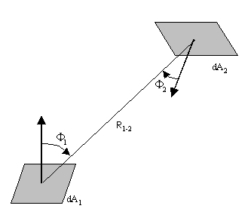
FIG. 1. Defining geometry for configuration factor [2]
B. View factor between two parallel directly opposite surfaces
One of the most revered sources of reference for configuration factor is the text of Siegel and Howell [3]. It contains a catalogue of configuration factor for different geometries. The cases, which find ready application with respect to building services, are two rectangular parallel surfaces and surfaces that are inclined to each other. First of them are in the focus of this paper.
The fundamental integral for the view factor between two rectangular surfaces – A₁ with dimensions a × b and A₂ with dimensions d × e is Eq. (3):
$F_{1−2}=\frac{1}{\text{ab}}\int{\int{\int{\int{\frac{\text{cos}Φ_{1}\text{.}\text{cos}Φ_{2}}{{πR}^{2}}}{\text{dy}}_{2}{\text{dx}}_{2}{\text{dy}}_{1}{\text{dx}}_{1}}}}$ (3)
For two parallel directly opposite rectangular surfaces (Fig. 2), Eq. (3) will have to be modified with these values of $R=\sqrt{(x_{1}−x_{2})^{2}+(y_{1}−y_{2})^{2}+(z_{1}−z_{2})^{2}}$ and $\text{cos}Φ_{1}=\text{cos}Φ_{2}=c/R$. The resulting integral for the estimation of VF₁₋₂ is Eq. (4):
$F_{1−2}=\frac{c^{2}}{π\text{ab}}\int{\int{\int{\int{\frac{1}{{\left[(x_{1}−x_{2})^{2}+(y_{1}−y_{2})^{2}+(z_{1}−z_{2})^{2}\right]}^{2}}}{\text{dy}}_{2}{\text{dx}}_{2}{\text{dy}}_{1}{\text{dx}}_{1}}}}$ (4)
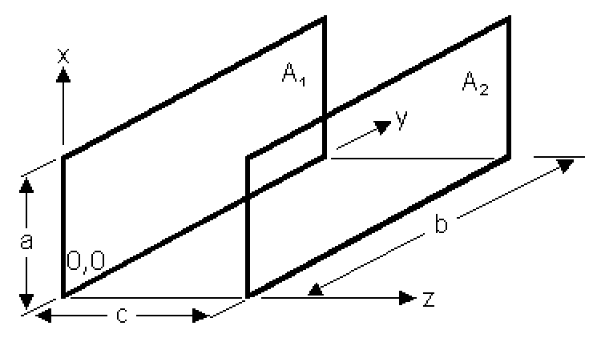
FIG. 2. Two parallel directly opposite rectangular surfaces

The configuration factor – solution of this integral, is Eq. (5) [4], where X= a / c and Y= b / c:
$F_{1−2}\text{ = }F_{2−1}\text{ = }\frac{2}{π\text{XY}}\begin{aligned}\left(X\sqrt{1+Y^{2}}{\text{tan}}^{\text{-1}}\left(\frac{X}{\sqrt{1+Y^{2}}}\right)+Y\sqrt{1+X^{2}}{\text{tan}}^{\text{-1}}\left(\frac{Y}{\sqrt{1+X^{2}}}\right) | \right) \\ \end{aligned}$ (5)
C. View factor between two parallel surfaces – generalized case
In order to estimate the VF from a rectangular surface to other rectangular surface let’s consider these 4 configurations of 2 parallel directly opposite surfaces with their subparts. Every next configuration is more complex than the previous and will use the results from it. Our goal for each configuration is to express the considered VF with the help of the basic VF in Eq. (5). For this purpose we will use the View Factor Algebra (VFA). It is a combination of basic configuration factors between surfaces with different geometries and fundamental relations between them [2].
Configuration 1: Let us have two directly opposite rectangular surfaces and let each of them is vertically divided in two rectangular parts with the same size for both surfaces: $A_{1}=A_{1'}$ and $A_{2}=A_{2'}$ (Fig. 3(a) ). Let us apply VFA to estimate F_{1’,2’ –1} and F_{1,2 –1’} – the VF from each rectangle to a part of the other rectangle:
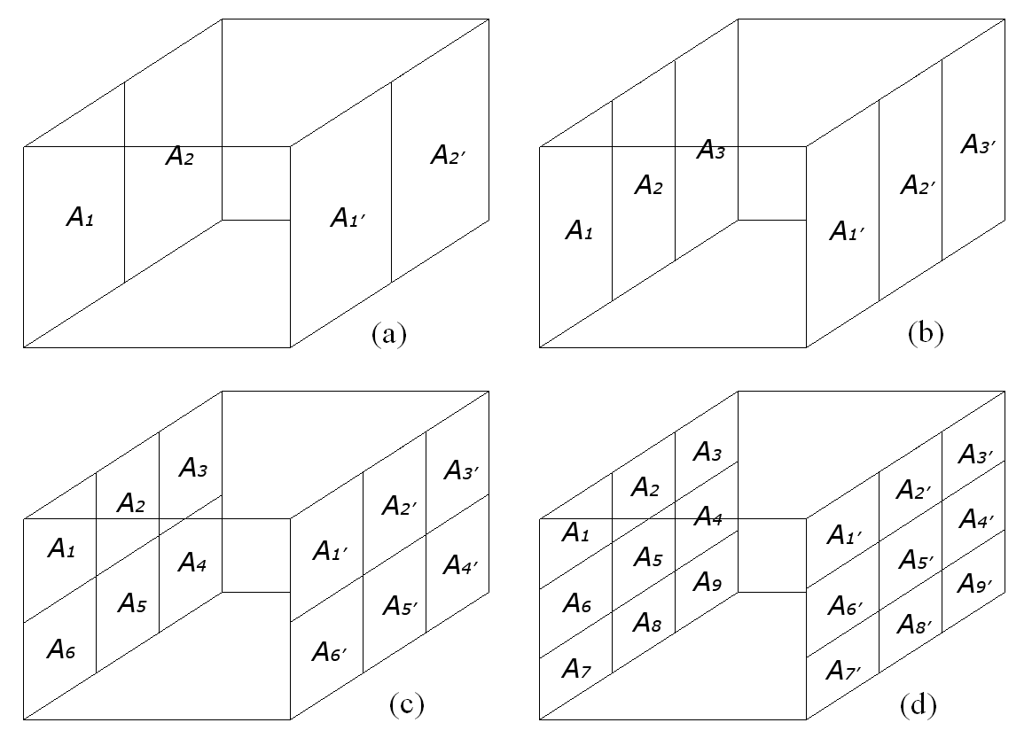
FIG. 3. Two parallel surfaces subdivided horizontally and vertically in different number of parts – different configurations to apply VFA

The K terms below are defined by $K_{m−n}=A_{m}F_{m−n}$ and $K_{(m)^{2}}=A_{m}F_{m−m'}$. The term $K_{(m)^{2}}$ corresponds to basic VF, estimated with Eq. (5).
With the help of VFA it is easy to prove that $A_{1}F_{\text{1-2'}}=A_{2}F_{\text{2-1'}}$ or $K_{\text{1-2'}}=K_{\text{2-1'}}$. We will use this equality to express the VF from surface (A₁+A₂) to surface (A_{1’}+A_{2’}) with the help of VF of different combinations of their subparts:
$K_{\text{1-2'}}+K_{\text{1-1'}}+K_{\text{2-1'}}+K_{\text{2-2'}}=K_{\text{1,2-1',2'}}$ (6)
$K_{\text{1-2'}}=K_{\text{2-1'}}={\left(K_{\text{1,2-1',2'}}−K_{\text{1-1'}}−K_{\text{2-2'}}\right)}/2$ (7)
$K_{\text{1-1',2'}}=K_{\text{1-2'}}+K_{\text{1-1'}}={\left(K_{\text{1,2-1',2'}}+K_{\text{1-1'}}−K_{\text{2-2'}}\right)}/2$ (8)
$K_{\text{1',2'-1}}=K_{\text{1-1',2'}}=\left(K_{(\text{1,2})^{2}}+K_{(1)^{2}}−K_{(2)^{2}}\right)2$ (9)
The result in Eq. (9) will be used in next configurations.
Configuration 2: Let us have two directly opposite rectangular surfaces and each of them have three rectangular parts with the same size for both surfaces: $A_{1}=A_{1'}$ and $A_{2}=A_{2'}$ and $A_{3}=A_{3'}$ (Fig. 3(b)). Let us apply View Factor Algebra (VFA) to estimate F_{3’ –1} – the VF from a part of the first rectangle to diagonally opposite part of the other rectangle – Eqs. (10-12):
$K_{\text{1',2',3'-1}}=\left(K_{(\text{1,2,3})^{2}}+K_{(1)^{2}}−K_{(\text{2,3})^{2}}\right)2=K_{\text{3'-1}}+K_{\text{1',2'-1}}$ (10)
$K_{\text{3'-1}}=K_{\text{1',2',3'-1}}−K_{\text{1',2'-1}}=\left(K_{(\text{1,2,3})^{2}}+K_{(1)^{2}}−K_{(\text{2,3})^{2}}\right)2−\left(K_{(\text{1,2})^{2}}+K_{(1)^{2}}−K_{(2)^{2}}\right)2$ (11)
$K_{\text{3'-1}}=\left(K_{(\text{1,2,3})^{2}}−K_{(\text{2,3})^{2}}−K_{(\text{1,2})^{2}}+K_{(2)^{2}}\right)2$ (12)
Configuration 3: Let us have two directly opposite rectangular surfaces and each of them have six rectangular parts in two rows with the same size for both surfaces: $A_{1}=A_{1'}$, $A_{2}=A_{2'}$ etc. (Fig. 3(c) ). This is a simpler case and a preparation for the more complex case with Configuration 4.
$K_{\text{3'-6}}+K_{\text{3'-1}}=K_{\text{3'-1,6}}$ (13)
$K_{\text{4'-6}}+K_{\text{4'-1}}=K_{\text{4'-1,6}}$ (14)
If we summarize left and right sides of last two Eqs. (13, 14) and with the help of the reciprocity relation $K_{\text{3'-6}}=K_{\text{4'-1}}$, it follows:
$K_{\text{3'-6}}=K_{\text{4'-1}}={\left(K_{\text{3',4'-1,6}}−K_{\text{3'-1}}−K_{\text{4'-6}}\right)}/2$ (15)
Configuration 4: Let us expand both surfaces in Configuration 3 with one more row of 3 rectangles. This way each surface will have 9 rectangular parts in three rows with the same size for both surfaces: $A_{1}=A_{1'}$, $A_{2}=A_{2'}$ etc. (Fig. 3(d) ). With the help of View Factor Algebra (VFA) we will estimate F_{3 –7’} – the VF from a part in the top row of the first rectangle to diagonally opposite part in the bottom row of the other rectangle. The equations for variables$K_{\text{3'-6}}$ and $K_{\text{3'-6,7}}$ follow from Eq. (15):
$K_{\text{3'-6}}={\left(K_{\text{3',4'-1,6}}−K_{\text{3'-1}}−K_{\text{4'-6}}\right)}/2$ (16)
$K_{\text{3'-6,7}}={\left(K_{\text{3',4',9'-1,6,7}}−K_{\text{3'-1}}−K_{\text{4',9'-6,7}}\right)}/2$ (17)
Variable $K_{\text{3'-7}}$ is estimated as a difference between $K_{\text{3'-6,7}}$ and $K_{\text{3'-6}}$:
$K_{\text{3'-7}}=K_{\text{3'-6,7}}−K_{\text{3'-6}}={\left(K_{\text{3',4',9'-1,6,7}}−K_{\text{4',9'-6,7}}−K_{\text{3',4'-1,6}}+K_{\text{4'-6}}\right)}/2$ (18)
$K_{\text{3'-7}}={\left(K_{\text{3',4',9'-1,6,7}}−K_{\text{4',9'-6,7}}−K_{\text{3',4'-1,6}}+K_{\text{4'-6}}\right)}/2$ (19)
The participating elements in Eq. (19) can be expressed with the help of Eq. (12) in this way:
$K_{\text{3',4',9'-1,6,7}}=\left(K_{(\text{1,2,3,4,5,6,7,8,9})^{2}}−K_{(\text{2,3,4,5,8,9})^{2}}−K_{(\text{1,2,5,6,7,8})^{2}}+K_{(\text{2,5,8})^{2}}\right)2$ (20)
$K_{\text{4',9'-6,7}}=\left(K_{(\text{4,5,6,7,8,9})^{2}}−K_{(\text{4,5,8,9})^{2}}−K_{(\text{5,6,7,8})^{2}}+K_{(\text{5,8})^{2}}\right)2$ (21)
$K_{\text{3',4'-1,6}}=\left(K_{(\text{1,2,3,4,5,6})^{2}}−K_{(\text{2,3,4,5})^{2}}−K_{(\text{1,2,5,6})^{2}}+K_{(\text{2,5})^{2}}\right)2$ (22)
$K_{\text{4'-6}}=\left(K_{(\text{4,5,6})^{2}}−K_{(\text{4,5})^{2}}−K_{(\text{5,6})^{2}}+K_{(5)^{2}}\right)2$ (23)
The final result $F_{\text{3'-7}}$ is as follows in Eq. (24), where all participating variables are basic view factors:
$F_{\text{3'-7}}=\frac{1}{A_{\text{3'}}}\begin{aligned}\left(K_{(\text{1,2,3,4,5,6,7,8,9})^{2}}−K_{(\text{2,3,4,5,8,9})^{2}}−K_{(\text{1,2,5,6,7,8})^{2}}+K_{(\text{2,5,8})^{2}}−K_{(\text{4,5,6,7,8,9})^{2}} | \right)\left(+K_{(\text{4,5,8,9})^{2}}+K_{(\text{5,6,7,8})^{2}}−K_{(\text{5,8})^{2}}−K_{(\text{1,2,3,4,5,6})^{2}}+K_{(\text{2,3,4,5})^{2}}+K_{(\text{1,2,5,6})^{2}} | \right) \\ \end{aligned}$ (24)
This result is given in this final form in [5] also and can be useful for uniform emitting surfaces and to validate the results from finite-element approach to the same problem.
D. Finite-element approach
If we consider both parallel and directly opposite rectangular surfaces A_{i} and A_{j} as composed of many very small rectangular areas (Fig. 4(a) ), we could use numeric integration to receive the same result with a small loss of accuracy:
$F_{j−i}=\frac{c^{2}}{π\text{.}\text{Na}\text{.}\text{Nb}}\sum_{j_{1}=1}^{\text{Na}}{\sum_{j_{2}=1}^{\text{Nb}}{\sum_{i_{1}=1}^{\text{Na}}{\sum_{i_{2}=1}^{\text{Nb}}{\frac{1}{{\left[(x_{i}−x_{j})^{2}+(y_{i}−y_{j})^{2}+(z_{i}−z_{j})^{2}\right]}^{2}}ΔbΔa}}}}$ (25)
where c is distance between both surfaces, Δa = a / Na, Δb = b / Nb and Na, Nb are the numbers of intervals for the numeric integration in both dimensions. The coordinates of each fragment’s center are: for surface i – x_{i}=(i₁–0.5)Δa; y_{i}=(i₂–0.5)Δb; for surface j – x_{j}=(j₁–0.5)Δa; y_{j}=(j₂–0.5)Δb. Such solution has one main significant advantage – it easily can be adapted for any disposition of both parallel rectangular surfaces (Fig. 4(b) ), but also has two serious disadvantages – it gives an approximate result and to avoid this with large numbers of intervals, it needs a considerable amount of computing time.
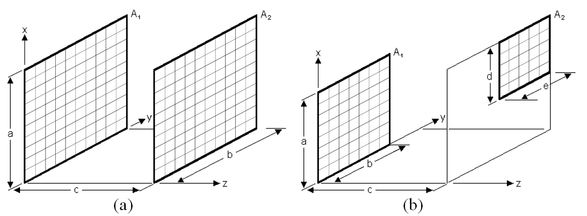
FIG. 4. The reflective and receiving surfaces are divided in two directions to receive a regular perpendicular grid: (a) both surfaces are identical and directly opposite; (b) two parallel surfaces – generalized arrangement

III. Non-uniform emitting or reflective surfaces
In case of non-uniform emitting or reflective of the surface, the finite-element approach is irreplaceable. Here we will use the word “emitting / emission” in its wider meaning of radiation that leaves a surface. There are many cases when the surfaces could be defined as non-uniform emitting or reflective:
- Surface that receive non-uniform incident radiation / light – in urban environment building surfaces (facades) receive irregular direct and diffuse irradiance. In this case the reflected radiance will not be uniform even for uniform reflectivity of the surface;
- Surface with non-uniform reflectivity – a building surface with windows and different kind of coats will have areas with different reflectivity, even for constant incident irradiance. For a surface with non-uniform reflectivity, the reflected radiation will not be uniform;
- Surface with non-uniform emitting – most surfaces emit their internal heat to the environment; typical example of this are the building surfaces – windows and doors lose more heat than the continuous walls;
- Complex case – it encompasses adequately most building surfaces, which have non-uniform reflectance, receive irregular irradiance and emit non-uniformly.
A. Non-uniform incident radiation – examples
The incident solar radiation on an external building surface in urban environment usually is not uniform. Some parts of the surface are sunlit, other are in shade. Upper parts of the structure may receive more diffuse irradiance, while lower parts less (Fig. 5). The internal building surfaces also receive non-uniform irradiance. Some areas that are close to the windows and doors, receive more- while the areas at the bottom end of the room receive less radiation. Let us divide such non-uniform illuminated rectangular surface in an orthogonal grid to estimate the average irradiance value for each cell of this grid. The view factor from a receiving surface A_{j} (with dimensions a × b) to another parallel reflective surface A_{i}, (with dimensions d × e at distance c), corrected with the values of the incident irradiance / illuminance I_{i} on surface A_{i} that reflects uniformly (with constant albedo ρ), gives the average (for the surface A_{j}) received irradiation from surface A_{i} – Eq. (26):
$F'_{j−i}=\frac{c^{2}ρ}{π\text{ab}}\sum_{j_{1}=1}^{\text{Na}}{\sum_{j_{2}=1}^{\text{Nb}}{\sum_{i_{1}=1}^{\text{Nd}}{\sum_{i_{2}=1}^{\text{Ne}}{\frac{I_{i}}{{\left[(x_{i}−x_{j})^{2}+(y_{i}−y_{j})^{2}+(z_{i}−z_{j})^{2}\right]}^{2}}ΔaΔbΔdΔe}}}}$ (26)
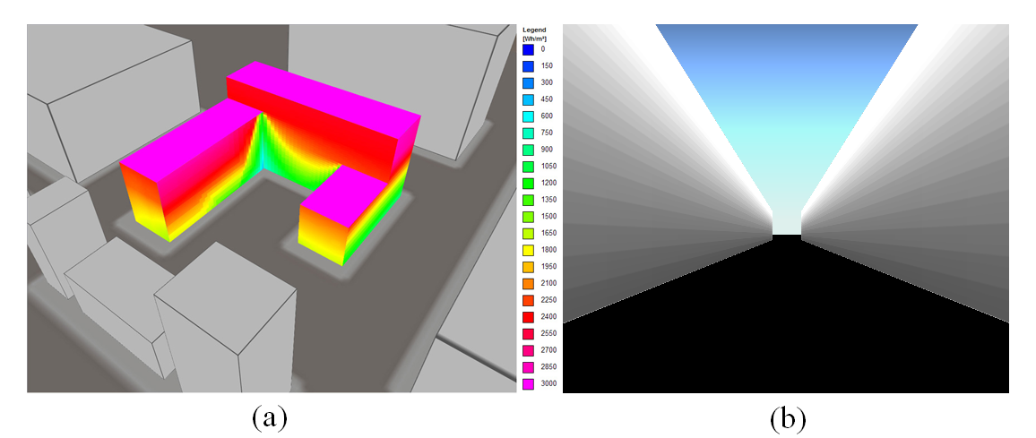
FIG. 5. (a) The exemplary image displays the non-uniform incident daily irradiation on the building surfaces for 21 June in Sofia – calculated data according [6]. These values can be used for the estimation of the reflected irradiance to the opposite building surfaces; (b) non-uniform incident daily solar irradiation on vertical surfaces of urban street canyon with H/W=1/1 for 21 June in Sofia – calculated data according [7].

B. Non-uniform reflective surfaces
Even for uniform values of the incident radiation it is possible for the reflective surface to have parts with different reflectance. The windows have different reflectance compared to walls. Different number of coats of paint and colors reflect different percent of the incident irradiance. Let us divide such non-uniform reflective rectangular surface in an orthogonal grid and to estimate the average albedo value ρ_{i} for each cell of this grid. The view factor from receiving surface A_{j} (with dimensions a × b) to another reflective surface A_{i} (with dimensions d × e at distance c), corrected with the reflectance values, is given by Eq. (27):
$F'_{j−i}=\frac{c^{2}}{π\text{ab}}\sum_{j_{1}=1}^{\text{Na}}{\sum_{j_{2}=1}^{\text{Nb}}{\sum_{i_{1}=1}^{\text{Nd}}{\sum_{i_{2}=1}^{\text{Ne}}{\frac{ρ_{i}}{{\left[(x_{i}−x_{j})^{2}+(y_{i}−y_{j})^{2}+(z_{i}−z_{j})^{2}\right]}^{2}}ΔaΔbΔdΔe}}}}$ (27)
C. Non-uniform emitting surfaces – examples
All building surfaces emit their internal heat to the environment. This emission is usually not regular – windows and doors may lose more heat than the continuous walls; even the walls lose their heat non-uniformly. The amount of the emitted internal heat depends also on the temperatures and view factors of the opposite surfaces and visible sky. This is described with Eq. (1). More details how to estimate the emitted irradiation are given in [8]. The resulting non-uniform heat emissions could be noticed by building thermography with infrared cameras, which measure surface temperatures and show the heat spectrum as visible light. On the resulting images the temperature variations of the building’s skin are visualized, ranging from white for warm regions to black for cooler areas [9].
Let us divide the non-uniform emitting rectangular surface in an orthogonal grid and to estimate the average value of emitting for each cell of this grid. The view factor from surface A_{j} (with dimensions a × b) to another parallel emitting surface A_{i} (with dimensions d × e), corrected with the emitted radiance values E_{i}, gives the average (for the surface A_{j}) received irradiation from surface A_{i} – Eq. (28):
$F'_{j−i}=\frac{1}{π\text{ab}}\sum_{j_{1}=1}^{\text{Na}}{\sum_{j_{2}=1}^{\text{Nb}}{\sum_{i_{1}=1}^{\text{Nd}}{\sum_{i_{2}=1}^{\text{Ne}}{\frac{c^{2}E_{i}}{{\left[(x_{i}−x_{j})^{2}+(y_{i}−y_{j})^{2}+(z_{i}−z_{j})^{2}\right]}^{2}}ΔaΔbΔdΔe}}}}$ (28)
where Δa = a / Na, Δb = b / Nb, Δd = d / Nd, Δe = e / Ne, Na and Nb are the numbers of intervals for the receiving surface, Nd and Ne are the numbers of intervals for the emitting surface.
D. Complex case
This case covers most building surfaces, i.e. those that have non-uniform reflectance, receive irregular irradiance and emit non-uniformly. Let us divide the non-uniform reflective and emitting rectangular surface in an orthogonal grid. For each cell of this grid we need to estimate the average received irradiance I_{i}, average reflectance ρ_{i} and average emittance value E_{i}. The view factor (VF) from receiving surface A_{j} to another parallel emitting surface A_{i}, corrected with these three values, gives the average (for the surface A_{j}) received irradiation from surface A_{i} – Eq. (29):
$F'_{j−i}=\frac{c^{2}}{π\text{ab}}\sum_{j_{1}=1}^{\text{Na}}{\sum_{j_{2}=1}^{\text{Nb}}{\sum_{i_{1}=1}^{\text{Nd}}{\sum_{i_{2}=1}^{\text{Ne}}{\frac{ρ_{i}I_{i}+E_{i}}{{\left[(x_{i}−x_{j})^{2}+(y_{i}−y_{j})^{2}+(z_{i}−z_{j})^{2}\right]}^{2}}ΔaΔbΔdΔe}}}}$ (29)
IV. Computational tool development. validation
Developed VBA code has two parts. First part includes 4 worksheets in Excel with corresponding 4 VBA modules that calculate VF between two parallel surfaces, using analytic integration. Four cases are developed:
- Case (a) – Vertical surface of infinite width and finite height facing another directly opposite parallel surface with infinite width and the same finite height (see more details in Fig. 13 – Scheme A1).
- Case (b) – Vertical surface of infinite width and finite height facing another parallel surface with infinite width and different finite height (see more details in Fig. 13 – Scheme A2).
- Case (c) – Vertical surface of finite width and finite height facing another directly opposite parallel surface with the same finite width and height, the solution is based on Eq. (5) (see more details in Fig. 13 – Scheme A3).
- Case (d) – View factor for generalized parallel rectangle arrangement, the solution is based on Eqs. (5) and (24) (see more details in Fig. 13 – Scheme A4).
The developed 4 modules of analytic integration help to validate the modules of numeric integration that are included in the second part of VBA code. These 3 modules are developed using Eqs. (25) to (29). This represents the evolution of the present work and demonstrates the code architecture from being simple-most to more complex. The cases dealt here are:
A. Cases with uniform emission
An uniform grid, where all cells are of same dimension and aspect ratio, is applied on the emitting / reflective surface. Likewise, the cells within the receiving plane have similar properties. The lengths of cells within the emitting and receiving planes may or may not be equal. Square grids for both surfaces show better accuracy in estimating VF. For square cells the total number of cells on the receiving surface is N_{receiving_cells} = (b/a).N_{a}², and the total number of iterations is N_{receiving_cells}.N_{emitting_cells}. This approach can easily be applied in these two cases:
- Case e) is a combination of two parallel, directly opposite surfaces, the solution is based on Eq. (25). See more details in Fig. 14 – Scheme A5.
- Case f) is a combination of two parallel rectangular surfaces in generalized arrangement, the solution is based again on Eq. (25). See more details in Fig. 14 – Scheme A6.
With the view to validate the present software, developed within the MS-Excel environment using a VBA tool, Table I has been prepared. It includes several sub-cases, illustrated in Fig. 7. The estimated values with our numerical approach were compared with values, received with the analytical approach, described in Sec. ID and validated with calculated data, published by Holman [5], Siegel and Howell [3], Hamilton and Morgan [10], Feingold [11] and Suryanarayana [12, 13].
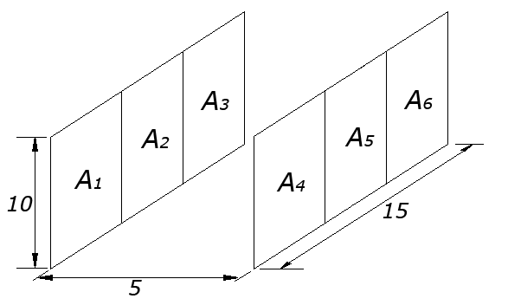
FIG. 6. Schematic image – test case for Table I.

TABLE I. Evaluation and validation of the numerical model with uniform grid: test case 1 – Fig. 6.
No | Sub case | Results in [13] | Numeric  results^{c} | Analytic  results | No. of iterations | Error% | Time^{c} (s) | TEPª | TEP2^{b}
1 | F₁₂₋₄₅ | 0.509 | 0.5090456 | 0.5089887 | 4.1*10⁷ | 0.011% | 10 | 0.00112 | 0.00035
2 | F₁₋₄ | 0.4153 | 0.4152878 | 0.4152533 | 4.1*10⁷ | 0.008% | 11 | 0.00092 | 0.00028
3 | F₁₂₃₋₄₅₆ | 0.5442 | 0.5442863 | 0.5442097 | 4.1*10⁷ | 0.014% | 11 | 0.00155 | 0.00047
4 | F₁₂₋₅₆ | 0.3044 | 0.3043568 | 0.3043440 | 4.1*10⁷ | 0.004% | 11 | 0.00047 | 0.00014
5 | F₁₂₋₄₅ | 0.509 | 0.5090251 | 0.5089887 | 10⁸ | 0.007% | 26 | 0.00186 | 0.00036
6 | F₁₋₄ | 0.4153 | 0.4152754 | 0.4152533 | 10⁸ | 0.005% | 25 | 0.00133 | 0.00027
7 | F₁₂₃₋₄₅₆ | 0.5442 | 0.5442587 | 0.5442097 | 10⁸ | 0.009% | 26 | 0.00234 | 0.00046
8 | F₁₂₋₅₆ | 0.3044 | 0.3043522 | 0.3043440 | 10⁸ | 0.003% | 27 | 0.00073 | 0.00014
9 | F₁₂₋₄₅ | 0.509 | 0.5090180 | 0.5089887 | 1.44*10⁸ | 0.006% | 37 | 0.00213 | 0.00035
10 | F₁₋₄ | 0.4153 | 0.4152720 | 0.4152533 | 1.44*10⁸ | 0.005% | 37 | 0.00167 | 0.00027
11 | F₁₂₃₋₄₅₆ | 0.5442 | 0.5442479 | 0.5442097 | 1.44*10⁸ | 0.007% | 37 | 0.00260 | 0.00043
12 | F₁₂₋₅₆ | 0.3044 | 0.3043520 | 0.3043440 | 1.44*10⁸ | 0.003% | 39 | 0.00103 | 0.00016
ª TEP is Time-Error-Product.
^{b} TEP2 is SQRT(Time)-Error-Product.
^{c} Time for execution on a desktop with 2 GB RAM and two 2.5 GHz Intel® Celeron® processors.

Table I includes 3 groups of 4 sub cases. The difference between the groups is the number of iterations. As we could expect, more iterations need more time, but they give more accurate result with smaller error. Last two columns in Table I contain two products. First value TEP is Time-Error-Product. It was introduced in our previous article [1]. It enables a direct comparison between different algorithms in a scoring system, where a low score is sought. The second value TEP2 is product of Error and square root of Time. For a specific configuration and algorithm this value is close to a constant. This could help us to calculate the necessary computer time to estimate the result with desired accuracy (error) – Eq. (30):
$\text{Time}=(\text{TEP}2/{\text{Error}})^{2}$ (30)
B. Cases with non-uniform emitting
Uniform grids, where all cells within the plane are of same dimension and aspect ratio, are applied on the emitting and receiving surface. Again square grids for both surfaces show better accuracy in estimating VF.
Using Eq. (29) a VBA module and corresponding worksheet are developed. They need 4 matrices with input data: matrix of incident global irradiation on the considered wall, matrix of incident global irradiation on the opposite wall, matrix of reflectivity and matrix of emitted radiation for the opposite wall. The results are of two kinds: the average value of the reflected and global irradiation for the considered wall and two matrices of reflected and global irradiation, incident to the finite elements of the same wall:
- Case g) Complex case with non-uniform incident radiation, non-uniform reflectivity and non-uniform emitted heat, it is based on Eq. (29) and it is illustrated in Scheme A7 in the Appendix, where more details about the input data and results are given. See more details in Fig. 14 – Scheme A7.
C. Example
As an example we choose a complex case with simple geometry – the urban street canyon. A street canyon is a place where the street is flanked by buildings on both sides creating a canyon-like environment [14]. These are most streets in city centers. The specific geometry of the urban canyons influences many climatic and other local parameters such as temperature, wind, air quality, etc. Initially the term “street canyon” was used for a relatively narrow street with tall buildings on both sides of the road. Today the term has a broader sense. The relationship between the geometric parameters of the canyon is used for its categorization. The most important geometrical detail about a street canyon is the ratio of the canyon height (H) to canyon width (W): H/W. The value of this aspect ratio can be used to classify street canyons as follows: regular canyon – with aspect ratio H/W ≈ 1 and no major openings on the canyon walls; avenue canyon – with aspect ratio H/W ≤ 0.5, deep canyon – with aspect ratio H/W ≈ 2.
The modification of the characteristics of the atmospheric boundary layer in a street canyon is called the street canyon effect. One of the reasons about it is the dynamic energy exchange with in the street canyon. Among the factors that affect this energy exchange, on first place must be mentioned the solar radiation that is dynamically changing and limited resource. The opposite wall of the canyon blocks а part of the incoming solar radiation. The rooms in the buildings in an urban canyon have a different view to the sky and receive different amounts of solar radiation and daylight. The estimation of the incident solar radiation on canyon walls is important for most solar energy related work, including many building applications.
In a previous research [7] the seasonal direct and diffuse irradiation on the facades of different types of canyons was estimated. We will use these values for winter (from 1st October to 31st March) in the geographical and climatic conditions of Sofia as input data for our complex case and will estimate the reflected radiation.
The used model of urban canyon is simple – it includes two parallel parallelepipeds with height H and distance W between them (Fig. 7). Their length L is 10 times longer than the distance W and the ratio H/W is 1. Two cases of urban canyons are considered, as in [15]: a) canyon with axis east – west (Fig. 7(a) ); b) canyon with axis north – south (Fig. 7(b) ).
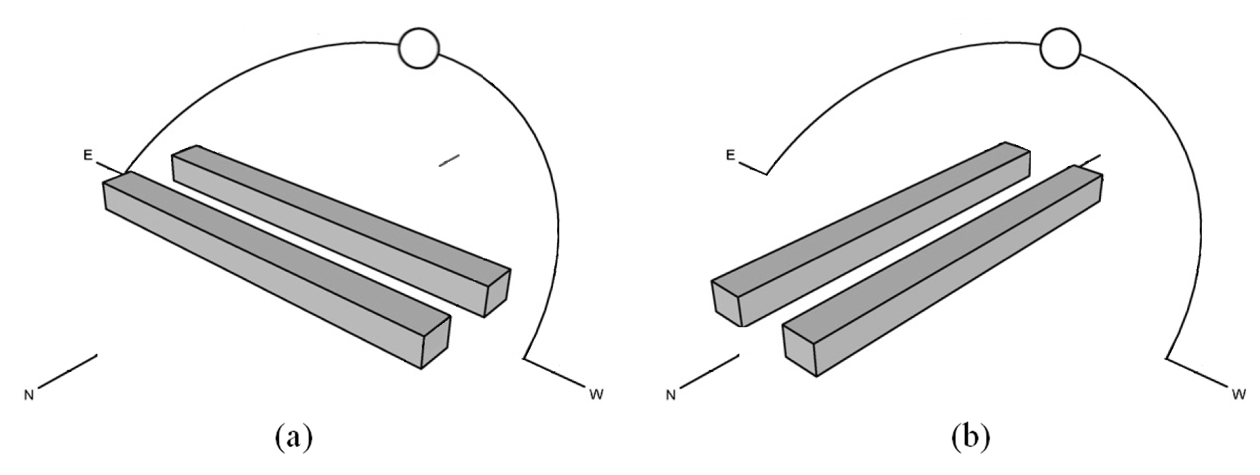
FIG. 7. Schematic representation of the street direction and building orientation: (a) canyon with axis east-west; (b) canyon with axis north-south.

Input data are: a_{1L}=c_{1L}=0; b_{3L}=d_{3L}=0; a_{1U}=c_{1U}=10; b_{3U}=d_{3U}=100; e₁=0: e₂=10; Na=Nc=40 ; Nb=Nd=80. The grid on every façade has 40 x 80=3200 cells.
The matrix of albedo includes reflectivity data. We will use two albedo matrix with different schemes, where dark areas have albedo 0.2 and light areas have albedo 0.7 (Figs. 8, 9).
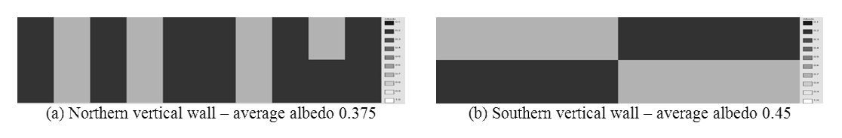
FIG. 8. Illustration of albedo values for northern and southern walls of a canyon with axis east-west.

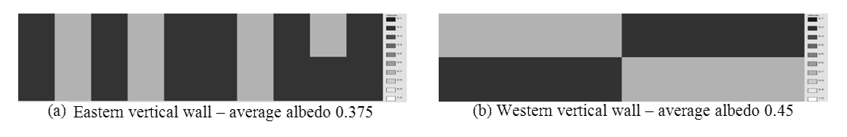
FIG. 9. Illustration of albedo values for eastern and western walls of a canyon with axis north-south.

The values of the incident beam and diffuse radiation on each cell are given in 3 matrices, placed in 3 worksheets (illustrated in Fig. 10).
- Worksheet incident irradiation east/west – it includes average daily beam + diffuse irradiation [Wh/m²/Day] on the eastern and western façade of a canyon with axis north – south, for winter;
- Worksheet incident irradiation south – it includes average daily beam + diffuse irradiation [Wh/m²/Day] on the southern façade of a canyon with axis east – west, for winter;
- Worksheet incident irradiation north – it includes average daily beam + diffuse irradiation [Wh/m²/Day] on the northern façade of a canyon with axis east – west, for winter;
All images in next 3 figures are prepared with PowerBasic program and OpenGL application programming interface for rendering 2D and 3D vector graphics.
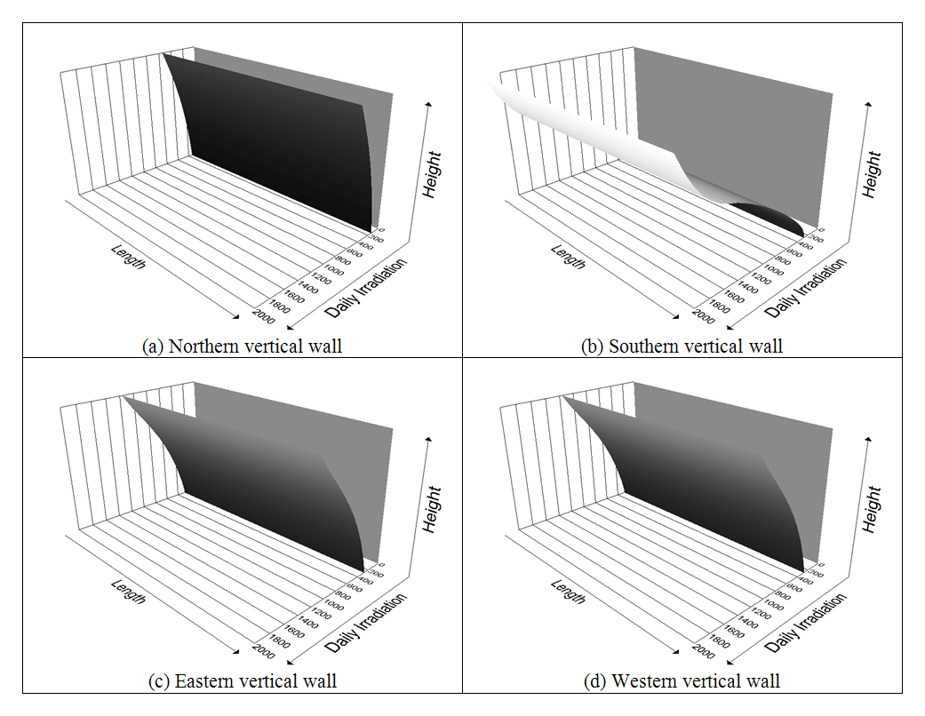
FIG. 10. Illustration of average daily beam and diffuse irradiation [Wh/m²/Day]: (a) northern vertical wall; (b) southern vertical wall; (c) eastern vertical wall; (d) western vertical wall.

To obtain data about the emissions from each cell on the reflective façade is a difficult task and we will leave this matrix empty.
Using the mentioned input data, the module for case g) calculates the listed below results:
- Numeric value of reflected irradiation, average for the surface.
- Numeric value of global (sum of beam, diffuse and reflected from the opposite wall) irradiation, average for the surface.
- Matrix of the incident reflected irradiation. Different resulting matrices are illustrated in Fig. 11. Note that the amount of the reflected irradiation is much less than the incident irradiation and it is shown in different scale. The example in Fig. 11(a) demonstrates the idea of albedo engineering – how the location of areas with higher reflectivity could impact significantly on the amount of the reflected irradiation incident to an opposite surface. Even if the amounts of the incident beam and diffuse daily irradiation on the eastern and western walls (Fig. 10(c) and 10(d) ) are equal, the patterns of the reflected by them irradiation are irregular in a different way because of the different albedo matrices (Fig. 11(c) and 11(d) ).
- Matrix of global (sum of beam, diffuse and reflected from the opposite wall) irradiation. Different resulting matrices are illustrated in Fig. 12. The biggest increase of global irradiation we could see on the northern façade in the area where the top part of the opposite southern wall has albedo 0.7 (Fig. 12(a) ). The irregular patterns of the global irradiation could be visually noticed for eastern and western facades (Fig. 12(c) and 12(d)).
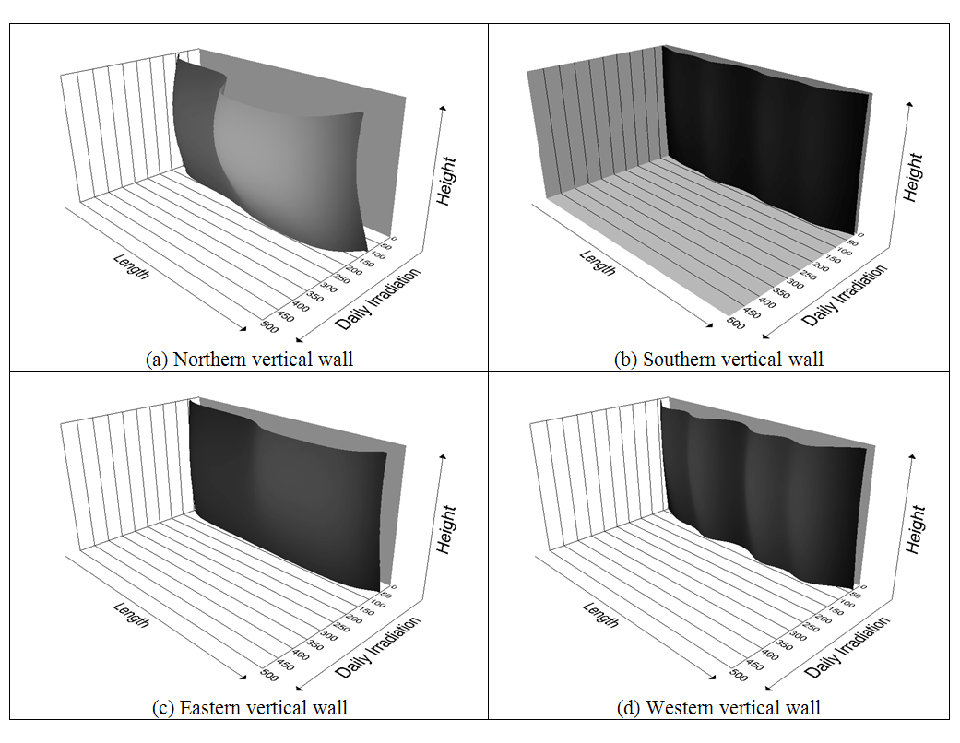
FIG. 11. Illustration of received average daily reflected irradiation [Wh/m²/Day]: (a) northern vertical wall; (b) southern vertical wall; (c) eastern vertical wall; (d) western vertical wall.

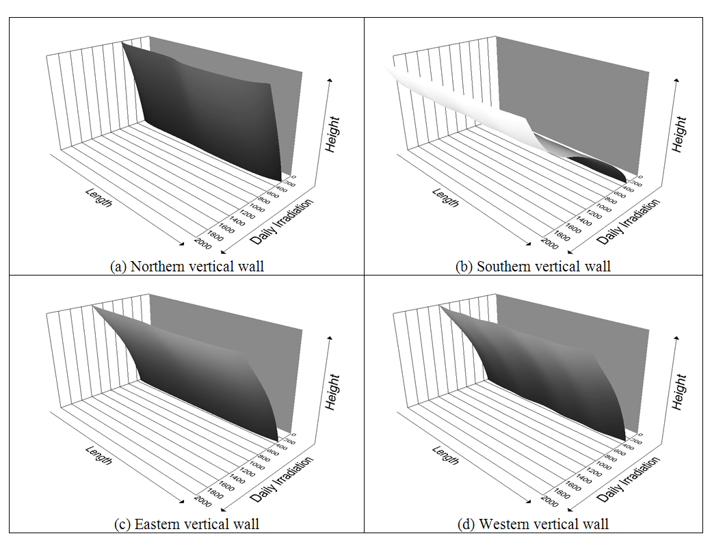
FIG. 12. Illustration of received average daily global irradiation [Wh/m²/Day]: (a) northern vertical wall; (b) southern vertical wall; (c) eastern vertical wall; (d) western vertical wall.

V. APPLICATION IN BUILDING DESIGN
The considered complex case encompasses adequately most building surfaces which have non-uniform reflectance, receive irregular irradiance and emit non-uniformly. The approach, combined with the algorithms in [1] is suitable to analyze the energy exchange between the building surfaces in a complicate urban environment. The estimation of the reflected irradiation is only a part in the algorithm of a more precious estimation of the total value of solar energy incident to the surfaces of the considered future building in the different seasons. This allows the architect to study a building shape in order to increase the solar gains in winter and to decrease the solar fluxes in summer in the current urban environment. Thus he could study different variants of the building’s shape and composition in the early design stage.
Depending of the building’s purpose the architect may need to assure more or less solar radiation on the building facades in the different seasons. This information could direct him also to find out the suitable places for openings – windows, glazed doors and glazed facades.
For surfaces with tilts close to 90° with high albedo, the value of the reflected irradiation becomes more significant. This means that the architect could use the color and albedo not only to reach esthetic goals, but also to decide some specific problems with insufficient or exaggerated solar radiation and daylight. Such calculations lie at the root of Albedo Engineering, which is the application of scientific and practical knowledge in order to design an environment that will enhance or modulate the reflected irradiation and illumination to structures (architectural objects, PV systems), which action depends on the incident solar radiation and daylight. It could be an important part of the design of buildings with low energy consumption and PV systems that use in higher degree the available solar resources in their urban environment.
VI. Results and discussion
In this paper we presented a review of the main analytic and numeric approaches for the estimation of heat transfer between two parallel surfaces that are or are not directly opposite. The numeric approach with finite-element calculations is expanded with the cases with non-uniform emitting and/or reflective. These approaches are illustrated with 7 developed VBA modules – 4 with analytic solutions and 3 for numeric estimation. To validate the software, we prepared Table I and compared our results with published previously by other authors.
The analytic solutions were used to check the accuracy of the numeric solutions of our other tests. As a complex example we considered the received reflected irradiation by the opposite facades of 2 urban street canyons with aspect ratio H/W=1 and different orientations, non-regular albedo and non-regular incident beam and diffuse irradiation on their facades. On this base we received an average value of the reflected and global irradiation on a considered canyon’ wall and two matrices of values of the incident reflected irradiation and the incident global irradiation, received by the finite elements on the same wall, as they are illustrated on Fig. 11 and 12. The results in this article, added to results in our previous research [1] about the heat transfer between two inclined to each other surfaces with or without a common edge, could cover all possible cases of arrangements of two surfaces, divided in rectangles with finite-element approach.
Finally the application of the examined approach in building design was considered. It lies at the root of Albedo Engineering that help to design an environment that is able to enhance or modulate the reflected irradiation and illumination to structures as architectural objects and PV systems.
APPENDIX: schematics related to vba code
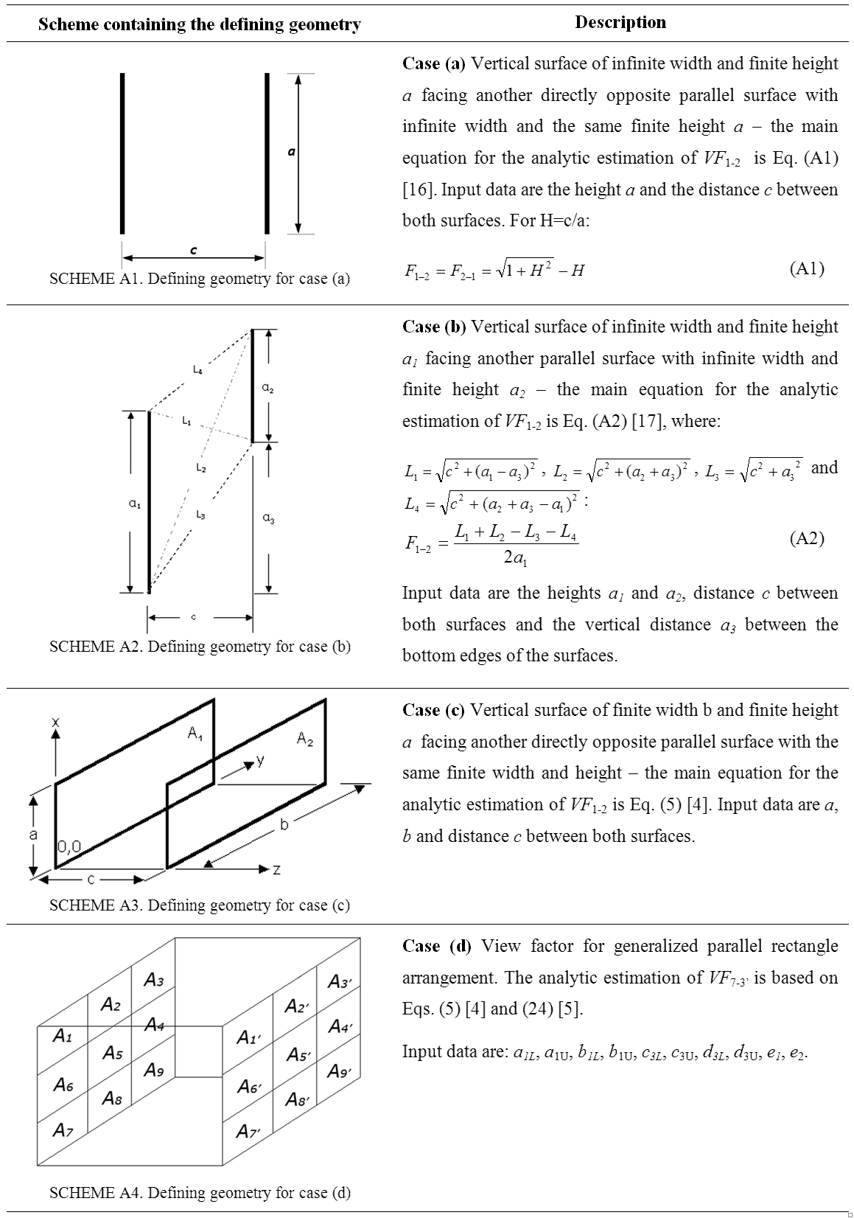
FIG. 13. The description of VBA code for analytic estimation of VF includes brief information for each of the given case, its main equation and a figure of the defining geometry (schemes A1–A4).
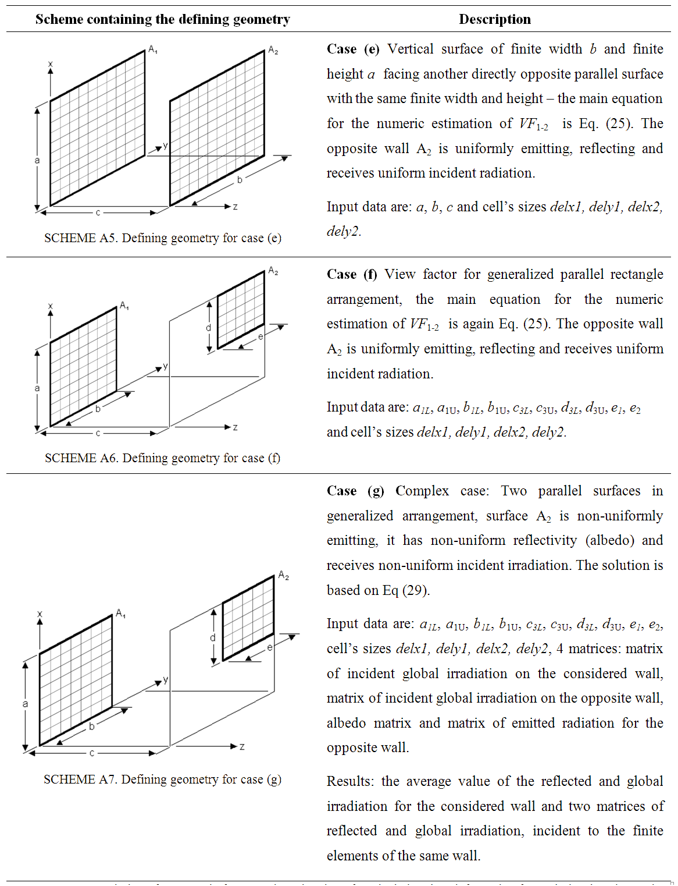
FIG. 14. The description of VBA code for numeric estimation of VF includes short information for each developed case, its main equation and a figure of the defining geometry.
References
[1] Muneer T., Ivanova S., Kotak Y. and Gul M., “Finite-element view-factor computations for radiant energy exchanges”, Journal of Renewable and Sustainable Energy, May-June 2015, pp. 033108-1 - 033108-20
[2] Howell, J. R., A catalog of radiation heat transfer - configuration factors. Introduction. Available on:
http://www.thermalradiation.net/intro.html
[3] Siegel R. and Howell J., Thermal Radiation and Heat Transfer, 4th ed. New York: Taylor & Francis, 2002
[4] Howell, J. R., A catalog of radiation heat transfer - configuration factors. C-11: Identical, parallel, directly opposed rectangles. Available on: http://www.thermalradiation.net/sectionc/C-11.html
[5] Holman J. P., Heat Transfer, 7th edition, McGraw-Hill, New York, 1992
[6] Ivanova, S., “3D Analysis of the incident diffuse irradiance on the building’s surfaces in an urban environment”, International Journal of Low-Carbon Technologies 01/2014; 9 (5)
[7] Ivanova, S., Chobanov P., “Variant analysis of the seasonal vertical solar irradiation for different types of urban street canyons”, Proc. of VII International scientific conference “Architecture, civil engineering – Modernity, 28-30 May 2015, Varna, Bulgaria, pp. 265-274
[8] Manfred K., Schmidt T., “Radiation effects on Exterior Surfaces”, Proceedings of the 8th Symposium on Building Physics, 2008.
[9] Energy Analysis, Available online on: http://toddwadena.coop/our-services/energy-solutions/energy-analysis/
[10] Hamilton, D. C. and Morgan, W. R. “Radiant interchange configuration factors”, Technical Note 2836, National Advisory Committee for Aeronautics, Washington D.C. (1952)
[11] Feingold, A. “Radiant interchange configuration factors between various selected plane surfaces”, Proc. Royal Society of London, Series A – Mathematical and Physical, Vol. 292, No. 1428, pp 51-60 (1966)
[12] Suryanarayana N.V., Engineering Heat Transfer, West Publishing Company, New York, 1995
[13] Suryanarayana N.V., Solution manual for Engineering Heat Transfer, West Publishing Company, New York, 1995
[14] Street canyon, From Wikipedia, the free encyclopedia. Available on:
https://en.wikipedia.org/wiki/Street_canyon
[15] van Esch, M.M.E., Looman, R.H.J., and de Bruin-Hordijk, G.J., “The effects of urban and building design parameters on solar access to the urban canyon and the potential for direct passive solar heating strategies”, Energy and Buildings 47 (2012), pp. 189-200
[16] Howell, J. R., A catalog of radiation heat transfer - configuration factors. C-1: Two infinitely long, directly opposed parallel plates of the same finite width. Available on:
http://www.thermalradiation.net/sectionc/C-1.html
[17] Howell, J. R., A catalog of radiation heat transfer - configuration factors. C-2a: Two infinitely long parallel plates of different widths contained in parallel planes. Available on:
http://www.thermalradiation.net/sectionc/C-2a.htm

